Environmental Assessment Worksheet

For

Name of proposal including town & county

&
USDA Rural Development

Revised 9/23/2013

POLICY
It is the policy of USDA Rural Development not to approve or fund any applicant proposals that, as a result of their identifiable impacts, direct or indirect, would lead to or accommodate the irreconcilable impact on the assessment categories listed in this document. The only exception to this policy is if the approving official determines that there is no reasonable alternative to the proposal, the proposal conforms to the planning criteria, and the proposal includes all practicable measures for reducing the impact in accordance to the corresponding federal regulation.

ORGANIZING THE REPORT
Page 1: Create a coversheet that includes the project name, location (i.e. city & county)
Page 2: This page
Page 3: Table of Contents
Page 4: Answer Sections I, II and III in narrative form. Do not include these questions in the EA.
Remaining Pages: Complete Section IV using this document or create your own following this format. All items with a (bullet •, italicized, and/or in BLUE PRINT) do not need to be copied into the final EA document.

INSTRUCTIONS FOR COMPLETING THE ASSESSMENT FOR THE CRITERIA IN THE

FOLLOWING PAGES:

In completing this assessment, it is important to understand the comprehensive nature of the impacts which must be analyzed. Consideration must be given to all potential impacts associated with the construction of the proposal, its operation and maintenance, the operation of all primary beneficiaries, and the attainment of the proposal’s major objectives.

The attainment of the proposal’s major objectives often induces or supports changes in population densities, land uses, community services, transportation systems and resource consumption. The scope of the assessment is broadened even further when there are related activities involved. The impacts of these activities must also be assessed.

The preparer will consult with appropriate experts from Federal, state, and local agencies, and other organizations or groups whose views could be helpful in the assessment of potential impacts. In so doing, each discussion which is utilized in reaching a conclusion with respect to the degree of an impact will be summarized in the assessment as accurately as possible and include the name, title, phone number, and organization of the individual contacted, plus the date contacted.
All related correspondence must be attached to the assessment, including;
Form RD 1940-20, “Request for Environmental Information.

The amount of analysis and detail provided must be commensurate with the magnitude of the expected impact. The analysis of each environmental factor (i.e., water quality, air quality, etc.) must be taken to the point that a conclusion can be reached and supported concerning the degree of the expected impact with respect to that factor.

- Assessment Questions: These will lead you to the rating. Not all questions apply to each type of proposal, if the question is not applicable answer with N/A.
- Informational Sheets, Forms & Notices: These can be found at the back of this assessment in their respective sections. Attach those that apply to your completed assessment.
- Source information: For each assessment criteria please list the informational source, which could be a person or where this information can be obtained. Also, create an appendix section for each criterion for the supporting documentation.
- Mitigation: If mitigation is required describe the proposed mitigation measures in the space provided under each criterion. Mitigation measure must be practicable and enforceable.
- Effects or impacts: (As used in this text are synonymous) Analyze each environmental resource and discuss the environmental effects or impacts including the consequences. All direct, indirect and cumulative effects or impacts need to be identified and discussed. A determination needs to be made for each environmental resource. e.g. “No effect/impact to wetlands based on…..”

Direct effects are caused by the proposal and occur at the same time and place (e.g. construction activities).

Indirect effects are those caused by the action and are later in time or further removed in distance, but still reasonably foreseeable (e.g. impacts caused by growth induced by the proposal).

Cumulative effects result from the incremental impact of the proposal when added to other past, present, and future actions regardless of who undertakes such other actions (e.g. effects of the interaction of this proposed proposal with other past, present, and future activities in the area).

- Rating: Evaluate the proposal using the following rating system in terms of actual or potential impacts on the environment.

0 = | No Impact Anticipated
1 = | Potentially Beneficial Impact
2 = | Minimal Adverse Impacts: impacts which can be easily mitigated with minimal expense or delay in the proposals implementation
3 = | Less Than Significant Adverse Impacts: impacts which can be mitigated through use of special measures which may add extra costs to the proposal or result in a short delay of the proposals implementation
4 = | Significant Adverse Impacts: impacts which cannot be mitigated or which would require extensive mitigation techniques which would be very costly and/or which would result in long delays in the proposals implementation.
N/P = | Resource Not Present: after investigation.

Table of Contents

I. Project Description Purpose and Need

A. Project Description
B. Need for the Project

II. Primary Beneficiaries and Related Activities

- Description of the Project Area

IV. Environmental Impacts Resource Criteria

- Air Quality
- Surface Water, Water Supply Quality, Groundwater, Storm Water, and Waste
Water
- Solid Waste Management and Hazardous Waste Management
- General Land Use
- Transportation
- Natural Environment
- Human Population Socio-Economic/Environmental Justice
- Construction
- Energy
- Miscellaneous

V. Coastal Zone Management Areas

VI. Cultural Resources, Historical, Archaeological

- Wild and Scenic Rivers

- Biological Resources Critical Habitat and Endangered/Threatened Species Act

- Important Farmland

- Floodplain Management and Wetlands Management

- Coastal Barrier Resources System

- State Environmental Policy Act

- Intergovernmental Review

- Environmental Analysis Of Participating Federal Agency

- Reaction To Project

- Cumulative Impacts

- Adverse Impacts

- Alternatives, Including the Proposed Action

- Mitigation

- Consistency with Rural Development Environmental Policies

Appendix (tab these)

PROPOSED PROJECT DESCRIPTION PURPOSE AND NEED

- This section must describe what is being asked of Rural Development by the applicant. It is important to remember that the Applicant’s proposal is not our federal action. The EA must always discuss who wants to do what, where, when and how consistently throughout the document as part of the justification for the purpose and need for requesting Agency assistance, including the project owner’s address and the facility’s location address.
- In addition to the on-site facilities being proposed there must be a discussion of any off-site facilities (connected actions) necessary to support the applicant’s overall proposal.
- Provide a description of the proposed project summarizing all proposed improvements and construction activities. Include a map of the project site.
- Clearly and definitively demonstrate the purpose and establish a need for the proposal. Why is there a need for the Applicant’s proposal?
- How was the need determined for an Environmental Assessment?
- Give a brief description of existing environmental conditions and trends likely to occur without implementation of the proposed activity.

PRIMARY BENEFICIARIES AND RELATED ACTIVITIES:

  - Identify any existing businesses or major developments that will benefit from the proposal and those which will expand or locate in the area because of the proposal. Specify by name, product, service or operation involved. This section must discuss the interdependent or connected parts of the applicant’s proposal. Those activities, if any that have been completed in the recent past and are now operational must be identified.

DESCRIPTION OF THE PROPOSED PROJECT AREA:

  - This section must describe the present use of the area by describing the surrounding land uses (indicate the directions and distances involved) pointing out any unique or sensitive areas such as residential, hospitals, historic properties; natural habitat; important farmlands. Maps, site photos, soil survey, if available, an aerial photograph of the site depicting the proposals location which have a descriptive purpose must be attached to aid the reader in becoming familiar with the existing conditions of the proposal area.

ENVIRONMENTAL IMPACTS RESOUCE CRITERIA:

- The following information is required and shall be addressed in the Environmental Assessment. In each category of environmental impact, a degree of intensity or level of impact must be identified. It is not adequate to subjectively state “would not be significantly affected” without any substantiating analysis or documentation. Refrain from using subjective statements that cannot be reinforced by analysis or supporting documentation. For example, if you expect an adverse or beneficial impact it needs to be identified, that it is anticipated or expected to be short-term, long-term, minimal, less than significant, or significant.

- AIR QUALITY

Iowa does not have any “non-attainment” areas.

Assessment Questions:
- Does the proposal require an installation permit, construction permit, operating permit or indirect sources permit in accordance with the Clean Air Act (42 U.S.C. 7400 Section 176 & 171) and follow local pollution control agency rules?
- For questions contact John Curtin (515) 281-3499 or (877) 247-4692 IDNR Air Quality.

- Provide information on the sources and types of any air emissions from the proposal including various chemical emissions, i.e. methanol, particulate matter, including potential bio-hazards or bio-security, pathogen issues from dust, aerosols, etc.

- Indicate the existing air quality in the area. Indicate if topographical or meteorological conditions hinder or affect the dispersal of air emissions. Provide information on the anticipated effects on air quality from operation of the facility; and, sources of odors and mitigation measures necessary to minimize off-site migration of odors.

- Provide information on the anticipated effects (including duration) on air quality from construction activities.

- Will the proposal emit large quantities of air pollutants?
- If yes, contact your CDBG representative or USDA-RD loan specialist and provide the information from IDNR’s air quality section..

- Will any air permits be required including Title V operating permits, Prevention of Significant Deterioration (PSD) permit? If so, provide status or a copy of any permit obtained. The IDNR provides guidance to developers on the types of air quality permits required.

7. Will there be other air quality issues resulting from operation of the proposal
Including; dust, vehicle traffic including cars, trucks and trains, above ground storage tanks, the use of generators or back-up generators?

- Are there air quality concerns in the vicinity of the proposal that could have a negative
impact? Including beneficiaries operations and known indirect effects.
- Areas of the country where air pollution levels persistently exceed the national ambient air quality standards may be designated as "non-attainment" Areas. Iowa does not have any “non-attainment” areas.
- To determine emissions from other facilities in the project area check the EPA website at www.epa.gov/echo/
- Click on “Air data”, in the Facility Characteristics check the “other minor” box.
- In the Geographic Location boxes click on region 7, State IOWA, and fill in county name, and search. Print out page for file.

Air permits can be viewed at: http://www.iowadnr.gov/air/prof/const/const.html

Effect/impact:

Mitigation:
Describe the mitigation measures (if necessary):

Documentation:
Supporting documentation can be found in Appendix

Impact  Category | Rating | Date/Name/Title of  Contact or Informational Source
Air Quality

- SURFACE WATER, WATER SUPPLY QUALITY, GROUNDWATER, STORM WATER, AND WASTE WATER:

SURFACE WATER Assessment Questions:

- Are there visual or other indications of water quality problems on or near the site?
- Reference the EPA Water website at http://www.epa.gov/echo/ to determine if water bodies in the project area are listed as impaired under section 303 (d) of the Clean Water Act.
- Will the proposal involve discharge of sewage effluent into surface water bodies? If so, will it meet state, federal, and other applicable standards?
- Contact the County Health Department and IDNR.

- Will the proposal involve a substantial increase in impervious surface areas? If so, have runoff control measures been included in the design to insure protection of surface water?

- Is the proposal located in a watershed management plan area?
• To determine if the project area has a watershed plan contact Steve Hopkins IDNR at (515) 281-6402. If they have a plan, discuss any potential water quality degradation caused by temporary construction activities and any mitigation measures that are proposed to avoid or minimize any adverse environmental effects.

Effect/impact:

Mitigation:
Describe the mitigation measures (if necessary):

Documentation:
Supporting documentation can be found in Appendix
Including:
- If the watershed has a Management Plan include how the proposed project will comply with the plan.
- The water quality map showing any impaired waterways. (if necessary)

Impact  Category | Rating | Date/Name/Title of  Contact or Informational Source
Surface Water
WATER SUPPLY QUALITY Assessment Questions:
Call the public water supply superintendent for answers to the following questions, (document the call):

- Is the existing water supply adequate to serve the proposal?

- Is the water supply to be used by the proposal safe and free from contamination?

Will additional demand for water affect any raw water sources?

Will wastewater discharges from any project source affect any water source?

Will a spill prevention plan be employed?

Are any waterways affected by this proposal?
- Identify and locate any waterways that may be receiving streams for effluent discharges or used for water appropriations for potable water.

Will the proposal involve drilling a well? If so, is the location subject to rapid water withdrawal problems that will change the depth of the water table?
- Contact the County Health Department about well issues.

Will the proposal use an existing well for its water supply? If so, has the source been investigated/tested to be sure it is not contaminated? For instance, if there are septic systems in use around the proposal’s location, have they been properly installed and maintained?
- Contact the County Health Department about well issues.

If the proposal will provide water for human consumption or for manufacturing or processing operations will any of the following permits be required; Water Use Permit, Well Construction Permit, Construction and Operation Permit, or a Certified Operator Certificate?
  - Contact IDNR’s Water supply Section

Effect/impact:

Mitigation:
Describe the mitigation measures (if necessary):

Documentation:
Supporting documentation can be found in Appendix

Impact  Category | Rating | Date/Name/Title of  Contact or Informational Source
Water Supply
Safe Drinking Water Act (42 USC 5.300)

GROUND WATER Assessment Questions:

Iowa does not have any designated sole source aquifers as referenced at the EPA website www.epa.gov/safewater/sourcewater/pubs/qrg_ssamap_reg7.pdf

1. Will the proposal contaminate groundwater by spills or wastewater from construction or
operation? Spills impact soils and also have the potential to migrate downward and laterally, and impact groundwater and surface water which in turn has the potential to impact insects, fish, amphibians, birds and other animal life.

Effect/impact:

Mitigation:
Describe the mitigation measures (if necessary):

Documentation:
Supporting documentation can be found in Appendix

Impact  Category | Rating | Date/Name/Title of  Contact or Informational Source
Ground Water

STORM WATER Assessment Questions:
1. Will the proposal disturb 1 acre or more of land?
- If yes an NPDES permit may be required, the project Engineer or Architect will need to contact the IDNR regarding permits. Contact Ruth Rosdail at IDNR (515) 281-6782.

2. Will the existing or planned storm water disposal treatment system adequately serve the proposal?

3. If no storm water system exists, will the proposal promote storm water run-off?
- If yes, consult the project Engineer/Architect about ways to minimize impact.

4. Will the proposal require a storm water discharge permit? Contact the IDNR Storm Water
Coordinator.

5. Will the proposal require a storm water prevention plan? If so, has it been prepared?

Effect/impact:

Mitigation:
Describe the mitigation measures (if necessary):

Documentation:
Supporting documentation can be found in Appendix

Impact  Category | Rating | Date/Name/Title of  Contact or Informational Source
Storm Water

WASTE WATER Assessment Questions:
- Call the wastewater authority for answers to the following questions (document the call):

- Will the existing or planned wastewater treatment system adequately serve the proposal and surrounding area? Describe the planned wastewater treatment system/s to be used and indicate their capacity and their adequacy in terms of the degree of treatment provided.

- How far away is the wastewater treatment plant from the proposal? Will its proximity negatively affect the proposal?

- If on-site systems are planned, are the lot sizes and soils suitable for this use?
  - Contact the County Health Department.

- Will the proposal require a pretreatment agreement with the local wastewater authority?

- If the proposal will construct it’s own wastewater treatment facility that
discharges to surface water, have the required wastewater construction permit and NPDES permit been acquired? Discuss the limits on the amounts and concentrations of pollutants that can be discharged based on the permit.

Effect/impact:

Mitigation:
Describe the mitigation measures (if necessary):

Documentation:
Supporting documentation can be found in Appendix

Impact  Category | Rating | Date/Name/Title of  Contact or Informational Source
Waste Water

3. SOLID WASTE MANAGEMENT AND HAZARDOUS WASTE MANAGEMENT
Assessment Questions:
- Does the proposal involve any hazardous waste dumps, facilities handling chemicals of an explosive matter or solid waste disposal sites?
- The Comprehensive Environmental Response Compensation and Liability Act of 1980 (CERCLA) (SUPERFUND) gave the Government authority to respond to emergencies involving uncontrolled releases of hazardous substances. Any release or threatened release of a reportable quantity of hazardous substance must be reported to EPA at (800)-424-8802.

- Are there toxic chemicals or radioactive materials stored or produced in the proposal’s area? Provide a list of all chemicals utilized or produced and their anticipated affect on any environmental resource.

- For a listing of hazardous waste generators and handlers as well as toxic releases in the project area check the HUD GIS website at http://egis.hud.gov/egis/ (Notice no “www”) and follow these directions:
- Click on Map Your Community
- Type in City and State, click continue (if in a rural area search for the nearest city)
- Click open the environmental folder on the right had side of the page
- Click on each criterion, a check will display in the box (i.e.: EPA air releases, etc.)
- Click on refresh map
- While holding down on the left mouse button, draw a box around the project area. Continue to zoom in until you are at the town, street level. Please note: For the maps to be useful you must zoom in very close to the proposal’s site.
- If a hazard icon shows up on the map and is near the proposal’s site, go up to the tool bar at the top of the page and click on the Info button, then move your cursor over the hazard icon and click – information about the hazard will be displayed.
- Print a copy of the map.
- The Resource Conservation and Recovery Act of 1976(RCRA) provides the government with a tracking system for the regulations of hazardous waste from generation to disposal. The Superfund Amendments and Reauthorization Act of 1986 (SARA) required the Environmental Protection Agency (EPA) to publish a list of extremely hazardous substances.
- Optional site: http://www.epa.gov/emefdata/em4ef.home

- In Iowa, the Resource Conservation and Recovery Act (RCRA) program is administered by
EPA Region 7 in Kansas City. RCRA regulates facilities that generate, transport, treat,
store or dispose of hazardous waste. Will the proposal require EPA identification numbers? Will the proposal require a RCRA permit to operate? The RCRA permit must be obtained from EPA.

- Will the existing waste disposal system adequately serve the proposal during construction and operation? Discuss the types and quantities of waste, including waste disposal techniques.

- How far away is the servicing landfill? Will the proposal require a Special Waste Authorization? Will the proposal dispose of waste containing pathogens or bio-hazards? Contact the IDNR Solid Waste Permitting Section.

- Will its proximity negatively affect the proposal?

- Will the owners or renters of the proposal be required to pay service costs? If so, will this create a financial hardship?

Effect/impact:

Mitigation:
Describe the mitigation measures (if necessary):

Documentation:
Supporting documentation can be found in Appendix
Including:
A copy of the map for the project site needs to be in the environmental file.
- Remember to zoom into the proposal’s…..not just at the county or city level, but street level.

Impact  Category | Rating | Date/Name/Title of  Contact or Informational Source
Solid Waste Management
Toxic & Radioactive Hazards

4. GENERAL LAND USE
Assessment Questions:
- Is the proposal consistent with local, regional or state comprehensive plans, policies, ordinances, and goals?

- Does the proposal comply with existing zoning regulations?

- What are the existing land uses adjacent to the proposal? Classify and estimate the number of affected land areas by type of current land use such as residential, commercial, agricultural, rangeland, forestland, etc. What effect will the changing land use have on the proposal’s site? How will this affect the surrounding land uses?

- Does the community (neighbors) think the proposal will be compatible with existing uses?

- What is the total land area required or proposed for purchase and the amount of land that will be disturbed by construction and operation?

- Will the proposal contribute to urban sprawl?

- Will the additional school age children in the proposed development exceed the capacity of the existing or planned school facility?

- Do local retail services meet the needs of proposal’s occupants/users? Are social services currently located in close proximity to the prospective users/residents?

- Are non-emergency and emergency health care services located within a reasonable proximity to the proposal?

Effect/impact:

Mitigation:
Describe the mitigation measures (if necessary):

Documentation:
Supporting documentation can be found in Appendix

A copy of the Zoning Ordinance can be obtained at

Impact  Category | Rating | Date/Name/Title of  Contact or Informational Source
Conformance with Comprehensive Plans and Zoning
Compatibility and Urban Impact

5. TRANSPORTATION

Assessment Questions:
- Is there a military airfield or primary/commercial service airport near the proposal’s site?
- If yes, contact the local military base and civil airport to determine dimensions of effected zones. Information concerning this issue may be required if the proposed project proposes the construction of highway crossings or elevated water storage facilities especially where these facilities are located adjacent to airports (including airport clearance or accident zones), roads, highways, railroads, and navigable waterways. Permits may be required from the applicable agencies prior to construction.

The designated primary/commercial airports in Iowa:

Primary Airports
Burlington Burlington Regional
Cedar Rapids The Eastern Iowa International
Des Moines Des Moines International
Dubuque Dubuque Regional
Fort Dodge Fort Dodge Regional
Mason City Mason City Municipal
Sioux City Sioux Gateway
Waterloo Waterloo Municipal

Other Commercial Service Airports
Carroll Arthur N. Neu
Ottumwa Ottumwa Industrial
Sheldon Sheldon Municipal
Sioux Sioux Center Municipal
Spencer Spencer Municipal

- Will transportation infrastructure, parking and mass transit services be adequate to meet the needs of the proposal’s users?

- Will the proposal encourage additional private vehicle trips and increase energy consumption? Will the proposal increase car, truck or train traffic to and from the proposal? Will traffic patterns be affected or additional roads be required?
Will increased car, truck, or train traffic increase air emissions? Has potential traffic from all sources emissions been considered with emissions from the proposal?
What types of goods will be transported to and from the proposed project, are any dangerous or hazardous materials? Will goods or materials transported to or from the proposed project be covered?

- Will the proposal create any transportation safety issues?

5. When offloading or loading goods and materials, will there be strategies in place to
address spill prevention and remediation?

- Will the proposed project employ a Hazardous Operation Manual? If so, summarize how it will minimize transportation impacts.

Effect/impact:

Mitigation:
Describe the mitigation measures (if necessary):

Documentation:
Supporting documentation can be found in Appendix

Impact  Category | Rating | Date/Name/Title of  Contact or Informational Source
Runway Clear Zones & Accident Potential Zones
Transportation

6. NATURAL ENVIRONMENT

Assessment Questions:

1. Identify what the proposed project’s construction and operation effects will be to wildlife,
their habitats and vegetation.

2. Will the proposal cause a change in migration patterns of any wildlife due to destruction of
habitat? Will species populations be forced to relocate or be reduced through mortality impacts as a result of the proposal?

3. Is the proposed project adjacent to any of the following (all are considered formally classified lands)? If so, what will the effects be?

National Parks and Monuments, National Natural Landmarks, National Battlefield Park sites, National Historic sites, National Historic Landmarks, Wilderness areas, Wildlife refuges, National seashores, lake shores, and trails; If an area listed on the National Registry of Natural Landmarks may be affected, consultation with the Department Of Interior is required. State parks, Bureau of Land Management (BLM) administered lands, National forest and grasslands, and Native American owned lands and leases administered by the Bureau of Indian Affairs (BIA).

- The National Park Service web site can be found at: http://www.nps.gov/index.htm
- Click on Iowa to locate national monuments, national historic sites, and historic trails.

- For wildlife refuges and wilderness areas access the Iowa DNR website at: http://www.iowadnr.com/wildlife/wmamaps/index.html
- Click on the County initial.

- For State Parks and State Preserves access the Iowa DNR website at: http://www.iowadnr.com/
- Click on State Parks and/or State Preserves.

- For County Parks see the County Conservation Board website at: http://www.iaccb.com/
- Click on a County web page. Some counties do not have web sites. At the bottom of the page is a County Conservation Board, click and find county and call county, document call.
- If No, then document the source used to make the determination. If yes, provide information on the amount of each type of such lands that will be affected by the proposed project, type of effect (direct, indirect, and cumulative), and the alternatives considered.

4. There are not any formally designated rangelands in Iowa.

Are any state rangelands and forestlands affected by this project?
Check the DNR website at www.iowadnr.gov/Environment/forestry

- Are recreation and local community points of interest within close proximity to the
proposal’s location? If yes, how will the proposal affect these resources?

Effect/impact:

Mitigation:
Describe the mitigation measures (if necessary):

Documentation:
Supporting documentation can be found in Appendix

Impact  Category | Rating | Date/Name/Title of  Contact or Informational Source
Natural Environment
Rangelands and Forestlands
State Protected Water Areas
Formally classified lands, Recreation, Points of Interest

7. HUMAN POPULATION SOCIO-ECONOMIC/ENVIRONMENTAL JUSTICE

Assessment Questions:
- Will the proposed project significantly alter the demographic characteristics of the community?
- If yes, discuss any potential changes to an area’s socio-economic make-up.

- Will the proposed project severely alter residential, commercial or industrial uses?
- According to the Environmental Justice Executive Order (E.O. 12898 form 2006-38) (this form can be found in the form section or at https://rd.sc.egov.usda.gov/teamrd/ia/CR/Shared%20Documents/Civil%20Rights%20Impact%20Analysis/RD2006-38.pdf
- the federal agency (CDBG recipient or USDA) must identify and address adverse human health or environmental effects of the project on minority and low income populations. Is the proposed project located in a minority or low-income community?
- If so, analyze if the location of the proposed project will have, or be perceived to have, disproportionately high adverse human health or environmental effects to the community. To look up ethnic information access http://quickfacts.census.gov, select Iowa, select a county and print out the list.

- Will the proposed project have a disproportionate impact to low income or minority
populations or the public in general resulting from any changes in land use, noise, water, or transportation?

- Will the proposal directly displace individuals or families?
- If yes, the Uniform Relocation Assistance and Real Property Acquisition Act (URA) (44 FR 30 946) regulation 24 CFR Part 42 guidelines must be followed.

- Will the proposal either significantly increase or decrease employment opportunities?
- If an increase in employment will result the Housing and Urban Development Act of 1968, section 103 guidelines must be followed.

- Does the proposal’s location provide adequate access to police, fire and emergency medical services?

- Does the proposal create obstacles for emergency services to other areas around the proposal’s location?

- Is the quality of the emergency services adequate to meet the proposal’s needs?

Effect/impact:

Mitigation:
Describe the mitigation measures (if necessary):

Documentation:
Supporting documentation can be found in Appendix
Including:

1. Form RD 2006-38 Civil Rights Impact Analysis Certification.
- this form can be found in the form section or at
https://rd.sc.egov.usda.gov/teamrd/ia/CR/Shared%20Documents/Civil%20Rights%20Impact%20Analysis/RD2006-38.pdf
- 2. A copy of the ethnic list from the census quickfacts website

Impact  Category | Rating | Date/Name/Title of  Contact or Informational Source
Displacement
Low Income or Minority Populations
Employment and Income Patterns
Demographic or Character Changes

- CONSTRUCTION

Assessment Questions:

1. How will air quality and water quality impacts of the proposed project be handled during
construction?

- What will be the noise impacts to any affected land use from the proposal’s construction
activities?

- How will fugitive dust from construction of the proposal be handled?
(See IAW Iowa Administrative Code 567-23.3(2) c.) Contact Jim McGraw at IDNR
regarding fugitive dust regulation questions at (515) 242-5167.

- Describe the measures that will be employed to limit soil erosion and stream siltation. Provide information required by all required permits (construction permit, NPDES permit,
Storm water Prevention Plan, etc.).

Effect/impact:

Mitigation:
Describe the mitigation measures (if necessary):

Documentation:
Supporting documentation can be found in Appendix
Including

Impact  Category | Rating | Date/Name/Title of  Contact or Informational Source
Construction

- ENERGY

Assessment Questions:

1. Will the proposal require an increase in use of the area’s energy resources (electricity,
natural gas, coal, or fuel)? Will there be a need for increased capacity of any energy
resources supply due to the proposal?

2. Will the proposal provide energy, (renewable i.e. ethanol, wind, etc.) if so discuss the
beneficial impacts.

3. Discuss any steps taken by the proposal to conserve energy.

Effect/impact:

Mitigation:
Describe the mitigation measures (if necessary):

Documentation:
Supporting documentation can be found in Appendix
Including

Impact  Category | Rating | Date/Name/Title of  Contact or Informational Source
Energy

10. MISCELLANEOUS

Assessment Questions:
- Is the site appropriate for the proposal’s activities and facilities in accordance with the Quiet Communities Act regulation 24 CFR Part 51, Subpart B?
- If noise sensitive uses are proposed review the noise restrictions outlined in Informational Sheet A

- Will the proposal contribute excessive noise levels in the vicinity of the project?

- Discuss the noise levels from construction and operation of the proposal to nearby noise sensitive receptors; and sound attenuation or any other mitigation measure taken to reduce or eliminate adverse effects from unacceptable noise levels.

4. Will the proposal pose any safety or health concerns to the surrounding area?

5. Will the proposal create excessive vibrations in the vicinity of the proposed project?

6. Will the proposal be located in a fire-prone location or create a fire-prone area?

7. If the proposal creates or handles materials containing any radio-active materials discuss
the effects and any proposed mitigation measures.

8. Discuss the proposal’s aesthetic effect on the environment and vicinity, including any proposed mitigation measures.

Effect/impact:

Mitigation:
Describe the mitigation measures (if necessary):

Documentation:
Supporting documentation can be found in Appendix

Impact  Category | Rating | Date/Name/Title of  Contact or Informational Source
Noise
(24 CFR Part 51, Subpart B)
Safety & Health

V. COASTAL ZONE MANAGEMENT AREAS

Iowa does not have any coastal zone management areas; consequently, no effect.

VI. CULTURAL RESOURCES, HISTORICAL, ARCHAEOLOGICAL

Assessment Questions:
Follow the guidelines in Informational Sheet B or for USDA Projects the PA :
Will there be demonstrable destruction or physical alteration of the natural or man-made environment that will affect a historical structure or archeological resources?
- Is proposal consistent with existing architectural styles, particularly in historic areas?
- Has background information been sought from local, regional, tribal or state historic commissions (including but not limited to SHPO)?
- Is the proposal covered under a Programmatic Agreement (PA) or Programmatic Memorandum of Understanding (PMOU)?
- If the proposed project will affect a National Historic Landmark, contact the USDA RD servicing official who will consult with the Secretary of the Interior/National Park Service.
- PA: USDA agreement with SHPO. Check with USDA-RD field office if jointly funded. You may want to sign a lead agency agreement.
- PMOU: IDED agreement with SHPO, check the PMOU (found in appendix 2 of CDBG management guide) to see if your activity is excluded from SHPO review. Reference Informational Sheet B for full details.

Effect/impact:

Mitigation:
Describe the mitigation measures (if necessary):

Documentation:
Supporting documentation can be found in Appendix
Including:
Documentation from the Section 106 Process

Impact  Category | Rating | Date/Name/Title of  Contact or Informational Source
Historic, Cultural, and Archaeological
(36 CFR Part 800)

VII. WILD AND SCENIC RIVERS

Assessment Questions:

1. Iowa does not have any Wild and Scenic River as defined under the Wild and Scenic Rivers
Act of 1968 (16 U.S.C. 1271) as referenced at the National Park Service website
www.rivers.gov

Will any state of Iowa important protected water areas affected by this proposal?
See informational sheet E for list of Iowa protected water areas.

Effect/impact:

Mitigation:
Describe the mitigation measures (if necessary):

Documentation:
Supporting documentation can be found in Appendix

Impact  Category | Rating | Date/Name/Title of  Contact or Informational Source
Wild and Scenic Rivers
State Protected Water Areas

VIII. BIOLOGICAL RESOURCES CRITICAL HABITAT OR ENDANGERED/THREATENED
SPECIES ACT
Assessment Questions:
1. Is there a federally listed threatened and endangered species present in the project area?
Will any critical habitat be adversely affected?
- Review the list of federally listed or proposed threatened or endangered species and a delineation of any critical habitat in the proposed project’s or any alternatives’ area of potential effect. Use the U.S. Fish & Wildlife Service, Rock Island Field Office Website at http://www.fws.gov/midwest/endangered/section7/s7process/7a2process.html to determine if federally listed threatened and endangered species are present in the project-county. You can also call them for a hard copy of the list at 309-757-5800. In order to be in compliance with the Endangered Species Act, regulation 50 CFR Part 402 federal agencies shall insure that their actions conserve listed species and that they do not modify critical habitat for these species.
- If a species is listed in the county of the project, review Informational Sheet D for the habitat that the endangered species occupies. If the proposal is not located on or adjacent to this type of habitat then document this determination. If the project is on or near this type of habitat then contact Jody Millar of the U.S. Fish and Wildlife Service, Rock Island Field Office at (309) 757-5800 ext. 202an for a determination if the project will impact a federally listed threatened and endangered species.
- Will the project adversely affect a proposed critical habitat for an endangered or threatened species or jeopardize the continued existence of a proposed endangered or threatened species?
- Is there a State listed species in the proposal’s area?
- See the Iowa Department Natural Resources at their website: http://www.iowadnr.gov/Environment/REAP and follow the instructions or contact Inga Foster at 515-281-8967. When you submit your material to DNR indicate that you expect a response in 30 days.
- Optional site: http://csbweb.igsb.uiowa.edu/imsgate/maps/species_risk.asp

- For proposal’s located within municipalities. If the proposal can meet the following criteria it is not necessary to contact the Iowa Department of Natural Resources.
  - Streams and rivers will not be crossed, channelized, or altered.
  - There will be no wetland impacts that require Section 404 individual permits.
  - The proposal occurs within city limits on developed or previously disturbed sites such as parking lots, or land that has been in row crop production at least once in the last 5 years.

2. Will any candidate species be affected by the proposal?

Effect/impact:

Mitigation:
Describe the mitigation measures (if necessary):

Documentation:
Supporting documentation can be found in Appendix
Including:

Endangered species list for the project county

Impact  Category | Rating | Date/Name/Title of  Contact or Informational Source
Endangered Species Act
(50 CFR Part 402)
State Listed Species

IX. IMPORTANT FARMLAND
Assessment Questions:
- What is the zoning of the proposed project’s property?
- Document the source.

- If this land is zoned agricultural is the land “committed” to urban development or water storage, this includes land that has been zoned for other uses besides agriculture even if it is currently being farmed?

- If the property is zoned for agricultural use is this land considered Important Farmland? If a conversion of important farmland may result, a determination if there is a practicable alternative to avoiding it needs to be made.
- The Farmland Protection Policy Act of 1981 (regulation 7 CFR Part 658) states that federal programs will minimize the extent to which they contribute to the unnecessary conversion of farmland to nonagricultural uses. Check the NRCS Important Farmland List to determine if the land is considered important farmland. The list can be found at www.nrcs.usda.gov/technical/efotg. Once you are on the website here is how to access the list:
- Click on Iowa on the US Map
- A map of Iowa will pop up, click on your county of interest
- At the right side of the page you will see a bar – find Section II folder and click
- click on A: Soils Information folder
- click on 1. Soil Survey Area folder
- click on your county name folder
- click on Soils Tables folder
- click on the Prime Farmland List folder
- The Prime Farmland List will come up; print this using the printer icon at the top of the document, not your web browser.
- Using a County Soil Survey (these can be obtained from County NRCS offices) compare the soils at the project site to those on the list. Be sure to save the list with your environmental assessment.
- If you find an important farmland soil, complete the Farmland Conversion Impact Rating Form (Form AD-1006) or the Farmland Conversion Impact Rating For Corridor Type Projects Form (SCS-CPA-106) (whichever is appropriate) found in the Form Section of this assessment. Complete PART VI of the form, if the score is less than 60, assume 100 points for PART III and make a determination of no important farmland. If PART VI is 60 or more points then send the form to the project county USDA Natural Resource Conservation Service office for completion of part III. A list of NRCS county contact numbers can be found at http://www.nrcs.usda.gov/
- If the project will impact Important Farmland mitigation measures are required. The following is an example of mitigation measures when a water or sewer utility line will cross or parallel Important Farmland.
Important Farmland has been identified and shall be protected from conversion. Water/Sewer service shall be restricted in areas classified as Important Farmland to agricultural uses or single family size service only. The City/County can change the classification by designating the area as future growth or rezoning the area.

Effect/impact:

Mitigation:
Describe the mitigation measures (if necessary):

Documentation:
Supporting documentation can be found in Appendix
Including:
The completed NRCS Farmland Conversion Impact Rating Form (if necessary)
OR
County Prime Farmland list and soils map of the project site

Impact  Category | Rating | Date/Name/Title of  Contact or Informational Source
Agricultural Lands
Farmland Protection Policy Act of 1981
7 CFR Part 658

X. FLOODPLAIN MANAGEMENT and WETLANDS MANAGEMENT

FLOODPLAIN Assessment Questions:
- Will the proposal be located in the 100-year floodplain or designated floodway?

- Is the proposal a critical action located in the 500-year floodplain?

- For USDA RD funded proposals, if the users or structures are located in the floodplain, the community is required to participate in the NFIP. (Contact the USDA RD specialist immediately if the community doesn’t participate in the NFIP).
- Use FEMA Flood Hazard Boundary Maps/Flood Insurance Rate Maps to make the determination. They are available for review in Rural Development State, Area, and Local Offices or can be ordered on the web at http://www.store.msc.fema.gov. If the proposed location of the project is not mapped by FEMA, check the NRCS web site at www.nrcs.usda.gov/technical/efotg to determine if the soil type is subject to flooding. Once you are on the website here is how to access the list:
- Click on Iowa on the US Map
- A map of Iowa will pop up, click on your county of interest
- At the right side of the page you will see a bar – find Section II folder and click
- click on A: Soils Information folder
- click on 1. Soil Survey Area folder
- click on your county name folder
- click on Soils Tables folder
- click on the water feature folder
- The Water Feature list will come up; print this using the printer icon at the top of the document, not your web browser.
- The terms utilized on the Water Features Sheets are; none, very rare = 500 year, rare = 100 year, and occasional, frequent, and very frequent. The latter three occur more frequently than the 100 year.
- Using a County Soil Survey (these can be obtained from County NRCS offices) compare the soils at the project site to those on the list. Be sure to save the list with your environmental assessment.
- Determine if the project location is in a 100-year floodplain or a critical action in the 500-year floodplain. A critical action is defined as an action which, if located or carried out within a floodplain, poses a greater than normal risk for flood-caused loss of life or property. That is, if flooded, the proposed project could create an added dimension to the disaster, with the result being a greater than normal loss of life or property.
- To be in compliance with E.O. 11988 (regulation 24 CFR Part 55) requirements, federal funds should not be used for direct or indirect support of floodplain development if there is a feasible alternative. Complete the 8-step process found in Informational Sheet C to evaluate practicable alternatives.
- If in a floodplain, appropriate permits will be required.
- If unsure if project area is in the floodplain contact Kelly Stone at IDNR phone
515-281-4312. FAX 515-281-8895 or send the following information to IDNR;
Project description, project location, USGS topographic map, and a to-scale site plan
Depicting the projects features both existing and proposed, the streams, roads, property lines and other pertinent features.

Effect/impact:

Mitigation:
Describe the mitigation measures (if necessary):

Documentation:
Supporting documentation can be found in Appendix
Including:
A photocopy of the FEMA Flood Hazard Boundary Maps/Flood Insurance Rate Map or the NRCS soil map for the project site and flood prone soil list.

A completed FEMA Standard Flood Hazard Determination (FEMA Form 81-93, Dec 08) (this form can be found at http://teamrd.usda.gov/rd/ia/env_SFHD.pdf or http://www.federalreserve.gov/boarddocs/caletters/2009/0901/09-01_attachment.pdf

If appropriate, a map showing the proposed utility lines, appurtenances, and facilities.

If appropriate a copy of the topographical map for the site.

Impact  Category | Rating | Date/Name/Title of  Contact or Informational Source
Floodplains
E.O. 11988
(24 CFR Part 55)
NOTE: Don’t forget to publish floodplain notices (found in this EA) if project occurs in a floodplain.

WETLANDS Assessment Questions:
- Will the proposed project affect or be affected by a wetland?

- Wetlands are those areas that are inundated or saturated by surface or ground water at a frequency and duration sufficient to support, and that under normal circumstances do support, a prevalence of vegetation typically adapted for life in saturated soil conditions. Wetlands generally include swamps, marshes, bogs, and similar areas.
- The following method must be used to determine if a wetland is present on a proposed site:
a. Check the NRCS list for Hydric soils at: www.nrcs.usda.gov/technical/efotg Print a copy of the Hydric Soils list for the environmental file.
Once you are on the website here is how to access the list:
- Click on Iowa on the US Map
- A map of Iowa will pop up, click on your county of interest
- At the right side of the page you will see a bar – find Section II folder and click
- click on A: Soils Information folder
- click on 1. Soil Survey Area folder
- click on your county name folder
- click on Soils Tables folder
- Click on the Hydric Soils List folder
- The Hydric soils List will come up,print this using the printer icon at the top of the document, not your web browser.
- Using a County Soil Survey (these can be obtained from County NRCS offices) compare the soils at the project site to those on the list.
- If you find indications of a wetland you must have someone qualified in wetland determination prepare a report. The U.S Army Corp of Engineers is responsible for wetland permitting. They use the 1987 Wetlands Delineation Manual to make a determination. If the site is farmland the NRCS can make the wetland determination. If the site is non-farmland a private consultant can be hired to make a determination. If you have questions about wetland determinations and delineations contact Donna Jones at the U.S. Army Corp. of Engineers at 309-794-5379.
- If the project location will be in a wetland alternative sites shall be considered. In order to be in compliance with E.O. 11990, (regulation 24 CFR Part 55) requirements, federal funds should not be used for direct or indirect support of new construction in wetlands if there is a feasible alternative. Refer to Informational Sheet C to evaluate alternatives. Attach the evaluation of alternatives considered in the appendix

- Will the proposed project involve dredging or filling in a wetland?
- If so, contact the U.S. Army Corps of Engineers concerning a permit.

Effect/impact:

Mitigation:
Describe the mitigation measures (if necessary):

Documentation:
Supporting documentation can be found in Appendix
Including:

A copy of the National Wetlands Inventory Map

AND
County Hydric Soils list and soil map for the project site

Attach the evaluation of alternatives considered.

Impact  Category | Rating | Date/Name/Title of  Contact or Informational Source
Wetlands
E.O. 11990
(24 CFR Part 55)
NOTE: Don’t forget to publish wetland notices (found in this EA) if project occurs in a wetland.

XI. COASTAL BARRIER RESOURCES SYSTEM

Iowa does not have any coastal barrier areas; consequently, no effect.

XII. STATE ENVIRONMENTAL POLICY ACT

Assessment Questions:

1. Is the proposal subject to the State Environmental Policy Act?

2. Summarize the results of compliance with the States requirements and attach
documentation.

XIII. INTERGOVERNMENTAL REVIEWS

The State of Iowa has revised the review process for meeting the requirements of E.O. 12372. Only applications for federal assistance filed by State Agencies are subject to review.

Contact: Kathy Mabie, Iowa Department of Management. Phone: (515) 281-8834

XIV. ENVIRONMENTAL ANALYSIS OF PARTICIPATING FEDERAL AGENCY

Indicate if another Federal Agency is participating in the proposal either through the provision of additional funds, a companion project, or a permit review authority.

Summarize the results of the involved Agency’s environmental impact analysis and attach available documentation.

XV. REACTION TO PROJECT

Discuss any negative comments or public views raised about the proposal from an environmental standpoint and the consideration given to these comments. Indicate whether a public hearing or public information meeting has been held either by the applicant or Rural Development to include a summary of the results and any objections raised. Indicate any other examples of the community’s awareness of the proposal, such as newspaper articles or Public notifications.

XVI. CUMULATIVE IMPACTS

Summarize the cumulative impacts of this proposal and the related activities. Give particular attention to land use changes and air and water quality impacts. Summarize the results of the environmental impact analysis done for any of the related activities and/or your discussion with the sponsoring agencies. Attach available documentation of the analysis.

XVII. ADVERSE IMPACTS

Summarize the potential adverse impacts of the proposed project as pointed out in the above analysis.

XVIII. ALTERNATIVES, INCLUDING THE PROPOSED ACTION

Discuss the feasibility of alternatives to the proposal and their environmental impacts. These alternatives should include;

  - Alternative locations.

  - Alternative designs.

  - Alternative proposals having similar benefits.

  - No project, including the “no action alternative”.

XIX. MITIGATION MEASURES

Describe any measures which will be taken by the Applicant or required by Rural Development or any permitting agencies to avoid or mitigate identified adverse impacts. Analyze the environmental impacts and potential effectiveness of the mitigation measures.

XX. CONSISTENCY WITH RURAL DEVELOPMENT ENVIRONMENTAL POLICIES

Discuss the proposed project’s consistencies and inconsistencies with Rural Development’s environmental policies.

List of required permits:

Rural Development Environmental Determination
The following recommendations shall be completed:

a. Based on an examination and review of the foregoing information and such supplemental information attached hereto, I recommend that the approving official determine that this project will not have a significant effect on the quality of the human environment.

b. I recommend that the approving official make the following compliance determinations for the below-listed environmental requirements.

Not In Compliance | In Compliance
 |  | Clean Air Act
 |  | Federal Water Pollution Control Act
 |  | Safe Drinking Water Act - Section 1424(e)
 |  | Endangered Species Act
 |  | Coastal Barrier Resources Act
 |  | Coastal Zone Management Act - Section 307(c)(1) and (2)
 |  | Wild and Scenic Rivers Act
 |  | National Historic Preservation Act
 |  | Archaeological and Historic Preservation Act
 |  | Executive Order 11988, Floodplain Management
 |  | Executive Order 11990, Protection of Wetlands
 |  | Farmland Protection Policy Act
 |  | Departmental Regulation 9500-3, Land Use Policy
 |  | Departmental Regulation 4300-4, Civil Rights Impact
 |  | State Office Natural Resource Management Guide
 |  | Subtitle B, Highly Erodible Land Conservation and Subtitle C, Wetland Conservation of the Food Security Act

c. I have reviewed and considered the types and degrees of adverse environmental impacts identified by this assessment. I have also analyzed the proposal for its consistency with RD environmental policies; particularly those related to important farmland protection and have considered the potential benefits of the proposal. Based upon a consideration and balancing of these factors, I recommend from an environmental standpoint that the assessment

Be approved
Not be approved because of the attached response.

Signature of RD Preparer Date

Title_______________________
(§1940.302 of this Subpart for listing of officials responsible for preparing assessment.)

__________________________________ ______________________
Signature of Concurring Official Date
(When required by §1940.316 of this Subpart)

Title_______________________

I have reviewed this environmental assessment and supporting documentation. Following are my positions regarding its adequacy and the recommendations reached by the preparer. For any matter in which I do not concur, my reasons are attached as Exhibit_______.

Do Not Concur | Concur
 |  | Adequate Assessment
 |  | Environmental Impact Determination
 |  | Compliance Determinations
 |  | Project Recommendations

____________________________________ ____________________________
Signature of State Environmental Coordinator Date
(When required by §1940.316 of this Subpart)

Based on the information derived from the review and evaluation of the above items and of supporting documentation, the following finding is made:

- Pick one:

_______The request for release of funds for the proposed activity is not an action that may significantly affect the quality of the human environment. Therefore, a finding of no significant impact (FONSI) has been reached.
_______The request for release of funds for the proposed activity is an action that may significantly affect the quality of the human environment. An environmental impact statement is required.
_______The proposed activity should not be undertaken. Even after appropriate modification to the proposal, there exist unacceptable environmental impacts that are unavoidable.

______________________________ ____________________________
Date Reviewed/Prepared Reviewer/Prepared

______________________________ ____________________________
Date Signed by Executive Officer Executive Officer

Informational Sheet Section

INFORMATIONAL SHEET A

Noise Assessment Guidelines

Noise: The Quiet Communities Act (24 CFR Part 51, Subpart B):

The Act establishes specific noise control requirements for proposals. Recipients must take into consideration the noise criteria and standards in the environmental review process and consider ameliorative actions when noise sensitive land development is proposed in noise exposed areas.

The prime concern of an environmental impact assessment for noise should be the effect of existing and projected noise levels on the proposed activities and facilities. An assessment will be needed if housing and other noise sensitive uses are proposed. If your project is not noise sensitive (water & Sewer project or most Community Facilities Projects) then you can skip this assessment. However, if a noise sensitive project is proposed and any of the following conditions are present:

- Existing or proposed commercial or military airports within 15 miles of the site.

- Roadways within 1,000 feet of the site with such characteristics (e.g., high traffic levels, high speed, heavy truck/bus usage, slope gradients, etc.) that would indicate high ambient vehicular noise levels.

- At-grade or elevated transit lines or railroads within 3,000 feet of the site.

- Other significant noise sources (e.g. industrial/manufacturing facilities, power generating stations, etc.) in proximity to the site.

Then, please contact your project manager for further information and instructions.

INFORMATIONAL SHEET B

Historic Preservation

Protection of Historic Properties: National Historic Preservation Act (36 CFR Part 800):

Introduction: Federally funded activities are subject to the review requirements of Section 106 of the National Historic Preservation Act. The review process involves consultation with various agencies, groups and individuals. The goal of consultation is to identify historic properties potentially affected by the undertaking, assess its effects and seek ways to avoid, minimize or mitigate any adverse effects on historic properties. Historic Properties are those properties that are listed on the National Register or are eligible for listing. A property is considered eligible when it meets specific criteria established by the National Park Service (36 CFR Part 63).

Lead Federal Agency: When more than one Federal agency is involved in a project, a lead agency can be identified to serve as the agency official who shall act on the others behalf to fulfill their collective responsibilities under Section 106. Please reference the CDBG Recipient Guide to Lead Federal Agency Designation to Complete a Portion of the Environmental Review found in the beginning of this appendix.

Excluded from SHPO Review: USDA-RD has a Programmatic Agreement instead of a PMOU. USDA-RD offices should follow their User’s Manual to discover SHPO procedures.

SHPO Consultation: If your project activity is not excluded from SHPO review, you must consult with SHPO. SHPO has established forms and instruction to help the recipient through the Section 106 process. These forms and instructions are included in this appendix or can be found at www.iowahistory.org (Historic preservation). This website also has a list of Prehistoric and Historical Archaeological Consultants (Historic Preservation, review & compliance, 106 consultants) that meet the Secretary of the Interior’s Professional Qualification Standards for archaeology and historical investigation. Surveys completed for Section 106 review must meet the Department of Interior Standards, Section 110 or the equivalent. If you have any questions about historic preservation requirements contact Dan Higginbottom at 515/281-8744 for archeological resources and Barbara Mitchell at 515/281-4013 for architectural resources at the Department of Cultural Affairs. Under the National Historic Preservation Act (NHPA) an advisory council on historic preservation was established. This Federal agency oversees the Section 106 process. Recipients can learn more about the council’s role, get copies of 36 CFR 800, and obtain other information about the Section 106 process on the Council’s web site at www.achp.gov.

Tribal Consultation: Even if your project is excluded from SHPO review, you are required to contact tribal authorities about your project. A list of tribal authorities who would like to be contacted can be found preceding this document. The list is called Tribal Authorities List: Contacts for Section 106 Consultation. The list was compiled by USDA-RD in 2004. Each tribe listed responded to a letter and stated that they would like to be consulted during the Section 106 review for projects. For a list of all tribal authorities contacted by USDA-RD visit the Native American Consultation Database Website at web.cast.uark.edu/other/nps/nacd.

INFORMATIONAL SHEET B (Continued)

Below is a simplified documentation process to meet the Section 106 requirements.
Use the below steps to determine if your project is an undertaking that has the potential to cause effects to historic properties.

Step 1 | Determine the Area of Potential Effects (APE) (36 CFR Section 800.16(d)
 | The APE is the surface and subsurface geographic area within which the undertaking may cause effects to historic properties if they exist. Usually it encompasses the project area including all easements’ borrow areas, equipment and material storage; and staging areas. Also take into account the excavation and other earthmoving activities including 3-dimensional parameters (length, width, and depth) of the intended subsurface impacts. This information is normally included in the engineering plans and schematics for the project.
Step 2 | Identify historic properties within the APE (36 CFR Section 800.4)  The recipient shall make a reasonable and good faith effort to carry out appropriate identification efforts. These include: Conduct background research: consult SHPO and Indian tribes, take oral history reviews: interview local historians, complete field surveys, initiate a phase 1 archeological survey. Remember only professionally qualified individuals can conduct an evaluation and identification of historic properties. Reference past planning, research and studies: Gather information on the types and number of recorded archaeological sites with a 1-mile radius of the project APE. This can be done by contacting the office of the State Archaeologist using the Request for Iowa Site File Search.

Step 3 Results of Identification and Evaluation (36 CFR 800.4(d))
After evaluation, the recipient must determine if the project will affect historic properties. Based upon the evaluation one of the following findings must be made:

No historic properties effected. This means that either there are no historic
properties present or there will be no effect upon the historic properties by the undertaking. If this finding applies to your project do the following:
- Complete and send the Request for SHPO Comment on a Project to SHPO. Make certain that Section III: Applicant Certification is marked appropriately and the form is signed by the Agency Official or Responsible Entity.
- 30 days after notification if SHPO or the Indian Tribes have not objected to the finding the recipients responsibilities under Section 106 are fulfilled

Historic properties effected. This means there are historic properties present and they will
be effected by the undertaking or that SHPO or the Indian Tribes have objected to the agency’s finding. You must now determine if the undertaking will have an adverse effect on the historic property (36 CFR Section 800.5).

Adverse Effect: an adverse effect is found when an undertaking may alter, directly or indirectly, any of the characteristics of a historic property that qualify the property for inclusion in the National Register in a manner that would diminish the integrity of the property’s location, design, setting, materials, workmanship, feeling, or association. If your project meets this criterion you need to contact SHPO immediately (36 CFR Section 800.6).
- No Adverse Effect: if your project does not meet the above definition of an adverse effect, complete and send the Request for SHPO Comment on a Project form. Make certain that Section III: Applicant Certification is marked appropriately and the form is signed by the Agency Official or Responsible Entity.

Remember: You must receive SHPO Concurrence or complete the section 106 process before you publish the FONSI for a proposal.
Tribal Authorities List: Contacts for Section 106 Consultation

A. Flandreau Santee Sioux Ex. Com.  Attn: Mr. Leonard Eller  P.O. Box 283  Flandreau, SD 57028  B. HO-Chunk Nation  Attn: Mr. George W. Garvin  W9814 Airport Road, P.O. Box 667  Black river Falls, WI 54615  B. HO-Chunk Nation  Attn: Mr. Troy Swallow  W9814 Airport Road, P.O. Box 667  Black River Falls, WI 54615  B. HO-Chunk Nation  Attn: Mr. George R. Lewis  W9814 Airport Road, P.O. Box 667  Black River Falls, WI 54615  C. Iowa Tribe of Kansas & Nebraska  Attn: Mr. Louis De Roin  3345 B Thrasher Road  White Cloud, KS 66094  D. Iowa Tribe of Oklahoma  Attn: E. Bernadette Huber  RR 1, Box 721  Perkins, OK 74059  E. Lower Sioux Indian Com. Council  Attn: Ms. Ann Larsen  39527 RES Highway 1, Box 308  Morton, MN 56270  F. Omaha Tribal Council  Attn: Mr. Donald grant  P.O. Box 368  Macy, NE 68039  G. Otoe-Missouri Tribe of Indians  Attn: Ms. Mildred Hudson  612 South 9th Street  Ponca City, OK 74601  H. Prairie Island Community Council  Attn: Ms. Doreen Hagen  5636 Sturgeon Lake Road  Welch, MN 55089  I. Sac & Fox Nation in Kansas  Attn: Ms. Freida Perkins  305 North Main Street  Reserve | K. Sac & Fox Tribe of the Mississippi in Iowa  Attn: Mr. Johnathan Buffalo  349 Meskwaki Road  Tama, IA 52339  L. Santee Sioux Tribe of Nebraska  Attn: Mr. Roger Trudell  Route 2  Niobrara, NE 68760  M. Sisseton-Wahpeton Dakota Nation  Attn: Mr. James “JC” Crawford  P.O. Box 509  Agency Village, SD 57262  N. Spirit Lake Tribal Council  Attn: Mr. Valentino White  P.O. Box 359  Fort Totten, ND 58335  O. Upper Sioux Community of MN  Attn: Mr. Tom V. Ross  P.O. Box 147  Granite Falls, MN 56241  P. Winnebago Tribal Council  Attn: Mr. David Lee Smith  LPTC P.O. Box 270  Winnebago, NE 68071  Q. Yankton Sioux Tribal Business & Claims Committee  Attn: Ms. Madonna Archambeau  P.O. Box 248  Marty, SD 57361  S. Sac & Fox Nation of Oklahoma  Attn: Ms. Kay Rhoads  Route 2, Box 246  Stroud, OK 74079  T. Sac & Fox Nation of Missouri  Attn: Mr. Edmore Green  Rural Route 1, Box 60  Reserve, KS 66434

Key to Tribal Authorities
A) Flandreau Santee Sioux Tribe of South Dakota
B) Ho-Chunk Nation
C) Iowa Tribe of Kansas and Nebraska
D) Iowa Tribe of Oklahoma
E) Lower Sioux Indian Comm. Of Minn. Mdewakanton Sioux Indians
F) Omaha Tribe of Nebraska
G) Otoe-Missouria Tribe of Indians, Oklahoma
H) Prairie Island Indian Community of Minn. Mdewakanton Sioux Indians
I) Sac & Fox Nation of Missouri in Kansas and Nebraska
J) Sac & Fox Nation, Oklahoma
K) Sac & Fox Tribe of the Mississippi in Iowa
L) Santee Sioux Tribe of the Santee Reservation of Nebraska
M) Sisseton-Wahpeton Sioux Tribe of the Lake Traverse Reservation, S. Dakota
N) Spirit Lake Tribe, North Dakota
O) Upper Sioux Indian Comm. Of the Upper Sioux Reservation, Minnesota
P) Winnebago Tribe of Nebraska
Q) Yankton Sioux Tribe of South Dakota
R) Otoe & Missouria Tribe of Indians
S) Sac & Fox Tribe of Indians of Oklahoma
T) Sac & Fox Tribe of Missouri
U) Sisseton & Wahpeton Tribe of Sioux of the Sisseton Reservation, S. Dakota
V) Sisseton & Wahpeton Tribe of the Fort Totten Reservation, South Dakota
W) Winnebago Tribe and Nation of Indians

Use Key above to determine which tribal authorities to contact for each county
ADAIR | C,D,F,G,I,J,K,R,S,T
ADAMS | C,D,F,G,I,J,K,R,S,T
ALLAMAKEE | A,B,D,E,H,I,J,K,L,M,N,O,P,S,T,U,V,W
APPANOOSE | C,D,I,J,K,S,T
AUDUBON | C,D,F,G,I,J,K,R,S,T
BENTON | D,I,J,K,S,T
BLACKHAWK | D,I,J,K,S,T
BOONE | D,I,J,K,S,T
BREMER | D,I,J,K,P,S,T,W
BUCHANAN | D,I,J,K,P,S,T,W
BUENA VISTA | C,D,F,I,J,K,O,R,S,T
BUTLER | A,D,E,H,I,J,K,L,M,N,O,S,T,U,V
CALHOUN | C,D,F,G,I,J,K,R,S,T
CARROLL | C,D,F,G,I,J,K,R,S,T
CASS | C,D,F,G,I,J,K,R,S,T
CEDAR | C,D,I,J,K,S,T
CERRO GORDO | A,D,E,H,L,M,N,O,P,U,V,W
CHEROKEE | C,D,F,G,I,J,K,O,R,S,T
CHICKASAW | A,D,E,H,I,J,K,L,M,N,O,P,S,T,U,V,W
CLARKE | C,D
CLAY | D,O
CLAYTON | D,I,J,K,P,S,T,W
CLINTON | D,I,J,K,P,S,T,W
CRAWFORD | C,D,F,G,I,J,K,R,S,T
DALLAS | C,D,I,J,K,S,T
DAVIS | C,D,I,J,K,S,T
DECATUR | C,D
DELAWARE | D,I,J,K,P,S,T,W
DES MOINES | C,D,I,J,K,P,S,T,W
DICKINSON | A,D,E,H,L,M,N,O,U,V
DUBUQUE | D,I,J,K,P,S,T,W
EMMET | A,D,E,H,L,M,N,O,U,V
FAYETTE | D,I,J,K,P,S,T,W
FLOYD | A,D,E,H,I,J,K,L,M,N,O,P,S,T,U,V,W
FRANKLIN | A,D,E,H,I,J,K,L,M,N,O,S,T,U,V
FREMONT | C,D,F,G,I,J,K,R,S,T
GREENE | D,I,J,K,S,T
GRUNDY | D,I,J,K,S,T
GUTHRIE | C,D,F,G,I,J,K,R,S,T
HAMILTON | D,I,J,K,S,T
HANCOCK | A,D,E,H,L,M,N,O,P,U,V,W
HARDIN | D,I,J,K,S,T
HARRISON | C,D,F,G,I,J,K,R,S,T
HENRY | C,D,I,J,K,S,T
HOWARD | A,D,E,H,L,M,N,O,P,U,V,W
HUMBOLDT | A,C,D,F,G,H,I,J,K,L,M,N,O,R,S,T,U,V
IDA | C,D,F,G,I,J,K,R,S,T
IOWA | D,I,J,K,S,T
JACKSON | D,I,J,K,P,S,T,W
JASPER | D,I,J,K,S,T
JEFFERSON | C,D,I,J,K,S,T
JOHNSON | C,D,I,J,K,S,T
JONES | D,I,J,K,S,T
KEOKUK | C,D,I,J,K,S,T
KOSSUTH | A,D,E,H,L,M,N,O,P,U,V,W
LEE | C,D,I,J,K,P,S,T,W
LINN | D,I,J,K,S,T
LOUISA | C,D,I,J,K,P,S,T,W
LUCAS | C,D
LYON | A,D,E,H,L,M,N,O,Q,U,V
MADISON | C,D,I,J,K,S,T
MAHASKA | C,D,I,J,K,S,T
MARION | C,D,I,J,K,S,T
MARSHALL | D,I,J,K,S,T
MILLS | C,D,F,G,I,J,K,R,S,T
MITCHELL | A,D,E,H,L,M,N,O,P,U,V,W
MONONA | C,D,F,G,I,J,K,P,R,S,T,W
MONROE | C,D,I,J,K,S,T
MONTGOMERY | C,D,F,G,I,J,K,R,S,T
MUSCATINE | C,D,I,J,K,P,S,T,W
O'BRIEN | A,C,E,F,G,H,I,J,K,L,M,N,O,R,S,T,U,V
OSCEOLA | A,E,H,L,M,N,O,U,V
PAGE | C,D,F,G,I,J,K,R,S,T
PALO ALTO | A,D,E,H,L,M,N,O,U,V
PLYMOUTH | C,D,F,G,I,J,K,P,Q,R,S,T,W
POCAHONTAS | A,C,D,E,F,G,H,I,J,K,L,M,N,O,R,S,T,U,V
POLK | C,D,I,J,K,S,T
POTTAWATTAMIE | C,D,F,G,I,J,K,R,S,T
POWESHIEK | D,I,J,K,S,T
RINGGOLD | C,D,F,G,I,J,K,R,S,T
SAC | C,D,F,G,I,J,K,R,S,T
SCOTT | D,I,J,K,P,S,T,W
SHELBY | C,D,F,G,I,J,K,R,S,T
SIOUX | A,C,D,E,F,G,H,I,J,K,L,M,N,O,Q,R,S,T,U,V
STORY | D,I,J,K,S,T
TAMA | D,I,J,K,S,T
TAYLOR | C,D,F,G,I,J,K,R,S,T
UNION | C,D,F,G,I,J,K,R,S,T
VAN BUREN | C,D,I,J,K,S,T
WAPELLO | C,D,I,J,K,S,T
WARREN | C,D,I,J,K,S,T
WASHINGTON | C,D,I,J,K,S,T
WAYNE | C,D
WEBSTER | A,C,D,E,F,G,H,I,J,K,L,M,N,O,R,S,T,U,V
WINNEBAGO | A,D,E,H,L,M,N,O,P,U,V,W
WINNESHIEK | A,D,E,H,I,J,K,L,M,N,O,P,S,T,U,W
WOODBURY | C,D,F,G,I,J,K,P,R,S,T,W
WORTH | A,D,H,L,M,N,O,P,U,V,W
WRIGHT | A,D,E,H,I,J,K,L,M,N,O,P,S,T,U,V
Rural Development’s 8 – Step Decision Making Process

Procedures for Ensuring Compliance with Executive Orders 11988 & 11990
Floodplain and Wetland Management:
And RD Instruction 1940-G including Exhibit C

RD’s and IDED’s requirements differ on time frames for the preliminary and final notices.

RD is required to protect the values and benefits of floodplains and wetlands. RD is required to reduce flood losses and wetland destruction by not conducting, supporting or allowing proposals to be located in floodplains or wetlands unless it is the only practicable alternative.
If it is determined that the proposal must be located in a floodplain or wetland, then measures must be undertaken to minimize potential harm to beneficial floodplain and wetland values, reduce the hazard and the risk of flood loss; and minimize the impact of floods on human safety, health and welfare.
Prior to proceeding with a proposal in or effecting a floodplain or wetland the applicant in conjunction with RD must comply with the requirements of Executive Order 11988 and 11990. RD and the applicant must complete the 8-step decision making process.
The 8-step process is as follows:

- Determine if the proposal is located in a wetland or the 100-year floodplain (or in the 500-year floodplain for a critical action i.e., actions for which even a slight chance of flooding would be too great). If the proposal will not be conducted in these areas, then no further compliance with this part is required.

2. Notify the public of the intent to locate the proposed action in the floodplain or wetland. The notice must be published as per 1940.331. The public must be given at least thirty days to comment as per 1940-G Exhibit C 2 b (3) (b) (iv).

3. Identify and evaluate practicable alternatives to locating in the floodplain. This requires the applicant to consider whether the floodplain or wetland can be avoided either through selecting alternative sites, choosing alternative actions to serve the identical project objective, or taking no action.

- Identify potential direct or indirect impacts associated with the occupancy or modification of the floodplain or wetland.

- Identify methods where practicable, to design or modify the proposal to minimize the potential adverse impacts within the floodplain or wetland and restore and preserve its natural and beneficial value.

- Reevaluate the alternatives, taking into account the identified impacts, the steps necessary to
minimize these impacts and the opportunities to restore and preserve floodplain values.

- If the reevaluation determines the only practicable alternative is locating in the floodplain or
wetland, a final public notice shall be published. This public notice must be published at least 15 days as per 1940-G Exhibit C 3 d and1940.331 (b) (4). The notice will include the reason for locating the proposal in a floodplain or wetland, the alternatives that were considered, and any mitigation measures that are planned.

- The proposed action can be implemented after steps 1 through 7 have been completed and all other requirements are met. There is a continuing responsibility to ensure that any mitigation measures identified in Step 7 are implemented.
NOTE:
Regarding wetlands, the Consolidated Farm and Rural Development Act (CONACT) Section 363 prohibits the use of loan funds (for compliance purposes, “loans” is interpreted to include grants and guarantees)...for any loan to drain, dredge, fill, level, or otherwise manipulate a wetland, or engage in any activity that results in impairing or reducing the flow circulation, or reach of water, except in the case of activity related to the maintenance of previously converted wetlands...
CONACT Section 363 essentially prohibits wetland conversion. If the proposal affects a wetland RD cannot approve the loan.
CONACT Section 363 does not apply to a loan or guarantee for a utility line; however, treatment plants and related structures are still covered by Section 363.
SFH or MFH do not come under the authority of CONACT Section 363.

INFORMATIONAL SHEET C

Procedures for Making Determinations on
Floodplain and Wetland Management

Floodplain and Wetland Management: Executive Order 11988 & Executive Order 11990 (24 CFR Part 55):
Recipients are required to protect the values and benefits of floodplains and wetlands. Recipients should reduce flood losses and wetlands destruction by not conducting, supporting or allowing projects to be located in floodplains or wetlands unless it is the only practicable alternative.
If it is determined that the proposed project must be located in the floodplain or wetland, then certain measures must be undertaken. These measures should minimize potential harm to beneficial floodplain and wetland value’s, reduce the hazard and the risk of flood loss; and minimize the impact of floods on human safety, health and welfare.
Prior to proceeding with a project in or effecting a floodplain or wetland a recipient must comply with the requirements of Executive Order 11988 and 11990. The recipient must complete an 8-step decision making process outlined in 24 CFR Part 55, Subpart C, Section 55.20. The 8-step process is:
- Determine if the proposed action is in a wetland or the 100-year floodplain (or in the 500-year floodplain for a critical action i.e., actions for which even a slight chance of flooding would be too great). If the proposed action would not be conducted in these areas, then no further compliance with this part is required.
- Notify the public of the intent to locate the proposed action in the floodplain or wetland. The notice must be published at least once in a local newspaper of general circulation (in cities where there is no newspaper of general circulation, notices must be displayed in the local post office and its substations). The public must be given at least thirty days to comment. The notice is titled Notice of Proposed Project to be Located in a Floodplain or Wetland. This Notice can be found in the Notice Section of this assessment. The recipient must use this form, or its equivalent, to meet federal requirements.
- Identify and evaluate practicable alternatives to locating in the floodplain. This determination requires the recipient to consider whether the floodplain or wetland can be avoided either through selecting alternative sites, choosing alternative actions to serve the identical project objective, or taking no action.
- Identify indirect or direct impacts associated with the occupancy or modification of the floodplain or wetland.
- Identify methods to minimize the potential adverse impacts within the floodplain or wetland and restore and preserve its natural and beneficial value.
- Reevaluate the alternatives, taking into account the identified impacts, the steps necessary to minimize these impacts and the opportunities to restore and preserve floodplain values.
- If the recipient determines the only practicable alternative is locating in the floodplain or wetland, a final public notice shall be published. This public notice MUST be published at least 15 days. A sample notice that is titled Notice of a Decision Regarding Project to be Located in a Floodplain or Wetland can be found in the Notice Section of this assessment. The notice will include the reason for locating the project in a floodplain or wetland, the alternatives that were considered, and any mitigation measures that are planned.
- The proposed action can be implemented after steps 1 through 7 have been completed and all other requirements are met.
INFORMATIONAL SHEET C (continued)

If the project will impact a floodplain or wetland mitigation measures are required. The following are examples of mitigation measures:

Floodplains:
In compliance with Executive Order 11988, Floodplain Management Guidelines, a floodplain has been identified and the following mitigation measures shall be followed. (State the mitigation requirements)

This is an example for a water or sewer project with the utility line in a floodplain.
All existing buildings in the floodplain will be served by the water/sewer project. For new construction in the floodplain the city shall identify and evaluate practicable alternatives to locating the new construction in the floodplain using E.O. 11988, Part II, Step 3. Water/Sewer service shall be denied to any and all new construction in the floodplain if a practicable alternative location outside the floodplain exists.

For other types of projects determine appropriate mitigation measures.

Wetlands:
In compliance with Executive Order 11990, Protection of wetlands, a wetland (or potential wetland) has been identified and the following mitigation measures shall be followed. (State the mitigation requirements).

This is an example for a water or sewer project with the utility line in a wetland.
- All existing buildings in the wetland will be served by the water/sewer project. For new construction in the wetland the city shall deny water/sewer service unless the conversion of the wetland is authorized by a Clean Water Act Section 404 Permit.

Or
- If the area was determined to be a potential wetland and no official wetland determination has been made on the parcel then the city shall request the parcel owner to complete an official wetland determination. If the parcel is determined to be a wetland the city shall deny water/sewer service unless the conversion of the wetland is authorized by a Clean Water Act Section 404 Permit.

INFORMATIONAL SHEET D
Habitat Description for
Federally Listed Threatened, Endangered, and Proposed Species in Iowa

The following paragraphs are the U.S. Fish and Wildlife Service standard paragraphs describing the status, counties of known occurrence, and potential or historical records, as well as habitat for listed species in Iowa.

1. The endangered Indiana bat (Myotis sodalis) is known to occur in Appanoose, Clarke, Davis, Decatur, Des Moines, Henry, Jasper, Jefferson, Keokuk, Lee, Louisa, Lucas, Madison, Mahaska, Marion, Monroe, Muscatine, Ringgold, Union, Van Buren, Wapello, Warren, Washington, and Wayne or portions of these Counties south of Interstate 80. It could potentially occur in counties of Adair, Adams, Audubon, Cass, Cedar, Dallas, Fremont, Guthrie, Harrison, Iowa, Johnson, Mills, Montgomery, Page, Polk, Pottawattamie, Poweshiek, Scott, and Taylor.

During the summer, the Indiana bat frequents the corridors of small streams with well developed riparian woods as well as mature upland forests. It forages for insects along the stream corridor, within the canopy of floodplain and upland forests, over clearings with early successional vegetation (old fields), along the borders of croplands, along wooded fencerows, and over farm ponds and in pastures. It has been shown that the foraging range for the bats varies by season, age and sex and ranges up to 81 acres (33ha). It roosts and rears its young beneath the loose bark of large dead or dying trees. It winters in caves and abandoned mines.

An Indiana bat maternity colony typically consists of a primary roost tree and several alternate roost trees. The use of a particular tree appears to be influenced by weather conditions (temperature and precipitation). For example, dead trees found in more open situations were utilized more often during cooler or drier days while interior live and dead trees were selected during periods of high temperature and/or precipitation. It has been shown that pregnant and neonatal bats do not thermoregulate well and the selection of the roost tree with the appropriate microclimate may be a matter of their survival. The primary roost tree, however, appears to be utilized on all days and during all weather conditions by at least some bats. Indiana bats tend to be philopatric, i.e. they return to the same roosting area year after year.

Suitable summer habitat in Iowa and Illinois is considered to have the following characteristics within a 1/2 mile radius of the project site:

a) Forest cover of 15 % or greater;
b) Permanent water;
c) one or more of the following tree species 11 inches diameter at breast height (dbh) or greater: shagbark and shellbark hickory that may be dead or alive, and dead bitternut hickory, American elm, slippery elm, eastern cottonwood, silver maple, white oak, red oak, post oak, and shingle oak with slabs or plates of loose bark;
d) At least 1 potential roost tree per 2.5 acres;
e) Potential roost trees must have greater than 10% coverage of loose bark (by visual estimation of peeling bark on trunks and main limbs).

If the project site contains any habitat that fits the above description, it may be necessary to conduct a survey to determine whether the bat is present. If Indiana bats are known to be present, they must not be harmed, harassed or disturbed when present. [for small tree clearing projects ...] Indiana bat habitat may be altered (i.e. trees cleared) only between the dates of September 1 and April 30.

2. The endangered peregrine falcon (Falco peregrinus) is listed as breeding in Polk (Des Moines) and Linn (Cedar Rapids), Counties in Iowa. Potential breeding may also occur in Rock Island County, Illinois/Scott County, Iowa (Quad Cities) and Muscatine County (Muscatine) based upon previous nesting attempts. Historical records include breeding in Allamakee, Black Hawk, Clayton, Dubuque, Johnson,
INFORMATIONAL SHEET D (continued)

Muscatine, and Wayne Counties in Iowa. It may be observed anywhere in the two states as an occasional visitor, particularly along the Mississippi River during migrational periods.

3. Bald eagle (breeding grounds). The threatened bald eagle (Haliaeetus leucocephalus) is listed as breeding in the -following counties in Iowa: Allamakee, Black Hawk, Clayton, Dubuque, Fremont, Iowa, Jackson, Jefferson, Howard, Linn, Lucas, Washington and Winneshiek. Potentially, it may also be found to breed in Benton, Delaware, Jones, Mahaska, Marion, Sac and Webster Counties.

3a. Bald eagle (wintering grounds). It is also listed as wintering along large rivers, lakes and reservoirs in the following Iowa counties: Allamakee, Appanoose, Clayton, Clinton, Des Moines, Dubuque, Fremont, Hardin, Harrison, Johnson, Lee, Linn, Louisa, Mahaska, Marion, Monona, Muscatine, Polk, Pottawattamie, Scott, Van Buren, Wapello, and Woodbury.

During the winter, this species feeds on fish in the open water areas created by dam tailwaters, the warm water effluents of power plants and municipal and industrial discharges, or in power plant cooling ponds. The more severe the winter, the greater the ice coverage and the more concentrated the eagles become. They roost at night in groups in large trees adjacent to the river in areas that are protected from the harsh winter elements. They perch in large shoreline trees to rest or feed on fish. There is no critical habitat designated for this species. The eagle may not be harassed, harmed or disturbed when present nor may nest trees be cleared.

4. The least tern (Stema antillarum) is listed as endangered in Pottawattamie and Woodbury Counties, Iowa (along the Missouri River). In addition, the following counties are considered to be potential habitat: Fremont, Harrison, Lyon, Plymouth, Polk, and Sioux Counties in Iowa. It nests on bare alluvial or dredged spoil islands and sand/gravel bars in or adjacent to rivers, lakes, gravel pits and cooling ponds. It nests in colonies with other least terns and sometimes with the piping plover. There is no critical habitat designated for this species. It must not be harmed, harassed or disturbed when present.

5. The piping plover (Charadrius melodus) is listed as threatened in Iowa where it nests on sandy beaches, bare alluvial and dredged spoil islands adjacent to rivers, streams, lakes and gravel pits. It nests in colonies with other piping plovers and sometimes with least terns. It is listed for Pottawattamie, and Woodbury Counties in Iowa and potential habitat can be found along the Missouri River in Fremont, Harrison, Kossuth, Lyon, Polk, Poweshiek, and Wapello Counties. No Critical Habitat has been designated. The birds must not be harmed, harassed or disturbed when present.

6. The endangered pallid sturgeon (Scaphirhynchus albus) is known from the Missouri River in Fremont, Harrison, Mills, Monona, Pottawattamie and Woodbury Counties and may potentially occur in Lyon, Plymouth, and Sioux Counties. Little is known of its habitat preferences; however, it is suspected that sand/gravel bars may be utilized for spawning.

7. The endangered Higgins' eye pearly mussel (Lampsilis higginsi) is listed for the Mississippi River north of Lock and Dam 20 which includes Allamakee, Clayton, Clinton, Des Moines, Dubuque, Jackson, Lee, Louisa, Muscatine, and Scott counties, Iowa. This species prefers sand/gravel substrates with a swift current and is most often found in-the main channel border or an open, flowing side channel.

While there is no designated critical habitat, the Higgins' eye Recovery Team has designated habitats essential to the recovery of the species. These areas include Allamakee County, Iowa (river miles 655.7-658.3R); Harper's Slough area, Allamakee County, Iowa (river mile 639644R); Marquette-McGregor area, Clayton County, Iowa (river mile 633.3-637); McMillan Island area, Clayton County, Iowa (river mile 616.5-619R); Cordova, Rock Island County, Illinois (river mile 503-505.4L; and Sylvan Slough, Rock Island, Illinois (river mile 485.4486L). If a project is located near a known Higgins eye mussel bed, it may be necessary to conduct a survey to determine the presence of the species.

INFORMATIONAL SHEET D (continued)
8. The endangered Iowa pleistocene snail (Discus macclintocki) is found on north-facing slopes of the
driftless area in Clayton, Clinton, Dubuque, Fayette, and Jackson Counties, Iowa. It occupies algific (cold producing) talus slopes at the outlet of underground ice caves along limestone bluffs within a narrow regime of soil moisture and temperature. There is no critical habitat designated. It must not be harmed, harassed or disturbed.

9. The northern monkshood (Aconitum novaboracense) is listed as threatened in Allamakee, Clayton, Delaware, Dubuque, Jackson and Hardin Counties in Iowa. It occupies north-facing slopes in the driftless area of northeast Iowa and one slope along the Iowa River. There is no critical habitat designated for this species. Federal regulations prohibit any commercial activity involving this species or the destruction, malicious damage or removal of this species from Federal land or any other lands in knowing violation of State law or regulation, including State criminal trespass law.

10. The prairie bush clover (Lespedeza leptostachya) is listed as threatened in Butler, Clarke, Delaware, Dickinson, Emmet, Howard, Kossuth, Lucas, Osceola, Story, and Winneshiek counties in Iowa. It is also considered to potentially occur statewide in Iowa based on historical habitat. It occupies dry to mesic prairies with gravelly soil. There is no critical habitat designated for this species. Federal regulations prohibit any commercial activity involving this species or the destruction, malicious damage or removal of this species from Federal land or any other lands in knowing violation of State law or regulation, including State criminal trespass law. This species should be searched for whenever prairie remnants are encountered.

11. The Mead's milkweed (Asclepias meadii) is listed as threatened in Adair, Clarke, Decatur, Ringgold, and Warren Counties, Iowa where it occupies virgin prairies. It may potentially occur in Lucas, Madison, Union and Wayne Counties, Iowa based on historical records and habitat distribution. There is no critical habitat designated for this species. Federal regulations prohibit any commercial activity involving this species or the destruction, malicious damage or removal of this species from Federal land or any other lands in knowing violation of State law or regulation, including State criminal trespass law. This species should be searched for whenever prairie remnants are encountered.

12. The eastern prairie fringed orchid (Platanthera leucophaea) is listed as threatened for Decatur and Johnson Counties in Iowa. It may potentially occur in Appanoose, Cedar, Davis, Des Moines, Henry, Iowa, Jefferson, Keokuk, Lee, Louisa, Lucas, Monroe, Muscatine, Scott, Wapello, Washington, Wayne, and Van Buren counties, Iowa based on historical records and habitat distribution. It occupies wet grassland habitats. There is no critical habitat designated for this species. Federal regulations prohibit any commercial activity involving this species or the destruction, malicious damage or removal of this species from Federal land or any other lands in knowing violation of State law or regulation, including State criminal trespass law. This species should be searched for whenever wet prairie remnants are encountered.

13. The western prairie fringed orchid (Platanthera praeclara) is listed as threatened for Adair, Bremer, Buena Vista, Cherokee, Clay, Dickinson, Emmet, Fayette, Guthrie, Howard, Kossuth, Mills, Pocahontas, and Taylor Counties in Iowa. It is considered to potentially occur statewide based on historical records and habitat distribution. It occupies wet grassland habitats. There is no critical habitat designated for this species. Federal regulations prohibit any commercial activity involving this species or the destruction, malicious damage or removal of this species from Federal land or any other lands in knowing violation of State law or regulation, including State criminal trespass law. This species should be searched for whenever wet prairie remnants are encountered.

14. Topeka Shiner (Notropis Topeka) to date, the shiner has been confirmed in 11 counties. It will likely be found in more. One interesting aspect that the sampling has revealed is that the shiner is not restricted to the main channels of streams as previously thought. Rather is has turned up in a number of off-channel habitats such as oxbows, cutoffs, and ponds. There may be a correlation between finding the shiner in these off-channel habitats and the discharge of groundwater into such areas via a sand/gravel lens. For a listing of streams the Topeka Shiner has currently been found in see the U.S. Fish & Wildlife service web site.
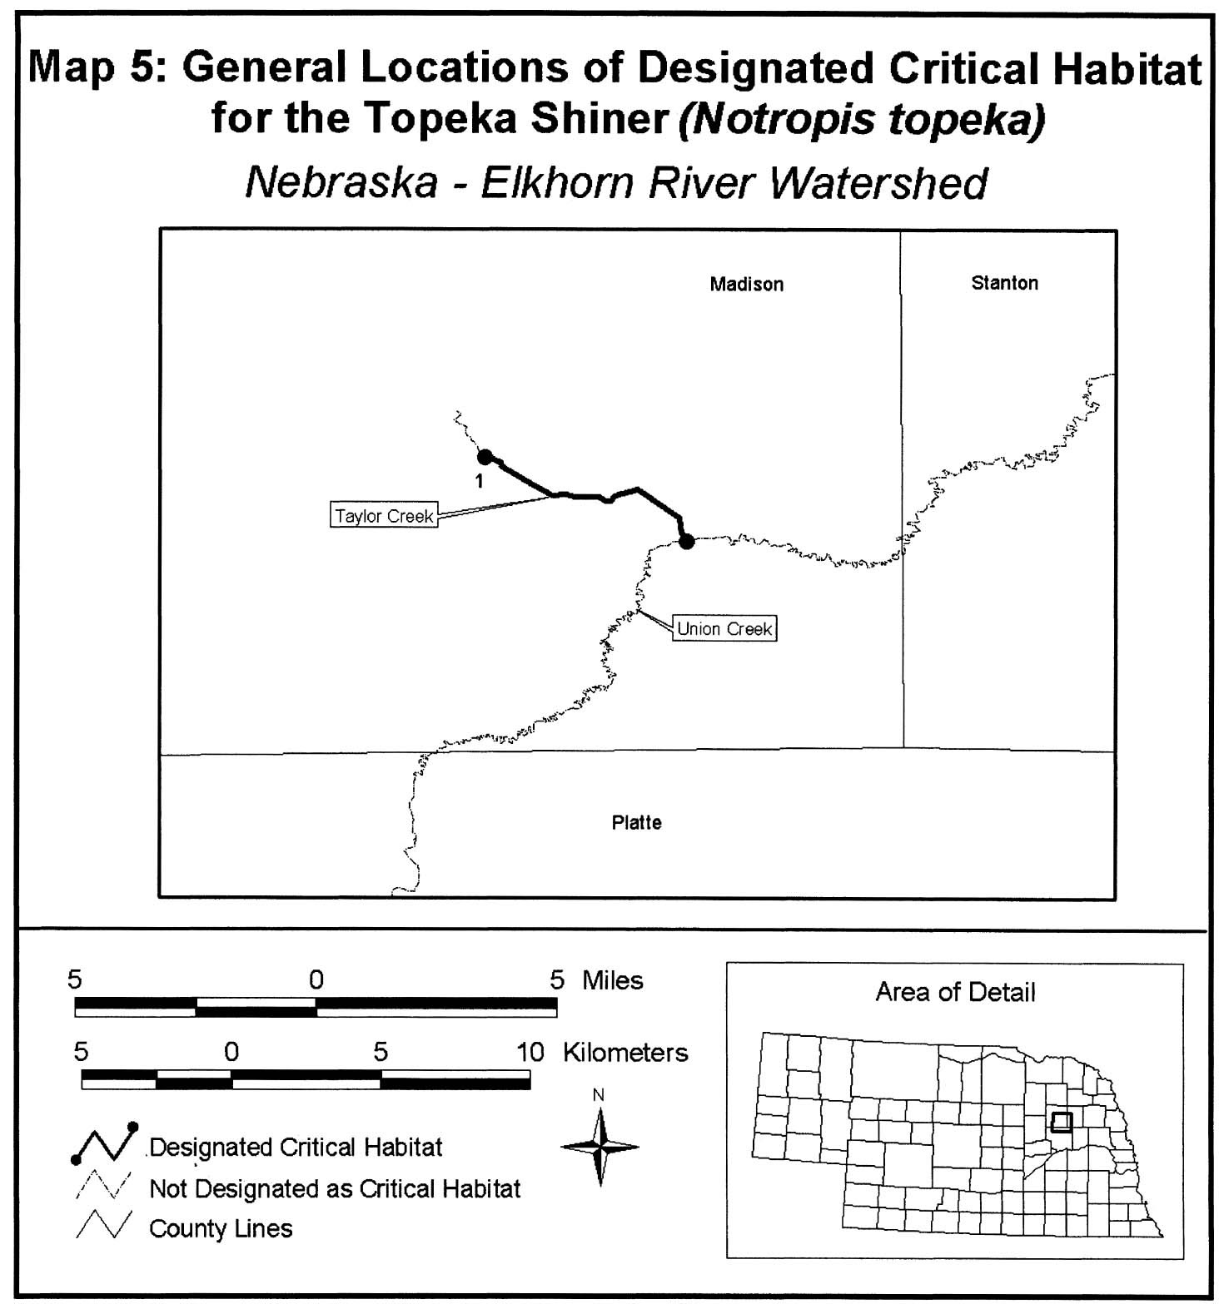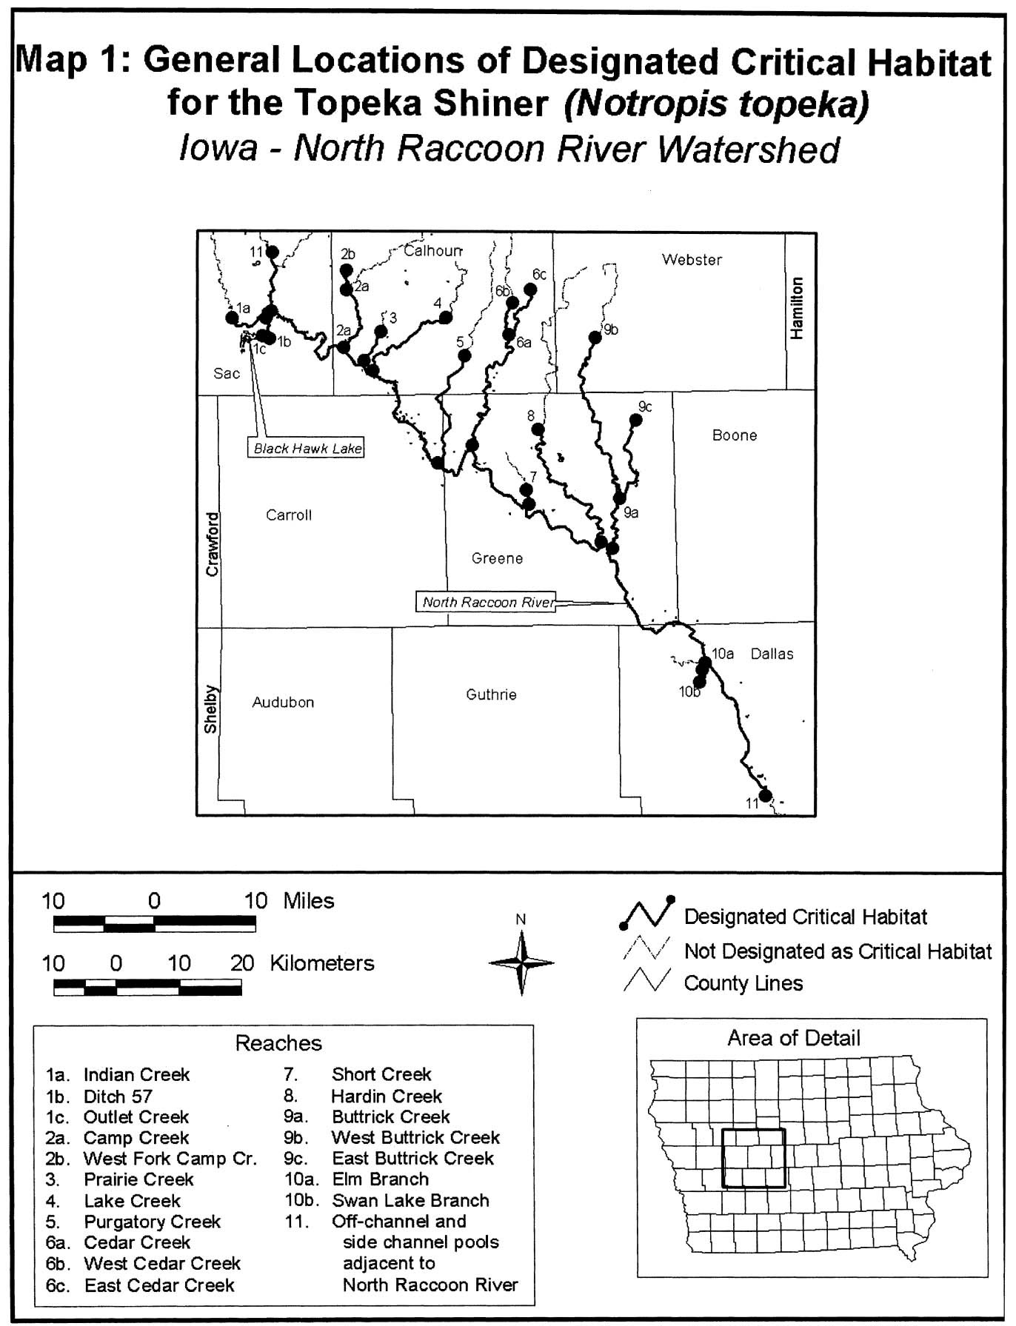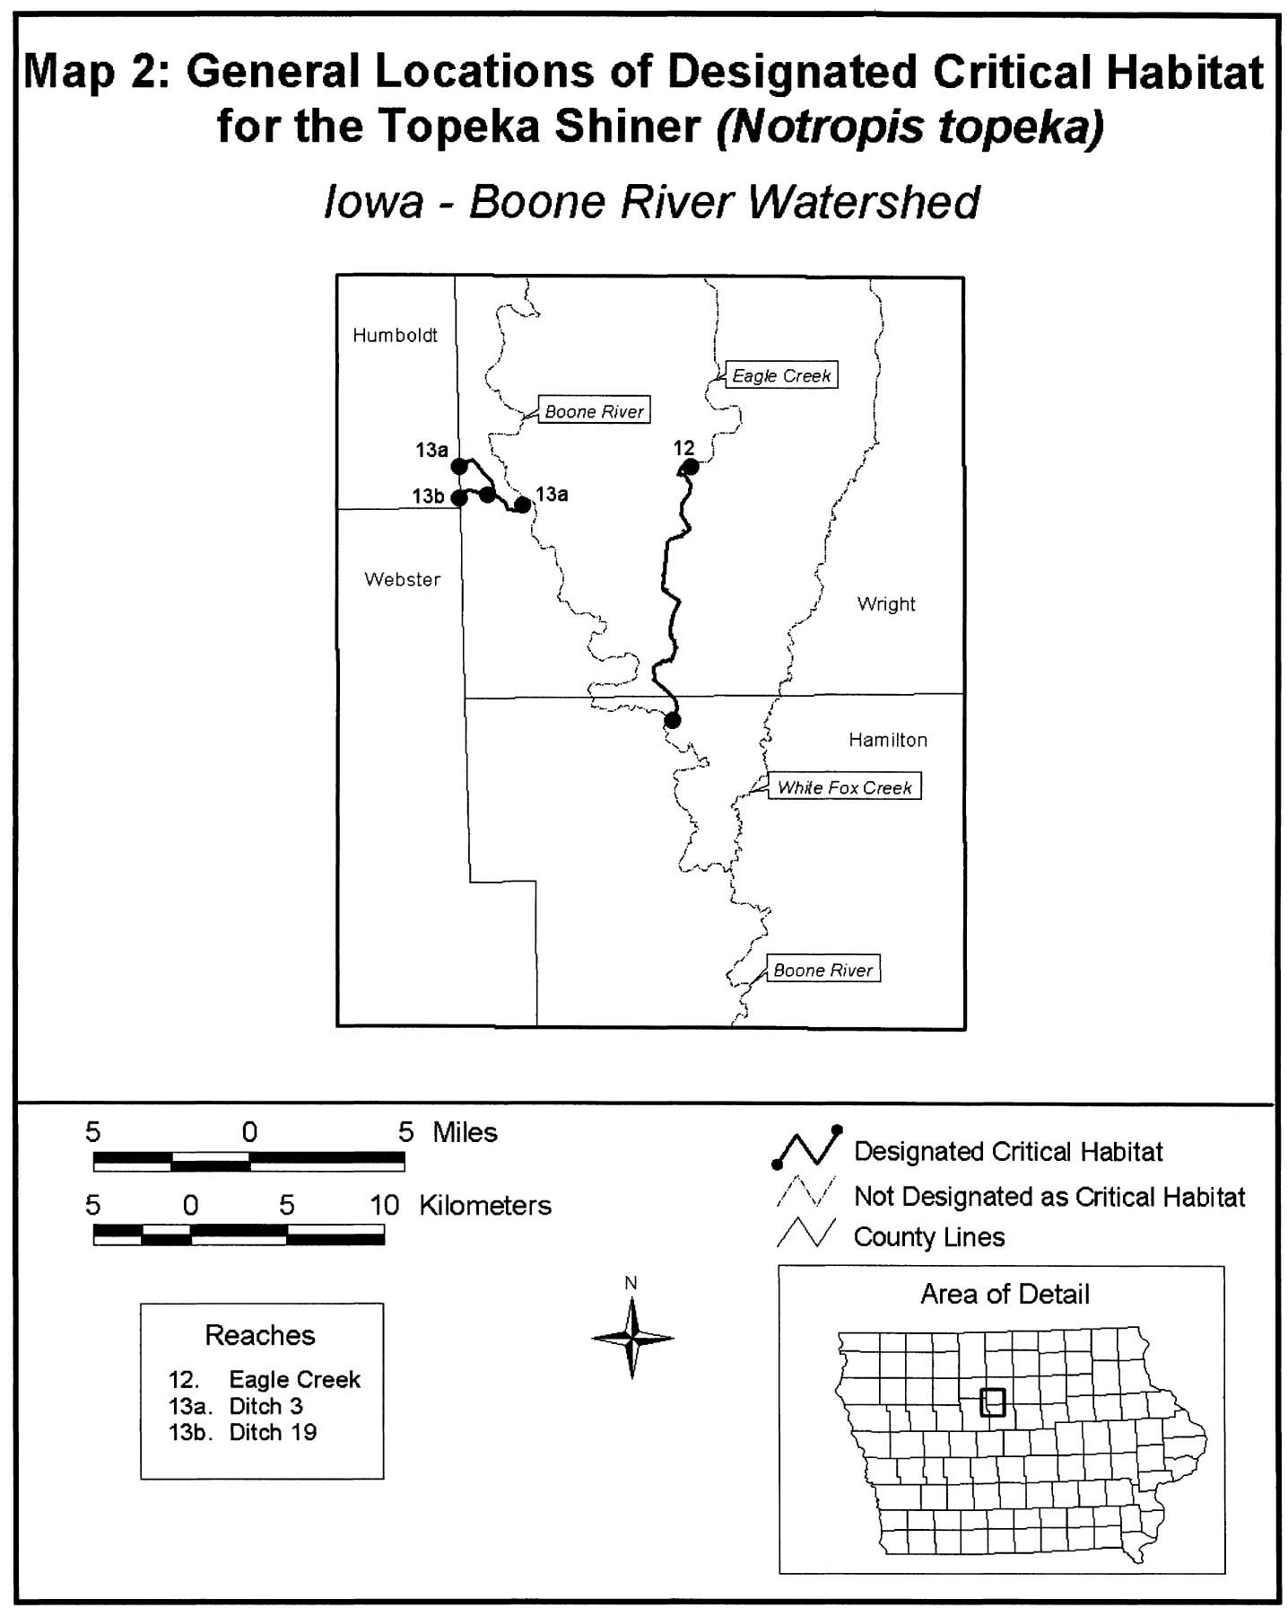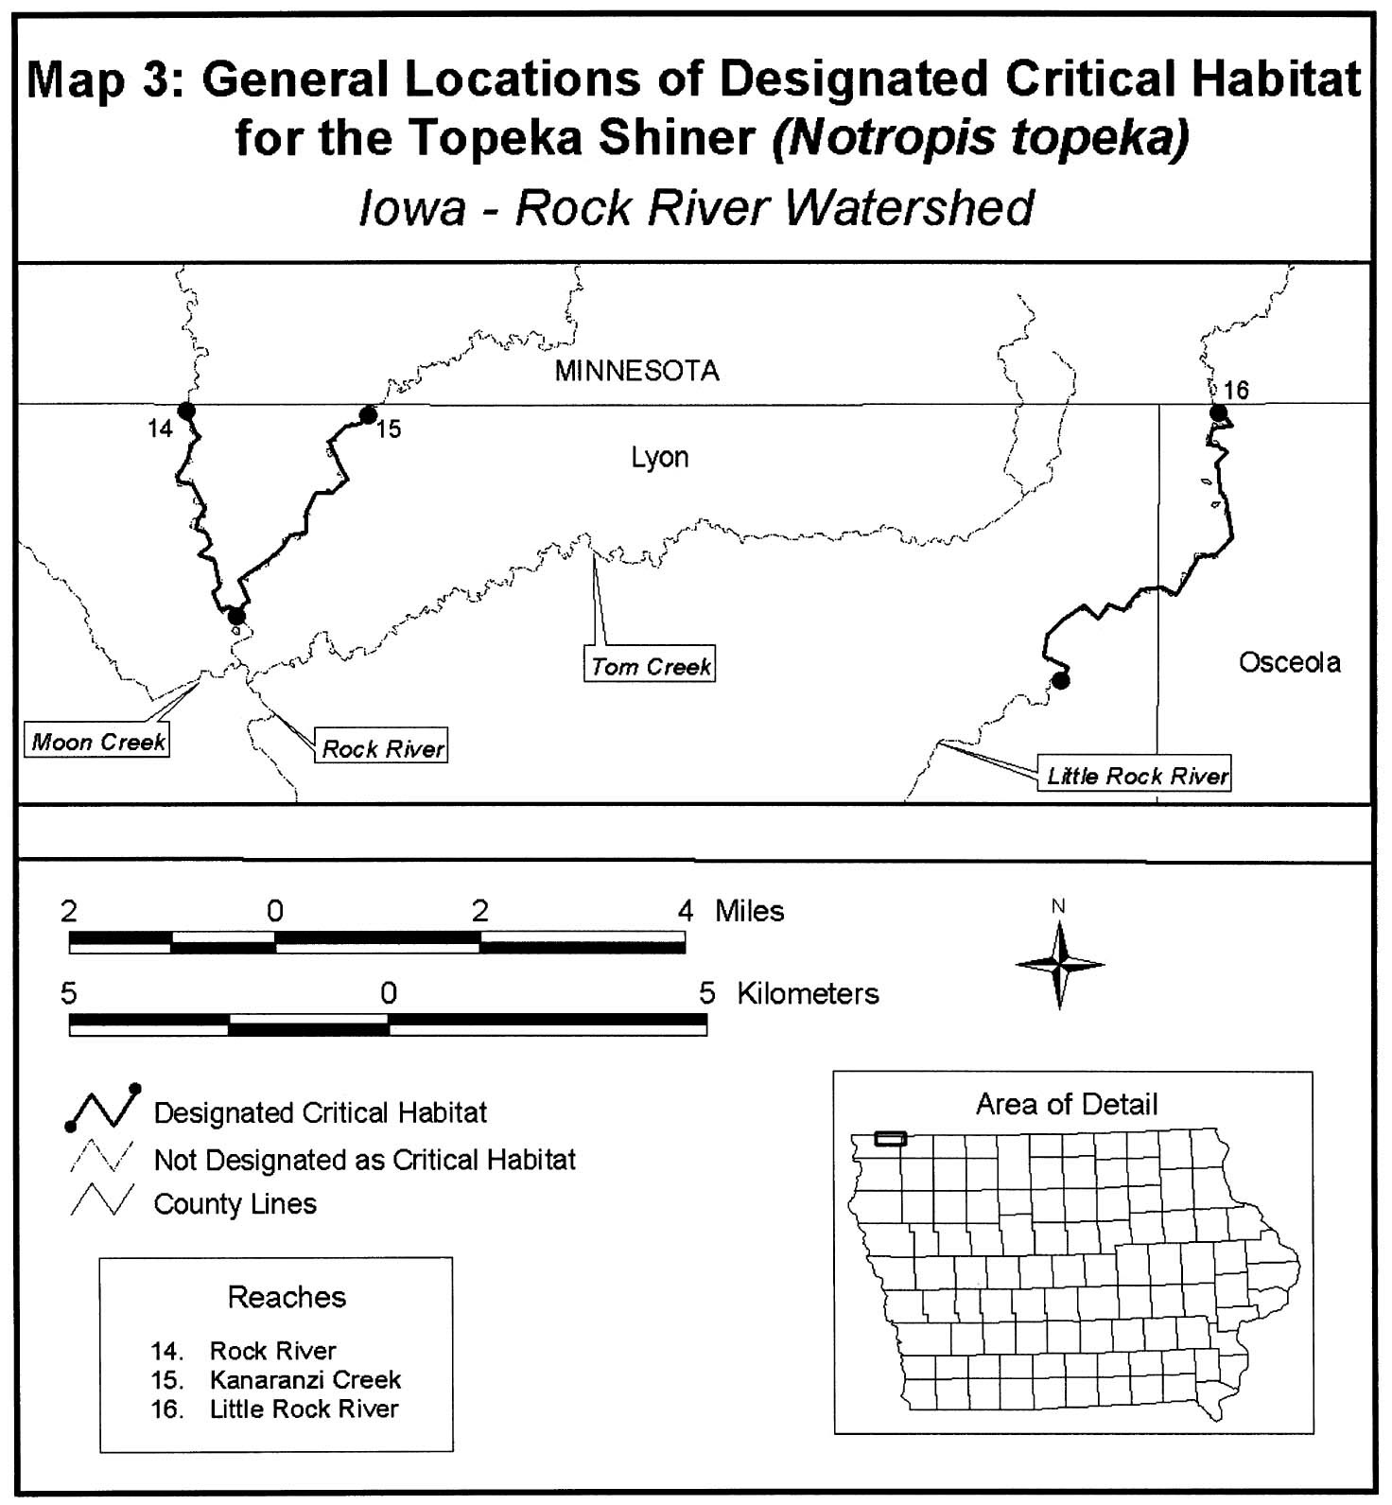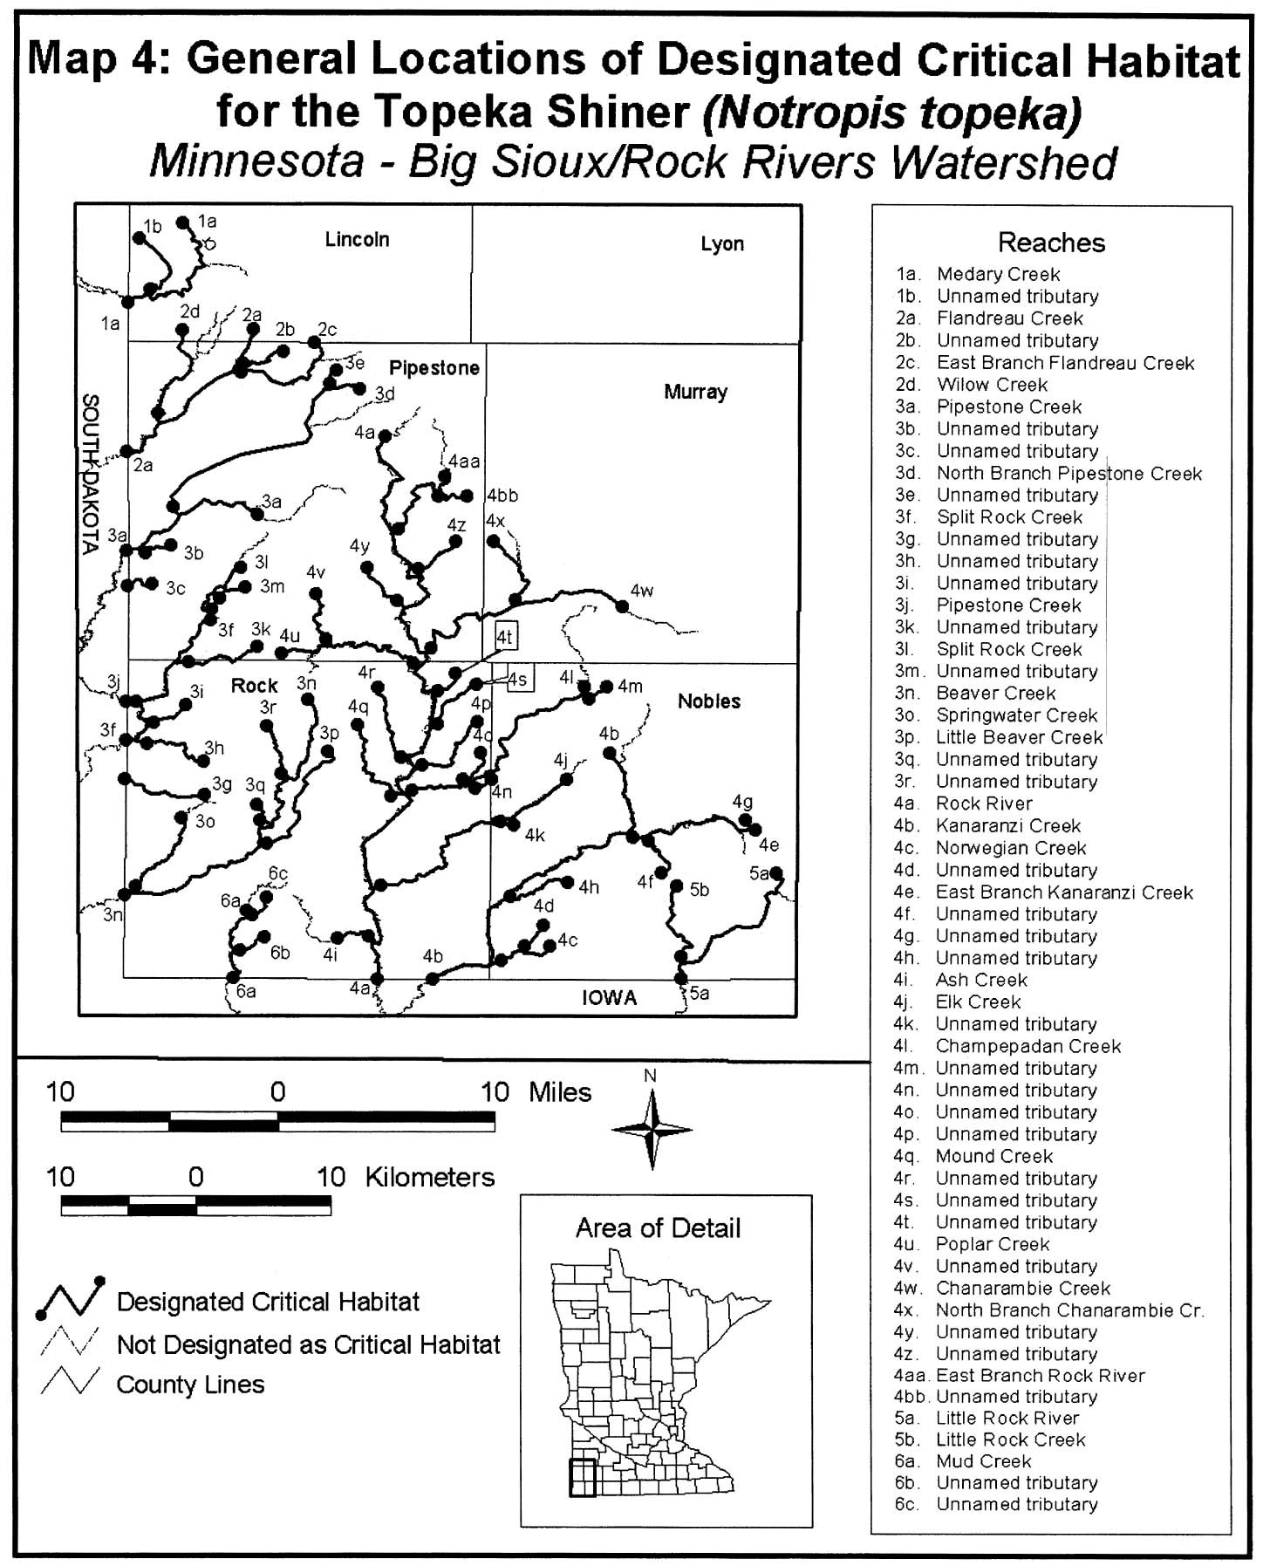
APPENDIX D

IOWA PROTECTED WATER AREA DESIGNATION

BOONE RIVER - from Webster City to Des Moines River
25.0 miles

LITTLE SIOUX RIVER - from Spencer to Linn Grove
34.5 miles
1,548 sq. mi. drainage area

MIDDLE RACCOON RIVER - from Panora to Redfield
14.6 miles
609 sq. mi. drainage area

UPPER IOWA RIVER - from Kendallville to Hwy 76
64.2 miles total
770 sq. mi. drainage area

WAPSIPINICON RIVER - from Sweet Marsh in Bremer County to the Mouth
177.0 miles
2,540 sq. mi. drainage area

From the 1995 Nationwide Rivers Inventory

Boone River From Webster City to confluence with Des Moines River. 25.0 miles

Cedar River Iowa River to Highway 6. 26.0 miles

Maquoketa River Mississippi River to US 151 Bridge 68.0 miles
(Omit small reservoir northwest of Maquoketa).

Middle Raccoon River City of Panora to the City of Redfield dam. 14.6 miles

Turkey River Mississippi River to Vernon Springs. 110.0 miles

Upper Iowa River City of Kendallville to Highway 76 crossing 64.2 miles

Wapsipinicon River Mississippi River to State Highway 334 at Frederika 195.0 miles
(Omit reservoir northwest of Independence).

Yellow River Mississippi River to Highway W60 near Myron. 34.0 miles

Yellow River Entire segment within Effigy Mounds National Monument 1.2 miles

Appendix D (continued)

FIVE PROTECTED WATER AREAS
(With PWA designation in parenthesis)

Wapsipinicon River (Sweets Marsh to Mississippi)
Middle Raccoon River (Panora to Redfield)
Upper Iowa River (Kendallville to Highway 76)
Little Sioux River (Spencer to Linn Grove)
Boone River (Brewers Creek to Des Moines River)

Forms Section
U.S. Department of Agriculture

FARMLAND CONVERSION IMPACT RATING
PART I (To be completed by Federal Agency) | Date Of Land Evaluation Request
Name Of Project | Federal Agency Involved
Proposed Land Use | County And State
PART II (To be completed by NRCS) | Date Request Received By NRCS

Does the site contain prime, unique, statewide or local important farmland? Yes No  (If no, the FPPA does not apply -- do not complete additional parts of this form). |  |  |  |  |  | Acres Irrigated |  | Average Farm Size
Major Crops) |  | Farmable Land In Govt. Jurisdiction  Acres: % |  |  |  | Amount Of Farmland As Defined in FPPA  Acres:
Name Of Land Evaluation System Used |  | Name Of Local Site Assessment System |  |  |  | Date Land Evaluation Returned By NRCS
PART III (To be completed by Federal Agency) |  |  |  | Alternative Site Rating
 |  |  |  | Site A | Site B |  | Site C |  | Site D
A. Total Acres To Be Converted Directly
B. Total Acres To Be Converted Indirectly
C. Total Acres In Site
PART IV (To be completed by NRCS) Land Evaluation Information
A. Total Acres Prime And Unique Farmland
B. Total Acres Statewide And Local Important Farmland
C. Percentage Of Farmland In County Or Local Govt. Unit To Be Converted
D. Percentage Of Farmland In Govt. Jurisdiction With Same Or Higher Relative Value
PART V (To be completed by NRCS) Land Evaluation Criterion
Relative Value Of Farmland To Be Converted (Scale of 0 to 100 Points)
PART VI (To be completed by Federal Agency)  Site Assessment Criteria (These criteria are explained in 7 CFR 658.5(6) |  |  | Maximum  Points
1. Area In Nonurban Use
2. Perimeter In Nonurban Use
3. Percent Of Site Being Farmed
4. Protection Provided By State And Local Government
5. Distance From Urban Built-up Area
6. Distance To Urban Support Services
7. Size Of Present Farm Unit Compared To Average
8. Creation Of Nonfarmable Farmland
9. Availability Of Farm Support Services
10. On-Farm Investments
11. Effects Of Conversion On Farm Support Services
12. Compatibility With Existing Agricultural Use
TOTAL SITE ASSESSMENT POINTS
PART VII (To be completed by Federal Agency)
Relative Value Of Farmland (From Part V)
Total Site Assessment (From Part VI above or a local
site assessment)
TOTAL POINTS (Total of above 2lines)
Site Selected: | Date Of Selection |  |  |  | Was A Local Site Assessment Used?  Yes E3 No

Reason For Selection:

(See Instructions on reverse side)
Form AD-1006 (10-83)
STEPS IN THE PROCESSING THE FARMLAND AND CONVERSION IMPACT RATING FORM

Step 1 - Federal agencies involved in proposed projects that may convert farmland, as defined in the Farmland Protection Policy Act (FPPA) to nonagricultural uses, will initially complete Parts I and III of the form.

Step 2 - Originator will send copies A, B and C together with maps indicating locations of site(s), to the Natural Resources Conservation Service (NRCS) local field office and retain copy D for their files. (Note: NRCS has a field office in most counties in the U.S. The field office is usually located in the county seat. A list of field office locations is available from the NRCS State Conservationist in each state).

Step 3 - NRCS will, within 45 calendar days after receipt of form, make a determination as to whether the site(s) of the proposed project contains prime, unique, statewide or local important farmland.

Step `4 - In cases where farmland covered by the FPPA will be converted by the proposed project, NRCS field offices will complete Parts II, IV and V of the form.

Step 5 - NRCS will return copy A and B of the form to the Federal agency involved in the project. (Copy C will be retained for NRCS records).

Step 6 - The Federal agency involved in the proposed project will complete Parts VI and VII of the form.

Step 7 - The Federal agency involved in the proposed project will make a determination as to whether the proposed conversion is consistent with the FPPA and the agency's internal policies.

INSTRUCTIONS FOR COMPLETING THE FARMLAND CONVERSION IMPACT RATING FORM

Part I: In completing the "County and State" questions list all the local governments that are responsible for local land controls where site(s) are to be evaluated.

Part III: In completing item B (Total Acres To Be Converted Indirectly), include the following:

1. Acres not being directly converted but that would no longer be capable of being farmed after the conversion, because the conversion would restrict access to them.

2. Acres planned to receive services from an infrastructure project as indicated in the project justification (e.g. highways, utilities) that will cause a direct conversion.

Part VI: See attached page for criteria for points:
Assign the maximum points for each site assessment criterion as shown on the attached page. In cases of corridor-type projects such as transportation, powerline and flood control, use the impact rating for corridor type projects form.

Individual Federal agencies at the national level, may assign relative weights among the 12 site assessment criteria other than those shown in the FPPA rule. In all cases where other weights are assigned relative adjustments must be made to maintain the maximum total weight points at 160.

In rating alternative sites, Federal agencies shall consider each of the criteria and assign points within the limits established in the FPPA rule. Sites most suitable for protection under these criteria will receive the highest total scores and sites least suitable, the lowest scores.

Part VII: In computing the "Total Site Assessment Points" where a State or local site assessment is used and the total maximum number of points is other than 160, adjust the site assessment points to a base of 160. Example: if the Site Assessment maximum is 200 points, and alternative Site "A" is rated 180 points:
Total points assigned Site A = 180 x 160 = 144 points for Site "A."
Maximum points possible 200
TITLE 7--AGRICULTURE
CHAPTER VI--NATURAL RESOURCES CONSERVATION SERVICE, DEPARTMENT OF AG
PART 658_FARMLAND PROTECTION POLICY ACT--Table of Contents

Site Assessment Criteria – Use to fill out Part VI of the Farmland Conversion Form (AD-1006). Federal agencies are to use the following criteria to assess the suitability of each proposed site or design alternative for protection as farmland. Each criterion will be given a score on a scale of 0 to the maximum points shown. Conditions suggesting top, intermediate and bottom scores are indicated for each criterion. The agency would make scoring decisions in the context of each proposed site or alternative action by examining the site, the surrounding area, and the programs and policies of the State or local unit of government in which the site is located. Where one given location has more than one design alternative, each design should be considered as an alternative site.

The site assessment criteria are:
(1) How much land is in nonurban use within a radius of 1.0 mile from where the project is intended?
- More than 90 percent--15 points
- 90 to 20 percent--14 to 1 point(s)
- Less than 20 percent--0 points

(2) How much of the perimeter of the site borders on land in nonurban use?
- More than 90 percent--10 points
- 90 to 20 percent--9 to 1 point(s)
- Less than 20 percent--0 points

(3) How much of the site has been farmed (managed for a scheduled harvest or timber activity) more than 5 of the last 10 years?
- More than 90 percent--20 points
- 90 to 20 percent--19 to 1 points(s)
- Less than 20 percent--0 points

(4) Is the site subject to State or unit of local government policies or programs to protect farmland or covered by private programs to protect farmland?
- Site is protected--20 points
- Site is not protected--0 points

(5) How close is the site to an urban built-up area?
- The site is 2 miles or more from an urban built-up area--15 points
- The site is more than 1 mile but less than 2 miles from an urban built-up area--10 points
- The site is less than 1 mile from, but is not adjacent to an urban built-up area--5 points
- The site is adjacent to an urban built-up area--0 points

(6) How close is the site to water lines, sewer lines and/or other local facilities and services whose capacities and design would promote nonagricultural use?
- None of the services exist nearer than 3 miles from the site--15 points
- Some of the services exist more than 1 but less than 3 miles from the site--10 points
- All of the services exist within \1/2\ mile of the site--0 points

(7) Is the farm unit(s) containing the site (before the project) as large as the average-size farming unit in the county? (Average farm sizes in each county are available from the NRCS field offices in each State. Data are from the latest available Census of Agriculture, Acreage of Farm Units in Operation with $1,000 or more in sales.)
- As large or larger--10 points
- Below average--deduct 1 point for each 5 percent below the average, down to 0 points if 50 percent or more below average--9 to 0 points

(8) If this site is chosen for the project, how much of the remaining land on the farm will become non-
farmable because of interference with land patterns?
- Acreage equal to more than 25 percent of acres directly converted by the project--10 points
- Acreage equal to between 25 and 5 percent of the acres directly converted by the project--9 to 1 point(s)
- Acreage equal to less than 5 percent of the acres directly converted by the project--0 points

(9) Does the site have available adequate supply of farm support services and markets, i.e., farm suppliers, equipment dealers, processing and storage facilities and farmer's markets?
- All required services are available--5 points
- Some required services are available--4 to 1 point(s)
- No required services are available--0 points

(10) Does the site have substantial and well-maintained on-farm investments such as barns, other storage buildings, fruit trees and vines, field terraces, drainage, irrigation, waterways, or other soil and water conservation measures?
- High amount of on-farm investment--20 points
- Moderate amount of on-farm investment--19 to 1 point(s)
- No on-farm investment--0 points

(11) Would the project at this site, by converting farmland to nonagricultural use, reduce the demand for farm support services so as to jeopardize the continued existence of these support services and thus, the viability of the farms remaining in the area?
- Substantial reduction in demand for support services if the site is converted--10 points
- Some reduction in demand for support services if the site is converted--9 to 1 point(s)
- No significant reduction in demand for support services if the site is converted--0 points

(12) Is the kind and intensity of the proposed use of the site sufficiently incompatible with agriculture that it is likely to contribute to the eventual conversion of surrounding farmland to nonagricultural use?
- Proposed project is incompatible with existing agricultural use of surrounding farmland--10 points
- Proposed project is tolerable to existing agricultural use of surrounding farmland--9 to 1 point(s)
- Proposed project is fully compatible with existing agricultural use of surrounding farmland--0 points
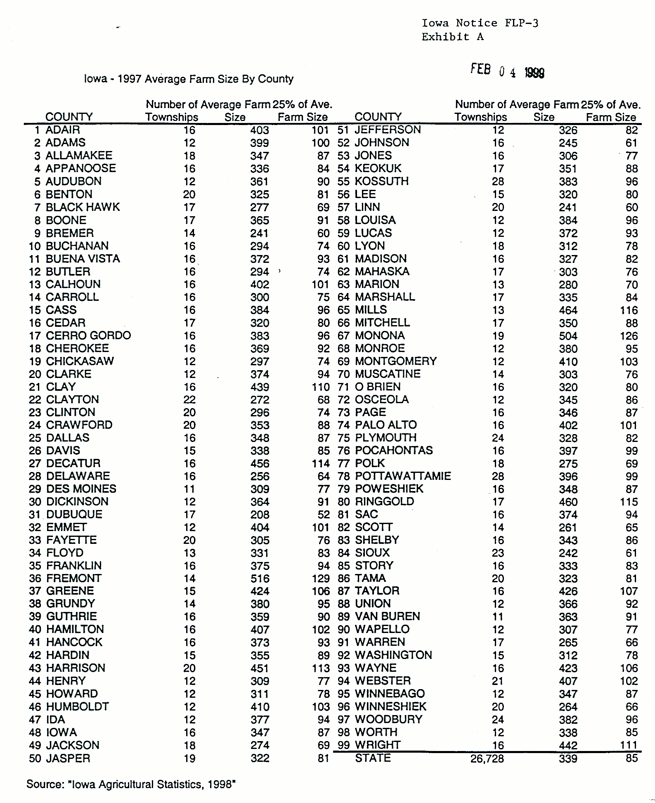

U.S. DEPARTMENT OF AGRICULTURE NRCS-CPA-106
Natural Resources Conservation Service FARMLAND CONVERSION IMPACT RATING (Rev. 1-91)
FOR CORRIDOR TYPE PROJECTS

PART I (To be completed by Federal Agency) |  |  |  | 3. Date of Land Evaluation Request |  |  |  |  | 4. Acres Irrigated |  |  | Average Farm Size
1. Name of Project |  |  |  | 5. Federal Agency Involved
2. Type of Project |  |  |  | 6. County and State
PART II (To be completed by NRCS) |  |  |  | 1. Date Request Received by NRCS |  |  | 2. Person Completing Form
3. Does the corridor contain prime unique statewide or local important farmland? YES NO  (If no, the FPPA does not apply - Do not complete additional parts of this form). |  |  |  |  |  |  | 4. Acres Irrigated |  |  | Average Farm Size
5. Major Crop(s) |  | 6. Farmable Land in Government Jurisdiction  Acres: % |  |  |  |  | 7. Amount of Farmland As Defined in FPPA  Acres:
8. Name Of Land Evaluation System Used |  | 9. Name of Local Site Assessment System |  |  |  |  | 10. Date Land Evaluation Returned by NRCS
PART III (To be completed by Federal Agency) |  |  |  |  | Alternative Corridor For Segment
 |  |  |  |  | Corridor A | Corridor B |  | Corridor C |  |  | Corridor D
A. Total Acres To Be Converted Directly
B. Total Acres To Be Converted Indirectly, Or To Receive Services
C. Total Acres In Corridor
PART IV (To be completed by NRCS) Land Evaluation Information
A. Total Acres Prime And Unique Farmland
B. Total Acres Statewide And Local Important Farmland
C. Percentage Of Farmland in County Or Local Govt. Unit To Be Converted
D. Percentage Of Farmland in Govt. Jurisdiction With Same Or Higher Relative Value
PART V (To be completed by NRCS) Land Evaluation Criterion Relative Value
of Farmland to Be Serviced or Converted Scale of 0 - 100 Points
PART VI (To be completed by Federal Agency) Corridor  Assessment Criteria (These criteria are explained in 7 CFR 658.5(c)) |  |  | Maximum  Points
1. Area in Nonurban Use |  |  | 15
2. Perimeter in Nonurban Use |  |  | 10
3. Percent Of Corridor Being Farmed |  |  | 20
4. Protection Provided By State And Local Government |  |  | 20
5. Size of Present Farm Unit Compared To Average |  |  | 10
6. Creation Of Nonfarmable Farmland |  |  | 25
7. Availablilit Of Farm Support Services |  |  | 5
8. On-Farm Investments |  |  | 20
9. Effects Of Conversion On Farm Support Services |  |  | 25
10. Compatibility With Existing Agricultural Use |  |  | 10
TOTAL CORRIDOR ASSESSMENT POINTS |  |  | 160
PART VII (To be completed by Federal Agency)
Relative Value Of Farmland (From Part V) |  |  | 100
Total Corridor Assessment (From Part VI above or a local site  assessment) |  |  | 160
TOTAL POINTS (Total of above 2 lines) |  |  | 260
1. Corridor Selected: | 2. Total Acres of Farmlands to be  Converted by Project: |  | 3. Date Of Selection: |  |  | 4. Was A Local Site Assessment Used?  YES [] NO
5. Reason For Selection:

Signature o Person Completing this Part: |  |  |  |  |  | DATE
NOTE: Complete a form for each segment with more than one Alternate Corridor
NRCS-CPA-106 (Reverse)

CORRIDOR - TYPE SITE ASSESSMENT CRITERIA

Corridor-type Site Assessment Criteria - Use to fill out Part VI of the Farmland Conversion Impact Rating for Corridor Type Projects Form. The following criteria are to be used for projects that have a linear or corridor-type site configuration connecting two distant points, and crossing several different tracts of land. These include utility lines, highways, railroads, stream improvements, and flood control systems. Federal agencies are to assess the suitability of each corridor-type site or design alternative for protection as farmland. All criteria for corridor-type sites will be scored using the criteria points from the Farmland Conversion Form AD-1006 except as noted below:
(1) Criteria 5 and 6 will not be considered.
(2) Criterion 8 will be scored on a scale of 0 to 25 points, and criterion 11 will be scored on a scale of 0 to 25 points.
USDA-RECD | Loan Type:
Form RECD 2006-38 | Date Approved:
(12-94)

Civil Rights Impact Analysis
Certification

- Office and Division or Location:
- Proposed Policy Action:
- I certify, I have reviewed and analyzed appropriate documentation and determined that:
(Check one and provide the required information)
a. No major civil rights impact is likely to result if the proposed action is implemented. Summarize your reasons for this conclusion. Identify supporting information and statistical data.

b. A major civil rights impact, as described below, is likely to result if the proposed action is implemented.
Identify the group, which may be adversely affected. Summarize your reasons for this conclusion. Identify supporting information and statistical data.

To minimize the potential for an adverse impact, the following alternatives or supplemental action(s) are recommended.

Name and Title of Certifying Official |  | Date

Notices Section

(Floodplain and Wetland Only)

NOTICE OF PROPOSED PROJECT TO BE LOCATED
IN A FLOODPLAIN OR WETLANDS

*Publication Date:

The (name of applicant) is proposing to conduct a (name of project, e.g. rental construction) project, to be funded USDA Rural Development/RUS.

The (name of applicant) has determined that this proposed project lies in a floodplain/wetlands (or will impact on a floodplain or wetlands) and thus is publishing this notice in compliance with Executive Orders 11988 and 11990 and the Floodplain Management Wetlands Protection Guidelines adopted by the Water Resources Council.

This proposed project is located at (describe by identifying streets, significant buildings, natural features and others) and will consist of (e.g., type of construction).

The (name of applicant) has additional information available on this project, which can be reviewed at (identify location such as City Hall, to include address and room number). Interested persons can also call (identify staff person) at (telephone number) for additional information about this proposed project. The (name of applicant) is now considering potential alternative sites, potential flood impact on the proposed project, and potential mitigation to minimize flood hazard or wetlands impact.

Written comments on this proposed project are invited and should be submitted by (date)** to (City Hall, etc.). All such comments will be taken into account by the (name of applicant) prior to its decision on the proposed project.

___________________________________________(Name of Certifying Officer or Applicant)

(Address)

* Day 1 - date of publication
** Day 30 - not less than 29 days from the date of publication

NOTICE OF DECISION REGARDING PROJECT TO
BE LOCATED IN A FLOODPLAIN OR WETLANDS

Publication Date: *_____________

The (name of applicant) is proposing to conduct a (name of project) project, to be funded with funds received through USDA Rural Development/RUS.

In order to comply with Executive Orders 11988 or 11990 and the Water Resources Council's Floodplain Management/Wetlands Protection Guidelines, the (name of applicant) hereby states that this (name of project) lies within an identified floodplain or wetlands (or will impact on an identified floodplain or wetlands). However, the (name of applicant) has reached a decision that this is the only practicable alternative for this project.

Its decision is based on an evaluation of the following alternatives (list all, including not to conduct the project). The (name of applicant) will, however, ensure that this project will conform to all state and/or local floodplain or wetlands protection standards, and will take the following actions to mitigate the flood hazard/impact on wetlands

(describe all mitigation measures or indicate that no such actions can be taken).

Written comments on this proposed project are invited and should be submitted by (date)** to (City Hall, etc.). All such comments will be taken into account by the (name of applicant) prior to its decision on the proposed project.

___________________________________________(Name of Certifying Officer or Applicant)

(Address)

* Day 1 - day of publication
** Day 15 - 15 calendar days, starting with day 1

Note: This notice can no longer be published with the concurrent notice. It must be a separate notice, published at least 15 days before the concurrent notice.

