Illinois Instruction 1942-A A
Guide 10

ADDENDUM TO RURAL DEVELOPMENT SUPPLEMENTAL GENERAL CONDITIONS

The following paragraphs will be added to RD Instruction 1942-A, Guide 18, “Rural Development Supplemental General Conditions”:

USDA Rural Development Construction Sign

In accordance with attached Exhibit A, the Contractor on Section(s) ___________________________, ______________________________ of the project shall each erect (one) (two) sign(s) at a prominent location(s) on the project when construction begins.

An electric version of this .pdf document may be found at: www.rurdev.usda.gov/IL_3575.html. This document may be edited by project architects to include specific project information.

USDA Rural Development will not approve plans and specifications until the sign detail is included in the appropriate contracts.

If funding from other Federal or a State Agency is being provided and a project sign is required by that funding source, the Community Programs Director may modify the standard project sign as determined appropriate. Sign details may also be modified to show multiple contractors, but typically only Prime Contractors should be shown.

The contractor will remove the temporary construction sign(s) when all construction has been completed.

o O o

(10/22/2014) PN 546
Illinois Instruction 1942-A A
Guide 10
Exhibit A

temporary construction sign for
RURAL DEVELOPMENT projects
Project Title
Sponsor / Developer
Contractor
USDA is an equal opportunity provider.
Barack Obama, President of the United States
Tom Vilsack, Secretary of Agriculture
WHITE BACKGROUND
BLACK
LETTERING
BLACK LETTERING
Official(s) or Sponsor Address
Architect or Engineer
(second line)
(second line)
Lettering
(GREEN, PMS 343)

Financed by United States Department of Agriculture (USDA) Rural Development

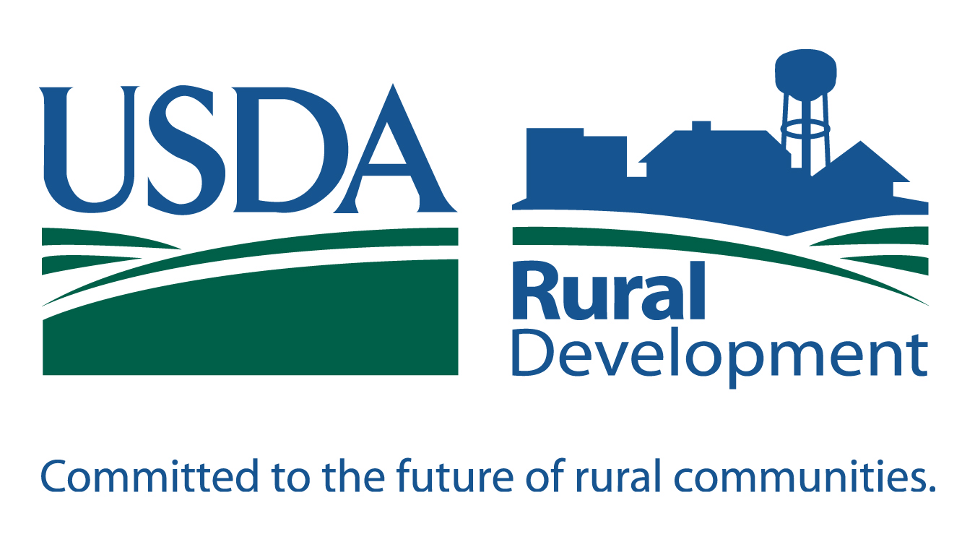
SYMBOL fields
(GREEN, PMS 343)

SYMBOL LETTERS
(BLUE, PMS 288)

United States
Department of
Agriculture
SIGN DIMENSIONS: 1200 mm x 2400 mm x 19 mm (approx. 4’ x 8’ x ¾”)
Plywood Panel (APA RATED A-B GRADE–EXTERIOR)

www.rurdev.usda.gov/IL_3575.html
(10/22/2014) PN 546
SIGNATURE
LETTERS
(BLACK)

