circular-graphic.emf

Rural and Small Systems Guidebook to Sustainable Utility Management

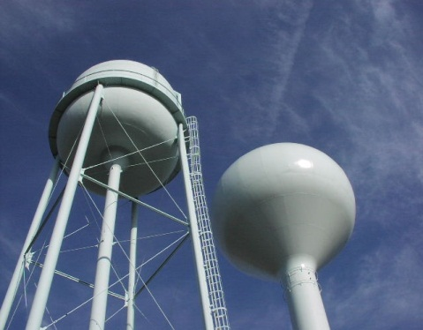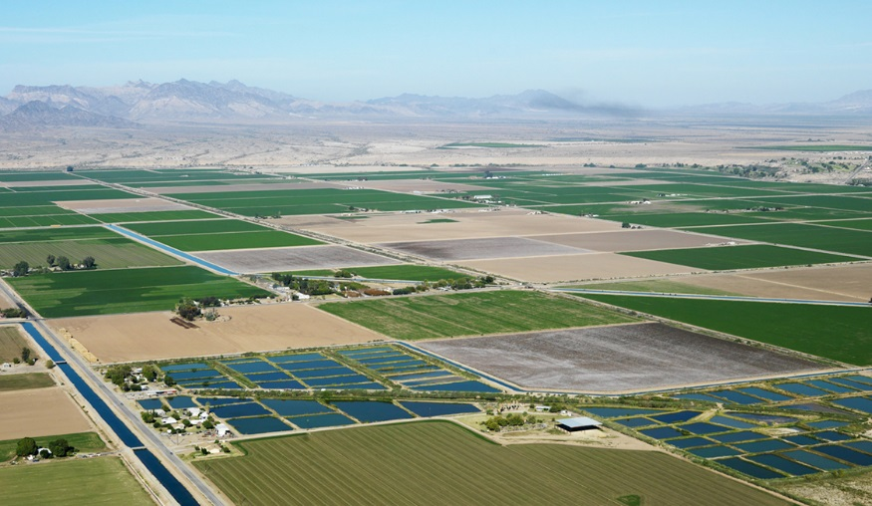





Table of Contents

Introduction 2

The Sustainably Managed Utility: Ten Key Management Areas 4

System Improvement Priorities: Self Assessment 7

Improving Outcomes 12

What’s Next: Creating Your Action Plan 18

Appendices 22

Appendix I: Self-Assessment Worksheet 23

Appendix II: Sustainable Management Action Plan Worksheet 26

Appendix III: Resources for Rural and small systems 27

Acknowledgements 54

# Introduction

## Background & Purpose

What’s in it For Me: Why should my system use this *Guidebook*?

The information in this Guidebook can help rural and small systems in several important ways by:

* Giving you a simple and objective way to evaluate your system’s strengths and areas for improvement.
* Helping you develop an easy to follow plan for improving your operations based on your assessment.
* Helping you better communicate internally and with others like board members and customers about your system and challenges.
* Help build the necessary support for improving your system over time.

Many rural and small systems throughout the country face significant management and operational issues. These may include aging or inadequate infrastructure, recruiting and retaining qualified staff, growing or establishing financial reserves, and setting rates that are reflective of their operational costs and capital needs. This *Rural and Small Systems Guidebook to Sustainable Utility Management (Guidebook)* speaks to these challenges. It is an important part of a Memorandum of Agreement (MOA) signed by the United States Department of Agriculture (USDA) and the United States Environmental Protection Agency (EPA). Instituted in 2011, the MOA supports a series of activities to help rural and small water and wastewater systems more effectively provide sustainable services to the communities they serve.

The *Guidebook* helps rural and small water and wastewater systems in their common mission to become more successful and efficient service providers. Because of its dynamic nature, this resource can be used effectively in many different ways:

* By system managers, water systems operations specialists, and staff as a guide for taking actions leading to short- and long-term improvement to system management and performance;
* By technical assistance service providers as they work with individual systems or groups of systems through workshops or other assistance efforts;
* As a resource for system improvement workshops;
* As a resource for guiding conversations about sustainability with utility board members; or
* As a resource for communicating and educating utility board members on the importance of effective management.

The *Guidebook* is designed to introduce rural and small water and wastewater systems to the key areas of effectively managed systems. It provides background information on ten key management areas, as well as instruction and assistance on how to conduct a system assessment process based on the key management areas. It also includes information on how to prioritize areas for improvement, while developing measures of progress that can help small systems with performance enhancement.

Workshop in a Box

The companion to this *Guidebook* is the *Workshop in a Box: Sustainable Management of Rural and Small Systems Workshops*. The *Workshop in a Box* is used by utilities, TA providers, water sector associations, and trainers around the United States to conduct workshops based on the Ten Key Management Areas described in this document. The workshops are designed to help small and rural utilities assess their strengths and challenges, and create an action plan for addressing these areas over time.

The *Guidebook* is accompanied by a companion resource, the *Workshop in a Box: Sustainable Management of Rural and Small Systems Workshops*. The *Workshop in a Box* is a toolkit for utilities, technical assistance (TA) providers, water sector associations, and trainers who conduct workshops based on the principles presented in this *Guidebook.* The *Workshop in a Box* provides guidance for workshop preparations, execution, and copies of all materials to run a successful workshop on utility management improvement. The information presented in these two resources draws on engagement with small and rural water sector systems, and the TA providers supporting them throughout the U.S.

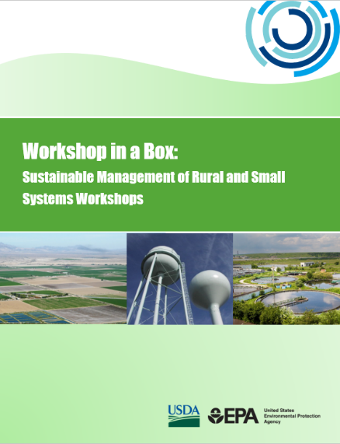At each workshop, participants are given an introduction to the ten key management areas, and then asked to conduct a short self-assessment of their operations based on the management areas. Participants also identify management improvement opportunities at their systems based on the assessment. The workshop further provides an opportunity for participants to share experiences from their systems to better understand how to implement improvements and establish a basis for working with staff and community members to operate more effectively. Participants are also introduced to a compendium of resources that can help them implement the improvements identified during the assessment.

The *Guidebook* begins by introducing the ten key management areas of effectively managed systems. A self-assessment follows to help users identify their strengths and challenges and to prioritize where to focus improvement efforts. It ends by discussing improving outcomes in the ten management areas. The *Guidebook* conveys what constitutes high achievement in each area and identifies resources for small systems. The overall approach and steps described in this *Guidebook* are similar to the approach in another initiative, called Effective Utility Management (EUM). EUM has been supported by EPA and several major water sector associations since 2008 and has been used successfully by medium and larger utilities. This *Guidebook* takes the approach embodied in EUM and adapts it for the needs of rural and small water and wastewater systems.

# The Sustainably Managed Utility: Ten Key Management Areas

The ten key management areas of sustainably managed utilities described here can help rural and small water and wastewater system managers address many ongoing challenges and move toward sustainable management of both operations and infrastructure. In aiming to increase their long-term sustainability and effectiveness, the eventual goal for systems is high achievement, consistent with the needs and expectations of their communities, in each of the management areas.

Product Quality

Customer Satisfaction

Employee & Leadership Development

Operational Optimization

Financial Viability

Infrastructure Stability

Operational Resiliency

Community Sustainability & Economic Development

Water Resource Adequacy

Stakeholder Understanding & Support

The management areas were developed by drawing on information and experience from a wide range of rural and small water system operations specialists and managers from across the United States. The management areas were further validated through the workshops held with rural and small systems, sponsored by EPA and USDA. Each management area is described as a desirable outcome for a system to achieve. Each can be considered a building block for improving system performance. Through working to improve performance in each of the ten areas, managers can help their systems to become more successful, resilient, and sustainable for the long term.

The management areas are not presented in a specific order. Together they make up the framework for a complete and well-rounded management approach. By making improvements in any of the areas, at a pace consistent with its most pressing challenges, a system will be able to deliver increasingly efficient, higher quality services. The graphic on the next page depicts the interconnectedness of the management areas. It also shows that no one area is weighted more heavily than another. All areas are equal in the context of the *Guidebook.* Descriptions of the management areas are found in the following pages, including the characteristics of successful outcomes for each.

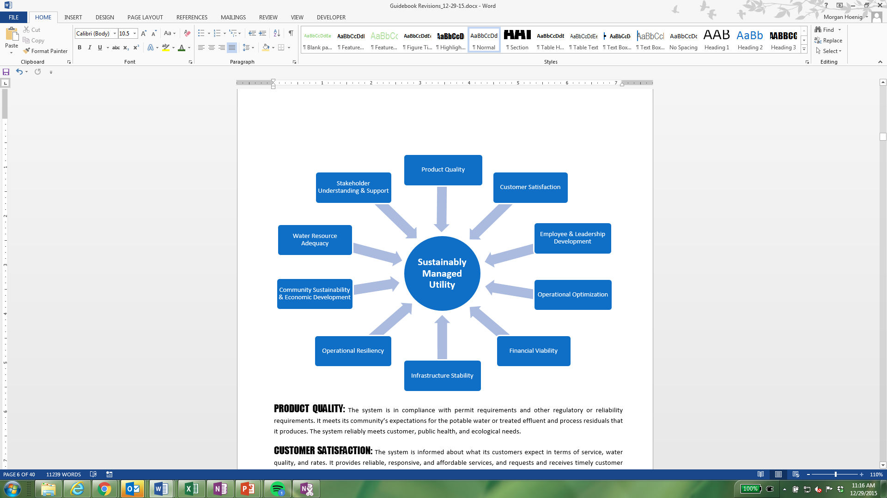

Product Quality: The system is in compliance with permit requirements and other regulatory or reliability requirements. It meets its community’s expectations for the potable water or treated effluent and process residuals that it produces. The system reliably meets customer, public health, and ecological needs.

Customer Satisfaction: The system is informed about what its customers expect in terms of service, water quality, and rates. It provides reliable, responsive, and affordable services, and requests and receives timely customer feedback to maintain responsiveness to customer needs and emergencies. Customers are satisfied with the services that the system provides.

Employee & Leadership Development: The system recruits and retains a workforce that is competent, motivated, and safe-working. Opportunities exist for employee skill development and career enhancement, and training programs are in place, or are available, to retain and improve their technical and other knowledge. Job descriptions and performance expectations are clearly established (in writing), and a code of conduct is in place and accepted by all employees.

Operational Optimization: The system ensures ongoing, timely, cost-effective, reliable, and sustainable performance in all aspects of its operations. The key operational aspects of the system (e.g., pressure, flow, quality) are documented and monitored. It minimizes resource use, loss, and impacts from day-to-day operations. It has assessed its current energy use and water loss and performed related audits.

Financial Viability: The system establishes and maintains an effective balance between long-term debt, asset values, operations and maintenance expenditures, and operating revenues. Rates are adequate to pay its bills, put some funds away for both future capital expenditures and unanticipated issues, and maintain, repair, and replace its equipment and infrastructure as needed. The system discusses rate requirements with its customers, decision making authorities, and other key stakeholders.

Infrastructure Stability: The system understands the condition and costs associated with its critical infrastructure assets. It has inventoried its system components, conditions, and costs, and has a plan in place to repair and replace these components. It maintains and enhances the condition of all assets over the long-term at the lowest possible life-cycle cost and acceptable level of risk.

Operational Resiliency: The system ensures that its leadership and staff members work together to anticipate and avoid problems. It proactively identifies legal, financial, non-compliance, environmental, safety, security, and natural threats to the system. It has conducted a vulnerability assessment for safety, natural disasters, and other environmental threats, and has prepared an emergency response plan for these hazards.

Community Sustainability & Economic Development: The system is active in its community and is aware of the impacts that its decisions have on current and long-term future community health and welfare. It seeks to support overall watershed, source water protection, and community economic goals, where feasible. It is aware of, and participates in, local community and economic development plans.

Water Resource Adequacy: The system ensures that water availability is consistent with current and future customer needs. It understands its role in water availability, and manages its operations to provide for long-term aquifer and surface water sustainability and replenishment. It has performed a long-term water supply and demand analysis, and is able to meet the water and sanitation needs of its customers now and for the reasonable future.

Stakeholder Understanding & Support: The system actively seeks understanding and support from decision making bodies, community members, and regulatory bodies related to service levels, operating budgets, capital improvement programs, and risk management decisions. It takes appropriate steps with these stakeholders to build support for its performance goals, resources, and the value of the services that it provides. The system performs active outreach and education to understand concerns and promote the value of clean, safe water and the services the utility provides, consistent with available resources.

# System Improvement Priorities: Self Assessment

A candid and comprehensive self-assessment is the first step in identifying where a system can begin to make improvements in the ten management areas. The self-assessment helps rural and small systems identify their strengths and challenges to prioritize where efforts and resources should be focused. It can be completed by a number of different individuals within a utility (e.g., managers, staff), or as a team exercise amongst management, staff, and external stakeholders such as board members or customers (if appropriate). As an internal team exercise, it is recommended that each participant complete the assessment on his/her own, followed by a group discussion about the similarities and differences in results. Although the utility may use the assessment in a number of ways, the goal for all systems should be high achievement, consistent with the needs and expectations of their communities, in each of the management areas.

The self-assessment has three steps:

1) Rate achievement for each management area;

2) Rank the importance of each management area; and

3) Plot results to identify critical areas for improvement.

Once completed, the self-assessment exercise can help the system develop a plan for improving management area performance.

## The Self-Assessment Worksheet

### Step 1 – Rating ACHIEVEMENT AREAS

Assess your system by rating your current level of achievement for each management area. Consider how effectively your current management efforts support each of the areas. Note that each management area has several dimensions (represented by the bullet points listed for each). Your rating should reflect the dimension with the lowest level of achievement. For example, if you believe that your achievement in one dimension of a management area was low, but your achievement in another dimension of that area was high, your overall rating for the area would be low. An example of the rating exercise can be found on the following page.

#### Scale from low achievement to high achievement:

* Select **Low** if your system has no workable practices in place for addressing this area – very low capacity and performance.
* Select **Medium** if your system has some workable practices in place with moderate achievement, but could improve – some capacity in place.
* Select **High** if your system has effective, standardized, and accepted practices in place. It either usually or consistently achieves goals – capacity is high and in need of very little or no further development.

**YOUR TURN: Proceed to Table A in Appendix I and fill out the column labeled “Step 1” for each management area before moving to Step 2.**

### Step 2 - Ranking PRIORITY AREAS

#### Rank the importance of each management area to your system. Base this ranking on your goals and the specific needs of your community. Your ranking may be influenced by current or expected challenges (e.g., if your community is experiencing elevated population growth rates, Water Resource Adequacy may be ranked as a high priority area to address). Again, note that each management area has multiple dimensions (represented by the bullet points listed). Your ranking should represent the highest priority of all of the points listed. Your ranking should also be independent of the achievement level. For example, an area can remain, and therefore be ranked, as a high priority even if the utility has high capacity and performance). An example of the rating exercise can be found on the following page.

#### Scale from low priority to high priority, keeping in mind the following:

* Current or expected challenges
* Customer or stakeholder impact (reliability, quality, timeliness)
* Consequences of not improving (non-compliance, increased cost, lost credibility, impacts to health and safety)
* Urgency (near or long-term needs)
* Community priorities

**YOUR TURN: Proceed to Table A in Appendix I and fill out the column labeled “Step 2” for each management area before moving to Step 3.**

Table A: Example

|  |  |  |  |
| --- | --- | --- | --- |
| Key Management Area | Management Area Description | Step 1: Rate Achievement (Low – High) | Step 2: Rank Priority (Low – High) |
|  | | | |
| 1. Water Resource Adequacy (e.g., water quantity) | * My system is able to meet the water or sanitation needs of its customers now and for the reasonable future. * My system or community has performed a long-term water supply and demand analysis. (Applies to drinking water systems only.) * My system understands its relationship to local water availability. (Drinking water utilities should focus on utilization rates relative to any local water stress conditions, wastewater utilities should focus on return flows.) | *Low* | *High* |
| 2. Product Quality  (e.g., clean & safe water) | * My system is in compliance with permit requirements and other regulatory or reliability requirements. * My system meets local community expectations for the potable water and/or treated effluent and process residuals that it produces. | *Medium* | *High* |
| 3. Customer Satisfaction | * Customers are satisfied with the services the system provides. * My system has procedures in place to receive and respond to customer feedback in a timely fashion. | *High* | *Medium* |
| 4. Community Sustainability & Economic Development | * My system is aware of and participating in local and regional community and economic development planning activities. * My system’s goals also help to support overall watershed and source water protection, and community economic goals. | *High* | *Low* |
| 5. Employee & Leadership Development | * Training programs are in place to retain and improve institutional knowledge. * Opportunities exist for employee skills development and career enhancement. * Job descriptions, performance expectations, and codes of conduct are established. | *Low* | *Medium* |
| 6. Financial Viability | * The rates that my system charges are adequate to pay our bills, put some funds away for the future, and maintain, repair, and replace our equipment and infrastructure as needed. (O&M, debt servicing, and other costs are covered). * My system discusses rate requirements with our customers, board members, and other key stakeholders. | *Medium* | *High* |
| 7. Operational Optimization (e.g., energy/water efficiency) | * My system has assessed its current energy usage and performed an energy audit. * My system has maximized resource use and resource loss (e.g., water loss, treatment chemical use). * My system understands, has documented, and monitors key operational aspects of the system (e.g., pressure, flow, quality). | *Medium* | *Medium* |
| 8. Infrastructure Stability  (e.g., asset management practice) | * My system has inventoried its current system components, condition, and cost. * My system has a plan in place for repair and replacement of system components. | *Low* | *Medium* |
| 9. Operational Resiliency | * My system has conducted an all hazards vulnerability assessment (safety, natural disasters, environmental risks, etc.). * My utility has prepared an all hazards emergency response plan. | *Medium* | *Low* |
| 10. Stakeholder Understanding & Support | * My system actively engages with local decision makers, community, watershed (where relevant), and regulatory representatives to build support for its goals, resources, and the value of the services it provides. * My system performs active customer and stakeholder outreach and education to understand concerns and promote the value of clean and safe water. | *Low* | *Low* |

### Step 3 - Plot Results

*To compare your results for each management area, you will plot each pair (rating, ranking) in Table B of Appendix I. For each management area, identify your high/medium/low rating in the green Step 1 box, and find the corresponding row in the table. Then, for the same management area, identify your high/medium/low ranking in the blue Step 2 box, and find the corresponding column in the table. The box where the row and column intersect is where you should place that management area (note abbreviations below for use in the plotting exercise). The example below shows how you should complete the Step 3 plotting exercise. The ranking and rating for each management area should be paired and placed into the corresponding box in the grid, based on the low/medium/high determinations given in Steps 1 and 2.*

## Table B: Example

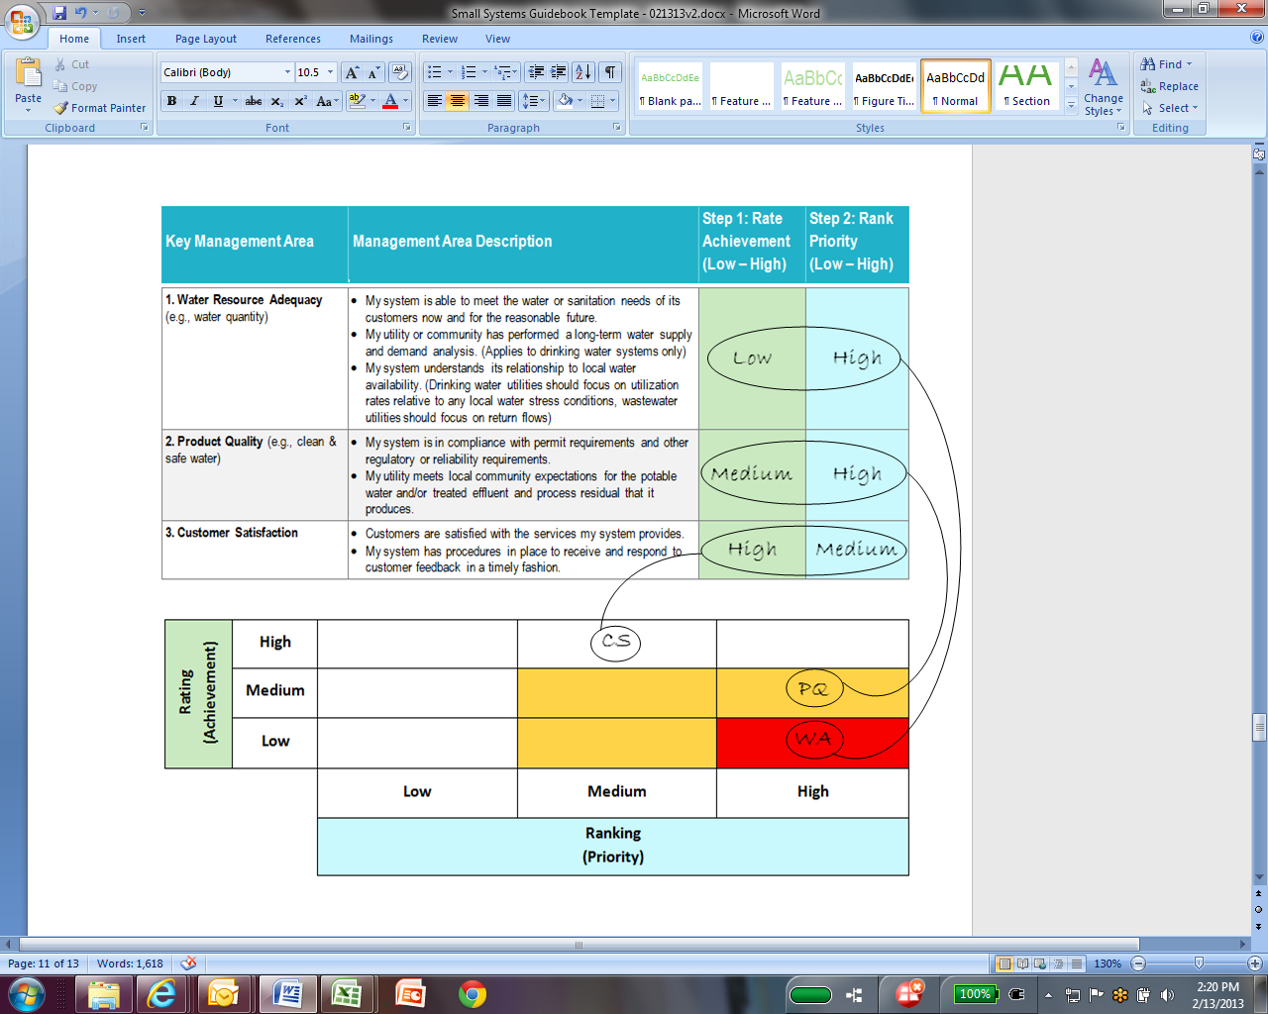

**YOUR TURN: Complete the plotting exercise in Step 3 in Table B of Appendix I before moving to Step 4.**

Step 4 - Analyze Results

**QUESTIONS TO CONSIDER:**

Where is my system strong?

Where is there the most room for improvement?

What should my areas of focus be?

Why are these areas priorities?

The results of the Step 3 plotting exercise identify management areas that will benefit from improvement. Generally speaking, management areas that fall into the **red box** are both **very important and need improvement.** They should be seen as a top priority for improvement. Management areas that land in the **yellow boxes** are next on the list for improvement, and those in the **white boxes** may be considered for long-term improvement efforts, but likely do not need immediate action. The eventual goal for all utilities should be high achievement in all management areas, but at a pace consistent with the system’s priorities and resources.

A sustainable management improvement plan is a good way to identify and prioritize the actions. This plan should be incorporated, as appropriate, into the utility’s annual budget, and coordinated with its capital improvement plans and long-range plan. The sustainable management improvement plan should derive directly from the analysis of the self-assessment results.

Both the self-assessment results and the sustainable management improvement plan can act as building blocks for long-range planning. A sustainable management improvement plan takes a long-term view of the system’s goals and establishes a clear vision and mission. The plan should incorporate goals and actions for each priority management area in a logical sequence. The plan should also incorporate actions needed to maintain high achievement in the areas of current strong performance. Utilities are encouraged to repeat the self-assessment and update their sustainable management improvement plans as changes to system operations or infrastructure take place.

Types of Plans

#### Sustainable Management Improvement Plan: A plan that addresses specific areas of utility management that need improvement. This type of plan should be designed around the assessment of the management areas presented in this *Guidebook.*

Capital Improvement Plan: A mid-term plan (typically over a period of four to ten years) that identifies capital projects and equipment purchases. It provides a planning schedule and identifies options for financing each item.

**Long-Range Plan:** A plan that addresses future outcomes to help meet goals over a long period of time (typically over a period of twenty years or more) by evaluating an organization and the environment in which it operates.

# Improving Outcomes

To create a successful sustainable management improvement plan, it is important to have at least a basic understanding of the following items:

**QUESTIONS TO CONSIDER FOR EACH MANAGEMENT AREA:**

What will constitute ‘high achievement’ in this area?

What factors have led to performance gaps in this area?

What changes will my utility need to make to improve performance?

Who will need to be involved for changes to take place?

How will my utility track performance progress?

What will be the biggest challenges to performance improvement?

Are there external resources that can support the improvement of performance in this management area?

* What it means to accomplish “high achievement” in each area;
* The changes a system will need to make to reach this level;
* The challenges that may arise for each management area; and
* How to track performance and progress.

This section of the *Guidebook* is designed to help systems develop a strategy for addressing each of these components of becoming a more sustainable and resilient system.

## How to Succeed in Each Management Area: High Achievement and Common Challenges

Once a system has decided to improve its performance in one or more of the key management areas, the next step is to develop and implement a plan. To create a plan, it is important to have an idea of what challenges may arise, and what practices can be adopted to address each area. Found on the following pages are overviews of challenges and effective practices for five management areas. These areas were discussed in-depth at the small system workshops that served as background for the *Guidebook*. Also included are examples of performance measures for each management area.

Employee & Leadership Development

Try this:

Develop relationships with neighboring systems to share training resources.

Challenges specific to **Employee & Leadership Development** include:

* Employee motivation and opportunities for development can be hampered by a lack of resources.
* Limited access to training opportunities can prevent personal and professional development.
* Lack of written job responsibilities can lead to uncertainty about management expectations and a lack of recognition for the work that is done.
* Time constraints on employees.

Examples of actions taken by high performing utilities in **Employee & Leadership Development** include:

* Have programs in place to retain and improve institutional knowledge, such as a “living document” with best practices for different areas of utility operations that is updated regularly (e.g., have a “best practices” document that includes sections for each area of operation, and every six months ask an operator from each area to review the content and make updates as necessary).
* Ensure that staff members are cross-trained (i.e., more than one staff member can do a specific job).
* Allow employees to work non-traditional schedules (e.g., a modified overtime schedule) to allow for on-the-job-training (e.g., job shadowing of other employees as a part of cross-training).
* Identify and schedule key training events that staff members are required to attend. Whenever possible, make training events short and focused, and build them into the regular work day.
* Establish and clearly communicate staff performance requirements (e.g., create a table of capabilities for successful performance in the different positions and review with staff annually).
* Create an outreach plan to attract qualified staff (e.g., with local schools or veteran’s associations).
* Create incentive programs to retain staff, encourage training, or encourage staff to take on additional duties (e.g., monthly or quarterly recognition/awards for staff that have gone above and beyond their regular duties or competition between staff members for accruing the most training hours in a set period of time).
* Develop training module templates for how to conduct trainings on different topics. Include presenter notes and materials for participants.
* Check in with staff regularly to identify new training needs.
* Create partnerships with the system’s insurance agency or state water organization to benefit from free or reduced rate training programs that they may offer.
* Help train, or otherwise assist, staff from neighboring utilities.

**Measures that you might consider for tracking accomplishments in Employee & Leadership Development:**

* **Employee turnover rate: $\frac{Number of employee departures per year}{Number of total positions per year}$**
* **Employee job satisfaction rate: $\frac{Number of employees satisfied with their jobs per year}{Total number of employees per year}$**
* **Annual training hours per employee**

Financial Viability

Try this:

Undertake a rate study to determine if current rates are adequate to meet both current and future needs.

Challenges specific to **Financial Viability** include:

* It is uncomfortable and politically challenging to discontinue service to neighbors, acquaintances, elderly customers, or fixed income customers who have not paid their bills.
* It is difficult to communicate to elected officials and consumers about how much it costs to produce drinking water and process wastewater, making it a challenge to get rate increases approved.
* Customers feel that flat rate billing practices are unfair (low volume users paying the same as high volume users).
* Elected officials may make campaign commitments to no rate increases.

Examples of actions taken by high performing utilities in **Financial Viability** include:

* Discuss rate requirements and related system repair requirements with customers, board members, and other key stakeholders so that there is a better understanding within the community of why rate decisions and changes are made. (Consider using a respected member of the community to facilitate this discussion).
* Have a study on rate requirements conducted by an independent consultant (e.g., National Rural Water Association, Rural Community Assistance Partnership) to back up discussions about rate requirements.
* Establish predictable rates, consistent with community expectations and acceptability.
* Have financial accounting policies and procedures in place.
* Have ordinances in place for automatic rate increases tied to cost of living increases.
* Set aside funds for reserves (i.e., have a “rainy day” fund).
* Increase equity in billing practices by using meters whenever possible.
* Conduct quarterly budget reviews.
* Identify priorities for system improvements to aid in allocation of available funds.
* Improve practices for reducing the number of outstanding bills (e.g., limit the carry-forward balance to a fixed amount or increase service connection fees or service deposits to discourage customers who move frequently or avoid paying their bills).
* Create incentives for early bill payment (e.g., a 5% discount for bills paid early, or a good customer discount such as a discount on the seventh month’s bill after six months of paying on time).
* Communicate financial viability information to stakeholders to keep them informed about rates.

**Measures that you might consider for tracking accomplishments in Financial Viability:**

* **Revenue to expenditures ratio: $\frac{Total annual revenue}{Total annual expenditures}$**
* **Debt ratio: $\frac{Total liabilities}{Total assets}$**
* **Number of late or unpaid bills per billing period**
* **Number of annual shutoffs**

Infrastructure Stability

Try this:

Create an inventory of your assets over time by setting up a template for logging assets. Log assets at the time that regular maintenance or emergency repairs are performed.

Challenges related to **Infrastructure Stability** include:

* Planning for repair and maintenance of infrastructure is hampered by a limited knowledge of the condition of existing infrastructure components.
* Many systems are trapped in a reactive repair and maintenance mode leaving little or no time for undertaking the proactive work needed to establish an asset management program.

Examples of actions taken by high performing utilities in **Infrastructure Stability** include:

* Create a complete and organized inventory of its current system components, condition, location, age, life expectancy, and cost.
* Conduct inflow and infiltration (I&I) and water loss analyses to determine the revenue and cost implications of deteriorating pipe conditions.
* As major collection system replacements are needed, consider sewer (sanitary and stormwater) separation to improve treatment performance and preserve treatment capacity.
* Track the status of all system components to be better aware of where weaknesses exist and when maintenance may be required (e.g., plotting valves, hydrants, and main breaks on a map).
* Coordinate asset repair, rehabilitation, and replacement with other community projects and repairs (e.g., road maintenance) to minimize disruptions and other negative consequences. Communicate these repairs in advance with customers in case of service disruptions.
* Track the frequency and cause of repeat collection, distribution, and maintenance problems.
* Establish a capital improvement plan that identifies capital projects and equipment purchases, as well as the resources needed to fund them.
* Have an understanding of system operating parameters (e.g., pressure).
* Organize all system documentation in a manner that it can be easily accessed by multiple staff members in the case of a break-down or other event.
* Focus on small annual projects and system upgrades rather than major undertakings.

**Measures that you might consider for tracking accomplishments in Infrastructure Stability:**

* **Inventory completeness rate: $\frac{Total number of critical assets inventoried}{Total number of critical assets owned and operated}$**
* **Condition assessment rate: $\frac{Number of assets with condition assessed and put into condition categories}{Total number of assets}$**

Operational Resiliency

Try this:

Use an annual board meeting as an opportunity to distribute and review key emergency documents.

Challenges related to **Operational Resiliency** include:

* A lack of system documentation.
* Insufficient time to conduct training and exercises on the emergency response plan.
* Employee and board member turnover make it difficult to maintain familiarity with emergency response procedures and materials.

Examples of actions taken by high performing utilities in **Operational Resiliency** include:

* Conduct an all hazards vulnerability assessment.
* Prepare an all hazards emergency response plan, including all associated documents (e.g., shut off checklists, notices, and contact information), and conduct training and exercises on the plan. In this plan, make sure to indicate who is responsible for each activity.
* Distribute all emergency documents to board members and other essential personnel, including local emergency responders.
* Participate in your state’s Wastewater Agency Response Network (WARN) program to share resources with neighboring utilities during an emergency through mutual aid and assistance.
* Develop relationships with contractors to ensure the types of equipment and services needed during emergencies are available in a timely fashion.
* Have safety policies in place to protect employees against work-related injuries.
* Identify and establish risk communication roles and responsibilities.
* Coordinate emergency response plans with local response partners, including emergency management agencies, police, fire, and critical independent sectors (e.g., hospitals and power companies).
* Identify a state certified laboratory that can help with emergency water testing during an incident.
* Plan for recovery by identifying funding resources that may be available to restore and strengthen the resiliency of your system. Identify opportunities to mitigate and adapt to climate change.

**Measures that you might consider for tracking accomplishments in Operational Resiliency:**

* **Annual number of work-related injuries**
* **Annual number of emergency response trainings or exercises held**
* **Period of time (hours or days) that minimum daily demand can be met with the primary water source unavailable**

Stakeholder Understanding & Support

Try this:

Host an annual open house or barbeque at your facility for stakeholders and community members. Offer tours of the facility to citizens and local media as a part of this event.

Challenges related to **Stakeholder Understanding & Support** include:

* Customers and stakeholders display a lack of interest in gaining a better understanding of utility needs.
* Customer resistance to paying water bills or supporting rate increases.

Examples of actions taken by high performing utilities in **Stakeholder Understanding and Support** include:

* Perform active customer and stakeholder outreach and education (e.g., hold meetings with stakeholders at the facility to convey a basic understanding and knowledge of utility operations).
* Utilize engagement and outreach activities as opportunities to also better understand community and customer needs and interests related to utility operations.
* Promote the value of clean and safe water (e.g., utilize pre-prepared National Rural Water Association education materials associated with its Quality on Tap program).
* Actively engage with local decision makers, watershed, and regulatory representatives through newsletters, regular meetings, and surveys.
* Have a capital improvement plan or other document to share with stakeholders that summarizes utility priorities. Make this information easily available.
* Establish active level of service goals to set performance measures for the utility and share with customers.
* Use free space in bills to provide important information to customers.
* Share positive information on your utility with local media sources as a way of establishing a positive working relationship.

**Measures that you might consider for tracking accomplishments in Stakeholder Understanding & Support:**

* **Annual number of stakeholder outreach activities conducted**
* **Amount of annual positive media coverage (number of media stories per year)**
* **Rate of responsiveness to stakeholder suggestions/complaints: $\frac{Number of stakeholder suggestions or complaints responded to}{Total number of stakholder suggestions or complaints}$**

# What’s Next: Creating Your Plan for Action

## Creating a Plan

Having gained a more complete understanding of strengths and challenges based on the self-assessment and an idea of what actions can strengthen performance in the management areas, a system will be better equipped to develop an effective sustainable management improvement plan. Where feasible it is useful for a single staff member (or, “champion”) to have responsibility of overseeing improvement plan development. Various staff members and managers, however, should be involved in its creation, if possible. In drafting a plan, the utility should create specific tasks for addressing its targeted improvement areas and identify adjustments necessary to make the desired changes.

After completing the self-assessment exercise, the system will select priority improvement areas from the red and yellow boxes of the plotting exercise. The sustainable management improvement plan should be **simple, specific, realistic, and complete.** Appendix III contains references for a wide range of resources covering all of the management areas. These resources will be useful for identifying the options you have for undertaking management area improvements. For each improvement action that you identify, the plan should include the following components:

* An easy-to-understand, but still thorough, **description** of what actions will be taken;
* Identification of **who will be responsible** for taking the action;
* Known **resources** already on-hand or needed to complete the actions (financial, informational, or other);
* Identification of key **challenges** that will need to be addressed;
* A **timeline** with key milestones for the actions in the plan, and a date by when the plan will be completed (or acknowledgement if it is ongoing); and
* A **review loop** to periodically assess progress in implementing the plan and adapting the plan to changing conditions (e.g., implementing a new billing system, measuring the efficiency of the system as implemented, and refining the system based on the information from the performance measures).

The utility can create its own action plan format based on its needs and circumstances, or use the blank Sustainable Management Action Plan Worksheet in Appendix II. A sustainable management improvement plan does not have to be long or even perfect. What’s most important is that the system has a plan in place and that it sticks with it!

## How You Can Take Action

Results of the Self-Assessment exercise can be implemented in many different ways to accommodate an individual utility’s regular near-term and long-term planning processes. For utilities that are just getting started with planning or those that would like to take immediate action outside of their normal planning cycle, an example timeline with suggested activities is outlined on the following page.

## The Sustainable Management Improvement Plan Worksheet

*Instructions:*

* *From your top priority management areas (determined by the self-assessment activity), select one management area for improvement planning.*
* *For your selected management area, consider the improvement actions that you will undertake.*
* *Fill out the details in the table below for an improvement action (one table per action).*

## Example Sustainable Management Improvement Plan Worksheet

## Priority Management Area: *Financial Viability*

**YOUR TURN: Complete the Improvement Plan Worksheet in Appendix II.**

|  |  |
| --- | --- |
| Improvement Action*: Improve practices for reducing the number of outstanding bills* | |
| Description:   * Action * Management Area(s) addressed * Objective(s) | * *Limit the carry-forward balance to a fixed amount and increase service deposits to discourage customers who move frequently to avoid paying their bills* * *Financial Viability* * *Reduce the amount of money lost to unpaid bills* |
| Timeline:   * Start date * Milestones * Target completion date | * *June 2019: Start - Draft new carry-forward balance allowance and new service deposit requirements for new customers* * *July 2019: Propose and approve new balance and deposit requirements at board meeting* * *August 2019: Notify customers of new requirements* * *September 2019: Completion – Implement new balance and deposit requirements* |
| Responsible Party (or Parties): | * *Bill Smith* * *Jane Anderson* |
| Relevant Resources (on-hand or needed): | * *Example ordinance text created by other utilities to support the desired policy change* |
| Challenges to Address: | * *Public pressure on board members to reject rate increases* |
| Review Process:   * Performance indicators or measures * Status reports and updates frequency/cycle | * *Milestone dates met* * *Weekly progress checks with utility director relative to identified milestones* |
| Other Notes: | * *Conduct calls with each board member to explain the need for the policy change and answer their questions* |

## Measuring Progress

As a part of the review loop built into an action plan, the system must determine how to track progress toward achievement of performance goals. For rural and small systems, it is most feasible to measure internal performance, rather than trying to gather external data needed for more complex evaluations. Some measurements to consider are included in the “How to Succeed in Each Area” section of the *Guidebook*, beginning on page 12, but it is important to remember that performance measures should be tailored to the specific needs and goals of each system.

Some points to keep in mind when selecting performance measures are included below:

* Select the **right number, level, and type of measures** for the utility’s capabilities and capacity. (As a general rule, having a short list of measures is probably best.)
* Measuring performance will require some level of **resource commitment**. (Resources can include money, time, and personnel.)
* Develop **clear and consistent definitions** for each measure. (How will it be tracked and reported?)
* Set **reasonable targets** based on criteria such as performance and improvement in previous years, or customer expectations. (How quickly does the community expect projects to be completed?)
* Develop a process for **evaluating and responding to the results** of measuring progress. (Now that the utility knows how it is doing, how will it use this information to continue to improve its performance?)
* Select measures that support the system’s **short-term and long-term goals**. (How do these measurements fit into the “big picture” of the utility?)
* **Periodically report on progress** to the board and other key stakeholders in the community.
* **Recognize and celebrate** progress along the way! (Every little bit counts.)

## Assessing Accomplishments and Making Improvements

**QUESTIONS TO CONSIDER:**

What is working? Why?

What is not working? Why?

Have internal or external conditions for my utility changed?

How can my plan be adjusted accordingly?

Having created a structure for measuring progress toward meeting improvement goals, a system will need to complete the third step in the review loop: assessing accomplishments (or pitfalls) and making adjustments as needed. Setting aside time on a quarterly, biannual, or annual basis to discuss the progress that has been made towards key management goals is one of the simplest, but most important, actions that a system can take. By addressing the key questions and modifying the improvement plan on a regular basis, a system will keep the goals, and itself, up-to-date on current issues and on the path to being a more resilient, sustainable system.

# Appendices

## Appendix I: Self-Assessment Worksheet

## Appendix II: Sustainable Management Action Plan Worksheet

## Appendix III: Resources for Rural and Small Systems

# Appendix I: Self-Assessment Worksheet

## Step 1 – Rating ACHIEVEMENT AREAS

Assess your system by rating your current level of achievement for each management area. Consider how effectively your current management efforts support each of the areas. Note that each management area has several dimensions (represented by the bullet points listed for each). Your rating should reflect the dimension with the lowest level of achievement. For example, if you believe that your achievement in one dimension of a management area was low, but your achievement in another dimension of that area was high, your overall rating for the area would be low. An example of the rating exercise can be found on the following page.

#### Scale from low achievement to high achievement:

* Select **Low** if your system has no workable practices in place for addressing this area – very low capacity and performance.
* Select **Medium** if your system has some workable practices in place with moderate achievement, but could improve – some capacity in place.
* Select **High** if your system has effective, standardized, and accepted practices in place. It either usually or consistently achieves goals – capacity is high and in need of very little or no further development.

## Step 2 - Ranking PRIORITY AREAS

#### Rank the importance of each management area to your system. Base this ranking on your goals and the specific needs of your community. Your ranking may be influenced by current or expected challenges (e.g., if your community is experiencing elevated population growth rates, Water Resource Adequacy may be ranked as a high priority area to address). Again, note that each management area has multiple dimensions (represented by the bullet points listed). Your ranking should represent the highest priority of all of the points listed. Your ranking should also be independent of the achievement level. For example, an area can remain, and therefore be ranked, as a high priority even if the utility has high capacity and performance). An example of the rating exercise can be found on the following page.

#### Scale from low priority to high priority, keeping in mind the following:

* Current or expected challenges
* Customer or stakeholder impact (reliability, quality, timeliness)
* Consequences of not improving (non-compliance, increased cost, lost credibility, impacts to health and safety)
* Urgency (near or long-term needs)
* Community priorities

### Table A

|  |  |  |  |
| --- | --- | --- | --- |
| Key Management Area | Management Area Description | Step 1: Rate Achievement (Low – High) | Step 2: Rank Priority (Low – High) |
|  | | | |
| 1. Water Resource Adequacy (e.g., water quantity)  WA | * My system is able to meet the water or sanitation needs of its customers now and for the reasonable future. * My utility or community has performed a long-term water supply and demand analysis. (Applies to drinking water systems only.) * My system understands its relationship to local water availability. (Drinking water utilities should focus on utilization rates relative to any local water stress conditions, wastewater utilities should focus on return flows.) |  |  |
| 2. Product Quality (e.g., clean & safe water)  PQ | * My system is in compliance with permit requirements and other regulatory or reliability requirements. * My utility meets local community expectations for the potable water and/or treated effluent and process residuals that it produces. |  |  |
| 3. Customer Satisfaction  CS | * Customers are satisfied with the services the system provides. * My system has procedures in place to receive and respond to customer feedback in a timely fashion. |  |  |
| 4. Community Sustainability & Economic Development  CE | * My utility is aware of and participating in local and regional community and economic development planning activities. * My utility’s goals also help to support overall watershed and source water protection, and community economic goals. |  |  |
| 5. Employee & Leadership Development  ED | * Training programs are in place to retain and improve institutional knowledge. * Opportunities exist for employee skills development and career enhancement. * Job descriptions, performance expectations, and codes of conduct are established. |  |  |
| 6. Financial Viability  FV | * The rates that my utility charges are adequate to pay our bills, put some funds away for the future, and maintain, repair, and replace our equipment and infrastructure as needed. (O&M, debt servicing, and other costs are covered.) * My utility discusses rate requirements with our customers, board members, and other key stakeholders. |  |  |
| 7. Operational Optimization (energy/water efficiency)  OO | * My utility has assessed its current energy usage and performed an energy audit. * My utility has maximized resource use and resource loss (e.g., water loss, treatment chemical use). * My utility understands, has documented, and monitors key operational aspects of the system (e.g., pressure, flow, quality). |  |  |
| 8. Infrastructure Stability(e.g., asset management)  IS | * My utility has inventoried its current system components, condition, and cost. * My system has a plan in place for repair and replacement of system components. |  |  |
| 9. Operational Resiliency  OR | * My utility has conducted an all hazards vulnerability assessment (safety, natural disasters, environmental risks, etc.). * My utility has prepared an all hazards emergency response plan. |  |  |
| 10. Stakeholder Understanding & Support  SS | * My system actively engages with local decision makers, community, watershed (where relevant), and regulatory representatives to build support for its goals, resources, and the value of the services it provides. * My utility performs active customer and stakeholder outreach and education to understand concerns and promote the value of clean and safe water. |  |  |

## Step 3 - Plot Results

*To compare your results for each management area, you will plot each pair (rating, ranking) in Table B of Appendix I. For each management area, identify your high/medium/low rating in the green Step 1 box, and find the corresponding row in the table. Then, for the same management area, identify your high/medium/low ranking in the blue Step 2 box, and find the corresponding column in the table. The box where the row and column intersect is where you should place that management area (note abbreviations below for use in the plotting exercise). The example below shows how you should complete the Step 3 plotting exercise. The ranking and rating for each management area should be paired and placed into the corresponding box in the grid, based on the low/medium/high determinations given in Steps 1 and 2.*

|  |  |
| --- | --- |
| **WA Water Resource Adequacy**  **PQ Product Quality**  **CS Customer Satisfaction**  **CE Community Sustainability & Economic Development**  **ED Employee & Leadership Development** | **FV Financial Viability**  **OO Operational Optimization**  **IS Infrastructure Stability**  **OR Operational Resiliency**  **SS Stakeholder Understanding & Support** |

### Table B

|  |  |  |  |  |
| --- | --- | --- | --- | --- |
| **Rating**  **(Achievement)** | **High** |  |  |  |
| **Medium** |  |  |  |
| **Low** |  |  |  |
|  | | **Low** | **Medium** | **High** |
| **Ranking**  **(Priority)** | | |

## Step 4 - Analyze Results

**QUESTIONS TO CONSIDER:**

Where is my utility strong?

Where is there the most room for improvement?

What should my areas of focus be?

Why are these areas priorities?

The results of the Step 3 plotting exercise identify management areas that will benefit from improvement. Generally speaking, management areas that fall into the **red box** are both **very important and need improvement.** They should be seen as a top priority for improvement. Management areas that land in the **yellow boxes** are next on the list for improvement, and those in the **white boxes** may be considered for long-term improvement efforts, but likely do not need immediate action. The eventual goal for all utilities should be high achievement in all management areas, but at a pace consistent with the system’s priorities and resources.

# Appendix II: Sustainable Management Action Plan Worksheet

*Instructions:*

* *For your top priority management area (determined by the self-assessment activity), choose one improvement action that you will undertake to address your priority management area.*
* *Fill out the details in the table below for your improvement action (one table per action).*

## Priority Management Area:

|  |  |
| --- | --- |
| Improvement Action: | |
| Description:   * Action * Management Area(s) addressed * Objective(s) |  |
| Timeline:   * Start date * Milestones * Target completion date |  |
| Responsible Party (or Parties): |  |
| Relevant Resources (on-hand or needed): |  |
| Challenges to Address: |  |
| Review Process:   * Performance indicators or measures * Status reports and updates frequency/cycle |  |
| Other Notes: |  |

# Appendix III: Resources for Rural and small systems

As a companion resource to this *Guidebook*, this list of resources offers additional information and guidance specific to small systems on the ten key management areas. Resources are identified in the table by the key management areas that they address (abbreviations in the table are identified in the key below). The majority of the resources listed are available free of charge.

|  |  |
| --- | --- |
| WA Water Resource Adequacy  PQ Product Quality  CS Customer Satisfaction  CE Community Sustainability & Economic Development  ED Employee & Leadership Development | FV Financial Viability  OO Operational Optimization  IS Infrastructure Stability  OR Operational Resiliency  SS Stakeholder Understanding & Support |

|  | WA | PQ | CS | CE | ED | FV | OO | IS | OR | SS |
| --- | --- | --- | --- | --- | --- | --- | --- | --- | --- | --- |
| ArcGIS for Water Utilities  <http://solutions.arcgis.com/utilities/>  *An industry specific configuration of ArcGIS designed to meet common needs of water, wastewater and stormwater utilities and is delivered as module of ArcGIS for Local Government. ArcGIS for Water Utilities is a free download that you can deploy on top of either the entire ArcGIS System or the individual components of the ArcGIS System that your organization licenses.* |  |  |  |  |  |  |  | ✓ |  |  |
| ArcGIS for Water Utilities – Water Conservation Dashboard  <http://solutions.arcgis.com/utilities/water/help/water-conservation-dashboard/>  *Allows operations managers to view the progress and results of green infrastructure verifications, watering violations, and service shutdown information. Helps managers to understand and ensure the completion of water conservation field operations.* | ✓ |  |  |  |  |  | ✓ |  |  |  |
| Asset Management: A Handbook for Small Water Systems  <http://nepis.epa.gov/Exe/ZyPDF.cgi/2000261D.PDF?Dockey=2000261D.PDF>  *Presents basic concepts of asset management and provides the tools to develop an asset management plan. It is designed for owners and operators of small community water systems (CWSs). CWSs include all systems (both publicly and privately owned) with at least 25 year-round residential customers or 15 year-round service connections.* |  |  |  |  |  | ✓ | ✓ | ✓ |  |  |
| AWWA Water Audit Software  <http://www.awwa.org/resources-tools/water-knowledge/water-loss-control.aspx>  *Free software to compile a preliminary audit.* |  |  |  |  |  |  |  |  |  |  |
| “Basic Training” for Drinking Water Board Members – Online Course Reference Guide  <http://www.newwa.org/Portals/0/Utility%20Resources/FINAL%202013-09-25_Wtr_Comm_Book-Low%20Res.pdf>  *A guide for new board members, developed by the New England Water Works Association with funding from EPA Region 1. Covers items such as roles and responsibilities, communications, board operations, working with operators, budgets and rate setting, planning for the future, and treatment and distribution basics.* | ✓ | ✓ |  |  | ✓ | ✓ |  | ✓ |  |  |
| The Basics of Financial Management for Small-community Utilities  <http://www.rcapsolutions.org/wp-content/uploads/2013/06/RCAP-Financial-Management-Guide.pdf>  *A basic guide that is ideal for a board member of a drinking water or wastewater utility who needs to understand the financial aspects of a utility's operations.* |  |  |  |  | ✓ | ✓ |  |  |  |  |
| The Big Guide for Small Systems: A Resource for Board Members  <http://rcap.org/wp-content/uploads/2016/03/Big-Guide-for-Small-Systems.pdf>  *A comprehensive desk reference that is ideal as an orientation and background for new members on a utility's board of directors. Designed for members of the board of a drinking water and/or wastewater system in a small community. In various parts of the guide, sample documents are provided that utilities can take and adapt for use in their own situations.* |  |  | ✓ |  | ✓ |  |  |  |  | ✓ |
| Board Member Training  <http://msucares.com/water/waterboard/waterindex.html>  *Trains board members in the areas of laws and regulations, duties and responsibilities, ethics, operation and maintenance, management and finance, rate setting, and public relations and customer service.* |  |  |  |  |  |  |  |  |  | ✓ |
| Building Water System Capacity: A Guide for Tribal Administrators  <http://www.epa.gov/sites/production/files/2015-04/documents/epa816k01006.pdf>  *Resource describes the process through which drinking water systems acquire and maintain the technical, financial, and managerial capabilities to consistently provide safe drinking water.* |  | ✓ | ✓ |  |  |  |  |  |  |  |
| Capital Improvement Plan (CIP) Tool for Water and Wastewater Utilities  <http://www.efc.sog.unc.edu/project/capital-planning-resources-water-and-wastewater-utilities>  *CIP tool with example data and tools to create easy-to-understand predictions on: financial reserves, rate increases, and capital investment.* |  |  |  |  |  |  |  | ✓ |  |  |
| Care and Conserve Sewer Line Repairs  <http://www.cleanwateratlanta.org/environmentaleducation/CareConserve.htm>  *Sample program for low income assistance.* |  |  |  |  |  | ✓ |  |  |  |  |
| Check Up Program for Small Systems  <http://www.epa.gov/dwcapacity/information-check-program-small-systems-cupss-asset-management-tool>  *Provides a simple, comprehensive approach based on EPA's highly successful Simple Tools for Effective Performance (STEP) Guide series. Use CUPSS to help you develop: a record of your assets, a schedule of required tasks, an understanding of your financial situation, and a tailored asset management plan.* |  |  |  |  |  | ✓ | ✓ | ✓ |  |  |
| Circuit Rider Program  <http://nrwa.org/initiatives/training-and-technical-assistance/>  *Provides technical assistance for the operations of rural water systems. Rural Utilities Service through contracting, has assisted rural water systems with day-to-day operational, financial, and management problems. The assistance may be requested by officials of rural water systems or RUS. The program compliments the loan supervision responsibilities for RUS. The National Rural Water Association has entered into a contract with RUS to provide this service. National Rural Water Association - State Affiliates do the work in their states.* |  |  |  |  | ✓ | ✓ |  | ✓ | ✓ |  |
| Cross-Connection Control: A Best Practices Guide  <http://nepis.epa.gov/Exe/ZyPDF.cgi/2000ZZB8.PDF?Dockey=2000ZZB8.PDF>  *This guide discusses the importance of controlling cross-connections and preventing backflow occurrences from unprotected cross-connections in the water system.* |  | ✓ |  |  |  |  |  |  |  |  |
| Drinking Water Security for Small Systems Serving 3,300 or Fewer Persons  <http://nepis.epa.gov/Exe/ZyPDF.cgi/20017JWD.PDF?Dockey=20017JWD.PDF>  *Presents basic information and steps you can take to improve security and emergency preparedness at your water system.* |  |  |  |  |  |  |  |  | ✓ |  |
| A Drop of Knowledge  <http://rcap.org/resource/a-drop-of-knowledge/>  *A Drop of Knowledge (formerly the eBulletin) is one of RCAP’s main communications resources. It is an electronic newsletter delivered via email that provides tools focusing on issues facing water and wastewater systems and small, rural communities. A Drop of Knowledge is designed for staff of water systems/utilities, board members and elected officials. It provides helpful tips, guides and resources on practical subjects and is written in plain English. The information it contains will help you make informed decisions to benefit your community, keep your system in compliance, and maintain water quality in the most proactive way.* |  |  |  |  |  | ✓ | ✓ | ✓ | ✓ |  |
| EFC Financial Dashboard  <http://www.efc.sog.unc.edu/project/utility-financial-sustainability-and-rates-dashboards>  *Free, interactive rates dashboards that are designed to assist utility managers and local officials analyze water and wastewater rates against multiple characteristics.* |  |  |  |  |  | ✓ | ✓ | ✓ |  |  |
| eLearning – Leadership & Management Courses  <http://www.awwa.org/conferences-education/distance-learning/elearning.aspx>  *AWWA's online courses on leadership and management.* |  |  |  |  | ✓ |  |  |  |  |  |
| eLearning – “Water Basics for Decision Makers”  <http://www.awwa.org/store/productdetail.aspx?productid=6655>  *Document for decision makers in water or wastewater utilities, or for those who regularly interact with professionals but don't clearly understand how water is distributed and treated.* |  |  |  |  |  |  |  |  |  | ✓ |
| Energy Efficiency in Water and Wastewater Facilities  <http://www3.epa.gov/statelocalclimate/documents/pdf/wastewater-guide.pdf>  A guide to developing and implementing greenhouse gas reduction programs. |  |  |  |  |  |  | ✓ |  |  |  |
| Financial Management Courses  <http://www.newwa.org/NetCode/courseDescList.aspx>  *Search under course category "Management.”* |  |  |  |  |  | ✓ |  |  |  |  |
| Financial Planning: A Guide for Water and Wastewater Systems  <http://www.nmenv.state.nm.us/dwb/Documents/Public%20Info/RCAC%20Financial%20guide_final_6.pdf>  *Guidebook that walks a utility through the annual budgeting process, the rate setting process, and creating a 6-year financial plan.* |  |  |  |  |  | ✓ |  |  |  |  |
| Formulate Great Rates: The Guide to Conducting a Rate Study for a Water System  <http://rcap.org/wp-content/uploads/2012/03/Formulate-Great-Rates.pdf>  *A guide to developing a fair and equitable rate structure in a small drinking water or wastewater system.* |  | ✓ | ✓ |  |  | ✓ |  |  |  |  |
| Getting in Step: A Guide for Conducting Watershed Outreach Campaigns  <http://cfpub.epa.gov/npstbx/files/getnstepguide.pdf>  *Provides some of the tools needed to develop and implement an effective watershed outreach plan. For a watershed practitioner trained in the sciences, this manual will help you address public perceptions, promote management activities, and inform or motivate stakeholders.* |  |  |  |  |  |  |  |  |  | ✓ |
| Getting in Step: Engaging Stakeholders in Your Watershed (2nd Edition)  <http://cfpub.epa.gov/npstbx/files/stakeholderguide.pdf>  *This guide is intended for federal, state, tribal, and local agency personnel, as well as nongovernmental organizations, that are involved in watershed management activities and are building a stakeholder group. Stakeholder groups are formal or informal assemblies that represent a variety of interest and points of view within a watershed.* |  |  |  |  |  |  |  |  |  | ✓ |
| Getting Your Project to Flow Smoothly: A Guide to Developing Water and Wastewater Infrastructure  <http://rcap.org/wp-content/uploads/2016/01/RCAP-Getting-Your-Project-to-Flow-Smoothly.pdf>  *A comprehensive guide on all the steps a project owner (governing body of a utility) should go through in planning, designing and constructing infrastructure.* | ✓ |  |  | ✓ |  | ✓ | ✓ | ✓ |  | ✓ |
| Local Safe Disposal Programs: Ex. Safe Medicine Disposal for Maine  <http://www.safemeddisposal.com/>  *The Safe Medicine Disposal for ME program provides Maine's residents with a safe disposal option for unused and unwanted medicine. Free medicine mail-back envelopes are available at participating sites.* |  |  |  |  |  |  |  |  |  | ✓ |
| Moving Toward Sustainability: Sustainable and Effective Practices for Creating Your Water Utility Roadmap  <http://www.epa.gov/sites/production/files/2015-04/documents/sustainable_practices_utilities_roadmap_crwu.pdf>  *The purpose of this document is to assist utility leaders with implementing proven and effective practices over time to improve their operations and move toward sustainability, at a pace consistent with their needs and the needs of their communities.* | ✓ | ✓ | ✓ | ✓ | ✓ | ✓ | ✓ | ✓ | ✓ | ✓ |
| Mutual Aid Networks  <http://www.epa.gov/waterutilityresponse/mutual-aid-and-assistance-drinking-water-and-wastewater-utilities> or [www.nationalwarn.org](http://www.nationalwarn.org)  *Describes how small systems can participate in WARN to share resources with neighboring utilities during an emergency.* |  |  |  |  |  |  |  |  | ✓ |  |
| National Rural Water Association Job Network  <http://nrwa-jobs.careerwebsite.com/home/index.cfm?site_id=678>  *Helps to connect the most skilled professionals in the fields of drinking water, wastewater, source water protection, utility management & engineering to potential employers.* |  |  |  |  |  |  |  |  |  |  |
| National Rural Water Association Technical Training and Assistance Program  <http://nrwa.org/initiatives/training-and-technical-assistance/>  *Click on your state for contact information to obtain services under the Technical Assistance and Training Program. National Rural Water Association provides training and on-site technical assistance to waste water systems in the contiguous 48 states, Alaska, Puerto Rico, and Hawaii. The training is provided to help reduce exposure to waste related health and safety hazards and enhance the sustainability of wastewater systems in rural and small communities.* |  | ✓ |  |  |  |  | ✓ |  |  |  |
| National Rural Water Association  [www.nrwa.org](http://www.nrwa.org)  *Website of the National Rural Water Association, the largest water and waste water utility membership association.* |  |  |  |  |  |  |  |  |  |  |
| Natural Disaster Preparedness Guidelines for Water and Wastewater Utilities  <http://rcap.org/resource/natural-disaster-preparedness-guidelines-for-water-and-wastewater-utilities/>  *This checklist was developed to assist water and wastewater utilities in natural disaster readiness.* |  |  |  |  |  |  |  |  | ✓ |  |
| The Non-operator's Guide to Drinking Water Systems  <http://rcap.org/wp-content/uploads/2011/12/Non-operators-Guide-to-DRINKING-WATER-Systems_Small.pdf>  *Explains in simple, everyday language the technical aspects of drinking water utilities from source to tap. Helpful as an orientation and background guide for new small utility board members and small community decision makers.* |  |  |  |  |  |  |  |  |  | ✓ |
| The Non-operator’s Guide to Wastewater Systems  <http://rcap.org/wp-content/uploads/2016/01/RCAP-Non-operators-Guide-to-WASTEWATER-Systems.pdf>  *Explains in simple, everyday language the various components/operations of a small wastewater system from when the customer flushes his/her toilet through collection, treatment, and return to source. This guide and its companion on drinking water treatment systems are the perfect orientation and background guides for new small utility board members and small community decision makers.* |  |  |  |  |  |  |  |  |  | ✓ |
| Only Tap Water Delivers Campaign  <http://www.awwa.org/resources-tools/public-affairs/communications-tools/only-tap-water-delivers.aspx>  *A public outreach campaign that is available to AWWA utility members free of charge. The materials are available in a CD toolkit, and can be adapted to meet local needs.* |  |  |  |  |  |  |  |  |  | ✓ |
| Pipe Repair Checklist  <http://www.awwa.org/Portals/0/files/resources/water%20knowledge/rc%20small%20systems/piperepairchecklist.pdf>  *AWWA small systems pipe repair checklist.* |  |  |  |  |  |  | ✓ |  |  |  |
| Preventive Maintenance Card File for Small Public Water Systems Using Ground Water  <http://www.epa.gov/sites/production/files/2015-04/documents/booket_smallsystems_preventmaint.pdf>  *Schedules for maintenance tasks and checklists and logs for easily recording your findings.* |  |  |  |  |  |  | ✓ |  |  |  |
| Protecting Water Quality by Optimizing the Operations and Maintenance of Distribution Systems  <http://rcap.org/wp-content/uploads/2015/03/Distribution-Systems-guide.pdf>  *This guide provides background information on how to maintain water quality in drinking water distribution systems and treated-water storage facilities by concentrating on common problems and challenges and identifying potential improvements and solutions. This guide uses regulatory requirements and best practices of the drinking water community as the basis of its discussion of water distribution systems.* |  |  |  |  |  |  | ✓ | ✓ |  |  |
| Protecting Your Community's Assets: A Guide for Small Wastewater Systems  <http://www.nesc.wvu.edu/subpages/WW_manage_plan.cfm>  *Helps utility managers, operators, and local officials improve security and plan for emergency situations affecting wastewater treatment systems.* |  | ✓ |  |  |  |  |  | ✓ | ✓ |  |
| Public Communications Toolkit  <http://www.awwa.org/resources-tools/public-affairs/communications-tools/public-communications-toolkit.aspx>  *Website with and online toolkit of various resources for water professionals related to public communication.* |  |  |  |  |  |  |  |  |  | ✓ |
| Quality On Tap! Public Relations Campaign  <http://nrwa.org/initiatives/quality-on-tap/>  *A nationwide, grassroots public relations and awareness campaign designed especially for the drinking water industry. Quality On Tap is the first practical "hands-on" guide to better public relations for small water utilities. It contains the tools small water systems need to do the most important job of all - spreading the truth to the public of the quality of work they do and the quality water they produce.* |  |  |  |  |  |  |  |  |  | ✓ |
| Quick Reference Guides – Drinking Water Rule (EPA)  <http://www.epa.gov/dwreginfo/drinking-water-rule-quick-reference-guides#ssqrg>  *These documents provide a simple and straightforward description of the rule and requirements. They include critical deadlines for drinking water systems and states, in addition to monitoring requirements.* |  | ✓ |  |  |  |  |  | ✓ |  |  |
| Record Keeping Rules: A Quick Reference Guide  <http://nepis.epa.gov/Exe/ZyPDF.cgi?Dockey=2000ZZB2.txt>  *A rule-by-rule summary of requirements for keeping monitoring, public notice, and other records, as well as helpful tips on record maintenance and security.* |  | ✓ |  |  |  |  | ✓ |  |  |  |
| Recruiting and Training Veterans Brochure: For Careers in the Water Sector  <http://www.workforwater.org/WorkArea/linkit.aspx?LinkIdentifier=id&ItemID=2147483686>  *The Department of Veterans Affairs and Department of Labor administer programs to assist Veterans in their transition to civilian careers and oversee funding to pay for education and job training. The Environmental Protection Agency, American Water Works Association and Water Environment Federation are working with these agencies to promote water sector careers nationally.* |  |  |  |  | ✓ |  |  |  |  |  |
| Revolving Loan Fund Program  <http://nrwa.org/initiatives/revolving-loan-fund/>  *The NRWA Revolving Loan Fund was established under a grant from USDA/RUS to provide financing to eligible utilities for pre-development costs associated with proposed water and wastewater projects. RLF funds can also be used with existing water/wastewater systems and the short term costs incurred for replacement equipment, small scale extension of services or other small capital projects that are not a part of your regular operations and maintenance.* |  |  |  |  |  | ✓ |  |  |  |  |
| Rural Community Assistance Partnership  [www.rcap.org](http://www.rcap.org)  *Aims to provide technical assistance and training services to rural communities develop and sustain critical infrastructure and promote economic opportunity.* |  |  |  |  |  |  |  |  |  |  |
| Rural Utilities Service  <http://www.rd.usda.gov/about-rd/agencies/rural-utilities-service>  *USDA’s Rural Utilities Service (RUS) administers programs that provide much-needed infrastructure or infrastructure improvements to rural communities. These include water and wastewater treatment, electric power and telecommunications services.* |  |  |  | ✓ |  | ✓ |  |  |  |  |
| Rural Water Supply and Sewer Systems: Background Information  <http://nationalaglawcenter.org/wp-content/uploads/assets/crs/98-64.pdf>  *CRS report for congress.* |  |  |  |  |  |  |  |  |  |  |
| Security and Emergency Management System (SEMS)  <http://semstechnologies.com/RAMCAP.asp>  *Software to assist small water systems in completing a vulnerability self-assessment.* |  |  |  |  |  |  |  | ✓ | ✓ |  |
| Setting Small Drinking Water Rates for a Sustainable Future  <http://nepis.epa.gov/Exe/ZyPDF.cgi/2000D2NM.PDF?Dockey=2000D2NM.PDF>  *A step-by-step rate setting guide for small utilities for assessing annual costs, revenue needs, and reserve requirements and setting appropriate rates.* |  |  |  |  |  | ✓ |  |  |  | ✓ |
| Small System Guide to Safe Drinking Water Act Regulations  <http://nepis.epa.gov/Exe/ZyPDF.cgi/1000478A.PDF?Dockey=1000478A.PDF>  *A resource for understanding current and anticipated drinking water regulations with which utilities need to comply.* |  | ✓ |  |  |  |  |  |  |  |  |
| Source Water Collaborative  http://www.sourcewatercollaborative.org/  *A web forum about where America’s safe drinking water begins – the lakes, streams, rivers, and aquifers we tap for public water systems. The Collaborative is a web portal of 25 national organizations that have united to protect America’s sources of drinking water.* | ✓ | ✓ |  |  |  |  |  |  |  |  |
| Survival Guide: Public Communications for Water Professionals  [www.wef.org/WorkArea/DownloadAsset.aspx?id=7120](http://www.wef.org/WorkArea/DownloadAsset.aspx?id=7120)  *A guidebook to help utilities learn how to communicate effectively with their community and customers. It provides an overview focused on the learning the basics of public communication and different public communication scenarios.* |  |  |  |  |  |  |  |  |  | ✓ |
| Sustainable Infrastructure for Small System Public Services: A Planning and Resource Guide  <http://rcap.org/wp-content/uploads/2016/01/RCAP-Sustainable-Infrastructure-Guide.pdf>  *Provides worksheets, examples, case studies and resources on water conservation, energy efficiency and renewable energy resources for small utilities.* |  |  |  | ✓ |  | ✓ | ✓ | ✓ | ✓ |  |
| Sustainable Sanitation and Water Management  <http://www.sswm.info/>  *“Linking up sustainable sanitation, water management, and agriculture.” The SSWM Toolbox includes: background on environmental, economic, and socio-cultural issues; planning, processing, and implementation tools; “mini toolboxes” on specific topics; trainings on sustainable sanitation and water management; and many other resources geared toward small systems.* | ✓ |  | ✓ |  |  |  | ✓ | ✓ |  |  |
| Tabletop Exercise Tool for Water Systems  <http://yosemite.epa.gov/ow/SReg.nsf/description/TTX_Tool>  *A PC-based tool that contains materials to assist those interested in planning and facilitating tabletop exercises that focus on Water Sector-related issues. The updated TTX Tool contains fifteen scenarios that address an all-hazards approach to emergency preparedness and response, including natural hazards and manmade incidents, as well as introduces users to the potential impacts of climate change.* |  |  |  |  |  |  |  |  | ✓ |  |
| Taking Stock of Your Water System: A Simple Asset Inventory for Very Small Drinking Water Systems  <http://www.epa.gov/sites/production/files/2015-04/documents/epa816k03002.pdf>  *Helps very small water systems, such as manufactured home communities and homeowners’ associations, assess their condition by preparing a simple asset inventory.* |  |  |  |  |  | ✓ |  | ✓ |  |  |
| Talking to Your Decision Makers: A Best Practices Guide  <http://nepis.epa.gov/Exe/ZyPDF.cgi/2000ZZB6.PDF?Dockey=2000ZZB6.PDF>  *Tips for working successfully with decision makers in your community to meet your water system’s needs.* |  |  |  |  |  |  |  |  |  | ✓ |
| Talking to Your Customers About Chronic Contaminants in Drinking Water: A Best Practices Guide  <http://nepis.epa.gov/Exe/ZyPDF.cgi/60000LWL.PDF?Dockey=60000LWL.PDF>  *Guidelines for effectively communicating with customers about the dangers of chronic contaminants and how water systems protect against contamination.* |  |  | ✓ | ✓ |  |  |  |  |  | ✓ |
| Technitrain Program  <http://rcap.org/service/technitrain/>  *Helps to protect public health and foster economic development in targeted rural communities throughout the United States and its territories by providing onsite, community-specific technical assistance and training that: identifies and evaluates solutions to water and waste disposal problems, assists communities in preparing funding applications for their water and waste projects, and improves operation and maintenance of existing water and waste-disposal facilities. It is part of RCAP’s overall mission of working with small, rural communities to increase local capacity.* |  |  |  | ✓ | ✓ | ✓ |  |  |  |  |
| USDA Rural Utilities Service Borrower's Guide: A How-to for Water and Wastewater Loans from USDA Rural Development  <http://rcap.org/wp-content/uploads/2011/12/RCAPs-USDA-RUS-Borrowers-Guide.pdf>  *Summarizes the managerial and financial requirements for communities that are receiving U.S. Department of Agriculture Rural Utilities Services (RUS) loan funds for their water or wastewater utility.* |  |  |  |  |  | ✓ |  |  |  |  |
| Vulnerability Self-Assessment Tool (VSAT)  <http://water.epa.gov/infrastructure/watersecurity/techtools/vsat.cfm>  *A risk assessment software tool that assists drinking water and wastewater utilities in assessing security threats and natural hazards and updating utility Emergency Response Plans; appropriate for any water system size or type.* |  |  |  |  |  |  |  | ✓ | ✓ |  |
| WaterPro Conference Website  <http://www.waterproconference.org/>  *WaterPro is the annual conference of the National Rural Water Association. It takes place in even numbered calendar years. WaterPro is designed to bring together water and wastewater utility systems - large and small, municipal and rural - for sessions in operations, management, boardsmanship and governance.* |  |  |  |  | ✓ | ✓ | ✓ | ✓ | ✓ |  |
| WaterSense  <http://www.epa.gov/WaterSense/>  *EPA's program to promote water efficiency and conservation. Provides information for consumers to identify products and practices that save water. Utilities and local governments can partner with EPA to receive access to a network of partners working on water conservation and promoting the value of water and using it wisely.* |  |  | ✓ |  |  |  |  |  |  | ✓ |
| Water System Operator Roles and Responsibilities: A Best Practices Guide  <http://nepis.epa.gov/Exe/ZyPDF.cgi/2000ZZBE.PDF?Dockey=2000ZZBE.PDF>  *Helps to understand: (1) Roles and responsibilities in delivering safe drinking water to system's customers; (2) Additional responsibilities, which can vary depending on size, characteristics, managerial structure, and regulatory requirements.* |  | ✓ |  |  | ✓ |  |  |  | ✓ |  |
| Water System Owner Roles and Responsibilities: A Best Practices Guide  <http://nepis.epa.gov/Exe/ZyPDF.cgi/2000ZZBC.PDF?Dockey=2000ZZBC.PDF>  *A summary of system owners’ key duties in protecting public health, overseeing system operation, and working with local officials.* |  |  |  |  | ✓ |  |  |  |  | ✓ |
| Water Quality in Small Community Distribution Systems  <http://nepis.epa.gov/Exe/ZyPDF.cgi/P1000OY3.PDF?Dockey=P1000OY3.PDF>  *Assists the operators and managers of small- and medium-sized public water systems. Provides a comprehensive picture of the impact of the water distribution system network on distributed water quality.* |  | ✓ |  |  |  |  |  | ✓ | ✓ |  |
| Water University  <http://www.wateruniversity.org/>  *The intent of Water University and the National Rural Water Association is to provide the highest level of instruction, education, training and discussion to the largest audience possible. To meet that goal, most of the webinar/lecture portions of these courses are presented at low or no cost. In addition to providing information to the entire water industry, Water University provides a method for licensed water professionals to earn their necessary Continuing Education Units through our advanced on-line educated modules. Access to these modules requires enrollment fees, but these fees are still very affordable compared to in-person training.* |  |  |  |  |  |  |  |  |  |  |
| Water & Wastewater Pricing  <http://nepis.epa.gov/Exe/ZyPDF.cgi/901U1200.PDF?Dockey=901U1200.PDF>  *EPA Website on water and wastewater pricing, explaining the concept of pricing and water conservation, as well as supplying tools, guides, and reports on pricing.* |  |  |  |  |  | ✓ |  |  |  |  |
| Work for Water Website  <http://www.workforwater.org/>  *Materials to encourage careers in the water sector, where opportunities to protect and preserve water resources are virtually unlimited and the chance to make a difference is unmatched.* |  |  |  |  | ✓ |  |  |  |  |  |

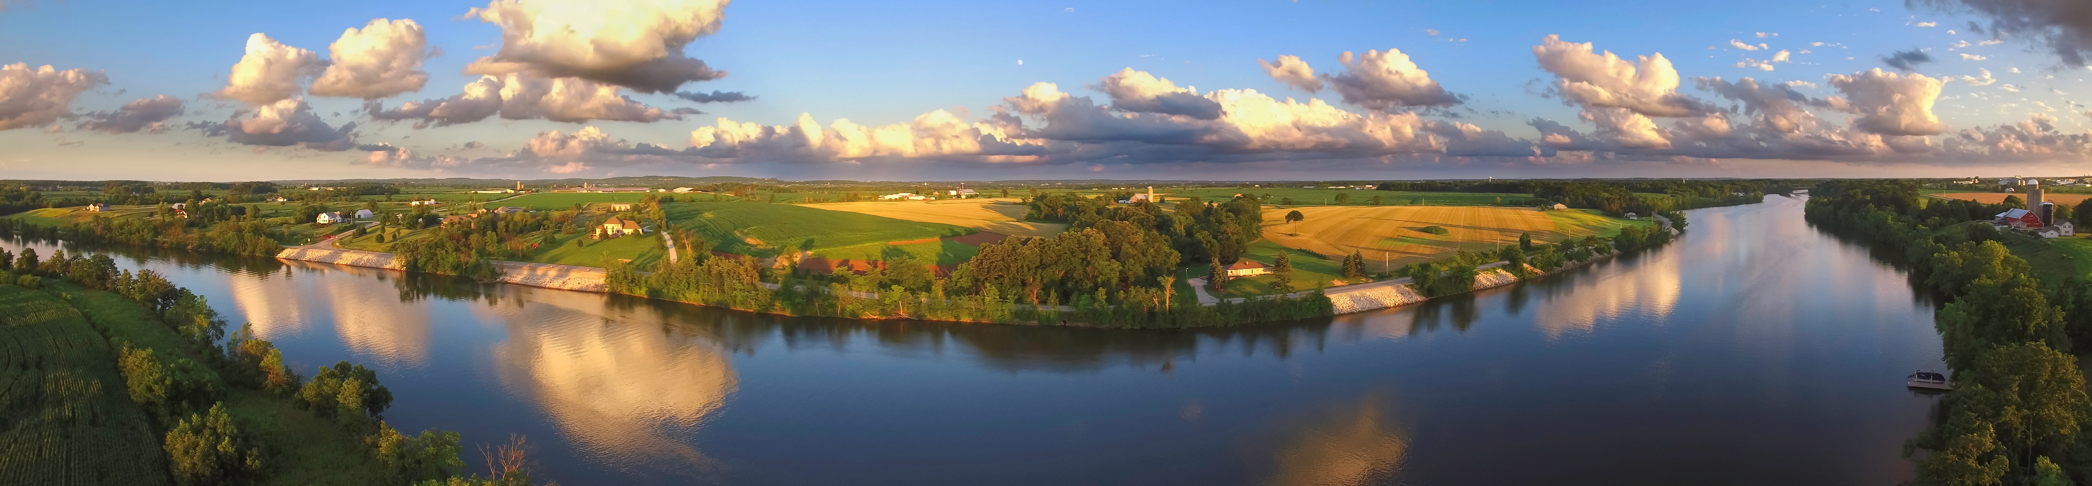

**Financial Viability for Rural and Small Systems**

Now that you have completed your *Rural and Small Systems* “Self-Assessment” exercise and determined that Financial Viability is important to your utility, this handout can help you get started on improving your Financial Viability practices. It describes some of the key “Building Blocks” of financial success for small utilities, giving you a starting place to improve utility financial practices. The handout also includes specific suggestions on how to measure a utility’s financial viability, and lists a number of free resources with practical information on how to improve practices. For more information on the Financial Viability management area, please refer to the *Rural and Small Systems Guidebook to Sustainable Utility Management*.

**FINANCIAL VIABILITY: The system establishes and maintains an effective balance between long-term debt, asset values, operations and maintenance expenditures, and operating revenues. Rates are adequate to pay its bills, put some funds away for both future capital expenditures and unanticipated issues, and maintain, repair, and replace its equipment and infrastructure as needed. The system discusses rate requirements with its customers, decision making authorities, and other key stakeholders.**

*— Rural and Small Systems Guidebook to Sustainable Utility Management*

**Additional Information**

**EPA website:** <https://www.epa.gov/sustainable-water-infrastructure/tools-effective-water-and-wastewater-utility-management>   
**USDA website:** <https://www.rd.usda.gov/programs-services/services/sustainable-management-tools>



**Building Blocks of Financial Viability**

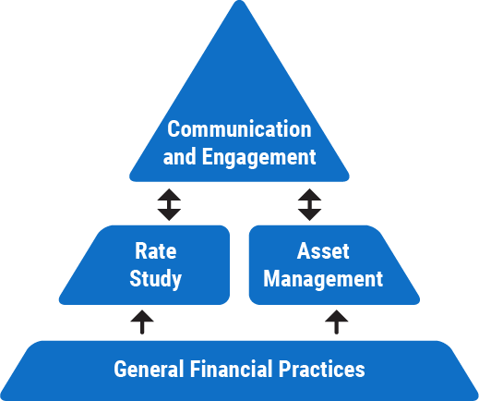**GENERAL FINANCIAL PRACTICES**

Basic financial practices and management skills are necessary to maintaining a financially viable utility. These skills and practices provide the foundation for all the other building blocks. Foundational practices include book-keeping and regular, systematic monitoring of the utility’s revenue and costs.

* Maintain a budget standard accounting and record-keeping practices

**EXAMPLE  
ACTIVITIES**

* Conduct regular budget reviews
* Prepare a “rainy day” reserve fund for unexpected obstacles

**Asset Management**

An asset management plan is an important step in achieving financial viability. First, a utility must identify all the utility’s assets and equipment (e.g., pumps, treatment systems, buildings, etc.) and assess the cost and condition of these assets. After identifying the value and condition of its assets, the utility predicts the lifespan of these assets, and creates a plan for funding the repairs, replacements, and upgrades to major assets as they age.

* Create an inventory of system assets, asset condition, and financial value of assets

**EXAMPLE  
ACTIVITIES**

* Estimate asset lifespans and identify priority assets for system improvements or repairs
* Plan for medium- and long-term expenses linked to asset upgrades and replacements

**Rate Study**

A rate study looks closely at the revenue needed to provide enough funding for operations and maintenance (O&M), capital investments, and debt service. The study will lay out the different options for rate design and rate structure for utility customers. A rate study also informs a utility’s strategy for funding operations or major infrastructure investments.

* Review the utility’s budget, along with water produced and sold

**EXAMPLE  
ACTIVITIES**

* Calculate utility’s O&M costs & create a plan to adjust rates over time to meet these costs
* Design a system for automatic rate increases tied to cost of living increases
* Create incentives to reduce the number of outstanding bills or for early bill paying

**Communication and Engagement**

Communication and engagement is necessary to explain the need for infrastructure investments and other operating needs of the utility to stakeholders (customers, community leaders, water utility governing boards). Creating an open discussion with stakeholders about the utility’s operations and financial needs will help to gain support and public acceptance for rate increases or other forms of financial support. This building block will rely on the information and activities from the Rate Study and Asset Management building blocks.

* Continually promote the value of water and water services within the community to increase public support for the utility, which will pave the way for communicating future investment needs and rate adjustments

**EXAMPLE  
ACTIVITIES**

* Engage board members, decision makers, and other community stakeholders with financial viability information, including communicating reasoning behind rates and utility operating costs
* Solicit feedback from customers on their preferences or concerns about water infrastructure and water services

**Measures**

It is important to have a method of measuring and tracking the financial health of a utility. Below several measurement areas are described, with specific example metrics or activities for each area.

**Budget Management Effectiveness**

Short-term measures are common financial performance indicators, which can be recorded annually or quarterly. Long-term measures may focus more on a “big picture” assessment, looking at a wide range of factors to assess budget health over many years or decades. Consider the measures below, the first three are short-measures. The revenue to expenditure ratio helps a utility see if they need to increase revenue (such as raising rates) or find ways to lower expenses. Regularly recording the debt ratio will help a utility see debt levels, and if the debt is growing or shrinking. Bond rating is a long-term metric that can generally show a utility’s overall financial health.

* Revenue to expenditure ratio: Total revenue ÷ total expenditures

**EXAMPLE  
Metrics**

* Debt ratio: Total liabilities ÷ total assets *(USDA recommends that a facility have a debt coverage ratio of at least 1.1, or a current ratio of at least 1.5)*
* Capital expenditures: capital expenditures ÷ total capital budget
* Bond rating

**Rate Adequacy**

This measure looks at a utility’s rates, and how these rates are affected by outside factors. These outside factors could include: general economic trends; short-term financial management; changes to a utility’s service population; and long-term financial goals. Since utilities operate in varied contexts (e.g., large or small, rural or urban) it is difficult to provide a “one size fits all” calculation for utility rates.

* Number of late or unpaid bills per billing period

**EXAMPLE  
Metrics**

EXAMPLE  
Metrics

* Number of annual shutoffs
* Comparison of rate changes to inflation and the Consumer Price Index (CPI). (Rate increases below inflation or CPI for very long may suggest rates are not keeping up with utility costs.)

**Financial Practices Assessment**

An active effort to self-assess the quality of financial management and procedures in the utility—aiming to find areas in financial management where the utility could improve.

* Does the utility have financial accounting policies and procedures (yes/no)?

**EXAMPLE  
Questions**

* Are financial results and internal controls audited annually (yes/no)?
* Does the utility have a formal policy for the bill collection process (yes/no)?

**Example Practices for Financial Viability at Rural and Small Systems**

*The practices listed below are drawn from the* [Rural and Small Systems Guidebook](https://www.rd.usda.gov/files/RuralandSmallSystemsGuidebook2016.pdf) *and the* [Moving Toward Sustainability Roadmap](https://www.epa.gov/sites/production/files/2016-01/documents/sustainable-utilities-roadmap-12-10-14_508.pdf) *document. They are examples of practices that utilities have implemented to improve their performance in the area of Financial Viability.*

|  |  |  |
| --- | --- | --- |
| Create policies for internal control procedures over financial management. | Conduct a financial feasibility analysis to identify funding and financing available for future infrastructure project needs. | Have a study on rate requirements conducted by third party (e.g., NRWA, RCAP). |
| Conduct quarterly budget reviews. | Create operating and capital “rainy day” funds. | Build in gradual, annual rate increases. |

**Resources**

Highlighted below are several practical and free resources that provide information for utilities on how to improve financial practices. For a longer list of resources that provide more information on specific areas of utility management, please see the ***Rural and Small Systems Guidebook to Sustainable Utility Management: Appendix III*.**

<https://www.rd.usda.gov/files/RuralandSmallSystemsGuidebook2016.pdf>

**The Basics of Financial Management for Small-Community Utilities**

This guide provides a review of basic financial management aspects of utility operations for board members and operators of drinking water and wastewater utilities in small communities. The guide addresses short- and long-term budgeting; how to develop a budget plan; systems for accounting and disbursing funds; and other general financial and record-keeping practices.

<http://www.rcapsolutions.org/wp-content/uploads/2013/06/RCAP-Financial-Management-Guide.pdf>

**Check Up Program for Small Systems (CUPSS) Asset Management Tool**

CUPSS is a free, easy-to-use asset management tool for drinking water and wastewater utilities. It can help you keep a record of your assets, schedule required tasks, better understand your financial situation, and create a tailored asset management plan.

<https://www.epa.gov/dwcapacity/information-check-program-small-systems-cupss-asset-management-tool>

**Financial Planning: A Guide for Water and Wastewater Systems**

This guide is designed as an introduction to general financial practices for any owner or manager of a water or wastewater system. The guide offers information on how to develop and monitor a utility budget; evaluate rate structures; and develop a 5-year financial plan. The guidebook provides details on exactly what information is necessary to do these activities, and includes worksheets walking through each step of the process.

<http://www.nmenv.state.nm.us/dwb/Documents/Public%20Info/RCAC%20Financial%20guide_final_6.pdf>

**Moving Toward Sustainability: Sustainable and Effective Practices for Creating Your Water Utility Roadmap**

This document helps utility leaders carry out successful practices to improve their operations and move toward sustainability, at a pace in line with community and utility needs. Level 1 practices highlighted in the “Financial Viability” section of this document are a good starting place for utilities looking to update their basic financial practices.

<http://www.epa.gov/sites/production/files/2015-04/documents/sustainable_practices_utilities_roadmap_crwu.pdf>

**Water Infrastructure and Resiliency Finance Center**

The Water Infrastructure and Resiliency Finance Center is an information and assistance center at the U.S. EPA, which helps communities make informed decisions for drinking water, wastewater, and stormwater infrastructure. The Center provides water infrastructure funding and financing information and assistance to local governments.

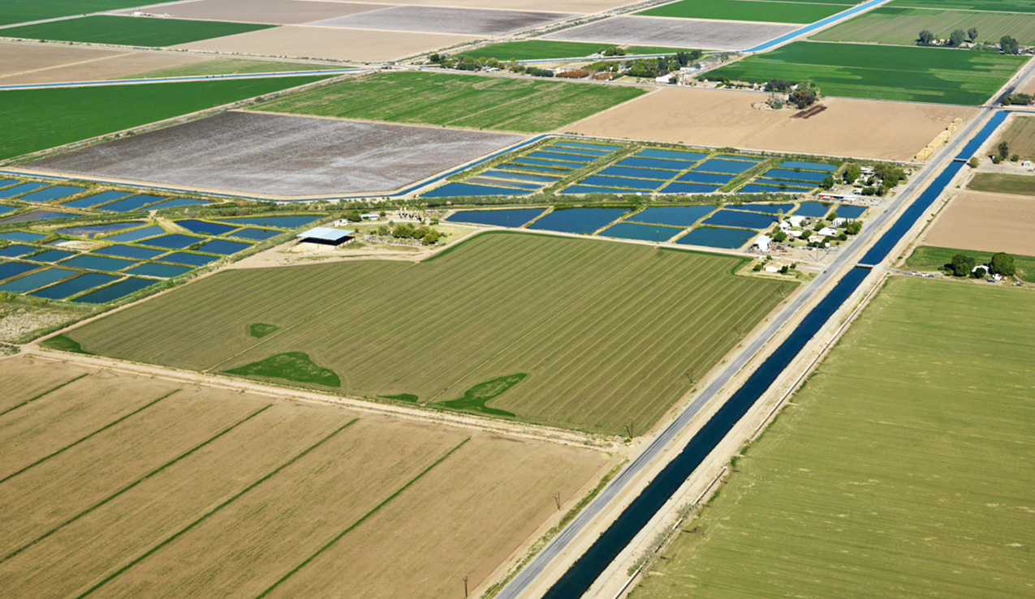<https://www.epa.gov/waterfinancecenter>





**Operational Resiliency for Rural and Small Systems**

Now that you have completed your *Rural and Small Systems* “Self-Assessment” exercise and determined that Operational Resiliency is important to your utility, this handout can help you get started on improving your Operational Resiliency practices. It describes some of the key “Building Blocks” of resiliency success for small utilities, giving you a starting place to improve utility resiliency practices. The handout also includes specific suggestions on how to measure a utility’s resiliency, and it lists a number of free resources with practical information on how to improve practices. Successful Operational Resiliency management is also highly dependent on successful management of a utility’s infrastructure. A complementary handout for *Infrastructure Stability* is available from USDA and EPA as a part of this resource series. For more information on the Operational Resiliency management area, please refer to the *Rural and Small Systems Guidebook to Sustainable Utility Management*.

**OPERATIONAL RESILIENCY: The system ensures that its leadership and staff members work together to anticipate and avoid problems. It proactively identifies legal, financial, non-compliance, environmental, safety, security, and other natural threats to the system. It has conducted a vulnerability assessment for safety, natural disasters, and other environmental threats, and has prepared an emergency response plan for these hazards.**

*— Rural and Small Systems Guidebook to Sustainable Utility Management*

**Additional Information**

******EPA website:** <https://www.epa.gov/sustainable-water-infrastructure/tools-effective-water-and-wastewater-utility-management>   
**USDA website:** <https://www.rd.usda.gov/programs-services/services/sustainable-management-tools>

**Building Blocks of Operational Resiliency**

**EMERGENCY PREPAREDNESS TOP TEN LIST**

**___________________________**

**10. Prepare** (or update) an emergency response plan. Make sure all employees help to create it and receive training on the plan.

**9. Post** updated emergency 24-hour numbers at your facilities in highly visible areas and give them to key personnel.

**8. Get to know** your local police and ask them to add your facilities to their local routine rounds. Practice emergency response procedures with local police and emergency response officials.

**7. Fence and lock** your facilities and vulnerable areas.

**6. Lock all** entry gates and doors, and set alarms to indicate illegal entry. Do not leave keys in equipment or vehicles at any time.

**5. Install good lighting** around your facilities and parking lots.

**4. Identify** existing and alternate supplies and maximize use of backflow prevention devices and interconnections.

**3. Work with** any businesses or homeowners that could be potential sources of contamination or damage to your infrastructure to reduce risk.

**2. Lock** monitoring wells and manholes to prevent vandals or terrorists from pouring contaminants into groundwater near your source, or accessing your underground infrastructure.

**1. In case of an emergency,** first call “911,” and then follow your emergency response plan.

*Source: Adapted from “Drinking Water Security and Emergency Preparedness Top Ten List” (EPA)*

**Risk assessment and reduction plan**

The first step in improving a system’s resilience is to identify the threats that could affect the system, followed by creating a plan to reduce the risk of those threats. Utilities should first focus on high-consequence assets (those that have the largest impact to the system if they fail) when undertaking risk-reduction planning. As the utility works through the risk assessment and reduction process, its ability to understand and detect threats will increase, helping to improve resiliency over time.

* Conduct an all-hazards vulnerability assessment

**EXAMPLE  
ACTIVITIES**

* Create a risk reduction plan with counter-measures (including internal safety measures)
* Create a prioritized list of mitigation projects for high-consequence assets

**emergency response planning**

An Emergency Response Plan (ERP) is a documented plan that describes the actions that a utility would take in response to various major incidents. These could include natural disasters or emergencies (e.g., storms, earthquakes, floods, fires), incidents that lead to mass damage or disruption to the community or system, or even terrorism.

* Prepare an all-hazards ERP, including all associated documents (e.g., shut-off checklists, notices, emergency contact information)

**EXAMPLE  
ACTIVITIES**

* Conduct internal training and exercises on the ERP, including making staff aware of who is responsible for each activity
* Coordinate the utility’s ERP with other local response partners, such as police and fire departments

**Recovery and Mitigation**

To recover quickly from any kind of disaster or emergency incident, the utility should be aware of mitigation and recovery activities that it would need to undertake for a range of threats in case the need should arise. This includes having reserve funds for system restoration (for more information, refer to the *Financial Viability* handout in this series).

* Identify resources that may be available to the utility for recovery after an emergency (e.g., FEMA or a local Mutual Aid Network (see page 4 of this document for more information)

**EXAMPLE  
ACTIVITIES**

* Predict maintenance and upgrade costs and incorporate these costs into financial plans
* Identify funding programs and understand required documentation for those that might be needed in a system recovery context

**Measures**

To gather information on a system’s resilience, it is necessary to use the measures most appropriate to the utility goals for resiliency performance. Below are several measurement areas, with specific example metrics for each.

**Recordable Incidents**

These measures allow utilities to understand how internal incidents may affect the system’s overall health and resilience.

* Annual number of work-related injuries

**EXAMPLE  
Metrics**

* Annual number of “near misses” (“near miss” is an unsafe situation where no injury occurred and no property was damaged, but these could have occurred with a slight shift in time or position)

**Risk Assessment and Response Preparedness**

This measure helps utilities to understand how completely they have assessed their vulnerabilities, and how completely they have put plans into place to respond to those threats, should they occur.

* Has the utility conducted a Vulnerability Assessment (VA)? (yes/no)

**EXAMPLE  
Metrics**

* Number of years since the last VA
* Does the utility have an ERP in place? (yes/no)
* Number of years since the last ERP update – less than five? (yes/no)
* Does ERP address current vulnerabilities?
* Annual number of ERP trainings or exercises held
* Is there a process in place to identify and address new risks? (yes/no)

**Overall Operational Resiliency**

This measure assesses a utility’s operational resiliency during ongoing operations (non-emergency conditions) and during emergencies.

Ongoing Operational Resiliency

**EXAMPLE  
Metrics**

* Period of time (hours or days) that minimum daily demand can be met with the primary water source unavailable
* Uptime for critical utility components on an ongoing basis:

$$100 x \frac{hours of critical component uptime}{hours that critical components have the physical potential to be operational}$$

Operational Resiliency Under Emergency Conditions

* Power resiliency: Period of time (hours or days) for which backup power is available for critical operations
* Chemical resiliency: Period of time (hours or days) for which minimum daily demand can be met with water treated to meet SDWA standards
* Treatment operations resiliency: Percent of minimum daily demand met with primary production or treatment plant offline for 24, 48, and 72 hours
* Average number of response-capable backup staff available for critical operation and maintenance positions

**Example Practices for Operational Resiliency at Rural and Small Systems**

*The practices listed below are drawn from the* [Rural and Small Systems Guidebook](https://www.rd.usda.gov/files/RuralandSmallSystemsGuidebook2016.pdf) *and the* [Moving Toward Sustainability Roadmap](https://www.epa.gov/sites/production/files/2016-01/documents/sustainable-utilities-roadmap-12-10-14_508.pdf) *document. They are examples of practices that utilities have implemented to improve their performance in the area of Operational Resiliency.*

|  |  |  |
| --- | --- | --- |
| Risk assessment for high consequence assets. | Emergency roles and responsibilities identification for utility personnel and local response partners. | Basic system information documentation (e.g., system maps and drawings). |
| Cybersecurity measures (e.g., virus protection on all computers). | Process improvement projects (e.g., fences and barriers around facilities, chemicals stored safely). | Local and state officials identified that would be involved in recovery. |

**Resources**

Highlighted below are several practical and free resources that provide information for utilities on how to improve Operational Resiliency. For a longer list of resources covering more information on specific areas of utility management, please see the ***Rural and Small Systems Guidebook to Sustainable Utility Management: Appendix III*.**

<https://www.rd.usda.gov/files/RuralandSmallSystemsGuidebook2016.pdf>

**Mutual Aid Networks**

This website provides information on mutual aid networks, including how to join one. A mutual aid and assistance network provides water and wastewater utilities with the means to quickly obtain help (e.g., personnel, equipment, associated services) from other utilities to restore critical operations impacted during an emergency.

<https://www.epa.gov/waterutilityresponse/mutual-aid-and-assistance-drinking-water-and-wastewater-utilities>

**Natural Disaster Preparedness Guidelines for Water and Wastewater Utilities**

This checklist was developed to assist water and wastewater utilities in natural disaster readiness.

<http://rcap.org/resource/natural-disaster-preparedness-guidelines-for-water-and-wastewater-utilities/>

**Taking Stock of Your Water System: A Simple Asset Inventory for Very Small Drinking Water Systems**

This is an EPA brochure with detailed information and sample forms on how to conduct an asset inventory. The brochure is designed for small water systems, and helps create a standardized approach to asset inventories.

<https://www.epa.gov/sites/production/files/2015-04/documents/epa816k03002.pdf>

**Vulnerability Self-Assessment Tool (VSAT)**

This tool helps drinking water and wastewater utilities of all sizes to enhance their security and resiliency by identifying the highest risks to mission-critical operations; and finding the most cost-effective measures to reduce those risks.

<https://www.epa.gov/waterriskassessment/conduct-drinking-water-or-wastewater-utility-risk-assessment>

**Water Infrastructure and Resiliency Finance Center**

The Water Infrastructure and Resiliency Finance Center is an information and assistance center, helping communities make informed decisions for drinking water, wastewater, and stormwater infrastructure to protect human health and the environment. The Center can help communities identify financing options for resilient and sustainable infrastructure projects.

<https://www.epa.gov/waterfinancecenter>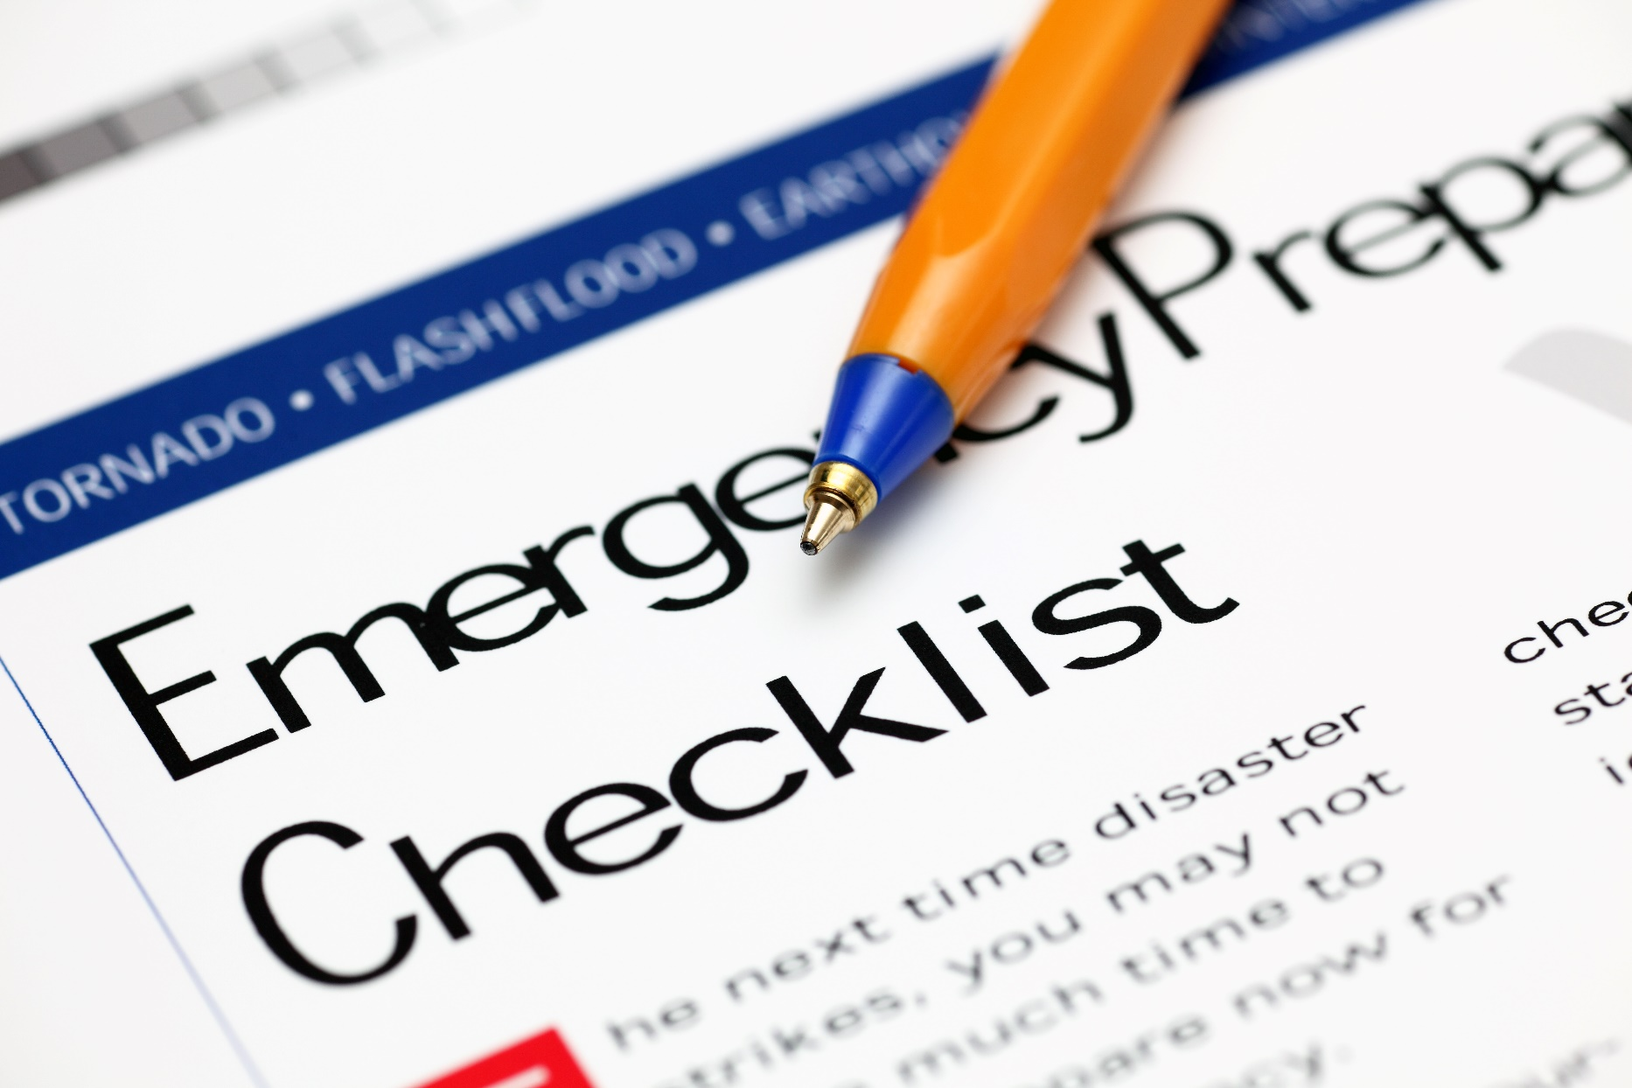





**Stakeholder Understanding and Support for Rural and Small Systems**

Now that you have completed your *Rural and Small Systems* “Self-Assessment” exercise and determined that Stakeholder Understanding and Support is important to your utility, this handout can help you get started on improving your Stakeholder Understanding and Support practices. It describes some of the key “Building Blocks” of successful stakeholder engagement for small utilities, giving you a starting place to improve stakeholder engagement practices. The handout also includes specific suggestions on how to measure a utility’s stakeholder engagement, and lists a number of free resources with practical information on how to improve practices. For more information on the Stakeholder Understanding and Support management area, please refer to the *Rural and Small Systems Guidebook to Sustainable Utility Management*.

**STAKEHOLDER UNDERSTANDING AND SUPPORT: The system actively seeks understanding and support from decision making bodies, community members, and regulatory bodies related to service levels, operating budgets, capital improvement programs, and risk management decisions. It takes appropriate steps with these stakeholders to build support for its performance goals, resources, and the value of the services that it provides. The system performs active outreach and education to understand concerns and promote the value of clean, safe water and the services the utility provides, consistent with available resources.**

*— Rural and Small Systems Guidebook to Sustainable Utility Management*

**Additional Information**

**EPA website:** <https://www.epa.gov/sustainable-water-infrastructure/tools-effective-water-and-wastewater-utility-management>   
**USDA website:** <https://www.rd.usda.gov/programs-services/services/sustainable-management-tools>

**Building Blocks of Stakeholder Understanding and Support**

**WHO ARE YOUR “STAKEHOLDERS?”**

**__________________**

A stakeholder is any individual or group that has an interest in or is impacted by the operations or future of the utility (e.g., community decision makers, board members, ratepayers, other residents of the community).

**Community Engagement and Participation**

Community engagement is necessary to educate stakeholders on the value of the utility and to build support for utility operations. These skills and practices provide the foundation to position the utility as a valued institution in the community. Foundational practices include participation in community events, volunteering, and sponsorships.

* Participate in community events (e.g., utility staff volunteer at fundraising events)

**EXAMPLE  
ACTIVITIES**

* Organize utility open house events
* Host community engagement forums to understand critical community values, set utility goals, and review infrastructure projects
* Co-sponsor community events with other local organizations related to water or watershed protection to increase the public visibility of water.

**Education and Promotion**

A communications plan is an important step in achieving community understanding of the utility and support for its work. First, a utility must ensure that basic information about the utility is readily accessible and understandable to community members. A utility can also work to change or strengthen the relationships with media and the portrayal of the utility through engagement with media on positive utility activities.

* + - Include information about major projects/initiatives and important documents on the website

**EXAMPLE  
ACTIVITIES**

* + - Create multiple-language utility documents consistent with community profile
    - Draft emergency event public communications templates for media contacts (e.g., create standardized text for boil water notices)
    - Conduct annual consumer confidence/water quality report
    - Publish value of water and water services educational brochures
    - Organize public education campaigns
    - Conduct school outreach programs (e.g., K–12 classroom presentations or local school science program water-related curriculum)
    - Tours of water and wastewater facilities for kids

**Customer and Stakeholder Feedback and Response**

Gathering stakeholder feedback and accurately assessing utility response is an important step in successfully engaging stakeholders and growing support for utility operations. Creating customer complaint and response mechanisms is a crucial first step in establishing trust with the community.

* Establish customer complaint response time targets

**EXAMPLE  
ACTIVITIES**

* Identify key community stakeholder opinion leaders list and schedule for outreach to each (e.g., phone calls, informal meeting)
* Create a customer information system to store billing information, service requests, and all resolutions
* Conduct annual customer service survey

**Measures**

To gather information on stakeholder understanding and support, it is important to have a method of measuring and tracking community engagement, public relations, and customer feedback. Below several measurement areas are described, with specific example metrics or activities for each area.

**Stakeholder Consultation and Community Partnering**

This measure addresses utility actions to reach out to and consult with stakeholders about utility matters, including utility goals, objectives, and management decisions. It also assesses how the utility engages with other partners in the community.

* Does the utility identify stakeholders, conduct outreach, and actively consult with stakeholders about utility matters? (yes/no)

**EXAMPLe  
Metrics**

* Number of active contacts with stakeholders in key areas (e.g., from local government, business, education, non-governmental groups).
* Frequency with which the utility actively consults with stakeholders.
* Number of projects completed associated with community partnerships.

**Media/Press Coverage**

A utility can better understand stakeholder awareness and support by better understanding the media portrayal of the utility (newspaper, TV, radio, etc.) in terms of awareness, accuracy, and tone.

* Amount of coverage: Total number of media stories (social media, newspaper, TV, radio, etc.) concerning the utility per year.

**EXAMPLE  
Metrics**

* Media coverage tone (percent): 100 X (number of media stories concerning the utility that portray the utility in a positive way ÷ total number of media stories concerning the utility) per year.

**Stakeholder Satisfaction**

Understanding stakeholder perceptions of and satisfaction with your utility is an important step in successfully engaging stakeholders and growing support for your utility. Stakeholder satisfaction can be measured through surveys sent to stakeholders, formal feedback surveys distributed to stakeholders at events, etc.

* + - Overall satisfaction (percent): 100 X (number of stakeholders who annually rate the overall job of the utility as positive ÷ total number of stakeholders surveyed).

**EXAMPLE  
Metrics**

* + - Responsiveness (percent): 100 X (number of stakeholders who annually rate utility responsiveness to stakeholder needs as positive ÷ total number of stakeholders surveyed).
    - Comparative rate rank (how utility rates compare to similar utilities): Typical monthly bill for average household as a percentage of typical monthly bills for similar utilities

**Example Practices for Stakeholder Understanding and Support at Rural and Small Systems**

*The practices listed below are drawn from the* [Rural and Small Systems Guidebook](https://www.rd.usda.gov/files/RuralandSmallSystemsGuidebook2016.pdf) *and the* [Moving Toward Sustainability Roadmap](https://www.epa.gov/sites/production/files/2016-01/documents/sustainable-utilities-roadmap-12-10-14_508.pdf) *document. They are examples of practices that utilities have implemented to improve their performance in the area of Stakeholder Understanding and Support.*

|  |  |  |
| --- | --- | --- |
| Perform active customer and stakeholder outreach and education. | Establish active level of service goals to set performance measures for the utility, share with customers. | Set customer complaint response time targets. |
| Use free space in bills to provide important information to customers. | Produce an annual consumer confidence/water quality report. | Create clear, visible signs for construction activities. |

**Resources**

Highlighted below are several practical and free resources that provide information for utilities on how to improve stakeholder engagement practices. For a longer list of resources that provide more information on specific areas of utility management, please see the ***Rural and Small Systems Guidebook to Sustainable Utility Management: Appendix III*.**

<https://www.rd.usda.gov/files/RuralandSmallSystemsGuidebook2016.pdf>

**Moving Toward Sustainability: Sustainable and Effective Practices for Creating Your Water Utility Roadmap**

This document helps utilities identify successful practices to improve their operations at a pace in line with community and utility needs. Level 1 practices highlighted in the “Customer Satisfaction and Stakeholder Understanding & Support” section of this document are a good starting place for utilities looking to update their basic customer and stakeholder-related practices.

<http://www.epa.gov/sites/production/files/2015-04/documents/sustainable_practices_utilities_roadmap_crwu.pdf>

**Getting in Step Guides**

These guides provide tools to develop and implement a watershed outreach plan and engage with stakeholder groups.

<https://cfpub.epa.gov/npstbx/files/getnstepguide.pdf> and <https://cfpub.epa.gov/npstbx/files/stakeholderguide.pdf>

**Only Tap Water Delivers Campaign**

This resource is a public outreach campaign that is available to AWWA utility members free of charge. The materials are available in a CD toolkit, and can be adapted to meet local needs.

<http://www.awwa.org/resources-tools/public-affairs/communications-tools/only-tap-water-delivers.aspx>

**Public Communications Toolkit**

This website contains an online toolkit of various resources for water professionals related to public communication.

<http://www.awwa.org/resources-tools/public-affairs/communications-tools/public-communications-toolkit.aspx>

**Quality On Tap! Public Relations Campaign**

This resource is a public relations and awareness campaign designed especially for the drinking water industry. It is a practical "hands-on" guide to better public relations for small water utilities. It contains the tools small water systems need to spread the word to the public about the work they do and the quality water they produce.

<https://nrwa.org/initiatives/quality-on-tap/>

**Value of Water Campaign**

The Value of Water Campaign educates and inspires the nation about how water is essential and in need of investment.

<http://uswateralliance.org/initiatives/value-of-water>



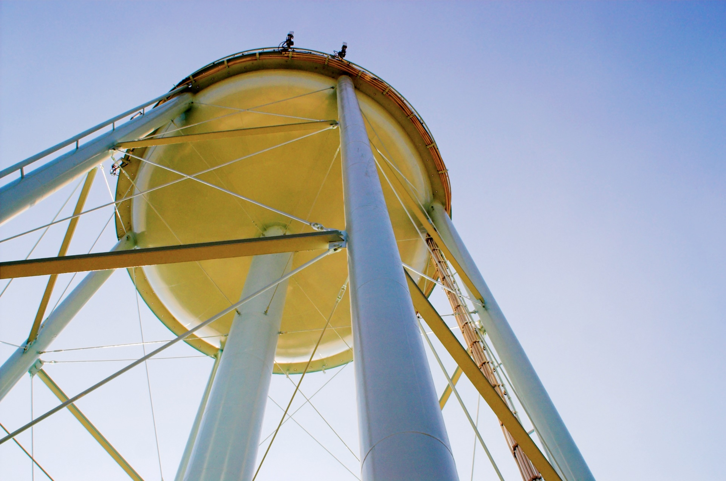

**Infrastructure Stability for Rural and Small Systems**

Now that you have completed your *Rural and Small Systems* “Self-Assessment” exercise and determined that Infrastructure Stability is important to your utility, this handout can help you get started on improving your Infrastructure Stability practices. It describes some of the key “Building Blocks” of infrastructure success for small utilities, giving you a starting place to improve utility infrastructure practices. The handout also includes specific suggestions on how to measure a utility’s infrastructure stability, and lists a number of free resources with practical information on how to improve practices. Successful Infrastructure Stability management is also highly dependent on successful management of a utility’s finances. A complementary handout for Financial Viability is also available from USDA and EPA as a part of this resource series. For more information on the Infrastructure Stability management area, please refer to the *Rural and Small Systems Guidebook to Sustainable Utility Management*.

Infrastructure Stability is all about asset management. The goal is to provide an operationally stable and financially viable system at the least feasible cost. The intent of an asset management program is to improve and/or stabilize the condition of physical assets with the with the appropriate amount of expenditures. Timely maintenance is an integral part of an effective asset management program and can renew the asset condition and prolong its life.

**INFRASTRUCTURE STABILITY: The system understands the condition and costs associated with its critical infrastructure assets. It inventories its system components, conditions, and costs, and has a plan in place to repair and replace these components. It maintains and enhances the condition of all assets over the long-term at the lowest possible life-cycle cost and acceptable level of risk.**

*— Rural and Small Systems Guidebook to Sustainable Utility Management*

**Additional Information**

**EPA website:** <https://www.epa.gov/sustainable-water-infrastructure/tools-effective-water-and-wastewater-utility-management>   
**USDA website:** <https://www.rd.usda.gov/programs-services/services/sustainable-management-tools>

**Building Blocks of Infrastructure Stability**

**HOW CAN ASSET MANAGEMENT HELP YOUR SYSTEM REACH SUSTAINABILITY?**

**________________________**

**COST EFFICIENCY:** Cost savings are achieved when assets are identified, tracked, and proactively managed to stabilize infrastructure, reduce unexpected costs, and utilize effective financial planning.

**RELIABILITY:** System reliability is achieved when water systems can anticipate, prepare for, and make contingency plans for critical asset failures. Asset management ensures that customers can rely on consistent service and access to assets, and that a water system has the ability to adapt to changing needs.

**COMMUNICATIONS:** Proactive asset management helps systems effectively communicate challenges and solutions to customers, which helps maintain customer satisfaction and protect human health in the event that assets fail or maintenance activities impact users.

*Source: Top Three Reasons to Support & Implement Asset Management at Your Water System (EPA/USDA)*

**Asset Inventory System**

To maintain and improve the infrastructure in a system, it is important to first identify and understand all of the parts in the system. Start with a complete catalogue of assets—e.g., pumps, treatment systems, buildings, etc.—and record the condition of these assets. The condition of an asset will help in predicting the remaining lifespan of the asset and planning for upgrades or repairs.

• Create an inventory of assets, including determining the current condition and predicted lifespan of each asset

**EXAMPLE  
ACTIVITIES**

• Create a standardized inventory checklist, and train all employees on inventory procedures

• Develop a routine for recording and updating the utility inventory on a regular basis

**System Monitoring**

Monitoring certain kinds of utility data provides important information on the condition of utility assets. This is especially important for assets which are difficult to visually inspect. Systems which regularly monitor data can better judge the condition of non-visible assets, and see if repairs are becoming more common or less common within the utility.

• Conduct inflow and infiltration (I&I) or water loss analyses to identify leakages in pipes

**EXAMPLE  
ACTIVITIES**

• Monitor and record annual breakages in pipes

• Track the frequency and cause of repeat maintenance problems

• Conduct an energy assessment to determine the energy use of each part of the system

**Asset Management Plan**

With the information gathered from inventories and data monitoring systems, a utility has a chance to make a proactive plan to improve their assets. An asset management plan combines the current conditions of assets, the predicted lifespans of assets, and the predicted repair/upgrade costs together to create a plan to prioritize and repair assets as needed. The asset management plan will help with this financial planning by providing information on future costs, making it easier to calculate necessary rates for operating and maintaining the utility’s assets.

* Identify aging and high-priority systems, and create a plan for maintenance/repairs/upgrades

**EXAMPLE  
ACTIVITIES**

* Predict maintenance and upgrade costs and incorporate these costs into financial plans
* Coordinate asset repair with other community repairs and projects (e.g., road maintenance)

**Measures**

To gather information on asset condition and maintenance requirements, it is necessary to use the measures most appropriate to the utility goals. Below are several measurement areas, with specific example metrics for each area.

**Asset Inventory**

These measures allow utilities to better know how far along they are in the inventory process. These metrics function as first-steps for a larger inventory improvement plan.

* Inventory completeness rate: total number of critical assets inventoried ÷ total number of critical assets owned and powered

**EXAMPLE  
Metrics**

* Condition assessment coverage: total number of critical assets assessed and categorized (in a time period) ÷ total number of critical assets

**System Renewal/Replacement**

This measure provides information on asset renewal rates over time. The measure should incorporate utility goals and the acceptable levels of risk for different kinds of assets.

* Asset replacement rate: total number of key assets replaced per year ÷ total number of key assets

**EXAMPLE  
Metrics**

* Asset fund replacement rate: estimate replacement cost of key assets ÷ total dollar amount in asset replacement reserve fund

**Water Distribution/Collection System Condition**

This measure offers information on the number of breaks or leaks. The condition of a distribution or collection system is important for public health, customer service, financial viability, and asset management.

* Leakage or breakage frequency rate: total number of leaks (or breaks) per year ÷ total miles of distribution piping

**EXAMPLE  
Metrics**

* Service outage rate: hours or number of (unplanned) service disruptions per year ÷ total number of operation hours

**Infrastructure Planning & Maintenance**

Planned maintenance is preventative and predictive maintenance, but does not include reactive maintenance (i.e., repairs in response to a system failure). Planned maintenance is performed by a regular schedule and predictive maintenance is performed when certain warning signals are triggered.

* Planned maintenance ratio by hours: hours of planned maintenance ÷ (hours of planned + reactive maintenance)

**EXAMPLE  
Metrics**

* Planned maintenance ratio by cost: cost of planned maintenance ÷ (cost of planned + reactive maintenance)

**Example Practices for Infrastructure Stability at Rural and Small Systems**

*The practices listed below are drawn from the* [Rural and Small Systems Guidebook](https://www.rd.usda.gov/files/RuralandSmallSystemsGuidebook2016.pdf) *and the* [Moving Toward Sustainability Roadmap](https://www.epa.gov/sites/production/files/2016-01/documents/sustainable-utilities-roadmap-12-10-14_508.pdf) *document. They are examples of practices that utilities have implemented to improve their performance in the area of Infrastructure Stability.*

|  |  |  |
| --- | --- | --- |
| Establish emergency maintenance procedures. | Support ongoing training and certification/licensing requirements for maintenance staff. | Create photographic documentation of assets to compare conditions over time. |
| Track operating system parameters (e.g., pressure). | Link maintenance requests/work orders to asset inventory. | Map critical infrastructure/assets (e.g., GIS-located mains, hydrants, valves). |

**Resources**

Highlighted below are several practical and free resources that provide information for utilities on how to improve Infrastructure Stability. For a longer list of resources covering more information on specific areas of utility management, please see the ***Rural and Small Systems Guidebook to Sustainable Utility Management: Appendix III*.**

<https://www.rd.usda.gov/files/RuralandSmallSystemsGuidebook2016.pdf>

**Capital Improvement Plan (CIP) Tool for Water and Wastewater Utilities**

This tool is a starting place for small utilities to create easy-to-understand CIPs. The tool includes example data, and helps utilities think about the connections between rate increases, financial reserves, and capital investment.

<http://www.efc.sog.unc.edu/project/capital-planning-resources-water-and-wastewater-utilities>

**Check Up Program for Small Systems (CUPSS) Asset Management Tool**

CUPSS is a free, easy-to-use asset management tool for drinking water and wastewater utilities. It can help you keep a record of your assets, schedule required tasks, better understand your financial situation, and create a tailored asset management plan.

<https://www.epa.gov/dwcapacity/information-check-program-small-systems-cupss-asset-management-tool>

**Getting Your Project to Flow Smoothly: A Guide to Developing Water and Wastewater Infrastructure**

This is a comprehensive guide to running an infrastructure project, designed for a project manager or utility board member. The advice is thorough enough to provide clear directions for each phase of a project, though specific details will vary between utilities and projects.

<https://rcap.org/wp-content/uploads/2016/01/RCAP-Getting-Your-Project-to-Flow-Smoothly.pdf>

**Sustainable Infrastructure for Small System Public Services**

This planning and resource guide provides worksheets, examples, case studies, and resources on water conservation, energy efficiency, and renewable energy for small utilities. It is designed for small utility leaders who are seeking to save on operating costs. It also includes a step-by-step process for utility decision-makers wanting to operate increasingly efficient systems.

<http://www.map-inc.org/uploads/5/2/2/1/52214049/rcap-sustainable-infrastructure-guide.pdf>

**Taking Stock of Your Water System: A Simple Asset Inventory for Very Small Drinking Water Systems**

This is an EPA brochure with detailed information and sample forms on how to conduct an asset inventory. The brochure is designed for small water systems, and helps create a standardized approach to asset inventories.

<https://www.epa.gov/sites/production/files/2015-04/documents/epa816k03002.pdf>

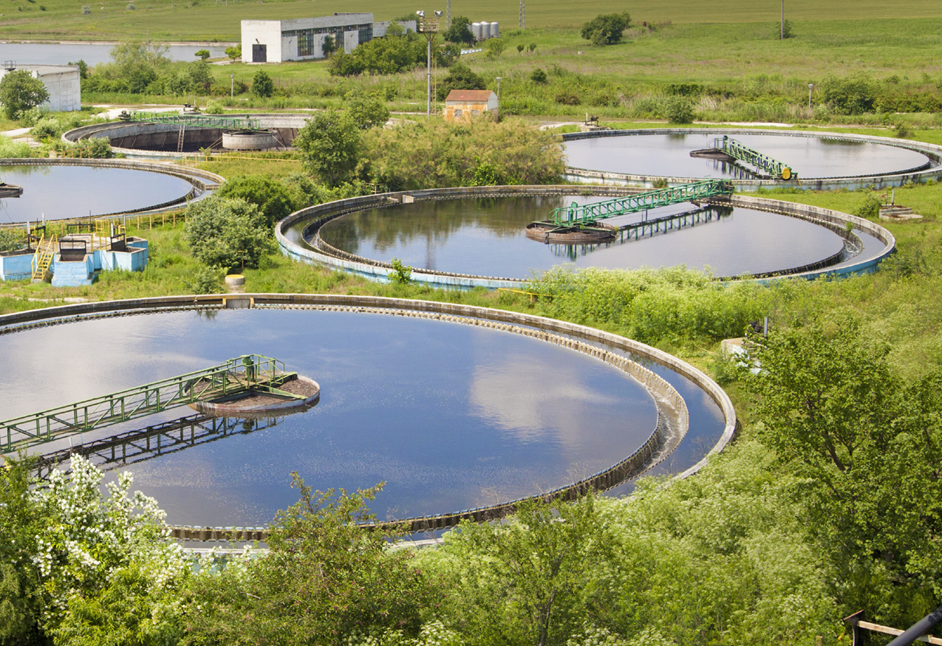



# Acknowledgements

## Steering Group

|  |  |
| --- | --- |
| **Tom Anthony**  *Village of Mattawan, Michigan* | **Jeremy Montes**  *Sunset Beach Mutual Water Company*  *Watsonville, California* |
| **William Austin**  *City of Riceboro, Georgia* | **Mike Murphy**  *Forest Springs Improvement and Maintenance Association – Boulder Creek, California* |
| **John Hamner**  *RCAC – West Sacramento, California* | **Mitsy Peterson**  *USDA* |
| **John Holland**  *City of Clare, Michigan* | **Rod Wilson**  *City of Zebulon, Georgia* |

## Collaborating Organizations

|  |  |
| --- | --- |
| Jim Horne *U.S. EPA* | **Jacqueline Ponti-Lazaruk**  *USDA* |
| **LaVonda Pernell**  *USDA* | **Sonia Brubaker**  *U.S. EPA* |
| **Joyce Hudson**  *U.S. EPA* | **Carolyn Hayek** *U.S. EPA* |
| **Allison Martin**  *ORISE Participant, U.S. EPA* | **Matthew Richardson** *U.S. EPA* |

**This product was originally developed in 2016 and updated in 2019, with assistance from Rob Greenwood, Morgan Torres, and Heather Martin with** [**Ross Strategic**](http://www.rossstrategic.com)**.**

circular-graphic.emf

***USDA is an equal opportunity provider, employer, and lender.***