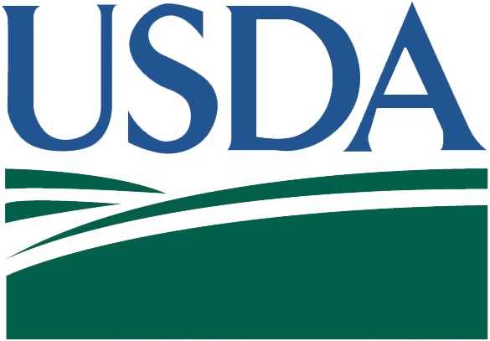
SIGN DIMENSIONS: 1200 mm x 2400 mm x 19 mm (approx. 4’ x 8’ x ¾”)

Plywood Panel (APA RATED A-B GRADE–EXTERIOR)

Project Title
Sponsor / Developer
Contractor
USDA is an equal opportunity provider, employer, and lender.

WHITE BACKGROUND
BLACK
LETTERING
BLACK LETTERING
Official(s) or Sponsor Address
Architect or Engineer
(second line)
(second line)
Lettering
(GREEN, PMS 343)
Rolling fields
(GREEN, PMS 343)

SYMBOL LETTERS
(BLUE, PMS 288)

Financed by United States Department of Agriculture (USDA) Rural Development
United States Department of Agriculture

Donald J. Trump, President of the United States
Sonny Perdue, Secretary of Agriculture

