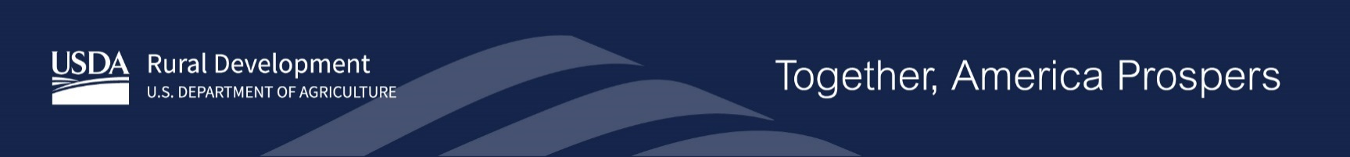

Stakeholder Announcement
USDA Seeks Partnerships to Help People in Rural America Build and Improve Water and Waste Systems in Their Homes
WASHINGTON, April 24, 2024 – U.S. Department of Agriculture (USDA) Rural Development Under Secretary Dr. Basil Gooden today invited applications to partner with organizations to ensure people in rural areas have access to clean drinking water and modern wastewater systems.
USDA is making the funding available for qualified nonprofits and Tribes under the Rural Decentralized Water Systems Grant Program.
Qualified nonprofits and Tribes may use the grants to create lending opportunities for people in rural areas seeking to build, refurbish, or service water well and septic systems in their homes or on their properties. Up to $15,000 in loans are available for each project.
When necessary, up to 50% of the awarded funds may be used as a subgrant. Subgrants can be used to help reduce the cost burden to the homeowner. Up to $15,000 in subgrants are available for each project.
Approximately $5,000,000 in funding will be available for fiscal year 2024. An additional $1,000,000 will be available for applications that directly support individually owned, household decentralized wastewater system subgrants. All applicants are responsible for any expenses incurred in developing their application.
Applications must be submitted electronically using Grants.gov no later than 11:59 p.m. Eastern Time on June 28, 2024.
USDA is particularly interested in applications that will advance Biden-Harris Administration priorities to:
- Reduce climate pollution and increase resilience to the impacts of climate change through economic support to rural communities.
- Ensure all rural residents have equitable access to Rural Development (RD) programs and benefits from RD-funded projects.
- Help rural communities recover economically through more and better market opportunities and through improved infrastructure.
Additional information on these key priorities is available at https://www.rd.usda.gov/priority-points.
To subscribe to USDA Rural Development updates, visit GovDelivery subscriber page.

###
USDA is an equal opportunity provider, employer and lender.

