PART 2006 – MANAGEMENT

Subpart SS – Rural Development Physical Security – Signage

§ 2006.2201 General.

(a) Signage is an integral part of physical security, keeping our employees, customers, data, and facilities, secure while performing the mission of Rural Development (RD).

(b) The proper display of official signs of a prohibitory, regulatory, or directory nature increases each office’s overall physical security posture.

(c) Persons in and on federal property must always comply with official signs of a prohibitory, regulatory, or directory nature and with the lawful direction of Federal police officers and other authorized individuals.

§ 2006.2202 Authorities and References.

(a) Title 41, Code of Federal Regulations, Part 102-74, Subpart C, Conduct on Federal Property.

(b) Interagency Security Committee, Risk Management Process, Appendix B; Countermeasures, 2021 For Official Use Only (FOUO). Government users with a need to know may request access by sending an email to ISCAccess@hq.DHS.gov with your full name and contact information, including email, the name of your agency, and the reason you need access.

§ 2006.2203 Applicability and Scope.

(a) This RD Instruction identifies procedures to properly display official signs of a prohibitory, regulatory, or directory nature for each RD office.

(b) These procedures provide necessary guidance and assign responsibilities to each RD office to properly display official signs of a prohibitory, regulatory, or directory nature in accordance with this instruction. Aligning this instruction with each office’s overall physical security posture will help to protect personnel, property, and equipment within individual offices.

§ 2006.2204 Applying the Standard.

Physical Security is a primary supervisory responsibility. The RD State Directors are responsible for appropriate physical security measures necessary to protect USDA personnel, facilities, and assets. This policy establishes procedures to properly display official signs of a prohibitory, regulatory, or directory nature for each RD office. The RD Building Management Specialist in coordination with the Enterprise Office, Security, Safety and Emergency Management Division (SSEMD) is responsible for posting signs at the Business Center facility in St. Louis, MO. The USDA Office Safety, Security and Protection (OSSP) is responsible for signage in the South and Whitten Buildings in Washington, DC.

§§ 2006.2205 – 2006.2250 [Reserved]

Attachments: Exhibits A, B, C, D, and E.

o0o

Weapons Prohibited Sign

Posting Requirements: Prominently display on all entry doors. If in a commercial building it should be displayed on all doors to RD space.
o0o

Employees Only Sign

Posting Requirements: Prominently display on all doors/entry ways leading from customer or public space into employee space.

o0o

Federal Management Regulation GSA Sign

Posting Requirements: Prominently display in lobbies or if in a commercial building it should be displayed on all doors to RD space and visible by RD visitors.

o0o

Restricted Area Sign

Posting Requirements: Prominently display in accordance with local laws and where necessary (i.e., Inside Service Center areas where customers do not need access; Storage sheds; Motor pools; etc.). If posted on an IT/ADP Room, ensure the sign does not identify the room as the IT/ADP Room.

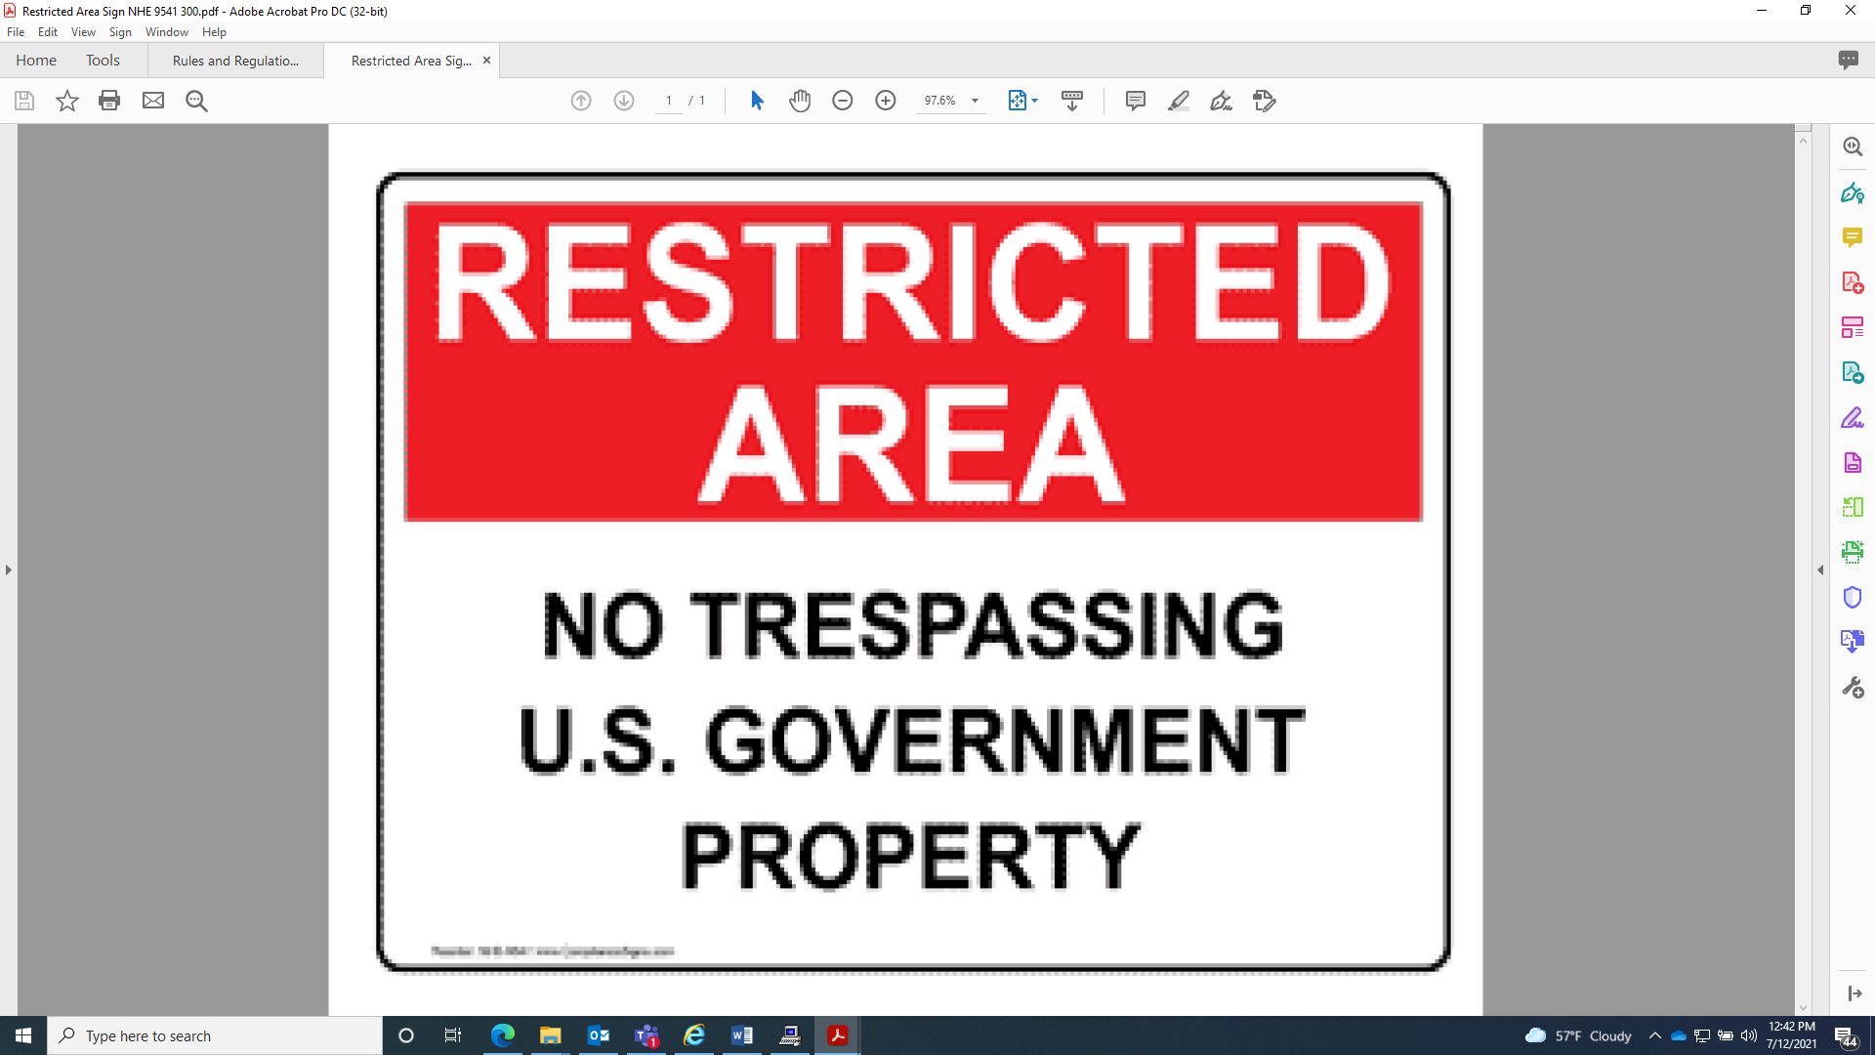

o0o

Video Surveillance Sign

Posting Requirements: If a video surveillance system is in operation, prominently display in lobbies or if in a commercial building it should be displayed on all doors to RD space and visible by RD visitors.

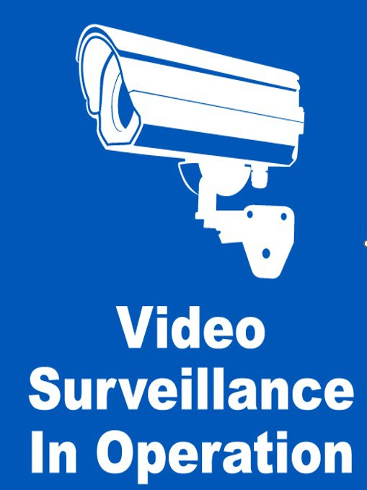

o0o

