SIGN DIMENSIONS: 1200 mm x 2400 (approx. 4’ x 8’ x ¾”)
Plywood Panel (APA RATED A-B GRADE–EXTERIOR)

Project Title
Sponsor / Developer
Contractor
Official(s) or Sponsor Address
Architect or Engineer
(second line)
(second line)

WHITE BACKGROUND

symbol letter
(Blue, pms 288

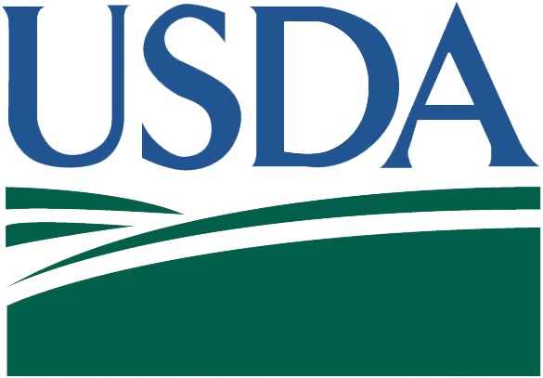
United States Department of Agriculture

SIGNATURE LETTERS
BLACK

BLACK
LETTERING
SYMBOL FIELDS
(GREEN, PMS 343
CDBG

BLACK

Community Development Block Grant


Pantone7450
CMYK: 0/0/0/72

Project Financed by:
United States Department of Agriculture (USDA) Rural Development
Community Development Block Grant
Iowa Economic Development Authority

Pantone7450
CMYK: 0/0/0/72
PANTONE 390
CMYK: 22/0/100/8

Joseph R. Biden, President of the United States
Thomas J. Vilsack, Secretary of Agriculture
Kim Reynolds, Governor

Pantone7450
CMYK: 0/0/0/72

USDA is an equal opportunity provider, employer, and lender.

