



__________________________

ELECTRONIC STATUS AND DEFAULT STATUS REPORTING (esr) USER GUIDE

June 2025

Table of Contents

1 Introduction 3

1.1 About the USDA LINC 3

1.2 Security 3

2 Logging in to ESR 4

2.1 eAuthentication ID 4

2.2 Logging in to ESR 4

2.3 eAuthentication Help 4

3 Electronic Data Interchange 5

3.1 About SFH Electronic Data Interchange Reporting 5

3.2 Sending SFH X12 Files 5

3.3 Displaying SFH 997 Files 6

4 SFH Web Reporting Help 6

4.1 Entering Monthly Status Reports 7

4.2 Reviewing Monthly Status Reports 9

4.3 Modifying Monthly Status Reports 9

4.4 Deleting Monthly Status Reports 10

4.5 Submitting Monthly Status Reports 10

4.6 Entering Monthly Default Status Reports 11

4.7 Reviewing Monthly Default Status Reports 12

4.8 Modifying Monthly Default Status Reports 12

4.9 Deleting Monthly Default Status Reports 12

4.10 Submitting Monthly Default Status Reports 13

5 SFH Electronic Status Report (ESR) Corrections 13

5.1 Logging in to Electronic Status Reporting Corrections 13

5.2 Lender Contact Maintenance 14

5.3 Search Rejected Records (Lender) 15

5.4 Lender Investor Status Error Corrections 16

5.5 Lender Investor Status Reject Errors 21

5.6 Lender Default Status Error Corrections 23

5.7 Lender Default Status Reject Errors 26

5.8 Default Status Codes and Usage 29

5.9 Default Status Codes and Usage 38

6 Contact US 40

Revision History

|  |  |  |
| --- | --- | --- |
| **Date** | **Page** | **Description** |
| Oct. 2018 | 60 | Moved Status Code 47 from the Bankruptcy Section (AB) to the Foreclosure Section (AF). It was mistakenly placed in the AB section in this guide only. |
| Oct. 2021 | 5-23 | Removed all pages and revised login and eAuth instructions on page 4 |
| Oct. 2021 | 48 | Moved error code MAO3515 to page 22 |
| Oct. 2021 | 58,59 | Moved Status Code 17, 47 to page 29,30 |
| Oct. 2021 |  | Added status reason codes on page 33 |
| July 2022/  2023 |  | Added new default codes/added new status reason codes/added new status and default rejects. |

# Introduction

## About the USDA LINC

The USDA Lender Interactive Network Connection (LINC) is an interactive system on the internet

that provides approved Rural Housing Service (RHS) lenders access to RHS systems for the

purpose of reporting status reports. Rural Housing Service (RHS) is committed to implementing direct computer application-to-computer application exchange of standardized information between private industry and RHS. Electronic Data Interchange (EDI) was introduced to RHS in 1996 making it easier for servicing lenders to fulfill their guaranteed loan reporting requirements and for RHS to collect and manage reported loan status

information. The growing guaranteed loan program makes it essential that RHS has access to current loan status

and delinquency information to better monitor lender performance and overall program results.

In order to better monitor lender performance and overall program results, USDA requires the servicing lender’s tax ID to be reported on the monthly loan statuses and monthly loan default statuses. RHS electronic reporting options will allow lenders to either send ANSI X12 files via batch integration techniques and the Internet, or use web pages designed for entering transactions manually.

If you are a lender with less than 100 loans, you may:

* enter on-line monthly status reports on the Web Reporting Input screens,
* review on-line monthly status reports,
* enter on-line monthly default status reports on the Web Reporting Input screens, and
* review on-line monthly default status reports; or
* Use EDI as described below.

If you are a lender with 100 or more loans, you will:

* send EDI X12 files for transaction set (TS) 203, Secondary Mortgage Market Investor Report, and for TS 264, Mortgage Loan Default Status
* view and print the EDI X12 File Transfer Confirmation page,
* retrieve EDI X12 transaction file receipts for TS 203 and TS 264 via EDI,
* determine if the transferred EDI X12 file was accepted, and
* retrieve EDI X12 transaction files that were not accepted.

Lenders will use USDA LINC on the Internet as the starting point for reporting monthly portfolio reports and monthly default status reports. USDA LINC website can be accessed at <https://usdalinc.sc.egov.usda.gov> and contains the Electronic Status Reporting (ESR) link. The ESR link will navigate to the web pages allowing the lender to either manually update the monthly loan status and monthly loan default status information or send the information via EDI ANSI ASC X12 file.

## Security

RHS takes security very seriously due to the sensitivity of the data electronically shared and the threat of compromised web sites. RHS uses multiple mechanisms, each building on the other to create a very secure environment. Two of the security mechanisms we utilize have a direct impact on the trading partners.

First, the web browser on the PC that you use to access the USDA LINC web site must support 128-bit encryption using Secure Socket Layer. Encryption scrambles the data sent so that no one except the intended recipient can read the confidential data.

Secondly, before an organization can sign into the Electronic Status Reporting (ESR) system, the organization will need to be set up with permissions for ESR. The organization will need to complete a [Trading Partner Agreement](https://www.rd.usda.gov/programs-services/lenders/usda-linc-training-resource-library#esr) with USDA Rural Development. In this agreement one or more Lender Administrators are identified. Each Lender Administrator and all other users needing access to ESR are required to obtain an e-Authentication ID and required to have an e-Authentication Level 2 account. USDA will set up Lender Security Administrators for ESR access. Lender Security Administrators will be required to set up access permissions for users in their organization, after the user obtains an e-Authentication ID. Detailed information on obtaining an e- Authentication ID is located in the [**SFHGLP System Access and Security Guide**](https://www.rd.usda.gov/sites/default/files/rd-sfh-systemaccessandsecurityguide.pdf) in the Training and Resource Library <https://www.rd.usda.gov/resources/usda-linc-training-resource-library>.

# Logging in to ESR

## eAuthentication ID

All users including Security Administrator’s (SA) must have a “Verified Identity” eAuthentication ID and password. The financials organization SA will appoint roles to staff to access ESR accordingly. See the [**SFHGLP System Access and Security Guide**](https://www.rd.usda.gov/sites/default/files/rd-sfh-systemaccessandsecurityguide.pdf) in the Training and Resource Library <https://www.rd.usda.gov/resources/usda-linc-training-resource-library> for further guidance on creating an eAuthentication ID, managing ID’s, and the AASM system.

## Logging in to ESR

Visit <https://usdalinc.sc.egov.usda.gov/RHShome.do> . Click on Electronic Status Reporting (ESR). 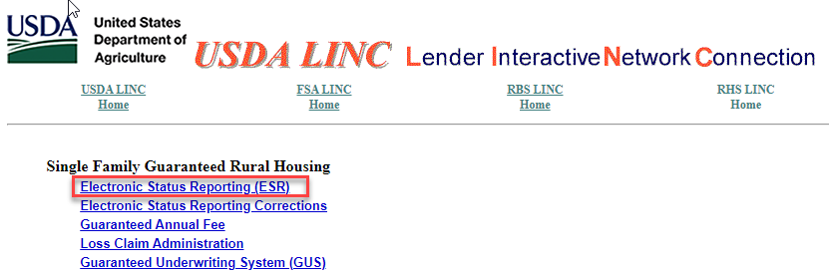

Enter your current eAuthentication User ID and Password and click Login

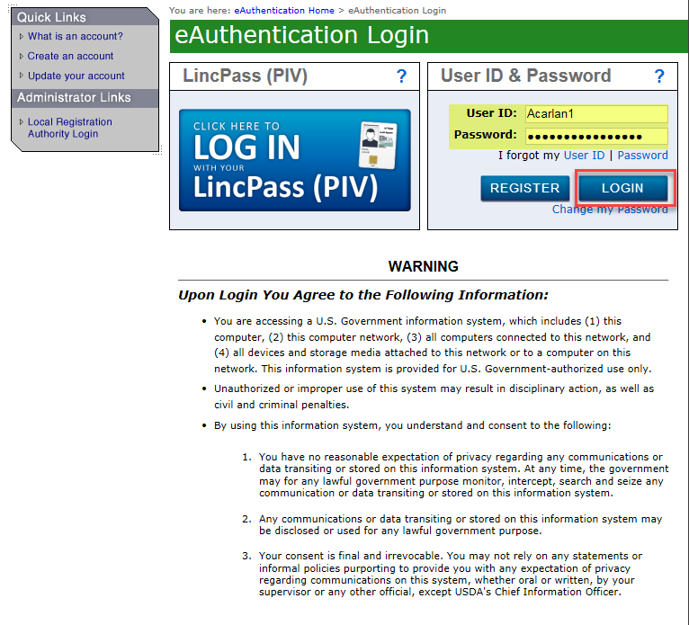

## eAuthentication Help

* Contact eAuthentication - <https://www.eauth.usda.gov/eauth/b/usda/contactus>
* FAQ’s - <https://www.eauth.usda.gov/eauth/b/usda/faq>

# Electronic Data Interchange

## About SFH Electronic Data Interchange Reporting

Lenders with 100 or more loans must submit their loan status information via electronic Data Interchange (EDI) files for their Electronic Status Reporting (ESR) reporting requirement. Lenders with less than 100 loans may opt for web based reporting. (See Web Reporting Help document).

EDI is the exchange of standardized information by computer application-to-computer application between private industry and Rural Housing Service (RHS). This exchange is accomplished by accessing the USDA Lender Interactive Network Connection (LINC) Electronic Status Reporting web pages.

Note: For more information about electronically exchanging business documents with RHS using the X12 file format, access the Electronic Status Reporting Electronic Data Interchange Implementation Guide located on the [USDA LINC Training and Resource Library](https://www.rd.usda.gov/programs-services/lenders/usda-linc-training-resource-library).

At this time, the standardized information we are exchanging is guaranteed loan monthly status and monthly default status information. Loan Servicers are required to report the status of all loans on a monthly basis using the EDI Transaction Code 203 (Secondary Mortgage Market Investor Report ) ANSI X12 file and a monthly default status report for all delinquent loans that are 30 days or more past due using the EDI Transaction Code 264 (Mortgage Loan Default Status) ANSI X12 file.

Note: A loan is delinquent if it is 30 or more days past due. For example: A loan is considered 30 days delinquent if the June 1st installment has not been paid as of June 30th. A loan is 60 days delinquent if the May 1st installment has not been paid as of June 30th.

The USDA LINC, Rural Housing Service page is the starting point for Electronic Status Reporting, whether you are using EDI or Web Reporting. The menus on the USDA LINC Electronic Status Reporting page into 2 major sections with 2 additional sections under each major section. Below is the menu layout.

1. EDI Reporting

* Send X12 File
* Retrieve 997 File

1. Web Reporting
   * Monthly Status
   * Monthly Default Status

## Sending SFH X12 Files

Once you have accessed the USDA LINC, click on the Send X12 file link in the left navigation bar. Click on the Browse button to locate the EDI file you are sending. You can send EDI X12 transaction sets (TS) 203, Secondary Mortgage Market Investor Report, and TS 264, Mortgage Loan Default Status to the EDI translator. You can send TS 203 and TS 204 in the same X12 file. Note: An X12 file cannot exceed 100 megabytes.

1. Click the ***Submit Transmission*** button after the file you will send is selected.

**HELPFUL HINT:**

If you click ***Browse***, you will receive a dialog box that either:

* Contains a dropdown list that allows you to select (double click) a file from any drive available on the Desk Top or Laptop executing the page. Click ***OPEN*** to display the file name on the Send EDI X12 Files page, or
* Contains a File Name box that allows you to type in the file name or select (double click) a file name from the list. Click ***OPEN*** to display the file name on the Send EDI X12 Files page.

1. Click ***Submit Transmission***. The Send EDI X12 File Transfer Confirmation page is displayed. Print this page for your files.
2. Wait one hour and then access the Lender Retrieve 997 Screen to verify that the translator has accepted the file.

## Displaying SFH 997 Files

The TS 997 (Functional Acknowledgment) informs the lender if the translator accepted the transferred EDI X12 file. If the translator did not accept the file, TS 997 details all errors that exist in the X12 file. Once you have accessed the USDA LINC Electronic Status Reporting application, you will be able to display TS's 997 for TS 203, Secondary Mortgage Market Investor Report, and TS 264, Mortgage Loan Default.

1. On the Electronic Status Reporting home page, the following navigation options are available on the left navigation bar.

• Send X12 File

• Retrieve 997 File

1. Click Retrieve 997 File. The Lender Retrieve 997 Screen is displayed. All TS's 997 created for X12 files that have been transferred during the previous six calendar months are displayed. TS's 997 are deleted when the current date is the same as the date of the file plus six months and one day. For example, a file dated 1/31/2017 would be deleted 08/01/20.

**HELPFUL HINTS:**

* The TS 997 file names correspond to the assigned names on the Send EDI X12 File Transfer Confirmation page.
* If you do not receive an X12 TS 997 within one hour after your submission, please contact the Lender Reporting Branch at 877-636-3789 or email them at [rd.so.hsb@usda.gov](mailto:rd.so.hsb@usda.gov)

# SFH Web Reporting Help

Only lenders/servicers with less than 100 loans should use the Web Reporting input pages to submit guaranteed loan status and mortgage loan default status information. Loan status reporting for all loans and reporting for all delinquent loans is required on a Monthly basis.

Example: A loan is delinquent if it is 30 or more days past due. For example: A loan is considered 30 days delinquent if the June 1st installment has not been paid as of June 30th. A loan is 60 days delinquent if the May 1st installment has not been paid as of June 30th.

The USDA LINC, Rural Housing Service page is the starting point for Electronic Status Reporting, whether you are using EDI or Web Reporting. The menus on the USDA LINC Electronic Status Reporting page into 2 major sections with 2 additional sections under each major section. Below is the menu layout.

1. EDI Reporting

* Send X12 File
* Retrieve 997 File

1. Web Reporting
   * Monthly Status
   * Monthly Default Status

## Entering Monthly Status Reports

Once you have accessed the USDA LINC, Electronic Status Reporting application, you can continue with Web Reporting using the left hand navigation bar. You are required to report on your entire Rural Development portfolio on a Monthly basis.

1. Access the USDA LINC, Electronic Status Reporting application.
2. Click ***Monthly Status Report*** in the left navigation section. The Monthly Status Reports page is displayed.

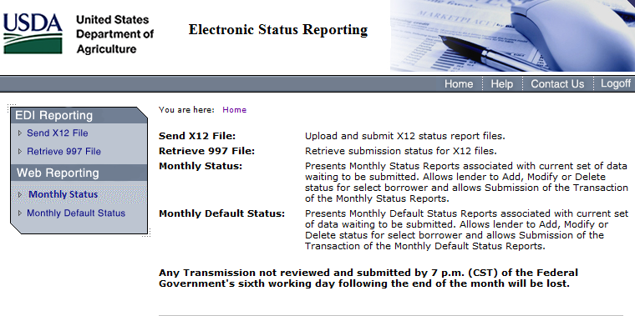

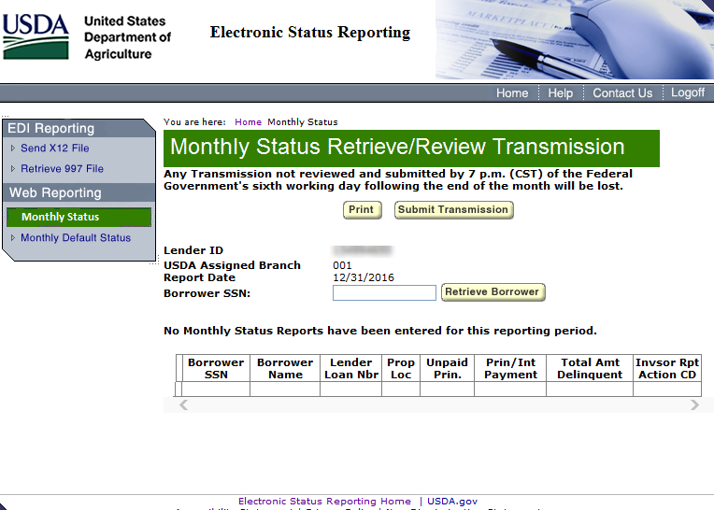

1. For borrowers whose status information is being entered on the Web Reporting input page for the first time:
   1. Enter the Borrower's SSN and click ***Retrieve Borrower***. The Monthly Status Reports page is redisplayed with the message" Borrower was not included in previous Monthly reporting cycle. Please enter data."
   2. Complete the following fields. Click ***Select*** for Property Location and Investor Reporting Action Code. Drop down lists display valid property locations and investor reporting action codes.

**Input Field: Definitions:**

Borrower Last Name Borrower's Last Name

Borrower First Name Borrower's First Name

Borrower Middle Initial Borrower's Middle Initial

Property Location State where Property is located

Lender Loan Number Lender Loan Number

Unpaid Principal This is the unpaid principal balance owed on the loan

Principal/Interest This is the principal and interest installment. Do **not** include taxes and insurance.

Total Amount Delinquent This is the principal and interest past due.

Investor Reporting Action Code Select the appropriate Investor Reporting Action

Code from the dropdown list.

01 – Active

02 – Loss Pending

09 – Paid in full, Charge Off, Third Party Sale or Redemption Paid in Full

10 – Servicing Transfer

“To fully terminate/close out a SFHGLP loan is a two-step process. The process must be done regardless if loan is paid in full, charged off, sold to third party, or redeemed, etc. This process includes termination of the guaranteed annual fee (GAF) (with appropriate termination reason depending on loan status) in the SFHANLFEES system **and** loan reporting (payoff or loss pending depending on loan status) in the ESRSFH system”

**NOTE***: A loan is delinquent if it is 30 or more days past due for all months* ***except February****. For example: A loan is considered 30 days delinquent if the June 1st installment has not been paid as of June 30th. A loan is 60 days delinquent if the May 1st installment has not been paid as of June 30th.*

***For February****: A loan is considered delinquent if the February 1st installment has not been paid as of February 28th, except in a leap year, the installment would be due on the 29th.*

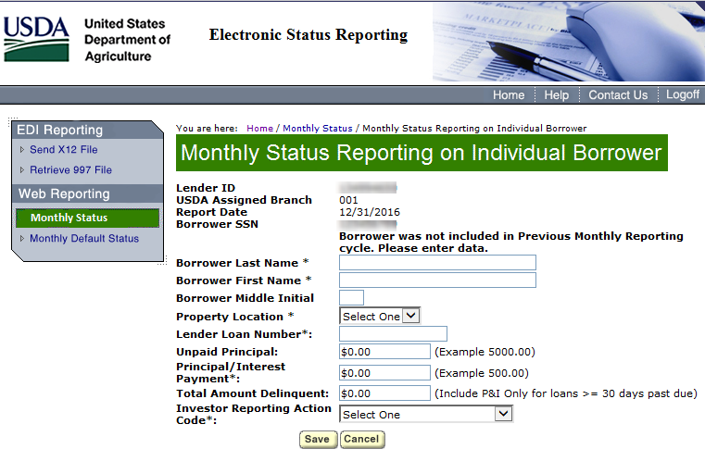

Click **Save.** If this borrower is not the last borrower in your portfolio that has not been previously reported, proceed back to step 3. Once all borrower's that have not been previously reported are entered, you should be at the Monthly Status Retrieve/Review Transmission screen. You will need to review each loan in the list for all loans previously reported by click Mod on the Monthly Status Retrieve/Review Transmission screen.

Reports page is displayed with the input status data. Refer to the Help for reviewing, modifying, deleting, and/or submitting Monthly status reports, if needed.

1. Repeat steps 3a-3c for each first time borrower, or to enter Monthly status reports for borrowers who were previously updated on the Web Reporting pages refer to Step 3e below.

For borrowers who had status information previously updated on the Web Reporting pages:

1. Enter the Borrower SSN and click ***Retrieve Borrower***. The Monthly Status Reports page is redisplayed with the message "The following fields have been prefilled from the prior Monthly status report. Please verify prefilled fields and complete blank items for this reporting period."
2. Complete the Unpaid Principal and Total Amount Delinquent input fields. Refer to step 3b for an explanation of these fields.
3. Click ***Next Borrower***. A new Monthly Status Reports page is displayed. If this borrower is not the last borrower in your portfolio, proceed to step 3h. If this is the last borrower in your portfolio, click ***Review Transmission***. The Review Monthly Status Reports page is displayed with the input status data. Refer to the Help for reviewing, modifying, deleting, and/or submitting Monthly status reports, if needed.
4. Repeat steps 3e through 3g for each borrower, or to enter Monthly status reports for first time borrowers refer to Step 3a above.

## Reviewing Monthly Status Reports

You can review current statuses *that have not been transmitted* by accessing the Review Monthly Status Reports page. You must also submit your statuses for transmission from this page.

Click ***Review Transmission*** on the Monthly Status Reports page. All status reports that were entered on the Monthly Status Reports page are displayed on the Review Monthly Status Reports page. The status reports are sorted by borrower social security number and displayed in ascending numerical order.

**HELPFUL HINT:** If you click ***Submit Transmission***, you cannot review, modify, or delete any statuses you just entered. Please be sure to make all modifications and/or deletions before you click ***Submit Transmission***.

## Modifying Monthly Status Reports

You can modify information for current statuses *that have not been transmitted* by accessing the Review Monthly Status Reports page. You also submit your statuses for transmission from this page.

1. Click ***Review Transmission*** on the Monthly Status Reports page. All status reports that were entered on the Monthly Status Reports page are displayed on the Review Monthly Status Reports page. The status reports are sorted by borrower social security number and displayed in ascending numerical order.
2. Click ***Mod*** (Modify) next to the borrower's status report that you want to modify. The Monthly Status Reports page for the selected status report is displayed with the data prefilled.
3. You can modify any of the fields listed below. All other data fields are protected.
   * Borrower Name
   * Property Location
   * Lender Loan Number
   * Unpaid Principal
   * Principal/Interest Payment
   * Total Amount Delinquent
   * Investor Reporting Action Code.
4. Click ***Update Modification***. The Review Monthly Status Reports page is redisplayed with the corrected data.
5. Repeat steps 2, 3, and 4 for all modifications.
6. After you have entered, reviewed, modified, and/or deleted your Monthly status report data for your entire portfolio, you are ready to submit the Monthly status reports for transmission. Access the Review Monthly Status Reports page to submit the Monthly status reports.

## Deleting Monthly Status Reports

You can delete current statuses *that have not been transmitted* by accessing the Review Monthly Status Reports page. You also submit your statuses for transmission from this page.

1. Click ***Review Transmission*** on the Monthly Status Reports page. All status reports that were entered on the Monthly Status Reports page are displayed on the Review Monthly Status Reports page. The status reports are sorted by borrower social security number and displayed in ascending numerical order.
2. Click ***Del*** (Delete) next to the borrower's status report that you want to delete. The Delete Confirmation message box is displayed.
3. Click ***OK*** to delete the selected status report or click ***Cancel*** to return to the Review Monthly Status Reports page. If you clicked ***OK***, the Review Monthly Status Reports page is redisplayed, and the selected status is deleted.

After you have entered, reviewed, modified, and/or deleted your Monthly status report data for your entire portfolio, you are ready to submit the Monthly status reports for transmission. Access the Review Monthly Status Reports page to submit the Monthly status reports.

## Submitting Monthly Status Reports

After you have entered, reviewed, modified, and/or deleted your Monthly status report data for your entire portfolio, you are ready to submit the Monthly status reports for transmission. You submit the Monthly status reports from the Review Monthly Status Reports page. Submit all your statuses together as one transmission.

1. Click ***Submit Transmission*** on the Review Monthly Status Reports page. The Submit Confirmation page is displayed with the following information:
   * verification that the transmission has been accepted,
   * number of records transmitted, and
   * date of transmission.
2. Print the page as receipt for submission of transmission.
3. Click ***OK***. The Monthly Status Reports page is displayed.
4. Click ***Exit*** to return to the USDA LINC Home page.

“Failure to report promptly and accurately can delay the closeout process/termination of loan process and/or impact the loss claim process”

## Entering Monthly Default Status Reports

Once you have accessed the GRH LINC, you can enter monthly default status report data. You are required to report on delinquent loans on a monthly basis. See a complete list of codes starting on page 26.

1. Access the GRH LINC.
2. Click ***Monthly Default Status Report***. The Monthly Default Status Reports page is displayed.
3. For borrowers whose default status information is being entered on the Web Reporting input page for the first time:
4. Enter the Borrower SSN and click ***Retrieve Borrower***. The Monthly Default Status Reports page is redisplayed with the message “Borrower was not included in previous monthly reporting cycle. Please enter data."
5. Complete the Borrower Name, Property Location, Lender Loan Number, Due Date of Last Installment Received, Status of Mortgage Code, and Status Reason Code input fields.
6. Click ***Next Borrower***. A new Monthly Default Status Reports page is displayed. If this borrower is not the last borrower in your portfolio, proceed to step 3d. If this is the last borrower in your portfolio, click ***Review Transmission***. The Review Monthly Default Status Reports page is displayed with the input status data. Refer to the Help for reviewing, modifying, deleting, and/or submitting monthly default status reports, if needed.
7. Repeat steps 3a through 3c for each first time borrower, or to enter monthly default status reports for borrowers who were previously updated on the Web Reporting input pages refer to Step 3e below.
8. For borrowers who had default status information previously updated on the Web Reporting input pages:
9. Enter the Borrower SSN and click ***Retrieve Borrower***. The Monthly Default Status Reports page is redisplayed with the message "The following fields have been prefilled from the prior monthly default status report. Please verify prefilled fields and complete blank items for this reporting period."
10. Enter the Due Date of Last Installment Received.
11. Click ***Select*** for Status of Mortgage Code and Status Reason Code. Drop down lists display valid status of mortgage codes and status reason codes. Click on the applicable status of mortgage code and status reason codes. Refer to the code definitions listed on the previous page, if necessary.
12. Click ***Next Borrower***. A new Monthly Default Status Reports page is displayed. If this borrower is not the last borrower in your portfolio, proceed to step 3i. If this is the last borrower in your portfolio click ***Review Transmission***. The Review Monthly Default Status Reports page is displayed with the input status data. Refer to the Help for reviewing, modifying, deleting, and/or submitting monthly default status reports, if needed.
13. Repeat steps 3e through 3h for each borrower, or to enter monthly default status reports for first time borrowers refer to Step 3a above.

## Reviewing Monthly Default Status Reports

You can review current default statuses *that have not been transmitted* by accessing the Review Monthly Default Status Reports page. You must also submit your default statuses for transmission from this page.

Click ***Review Transmission*** on the Monthly Default Status Reports page. All default status reports that were entered on the Monthly Default Status Reports page are displayed on the Review Monthly Default Status Reports page. The default status reports are sorted by borrower social security number and displayed in ascending numerical order.

**HELPFUL HINT:** If you click ***Submit Transmission***, you cannot review, modify, or delete any default statuses you just entered. Please be sure to make all modifications and/or deletions before you click ***Submit Transmission***.

## Modifying Monthly Default Status Reports

You can modify information for current default statuses *that have not been transmitted* by accessing the Review Monthly Default Status Reports page. You also submit your default statuses for transmission from this page.

1. Click ***Review Transmission*** on the Monthly Default Status Reports page. All default status reports that were entered on the Monthly Default Status Reports page are displayed on the Review Monthly Default Status Reports page. The default status reports are sorted by borrower social security number and displayed in ascending numerical order.
2. Click ***Mod*** (Modify) next to the borrower's monthly default status report that you want to modify. The Monthly Default Status Reports page for the selected monthly default status report is displayed with the data prefilled.
3. You can modify any of the fields listed below. All other data fields are protected.
   * Borrower Name
   * Property Location
   * Lender Loan Number
   * Due Date of Last Installment Received
   * Status of Mortgage Code
   * Status Reason Code
4. Click ***Update Modification***. The Review Monthly Default Status Reports page is redisplayed with the corrected data.

After you have entered, reviewed, modified, and/or deleted monthly default status report data for your delinquent borrowers, you are ready to submit the monthly default status reports for transmission. Access the Review Monthly Default Status Reports page to submit the monthly default status reports.

## Deleting Monthly Default Status Reports

You can delete current default statuses *that have not been transmitted* by accessing the Review Monthly Default Status Reports page. You also submit your default statuses for transmission from this page.

1. Click ***Review Transmission*** on the Monthly Default Status Reports page. All default status reports that were entered on the Monthly Default Status Reports page are displayed on the Review Monthly Default Status Reports page. The default status reports are sorted by borrower social security number and displayed in ascending numerical order.
2. Click **Del** (Delete) next to the borrower's monthly default status report that you want to delete. The Delete Confirmation message box is displayed.
3. Click ***OK*** to delete the selected monthly default status report or click ***Cancel*** to return to the Review Monthly Default Status Reports page. If you clicked ***OK***, the Review Monthly Default Status Reports page is redisplayed, and the selected default status is deleted.

After you have entered, reviewed, modified, and/or deleted monthly default status report data for your delinquent borrowers, you are ready to submit the monthly default status reports for transmission. Access the Review Monthly Default Status Reports page to submit the monthly default status reports.

## Submitting Monthly Default Status Reports

After you have entered, reviewed, modified, and/or deleted monthly default status report data for your delinquent borrowers, you are ready to submit the monthly default status reports for transmission. You submit the monthly default status reports from the Review Monthly Default Status Reports page. Submit all your default statuses together as one transmission.

1. Click ***Submit Transmission*** on the Review Monthly Default Status Reports page. The Submit Confirmation page is displayed with the following information:
   1. verification that the transmission has been accepted,
   2. number of records transmitted, and
   3. date of transmission.
2. Print the page as receipt for submission of transmission.
3. Click ***OK***. The Monthly Default Status Reports page is displayed.

Click ***Exit*** to return to the USDA LINC Home page.

# SFH Electronic Status Report (ESR) Corrections

USDA LINC SFH Electronic Status Report (ESR) Corrections is an interactive system that provides approved Rural Housing Service (RHS) lenders access to RHS system for the purpose of correcting errors on their monthly loan status reports and monthly default status reports. This section also allows lenders to enter contact information of their personnel responsible for the default and loan status reports as well as uploading supporting documentation. A glossary of Default Status Codes and Usage is included in this section.

## Logging in to Electronic Status Reporting Corrections

Access the USDA LINC portal: <https://usdalinc.sc.egov.usda.gov/>

Select the RHS LINC Home or the Rural Housing Service picture

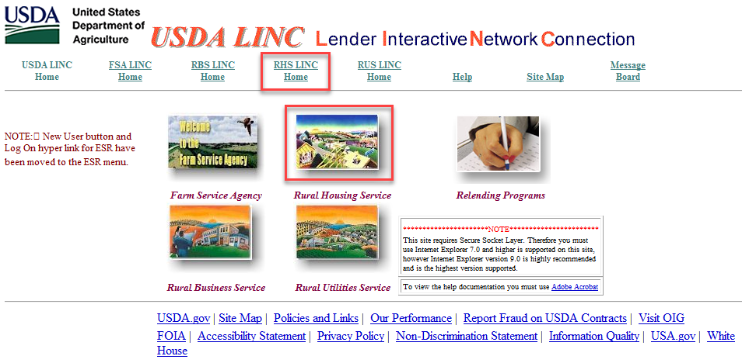

On the RHS LINC Home page, select Electronic Status Reporting Corrections hyperlink:

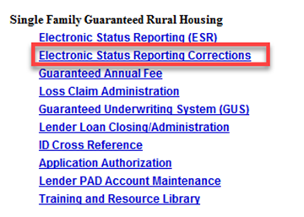

NOTE:

Users eAuth Account must be “Verified Identity” to access the ESR system.

Users e-Auth ID must be given to the company’s Security Administrator, who will add users ID to the ESR system for access.

Input your e-Auth User Id and Password. Click LOGIN.

From the ESR Search Rejected Records (Lender) page users can search for default and/or investor status reports, navigate to borrower correction and view/update Contact Maintenance.

From the ESR Search Rejected Records (Lender) page users can search for default and/or investor status reports, navigate to borrower correction and view/update Contact Maintenance.

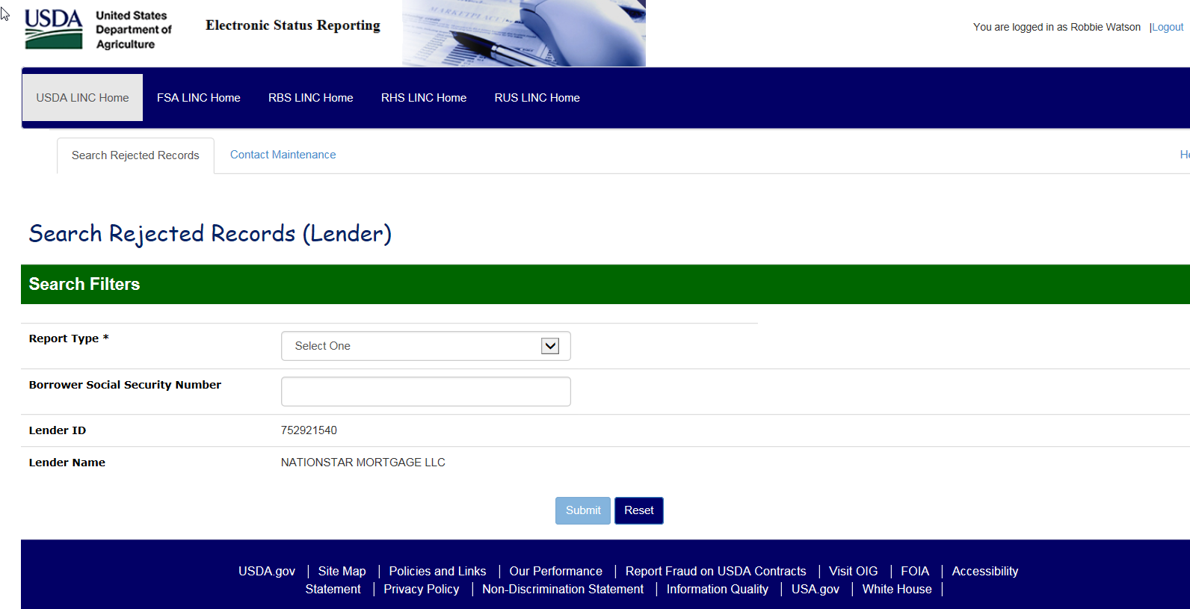

## Lender Contact Maintenance

Contact Maintenance page allows the lender to view/update contacts for their organization. The page will display Lender information and a list of the current contacts. Contacts may be added, and existing contacts may be updated or deleted within this page.

*Note: Lenders must be logged in with their User ID associated with their respective Lender ID and Branch number to view the list of lender contacts.

Click Contact Maintenance.

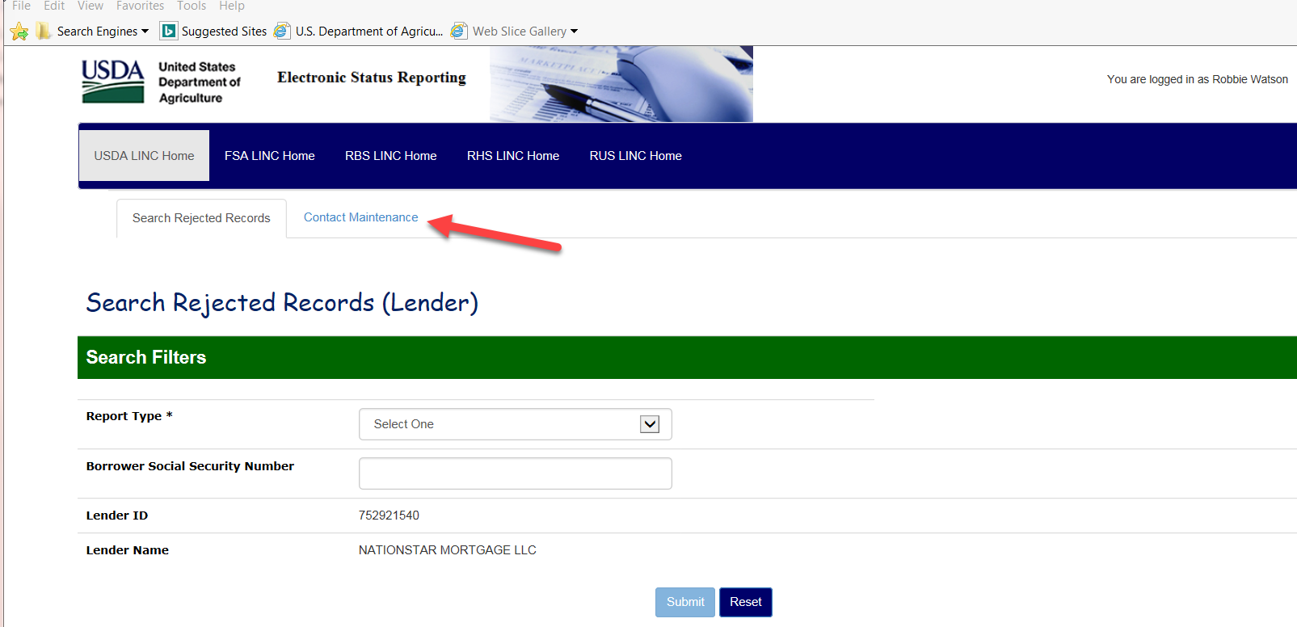

Click Add New to add new Contacts.

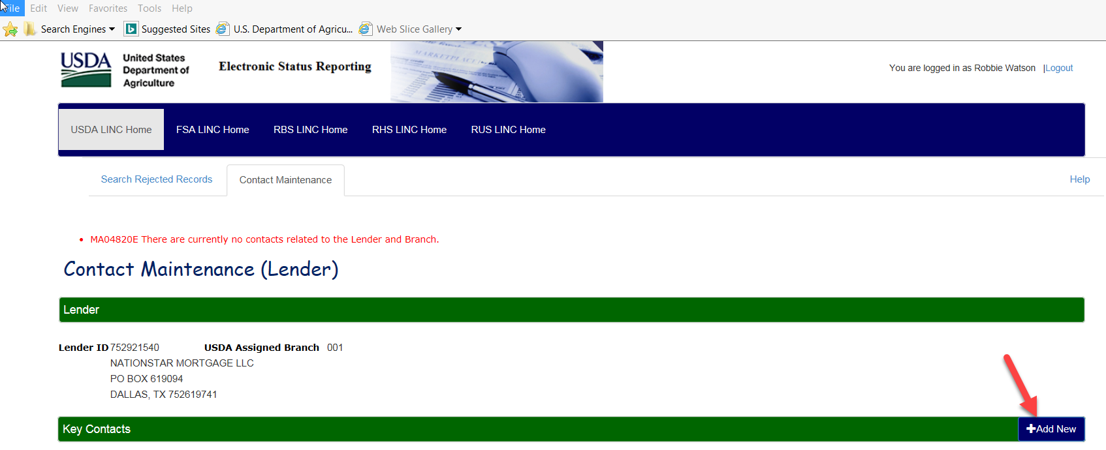

A blank row will appear under the Key Contacts banner. Enter all required information. Once all the information is entered, click Submit at the bottom of the page to save your contact. Note: All fields with an * are required.

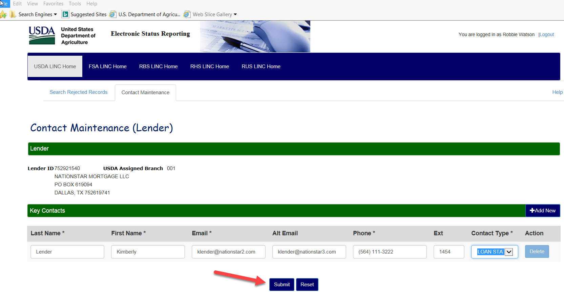

The information is now saved, and an additional blank row is presented for entering more contacts.

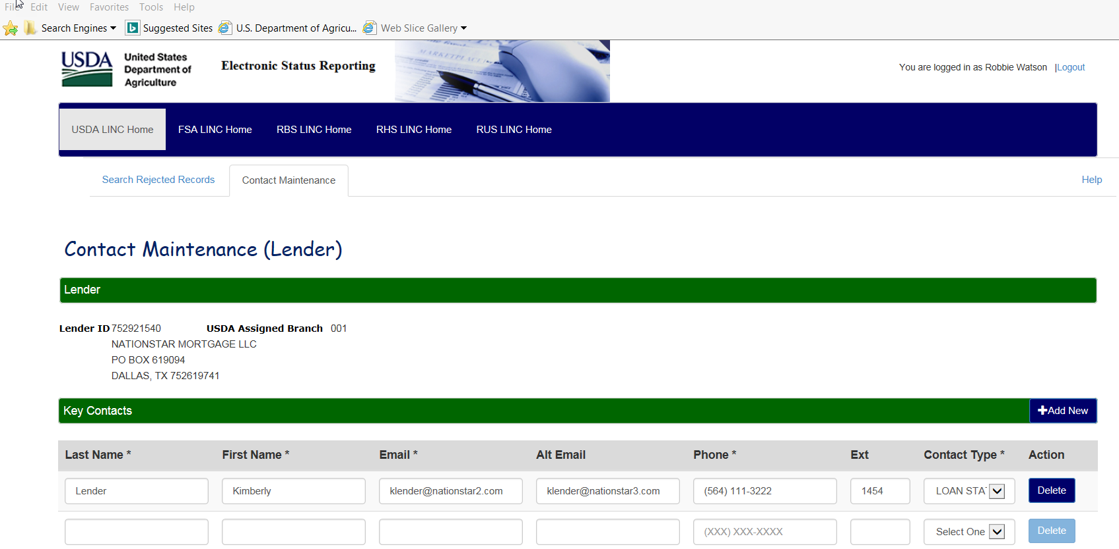

## Search Rejected Records (Lender)

Lenders will be able to view and correct Rejected Investor Status Reports and Rejected Default Status Reports. The status reports will be accessed on the Search Rejected Records tab no matter the reporting method (EDI or Web Reporting). Lenders can begin processing error codes on the 13th business day of each month and must complete the list by the last day of each month.

Click on Search Rejected Records tab. Select Investor Status or Default Status as the Report Type. Input Borrowers SSN to limit the search. To display all rejected statuses leave the Borrower SSN field blank and click Submit.

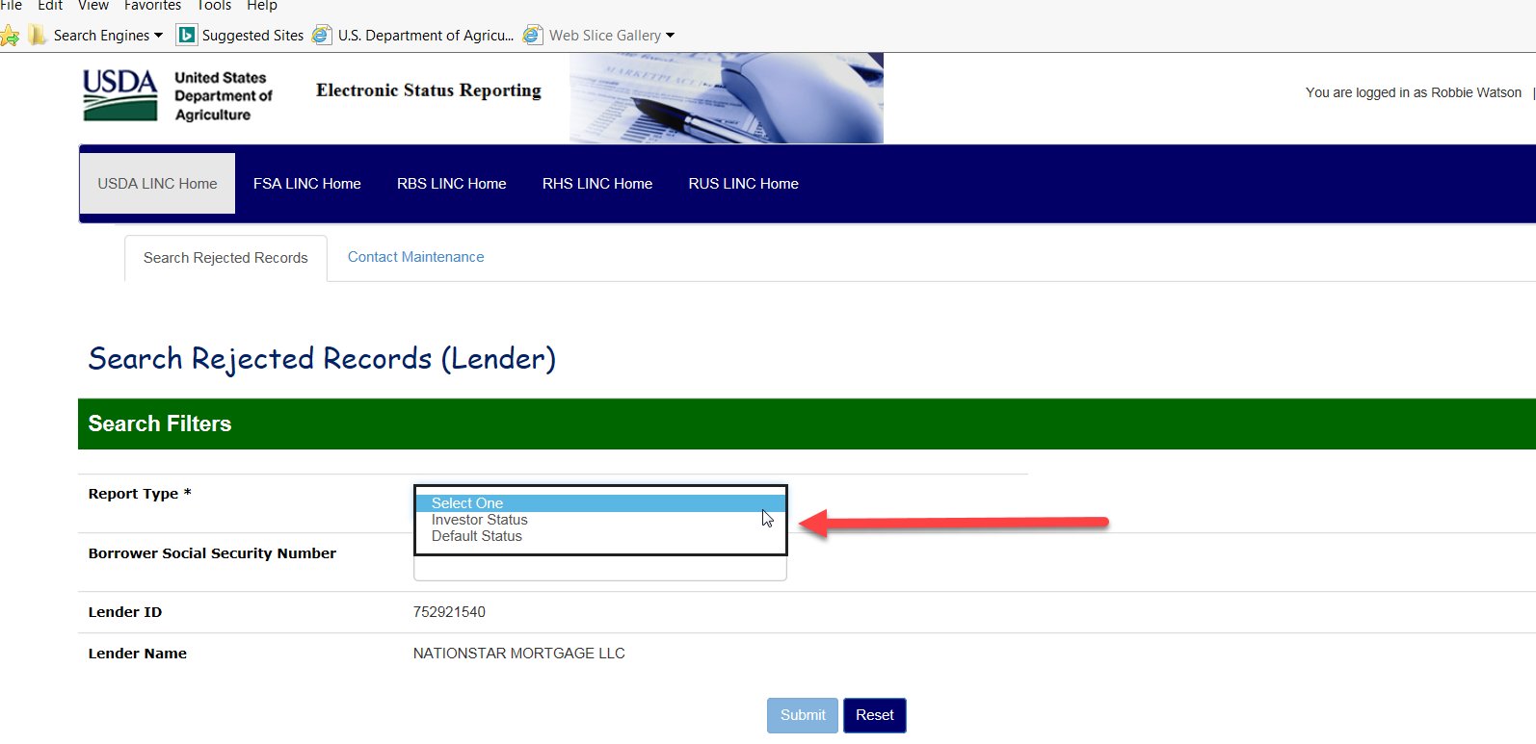

A full list of borrower error codes will display if no SSN was entered.

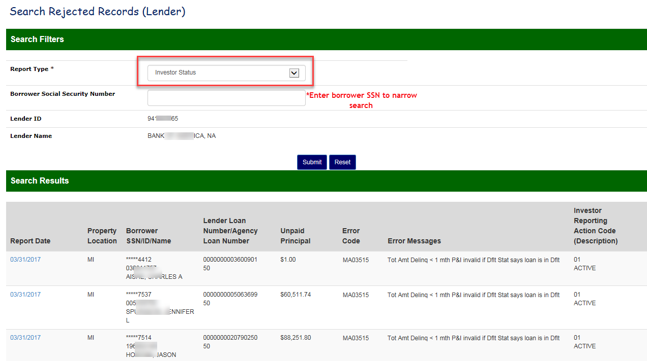

## Lender Investor Status Error Corrections

The lender is responsible for reporting their entire portfolio monthly via Electronic Data Interchange (EDI) or Web reporting system. Investor status reports require the principal/interest payment, unpaid principal balance, total amount delinquent and investor reporting action code. Only 1 code can be used out of the 4 choices of 01-Active, 02-Loss Pending, 09-Payoff, 10-Servicing Transfer.

The lender will click on the blue link in the Report Date column of the selected borrower from the Search Rejected Records screen list.

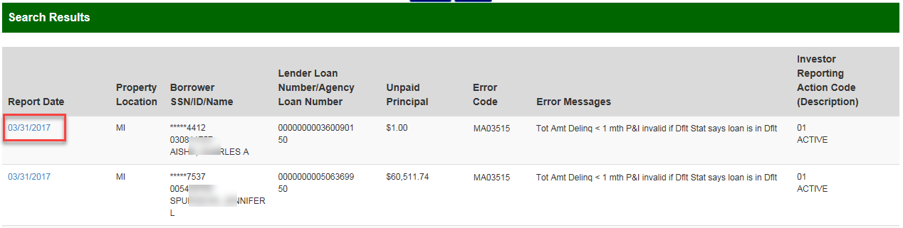

A new tab will appear “Maintain Rejected Record” where the lender can correct the data.

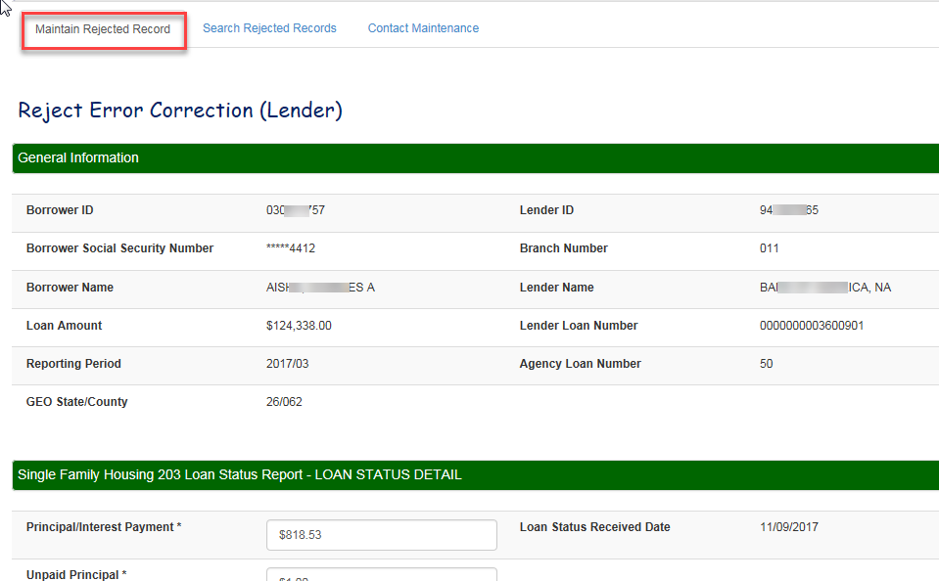

**Lender Investor Status Correction Example 1: Error Code MA03507 Unpaid Principal must be > 0, if the Investor Reporting Action Code = 01 or 02:**

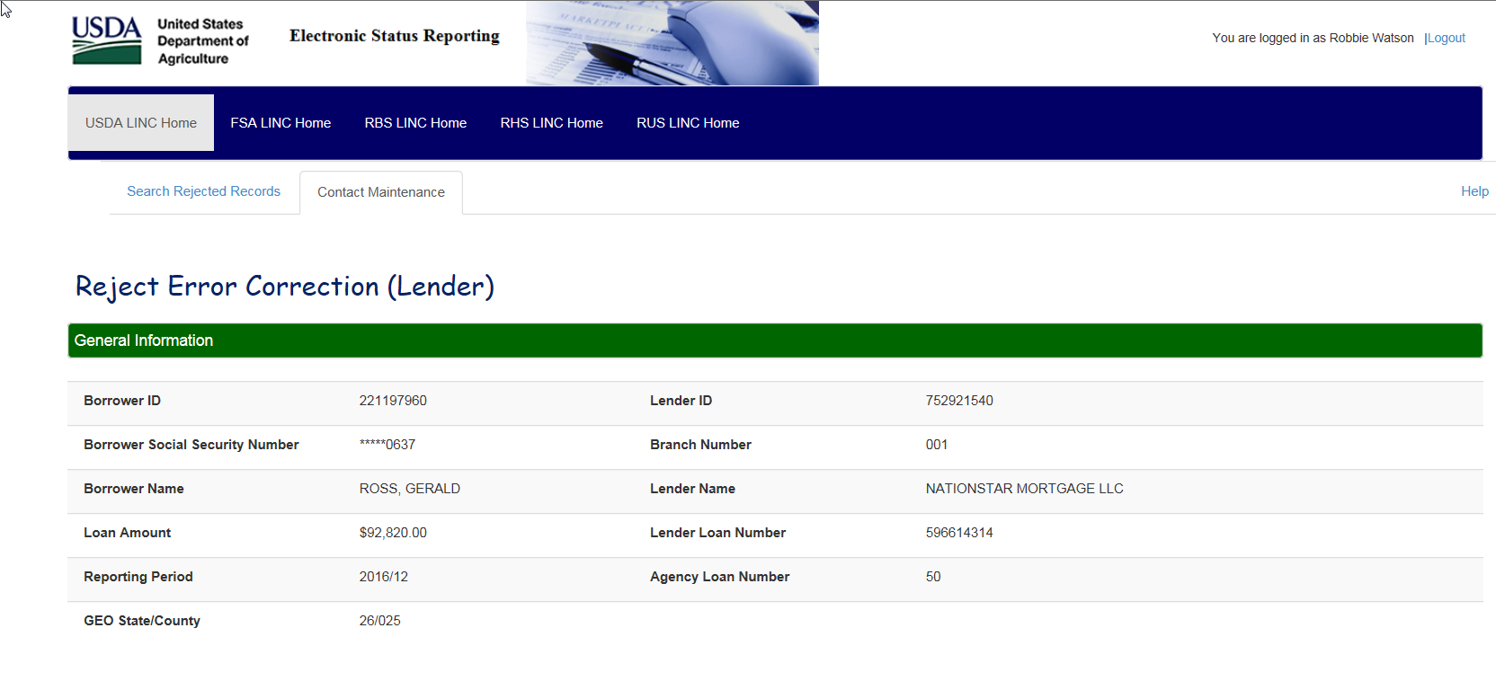

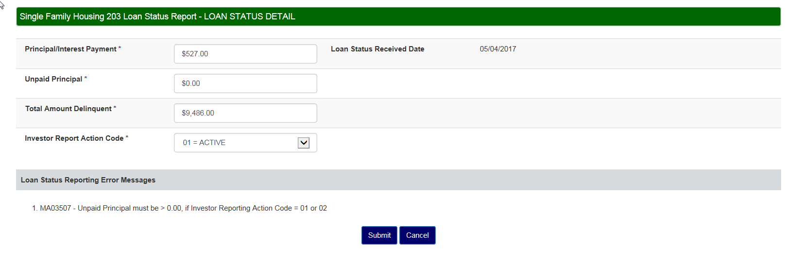

In this case we will assume that the unpaid principal was zeroed out by mistake. Lender will type the correct dollar amount of $20,000 in the unpaid principal field and click submit.

*Note- you can only choose 1 Investor Report Action Code.

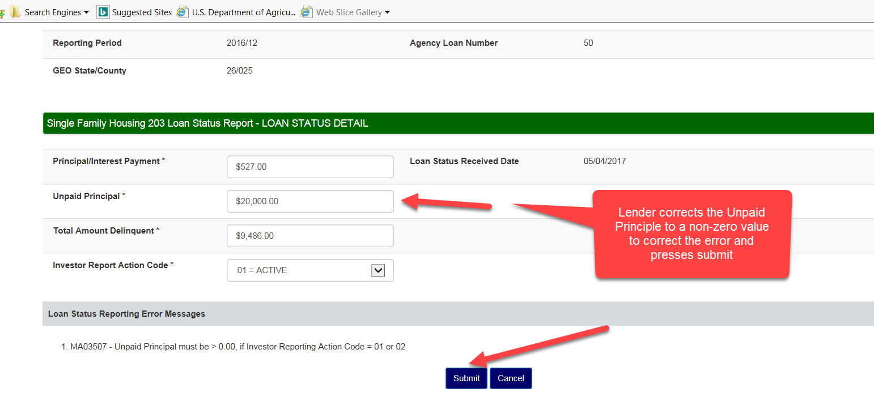

Message box will appear letting the lender know that the changes have been accepted.

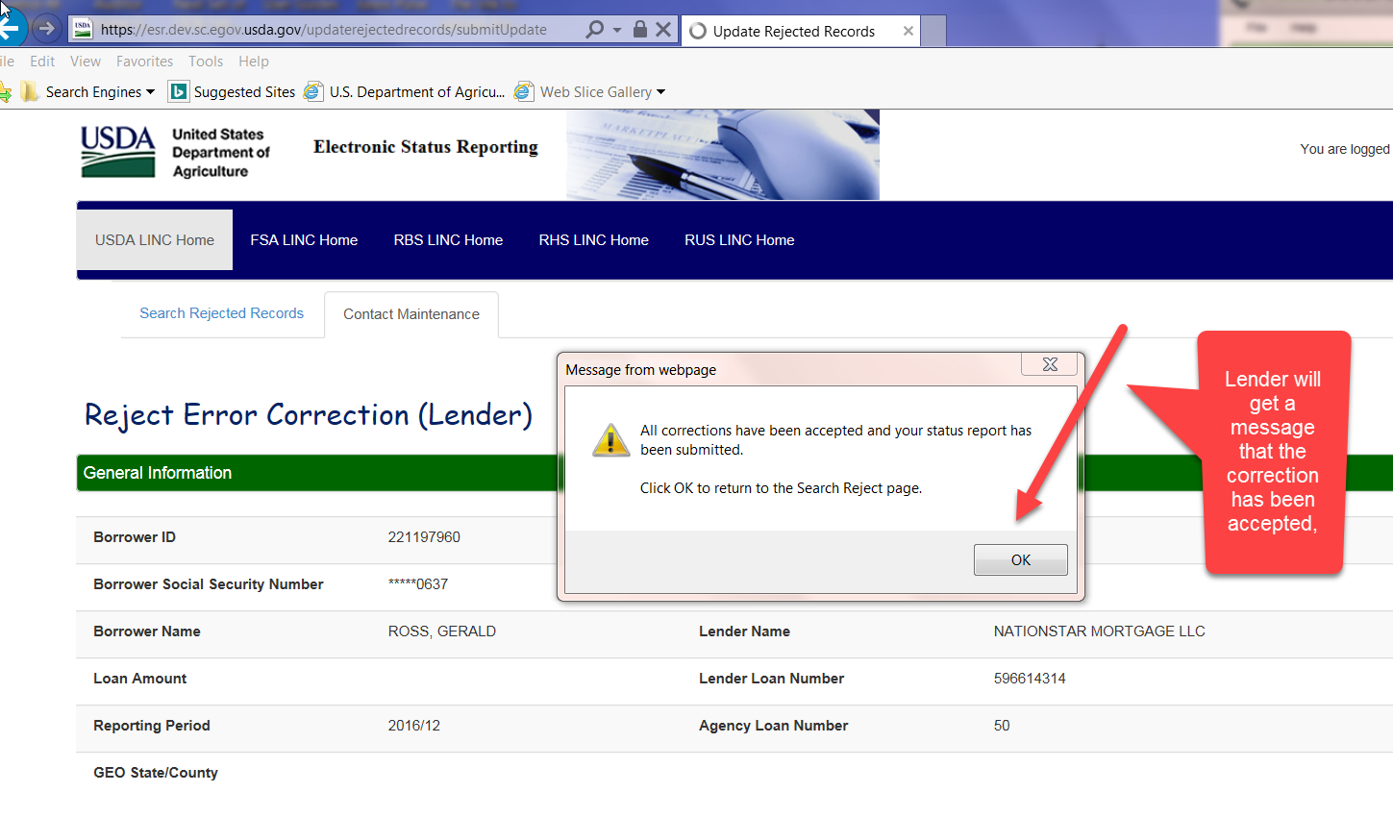

Lender will be returned to the Search Rejected Records homepage and the borrower rejection will be removed. Lender can work the next record or search for a new borrower.

**Lender Investor Status Correction Example 2: Working a MA04300 Borrower Not Found Reject Error:**

In this example, the lender knows that this borrower’s loan is a (SFHG) Single Family Housing Guaranteed Loan. Scroll down on the Maintain Rejected Record page to Borrower Not Found Resolution Information. Click Yes and Submit.

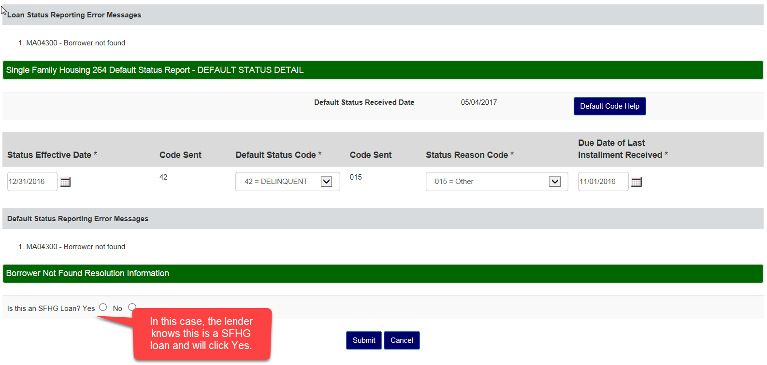

2 text boxes will appear. Enter the Borrower’s Social Security Number. Click Submit

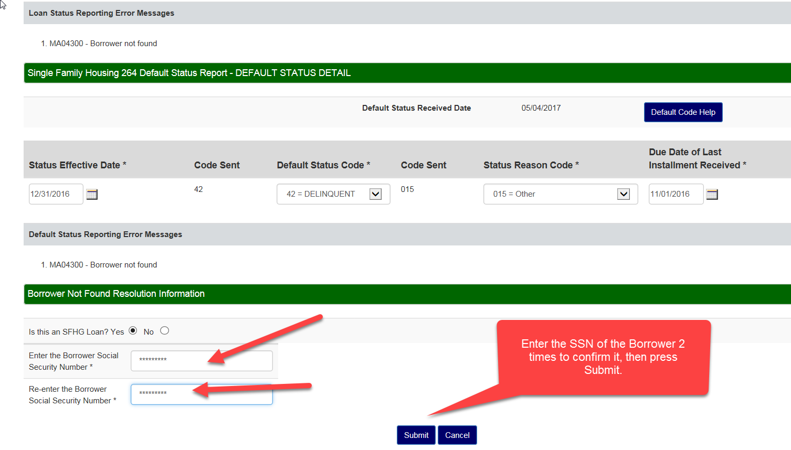

If the SSN is found in GLS and is different than what was originally entered a pop up box will display. Click OK.

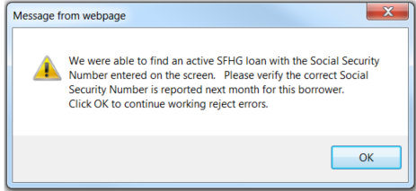

If the SSN is not found in GLS the page redisplays. Verify the SSN is correct and click Upload SSN Verification Document.

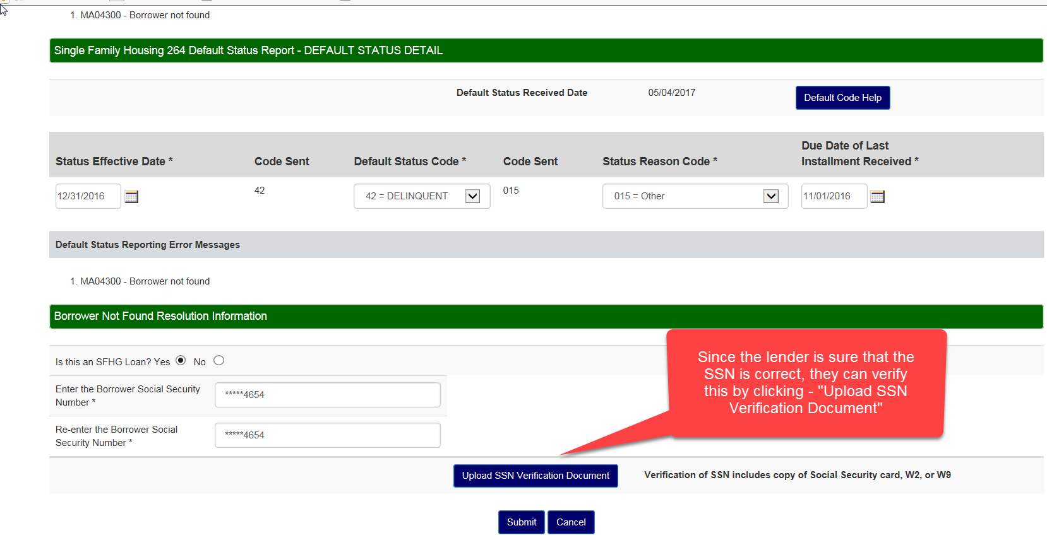

The user is directed to the ESR Upload Document page. Select the type of document of 11067 – SSN Verification. Click Browse button.

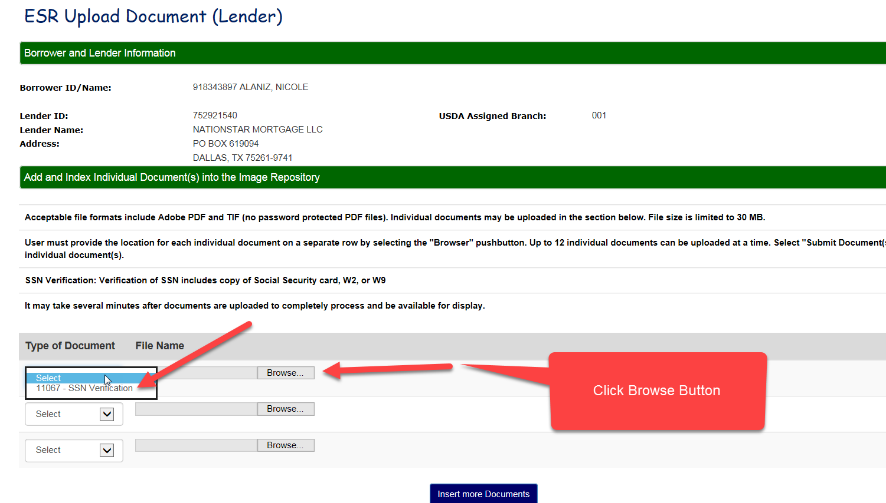

Navigate to the document, Select document and click Open. The file is attached and appears in the File Name. Click Submit Document(s)

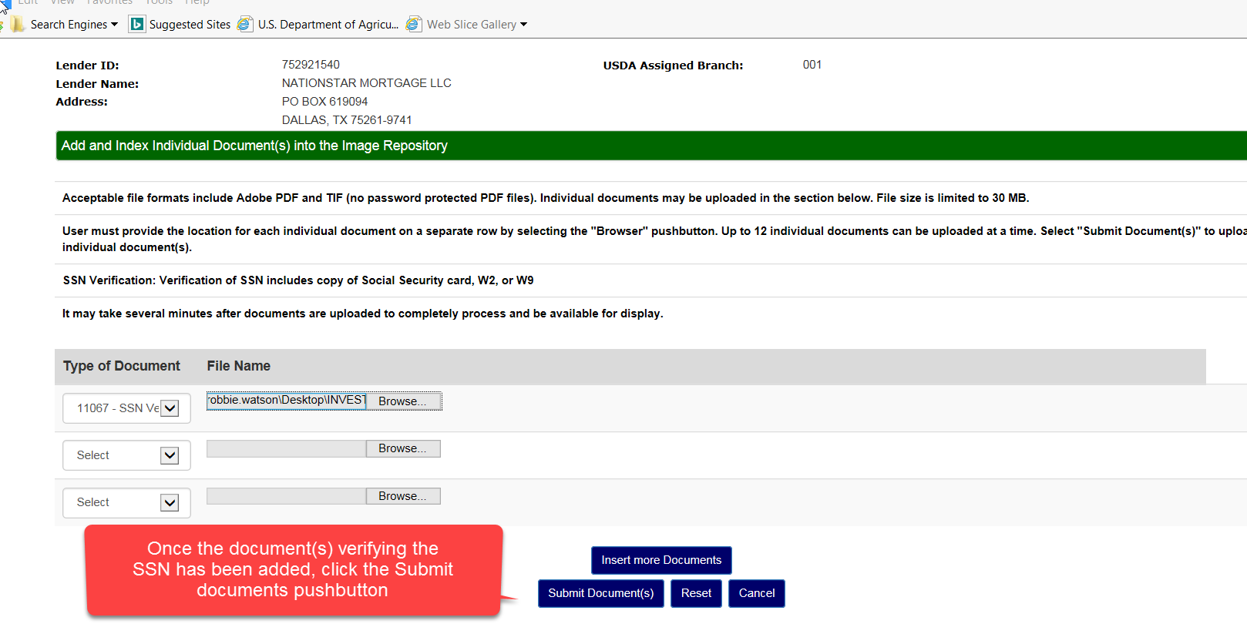

Lender will be returned to the Search Rejected Records homepage and the borrower rejection will be removed. Lender can work the next record or search for a new borrower.

## Lender Investor Status Reject Errors

| **Error Code** | **Error Message** | **What Lender Needs to Check** | **Action Advice For Lender** | **Report Type**  L - Loan Status D - Default Status B - Both C - Conflict |
| --- | --- | --- | --- | --- |
| MA03505 | Unpaid Principal must = 0.00 if Investor Reporting Action Code = 09 | Is loan paid off? | If loan is paid off, then Unpaid Principal must = ZERO. Change the Unpaid Principal to ZERO.  If loan is not paid off, then change the Investor Reporting Action to 01 (None), 02 (Loss Pending) or 10 (Servicing Transfer) to reflect the state of the loan. | L |
| MA03506 | Total Amount Delinquent must = 0.00, if Investor Reporting Action Code = 09 | Is loan paid off? | If loan is paid off, then Total Amount Delinquent must = ZERO. Change the Total Amount Delinquent to ZERO.  If loan is not paid off, then change the Investor Reporting Action to 01 (None), 02 (Loss Pending) or 10 (Servicing Transfer) to reflect the state of the loan. | L |
| MA03507 | Unpaid Principal must be > 0.00, if Investor Reporting Action Code = 01 or 02 | Is loan paid off?  Has the correct Default Status Code been reported? | Investor Reporting Action Code of 01 or 02 indicates the loan is not paid off. If Loan is not paid off, the Unpaid Principal must be > ZERO.  If the default status code is not 1A, 1B, 17 or 47 change the Unpaid Principal to be > ZERO.  If loan is paid off, then Investor Reporting Action Code must be 09 (Payoff). | C |
| MA03508 | Total Amount Delinquent must be > 0.00, if Investor Reporting Action Code = 02 | Is loan in a state of Loss Pending (02)? | If loan is in a state of Loss Pending (02), then Total Amount Delinquent must be > ZERO. Change the Total Amount Delinquent to be > ZERO.  If loan is not in a state of Loss Pending (02), then change the Investor Reporting Action to 01 (None), 09 (Payoff) or 10 (Servicing Transfer) to reflect the state of the loan. Appropriately change the Total Amount Delinquent and/or Unpaid Principal Balance if needed. | L |
| MA03510 | Total Amount Delinquent must be <= Loan Amount | USDA displays the Loan Amount. Determine the Total Amount Delinquent. | Change the Total Amount Delinquent to be <= to the Loan Amount. | L |
| MA03514 | Total Amount Delinquent >= 1 month P&I invalid when Default Status indicates the loan is not in default | Has the correct Default Status Code been reported? Has the correct Total Amount Delinquent been reported? | If the reported Default Status Code is correct, then change the Total Amount Delinquent to be < one month P&I.  If the reported Total Amount Delinquent is correct ( >= 1 month P&I ), then change the default status code to an account reinstatement default status code, claim termination of insurance default status, non-claim termination of insurance default status or a 1A default status | C |
| MA03515 | Total Amount Delinquent < 1 month P&I invalid when Default Status indicates the loan is in default | Has the correct Default Status Code been reported? Has the correct Total Amount Delinquent been reported? | If the Default Status Code is correct, then change the Total Amount Delinquent to be >= one month P&I, to reflect the delinquency amount.  If the reported Total Amount Delinquent is correct (< 1 month P&I), then change the default status code to a default status code to be an account reinstatement default status, claim termination of insurance default status, non-claim termination of insurance default status or a 1A default status. | C |
| MA03516 | Default Status Code must be from the category of Non-Claim Termination of Guarantee, if Investor Reporting Action Code = 09 | Is loan paid off? Has the correct Loan Status Code been reported? | If the Loan is paid off, then must report a default status from the category of Non-Claim Termination of Insurance.  If the Loan is not paid off, then change Investor Reporting Action Code, and report the appropriate Default Status Code to go along with the Investor Reporting Action Code. | C |
| MA03517 | Default Status Code must be from the category of Claim Termination of Guarantee, if Investor Reporting Action Code = 02 | Is loan a loss pending? Has the correct Loan Status Code been reported? | If the Loan is Loss Pending, then must report a default status from the category of Claim Termination of Insurance.  If the Loan is not Loss Pending then change Investor Reporting Action Code, and report the appropriate Default Status Code to go along with the Investor Reporting Action Code. | C |
| MA03531 | Loss exists; Investor Reporting Action code cannot = 09 |  | A loss exists, change the Investor Reporting Action Code to a valid code other than a 09. | L |
| MA04300 | Borrower not found | Is this a USDA SFH loan? Was the correct Social Security Number reported? | If this is a USDA SFH loan and the wrong Social Security was reported, change and report the correct Social Security Number. | B |
| MA11210 | Loan payoff not allowed - Annual fee is not terminated. | Is loan paid off? Has annual fee been terminated and paid? | If loan is not paid off, then change the Investor Reporting Action to 01 (None), 02 (Loss Pending) or 10 (Servicing Transfer) to reflect the state of the loan.  If the loan is paid off, then the Annual Fee must be terminated and paid. USDA will recognize the Loan Status as being reported, but it will not be processed until Annual Fee is terminated, been paid and received by USDA. | L |
| MA11211 | Loan payoff not allowed - Unpaid annual fee. | Is loan paid off? | If loan is not paid off, then change the Investor Reporting Action to 01 (None), 02 (Loss Pending) or 10 (Servicing Transfer) to reflect the state of the loan.  If the loan is paid off, then the Annual Fee must be paid. USDA will recognize the Loan Status was reported, but it will not be processed until Annual Fee has been paid and received by USDA. | L |
| MA13010 | Investor Reporting Action Code must = 09 if the Default Status Code is from the category of Non-Claim Termination of Guarantee | Is the loan terminated or paid in full? | If the Default Status Code 13, 29, 30 or 73 is correct, then change the Investor Action Code to 09    If the Default Status Code is incorrect, report the appropriate code to go with the Inv Action Code submitted | C |

## Lender Default Status Error Corrections

The lender is responsible for reporting default statuses monthly via EDI or Web reporting.

The lender will click on the blue link in the Report Date column of the selected borrower from the Search Rejected Records screen display list.

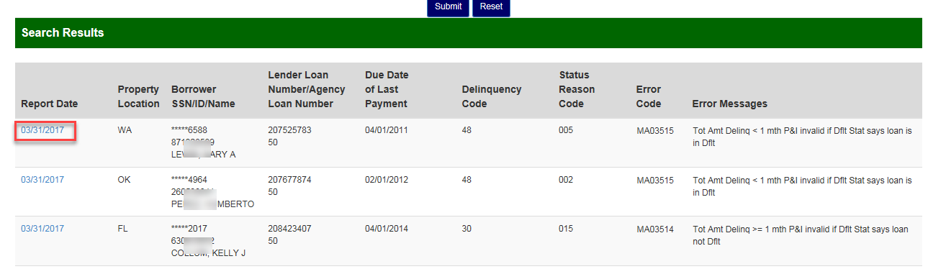

A new tab will appear “Maintain Rejected Record” where the lender can correct the data.

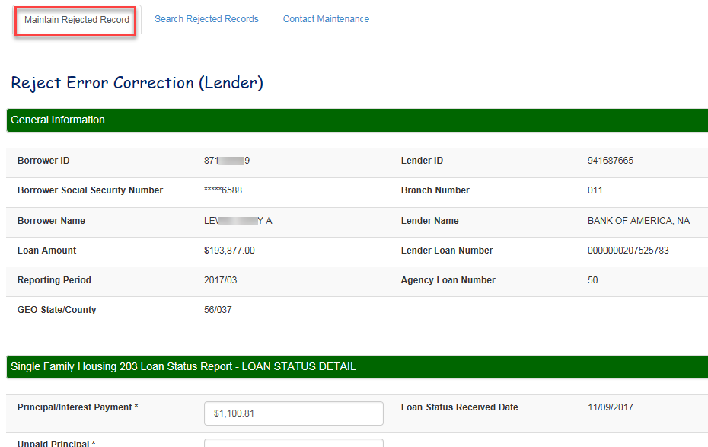

Lender Default Status Correction Example 1: Error Code MA03515 Total Amount Delinquent < 1 month P&I invalid when Default Status indicates the loan is in default. In this case lender entered the Total Amount Delinquent and clicked Submit.

Note: If lender notices additional fields that need correction such as Unpaid Principal, Default Status Code, etc. please correct those fields as well.

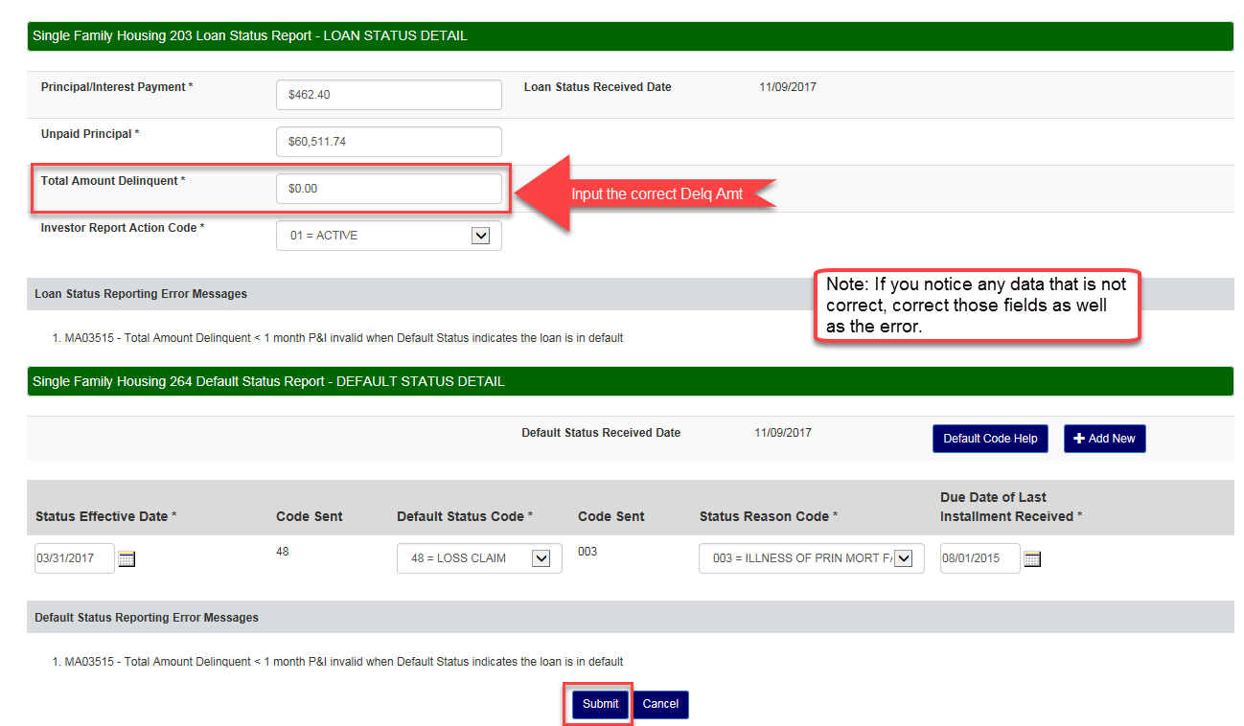

Message box will appear letting the lender know that the changes have been accepted.

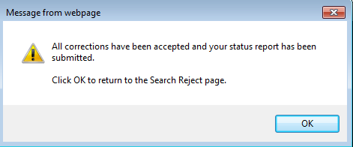

Lender will be returned to the Search Rejected Records homepage and the borrower rejection will be removed. Lender can work the next record or search for a new borrower.

## Lender Default Status Reject Errors

| **Error Code** | **Error Message** | **What Lender Needs to Check** | **Action Advice For Lender** | **Report Type**  L - Loan Status D - Default Status B - Both C - Conflict |
| --- | --- | --- | --- | --- |
| MA03507 | Unpaid Principal must be > 0.00, if Investor Reporting Action Code = 01 or 02 | Is loan paid off?  Has the correct Default Status Code been reported? | Investor Reporting Action Code of 01 or 02 indicates the loan is not paid off. If Loan is not paid off, the Unpaid Principal must be > ZERO.  If the default status code is not 1A, 1B, 17 or 47 the Unpaid Principal must reflect an amount > ZERO.  If loan is paid off, then Investor Reporting Action Code must be 09 (Payoff). Change Investor Reporting Action Code to be 09 (Payoff). | C |
| MA03509 | Loan Default Status Code is not valid for USDA SFH Default Reporting | What valid USDA SFH Loan Status Code is applicable to this loan? | Change Loan Status Code to a valid USDA SFH Loan Status Code that is applicable to the status of the loan. | D |
| MA03511 | Status Reason Code is not valid for USDA SFH Default Reporting | What valid USDA SFH Status Reason Code is applicable to this loan? | Change Loan Status Code to a valid USDA SFH Loan Status Code that is applicable to the status of the loan. | D |
| MA03512 | Must start new loan default event with a default status code of 42 | Does the loan have an open default event? | If loan does not have an open default event and a default status other than a 42 was reported, then change loan status to a 42.  If multiple default statuses are being reported, a loan default event must first be opened by reporting a default status code of 42, before reporting any other loan status code.  A loan is considered to have an open default event, if the last reported default status was from one of these categories:  General Account Delinquency  Delinquency Workouts  Ineligible for Loss Mitigation  Account in Foreclosure  Account in Bankruptcy   A loan is not considered to have an open default event,  If the loan has never had a default status reported in the past  OR If the last reported default status was from one of these categories:  Account Reinstated  Claim Termination of Insurance  Non-Claim Termination of Insurance   A default status "42 - Delinquency" must always start a new loan default event. | D |
| MA03513 | Due Date of Last Installment Received must be within 90 days of the current reporting period, when an Account Reinstated Default Status Code is reported | Is the loan being reinstated?  Was the correct Date of Last Paid Installment reported? | If the loan is being reinstated, change the Due Date of Last Installment Received, so that the Month and Year is within 90 days of the Month and Year of the Reporting Period. | D |
| MA03529 | Status of Mortgage Date cannot exceed Date of Report | Was the correct Status of Mortgage Date reported? | Reporting a Default Status with a date in the future is not allowed. Change the Status of Mortgage Date to be less than or equal to the Date of Report. | D |
| MA11104 | Due Date of Last Installment Received must be within 90 days of the current reporting period | Was the correct Due Date of Installment Received reported? | Change the Last Installment Received Date to be within 90 days of the current reporting period  If a default status from the category "Account Reinstated is being reported, then change Due Date of Last Installment Received, so that the Month and Year is within 90 days of the Month and Year of the Reporting Period | D |
| MA03514 | Total Amount Delinquent >= 1 month P&I invalid when Default Status indicates the loan is not in default | Has the correct Default Status Code been reported? Has the correct Total Amount Delinquent been reported? | If the reported Default Status Code is correct, then change the Total Amount Delinquent to be < one month P&I.  If the reported Total Amount Delinquent is correct ( >= 1 month P&I ), then change the default status code to an account reinstatement default status code, claim termination of insurance default status, non-claim termination of insurance default status or a 1A default status | C |
| MA03515 | Total Amount Delinquent < 1 month P&I invalid when Default Status indicates the loan is in default | Has the correct Default Status Code been reported? Has the correct Total Amount Delinquent been reported? | If the Default Status Code is correct, then change the Total Amount Delinquent to be >= one month P&I, to reflect the delinquency amount.  If the reported Total Amount Delinquent is correct (< 1 month P&I), then change the default status code to a default status code to be an account reinstatement default status, claim termination of insurance default status, non-claim termination of insurance default status or a 1A default status. | C |
| MA03516 | Default Status Code must be from the category of Non-Claim Termination of Insurance, if Investor Reporting Action Code = 09 | Is loan paid off? Has the correct Loan Status Code been reported? | If the Loan is paid off, then must report a default status from the category of Non-Claim Termination of Insurance.  If the Loan is not paid off, then change Investor Reporting Action Code, and report the appropriate Default Status Code to go along with the Investor Reporting Action Code. | C |
| MA03517 | Default Status Code must be from the category of Claim Termination of Insurance, if Investor Reporting Action Code = 02 | Is loan a loss pending? Has the correct Loan Status Code been reported? | If the Loan is Loss Pending, then must report a default status from the category of Claim Termination of Insurance.  If the Loan is not Loss Pending then change Investor Reporting Action Code, and report the appropriate Default Status Code to go along with the Investor Reporting Action Code. | C |
| MA04300 | Borrower not found | Is this a USDA SFH loan? Was the correct Social Security Number reported? | If this is a USDA SFH loan and the wrong Social Security was reported, change and report the correct Social Security Number. | B |
| MA13000 | Foreclosure Sale Held (1A) > time frame allowed | Is there a property redemption/confirmation period and/or is a loss claim pending? | Foreclosure Sale Held (1A) cannot be reported more than 3 consecutive months.  If property is located in a state with an applicable redemption/confirmation period change code to 1R  If loss claim is pending change code to 48 | D |
| MA13001 | Redemption/Confirmation action > time frame allowed | Has the applicable redemption/confirmation period expired and/or has a loss claim been filed? | Redemption/Confirmation Required (1R) cannot be reported more than 12 consecutive months if the foreclosure sale has been held.  If property has been redeemed change code to 73 or 74  If loss claim is pending change code to 48 | D |
| MA13010 | Investor Reporting Action Code must = 09 if the Default Status Code is from the category of Non-Claim Termination of Guarantee | Is the loan terminated or paid in full? | If the Default Status Code 13, 29, 30 or 73 is correct, then change the Investor Action Code to 09    If the Default Status Code is incorrect, report the appropriate code to go with the Inv Action Code submitted | C |

## Default Status Codes and Usage

| **STATUS CODE** | **DEFINITION** | **GUIDANCE FOR USAGE** |
| --- | --- | --- |
| General Account Delinquency (AD): further reporting is required | | |
| 42 | Delinquent | * Servicers must report a 42 code first to open a delinquent event * Only report this code alone when no additional servicing actions are occurring * Once a 42 is reported, the servicer does not have to report this code for subsequent monthly default status reports * If a loss mitigation option fails, no additional actions are pending, and the account remains in default: the most appropriate code may be 42 |
| 01 | Quality Right Party Contact (QRPC) | * Servicer has made live, confirmed contact with a borrower, or authorized representative. This is a onetime use code. |
| 24 | Government Seizure | * The dwelling is a government seizure * Report code 24 when the servicer receives notification of the seizure |
| 31 | Probate | * The property is subject to probate. This may delay loss mitigation or foreclosure activity as the dwelling could be in the process of distribution to heirs/beneficiaries * Servicer must report code 31 upon receipt of a death certificate or notification the borrower is deceased * Servicer must retain evidence of probate which may include: a copy of the will, legal correspondence, etc. |
| 32 | Military Indulgence | * Servicers may grant a delinquent service member forbearance or stop foreclosure proceedings under the Service Members Civil Relief Act (SCRA) or similar State law. This includes borrowers on active duty, National Guard, and/or State supported military unit assignment. * The ability to make mortgage payments must be directly impacted by the military service. * If the account was not reported delinquent for the previous cycle, report code 42 and 32 * If the account was reported as 42 for the previous cycle, report code 32 |
| 34 | Natural Disaster  To qualify as impacted by a natural disaster, the dwelling or employment must be located in a Presidentially Declared Disaster (PDD) area as defined by FEMA.  USDA may publish extensions to moratorium timeframes. | Accounts paid as agreed:   * If the loan is current, do not report it as code 34   New delinquent accounts/imminent default:  This guidance applies to:   * + loans that are a minimum of 30 days delinquent   + loans facing imminent default and the borrower has contacted the servicer to inform them of their current property/employment due to PDD * Servicer must report a code 42 and code 34 * Continue to report code 34 until another code applies * If the borrower is determined to not be impacted by the PDD, stop reporting code 34 and report the applicable code   Delinquent accounts (previously reported as 42):   * Continue to report the identified reason for the current default * If it is determined the disaster did impact the borrower’s ability to make timely payments, report code 34   Accounts in approved loss mitigation plans:   * Continue to report the approved loss mitigation code * If it is determined the disaster impacts the borrower’s ability to be successful under the loss mitigation plan, report code 34 until a different code applies   Accounts in foreclosure (previously reported as 42):   * A 90 day moratorium on all active or pending foreclosure activity is automatic from the date FEMA publishes the PDD * If the property is currently in foreclosure, the servicer must report the loan as code 34 and code AS (RD Moratorium) until it expires   Accounts in bankruptcy (previously reported as 42):   * Stop reporting the bankruptcy code and report code 34 and code AS until the moratorium expires or it is determined the borrower was not impacted by the PDD * If the borrower is determined to not be impacted by the PDD, report the applicable bankruptcy, loss mitigation (if court approved) or delinquency code |
| AS | RD Moratorium | * The property is currently in foreclosure or has been referred for foreclosure action * The dwelling or employment of the borrower(s) is located in a PDD * A 90 day moratorium on all active or pending foreclosure activity is automatic from the date FEMA publishes the PDD, but the servicer must continue to report a monthly default status for these loans * If the loan was not already reported as a foreclosure, report code 34 as the first code and then code AS to indicate to USDA that the moratorium is due to a natural disaster * Continue to report code AS until: the moratorium expires, the borrower is able to resume regular payments, or a loss mitigation option is approved * If the borrower fails on a loss mitigation option while the moratorium is still active, report code AQ for the failure, code 34 to denote the natural disaster, and code AS until the moratorium expires or another delinquency code is applicable * If the borrower enters into bankruptcy during the moratorium timeframe, report code 34 and code AS. When the moratorium expires report the applicable bankruptcy code or an approved loss mitigation code |
| H4 | Solicitation Letter | * Solicitation letter to borrower for loss mitigation options has been sent |
| H5 | Streamline Solicitation Letter | * The borrower is at least 90 days past due * The borrower has a deficiency balance of greater than $5,000 * Subsequent reporting cycles must report the applicable status code |
| 78 | Borrower Program Assistance Received | * Borrower has applied and is approved to receive assistance from a state, local, or federal program to assist with the mortgage obligation (Hardest Hit Fund, Emergency Homeowners Loan Program, etc.) * Servicer may report code 78 upon notification from borrower of assistance, do not wait until funds are received * If the assistance program does not help cure the delinquency or it runs out of funds, report the applicable delinquency code or an approved loss mitigation code |
| **Delinquency Workouts (AL): further reporting is required** | | |
| 06 | Formal Forbearance Plan | * Borrower has been approved for a formal forbearance plan * There is a written and signed agreement designed to bring the loan current typically within 6 months, but longer forbearance timeframes may be permitted * If the borrower fails on the formal forbearance plan, report the delinquency status as code AQ * If the formal forbearance plan fails but another loss mitigation option is approved, report code AQ along with the applicable new loss mitigation code   Formal Forbearance due to natural disaster:   * This code may also be used for plans designed specifically for borrowers affected by natural disasters, and must be reported until the borrower’s financial condition improves. These plans may be extended for up to 12 months when the dwelling or employment is located in a PDD * Report code 42 (if now delinquent), code 34, and finally code 06 * If the formal forbearance plan fails during the moratorium timeframe due to the natural disaster report code AS until another loss mitigation or delinquency status code applies |
| 08 | Trial Payment Plan | * Borrower has been approved for a trial payment plan * Borrower is paying as agreed on trial payments * Servicer must report code 42 (if not previously reported delinquent) and code 08 * If the trial repayment plan fails, report code AQ * Subsequent reporting cycles must report the applicable status code |
| 09 | Special Forbearance | * Borrower has been approved for a special forbearance due to unemployment * Servicer must report code 42 (if not previously reported delinquent) and then code 09 * If the special forbearance fails, report code AQ * Subsequent reporting cycles must report the applicable status code |
| 10 | Payment Supplement Acct (PSA) | * Servicer is participating in the Payment Supplement Account (PSA) Pilot * Borrower is not eligible for any other retention options * Servicer has received the signed agreement from the borrower |
| 11 | Promise to Pay | * Borrower agrees to bring the mortgage current with one lump sum payment * If the payment arrangement involves more than one scheduled payment, then this is not a promise to pay * Loans delinquent for more than 30 or 60 days may not be appropriate for a promise to pay. Servicers must pursue alternative loss mitigation options if one lump sum payment cannot be met * If the promise to pay is received in the same month the loan becomes delinquent, report code 42 and then code 11 * If the borrower fails to remit the agreed upon lump sum payment, report code AQ * Subsequent reporting cycles must report the applicable status code * If the borrower is approved for the promise to pay, but before the reporting cycle begins is approved for a different loss mitigation option, report the applicable code for the most recent approval |
| 12 | Repayment / Informal Forbearance Plan | * An informal forbearance plan is an oral agreement to bring the loan current within 3 months or less * If the account has not been previously reported as delinquent, report code 42 and then code 12 * If the account was previously reported as a 42, only report code 12 * If the borrower fails on the oral agreement, report code AQ * Subsequent reporting cycles must report the applicable status code |
| 15 | Pre-foreclosure Acceptance Plan Available | * Borrower is approved to participate in the pre-foreclosure sale program * If a sale falls through, servicers must continue to report code 15 while the marketing timeframe is active * If the marketing timeframe expires and no offers have been accepted, report code AQ and any delinquency or loss mitigation code as applicable |
| 26 | Refinance Started | * Borrower has been approved to refinance the mortgage * Evidence of loan approval is documented |
| 28 | Modification Started | * Servicer has received signed modification agreement and applicable documents from the borrower * Modified payments are not required to have been received at this time to report code 28 * If the modification fails, report code AQ * Subsequent reporting cycles must report the applicable status code |
| 36 | Stand Alone Mortgage Recovery Advance (MRA) | * Servicer has received signed MRA documents from the borrower * Subsequent reporting cycles must report the applicable status code |
|  |  |  |
| 41 | Modification w/ Mortgage Recovery Advance | * Borrower has successfully completed a Trial Payment Plan * Borrower is approved for a Modification with a Mortgage Recovery Advance (MRA) * If the Modification with MRA fails, report code AQ * Subsequent reporting cycles must report the applicable status code |
| 44 | Deed-in-Lieu Started | * Borrower has been approved for a Deed-in-Lieu |
| 50 | Disaster Payment Deferral Modification | * The property or the borrower’s employment has been impacted by a PDD * The borrower can maintain the current contractual payment including any escrow shortage created by advances during the forbearance period * Servicer has received a signed modification agreement from the borrower * Subsequent reporting cycles must report the applicable status code |
| 51 | Disaster Cap and Extend Modification | * The property or the borrower’s employment has been impacted by a PDD * The borrower can maintain the current contractual payment but cannot manage the additional escrow repayment amount * Servicer has received a signed modification agreement from the borrower * Subsequent reporting cycles must report the applicable status code |
| 52 | Disaster Stand Alone MRA | * The property or the borrower’s employment has been impacted by a PDD * Servicer has received signed MRA documents from the borrower * Subsequent reporting cycles must report the applicable status code |
| 55 | COVID Special Relief Measure | * The Borrower has been approved for COVID-19 Special Relief Measures * Subsequent reporting cycles must report the applicable status code |
| 56 | Pandemic Mortgage Recovery Advance (PMRA) | * Servicer is participating in the PMRA Pilot * Servicer has received signed agreement from the borrower * Subsequent reporting cycles must report the applicable status code |
| AA | Complete Financials Received and in Review | * Servicer has received complete borrower financials * Financials are under review to determine appropriate loss mitigation options |
| AH | Streamline Modification | * Servicer has received a signed modification agreement from the borrower * Subsequent reporting cycles must report the applicable status code |
| AQ | Workout Failure | * Borrower has failed to perform under the selected loss mitigation option * Report code AQ for a missed scheduled payment for a trial payment plan, forbearance, or promise to pay * Report code AQ when borrowers fail to return documents required for loss mitigation consideration * Report AQ for one cycle, and then revert to code 42 or other applicable loss mitigation code |
| **Ineligible for Loss Mitigation (AI): further reporting is required** | | |
| AO | Ineligible for Loss Mitigation | * Servicer has exhausted all loss mitigation options * Borrower is not eligible for any loss mitigation options or they declined options offered * Report code AO before initiating foreclosure activity when these criteria apply |
| AP | Ineligible for Loss Mitigation Due to No Response | * Servicer has offered loss mitigation options * Borrower has failed to respond * Report code AP before initiating foreclosure activity when these criteria apply * A borrower who submitted a complete financial package but then is unresponsive may reflect code AA and code AP * A borrower who failed on a loss mitigation option and then is unresponsive to new options may reflect code AQ and code AP * A borrower who does not reaffirm their mortgage debt following bankruptcy (due to the servicers inability to perform collection calls/offer loss mitigation options) may reflect code AP and code 68 |
| **Account in Foreclosure (AF): further reporting is required** | | |
| 95 | State Mandated Delay & / or Mediation | * Foreclosure in process or pending foreclosure actions must be suspended due to a State mandated delay, a state law change, or the referral of the loan to mediation * Report code 95 for suspension of foreclosure activity * Continue to report code 95 until the impediment to foreclosure is resolved * When impediment is resolved, report code 68 for foreclosures that were already in progress * If the servicer must reinitiate the foreclosure, report the most applicable code which may be code 42 * Report code 95 before code 68 as applicable * Do not report code 95 if title issues must first be resolved before further foreclosure action may occur |
| 68 | First Legal Action to Commence Foreclosure | * The first public legal action required to initiate foreclosure is complete |
| 33 | Contested Foreclosure | * Foreclosure is suspended due to borrower contesting the action * Scenarios include but are not limited to these borrower actions: filed response to the foreclosure through an attorney or pro se, dispute of payments due, or allegations of predatory lending including origination, servicing, or document errors |
| 1A | Foreclosure Sale Held | * The foreclosure sale was held * Subsequent reporting cycles must report the applicable status code |
| 1B | 3rd Party Foreclosure Sale Held | * The foreclosure sale was held to a 3rd party for less than the full indebtedness * Subsequent reporting cycle must report code 48 once the loss claim is filed |
| **Account in Bankruptcy (AB): further reporting is required** | | |
| 65 | Chapter 7 Bankruptcy | * Borrower has filed a petition of bankruptcy under Chapter 7 |
| 66 | Chapter 11 Bankruptcy | * Borrower has filed a petition of bankruptcy under Chapter 11 |
| 67 | Chapter 13 Bankruptcy | * Borrower has filed a petition of bankruptcy under Chapter 13 |
| 59 | Chapter 12 Bankruptcy | * Borrower has filed a petition of bankruptcy under Chapter 12 |
| 69 | Bankruptcy Plan Confirmed | * Bankruptcy court confirmed the bankruptcy plan * Applicable code for all eligible bankruptcy plans |
| 76 | Bankruptcy Court Clearance Obtained | * Bankruptcy is no longer an impediment to foreclosure |
| **Pending Claim – further reporting is required** | | |
| 17 | Pre-Foreclosure Sale Completed | * The pre-foreclosure sale has been held. |
| 47 | Deed‐in‐Lieu Completed | * Deed in lieu of foreclosure was completed |
| 74 | Property Redeemed Not Paid in Full | * According to state law requirements the borrower redeemed the property after the foreclosure sale * Redemption amount less than full indebtedness; loan is not paid in full |
| 1E | Eviction Started | * The first public action to initiate eviction was completed |
| 1R | Foreclosure Sale Held – Redemption/Confirmation Required | * The foreclosure sale was held and according to state law requirements; there is an applicable redemption/confirmation period |
| **Account Reinstated (AR): reporting on this case is concluded** | | |
| 20 | Reinstated by borrower who retains homeownership w/out Loss Mitigation Intervention | Borrower reinstated the mortgage **without** the use of:   * loss mitigation (special forbearance, loan modification, or SLS modification) * informal or formal forbearance or repayment plan * borrower assistance * promise to pay |
| 21 | Reinstated by Assumptor | * Mortgage was reinstated by assumptor |
| 98 | Reinstated after Loss Mitigation Intervention | Borrower reinstated the mortgage **with** the use of:   * loss mitigation (special forbearance, loan modification, or SLS modification) * informal or formal forbearance or repayment plan * borrower assistance * promise to pay |
| **Claim Termination of Guarantee: reporting on this case is concluded** | | |
| 48 | Loss Claim | * Servicer has filed the loss claim |
| **Non-Claim Termination of Guarantee (NC): reporting on this case is concluded. IRA Investor Reporting Action Code “09” must also be reported to terminate the loan.** | | |
| 13 | Paid in Full | * The mortgage has been paid in full |
| 29 | Charge-off | * Servicer has charged off part of the funds that would have paid the account in full * No loss claim will be filed with USDA |
| 30 | Third Party Sale | * Foreclosure sale was held * 3rd party paid the indebtedness in full * No loss claim will be filed with USDA |
| 73 | Property Redeemed Paid in Full | * According to state law requirements the borrower redeemed the property after the foreclosure sale * Loan is paid in full * No loss claim will be filed with USDA |

## Default Status Codes and Usage

| **STATUS CODE** | **DEFINITION** | **GUIDANCE FOR USAGE** |
| --- | --- | --- |
| 001 | Death of Principal Mortgagor | The delinquency is attributed to the death of the principal borrower. |
| 002 | Illness of Principal Mortgagor | The delinquency is attributed to a prolonged illness that keeps the principal borrower from working and generating income. |
| 003 | Illness of Mortgagor’s Family Member | The delinquency is attributed to a principal borrower having incurred extraordinary expenses as the result of the illness of a family member or having taken on the sole responsibility for repayment of the mortgage debt as the result of the co-borrower’s illness. |
| 004 | Death of Mortgagor’s Family Member | The delinquency is attributed to a principal borrower having incurred extraordinary expenses as the result of the death of a family member or having taken on the sole responsibility for repayment of the mortgage debt as the result of the co-borrower’s death. |
| 005 | Marital Difficulties | The delinquency is attributed to problems associated with a separation or divorce, such as a dispute over ownership of the property, a decision not to make payments until the divorce settlement is finalized, or a reduction in the income to repay the mortgage debt. |
| 006 | Curtailment of Income | The delinquency is attributed to a reduction in the borrower’s income, such as a garnishment of wages, a change to a lower paying job, reduced commissions or overtime pay, or loss of a part-time job. |
| 007 | Excessive Obligations | The delinquency is attributed to a borrower having incurred excessive debts (either in a single instance or as a matter of habit) that prevent them from making payments on both those debts and the mortgage debt. |
| 008 | Abandonment of Property | The delinquency is attributed to a borrower having abandoned the property for reasons that are not known by the Mortgagee (because the Mortgagee has not been able to locate the borrower). |
| 009 | Distant Employment Transfer | The delinquency is attributed to a borrower being transferred or relocated to a distant job location and incurring additional expenses for moving and housing in the new location, affecting their ability to pay both those expenses and the mortgage debt. |
| 010 | Neighborhood Problem | The delinquency is attributed to the property's location, which affects the borrower's ability to pay the mortgage debt. |
| 011 | Property Problem | The delinquency is attributed to the condition of the property’s improvements (substandard construction, expensive and extensive repairs needed, etc. requiring due of funds that would have been available for the Mortgage Payment) or to the borrower’s dissatisfaction with the property or neighborhood. |
| 012 | Inability to Sell Property | The delinquency is attributed to an employment-related transfer. |
| 013 | Inability to Rent Property | The delinquency is attributed to borrower needing rental income to make the mortgage payments and having difficulty in finding a tenant following an employment-related transfer. |
| 014 | Military Service | The delinquency is attributed to the principal borrower having entered active duty status and their military pay is insufficient to enable the continued payment of the existing mortgage debt. |
| 015 | Other | Should be rarely used – additional reason codes at the request of the industry have been added; indicates that the delinquency is attributed to reasons that are not otherwise included in the list. | |
| 016 | Unemployment | The delinquency is attributed to a reduction in income resulting from the principal borrower having lost their job. | |
| 017 | Business Failure | The delinquency is attributed to a self-employed principal borrower having a reduction in income and/or excessive obligations that are the direct result of the failure of their business to remain a viable entity or, at least, to generate sufficient profit that the borrower can rely on to meet their personal obligations. | |
| 019 | Casualty Loss | The delinquency is attributed to the borrower having incurred a sudden, unexpected property loss as the result of an accident, fire, storm, theft, earthquake, etc. | |
| 022 | Energy-Environment Cost | All other factors remained the same, but funds that would have been available for the mortgage payment have been used for sharp increases in utility costs or costs associated with the removal of environmental hazards in or near the property. | |
| 023 | Servicing Problems | The delinquency is attributed to the borrower being dissatisfied with the way the mortgage servicer is servicing the mortgage or with the fact that the servicing of the mortgage has been transferred to a new mortgage servicer. | |
| 026 | Payment Adjustment | The delinquency began after an increase in Principal and Interest (P&I) due to a modification or after an escrow analysis where one or more escrow item increased, including the spreading of the amount needed to repay an escrow shortage over the next year. | |
| 027 | Payment Dispute | The delinquency is attributed to a disagreement between the borrower and the mortgage servicer about the amount of the mortgage payment, the acceptance of a partial payment, or the application of previous payments, resulting in the borrower’s refusal to make payments until the dispute is resolved. | |
| 029 | Transfer of Ownership Pending | The delinquency is attributed to the borrower having agreed to sell the property and deciding not to make any additional payments. | |
| 030 | Fraud | The delinquency is attributed to fraud related to the mortgage itself, whether during origination or after. | |
| 031 | Unable to Contact Borrower | For use with 30- and 60-day delinquencies where contact with the borrower has not yielded a response; should be used rarely for any 90 day or more delinquency. Indicates that the reason for delinquency cannot be ascertained because the borrower cannot be located or has not responded to the servicer’s inquiries. | |
| 032 | Eligible Disaster Area | Must be reported when a mortgage (mortgaged premises or borrower’s place of employment) is affected by a disaster and is more than 30 days delinquent. | |
| 033 | Bank Issues | The delinquency is attributed to issues arising with the borrowers financial institution. This may include bank errors, deposit account fraud, etc. | |
| 034 | Forgot to Pay | The delinquency is attributed to the borrower forgetting to make a mortgage payment. | |
| 055 | National Emergency | The delinquency is attributed to a National Emergency declaration that is not associated with a weather-related natural disaster. | |
| INC | Incarceration | The delinquency is attributed to the principal borrower having been jailed or imprisoned (regardless of whether they are still incarcerated). | |

# Contact US

|  |  |
| --- | --- |
| **Technical Issues:** | [RD.HD@usda.gov](mailto:RD.HD@usda.gov) or  800-457-3642 Option 2, Option 2 |
| **Lender Reporting Branch:** | [rd.so.hsb@usda.gov](mailto:rd.so.hsb@usda.gov) or  877-636-3789 |
| **Technical Issues: e-Authentication** | <https://www.eauth.usda.gov/eauth/b/usda/contactus>  <https://www.eauth.usda.gov/eauth/b/usda/faq> |
| **Training & Guides** | [USDA LINC Training & Resource Library](https://www.rd.usda.gov/resources/usda-linc-training-resource-library) |