Draft Environmental Assessment
Indianola Proposed Solar Project
Indianola, Warren County, Iowa

May 2025 | Terracon Project No. 0822P069

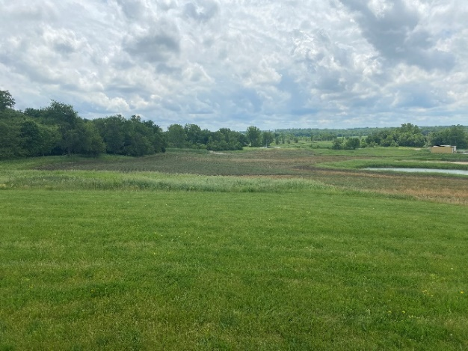

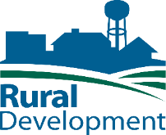

Prepared for:
U.S. Department of Agriculture
Rural Development (RD)
Rural Utilities Service (RUS)

and

SE Municipal Iowa, LLC
1209 Harney Street, #400
Omaha, NE 68102

Prepared by:
Terracon Consultants, Inc., Omaha, Nebraska

Table of Contents
1.0 PURPOSE AND NEED 2
1.1 Purpose and Need 2
1.2 Project Description 2
2.0 Alternatives evaluated including the proposed action 5
2.1 Proposed Action and Preferred Alternative 6
2.2 Other Alternative Evaluated and Not Carried Forward 8
2.3 No Action Alternative (Status Quo) 9
2.4 Environmental Resources Not Carried Forward for Detailed Analysis 9
3.0 affected environment, environmental consequences, and mitigation measures 10
3.1 Land Use 11
3.1.1 Affected Environment 11
3.1.2 Environmental Consequences 14
3.1.3 Mitigation Measures 15
3.2 Floodplains 15
3.2.1 Affected Environment 15
3.2.2 Environmental Consequences 16
3.2.3 Mitigation Measures 18
3.3 Wetlands 18
3.3.1 Affected Environment 18
3.3.2 Environmental Consequences 18
3.3.3 Mitigation Measures 19
3.4 Water Resources 19
3.5 Biological Resources 21
3.5.1 Affected Environment 21
3.5.2 Environmental Consequences 26
3.5.3 Mitigation Measures 29
3.6 Cultural Resources and Historic Properties 30
3.6.1 Affected Environment 30
3.6.2 Environmental Consequences 31
3.6.3 Mitigation Measures 32
3.7 Aesthetics 33
3.7.1 Affected Environment 33
3.7.2 Environmental Consequences 33
3.7.3 Mitigation Measures 34
3.8 Air Quality 34
3.8.1 Affected Environment 34
3.8.2 Environmental Consequences 35
3.8.3 Mitigation Measures 36
3.9 Socio-Economic Impact Assessment 37
3.9.1 Affected Environment 37
3.9.2 Environmental Consequences 38
3.9.3 Mitigation Measures 38
3.10 Miscellaneous Issues 38
3.10.1 Noise 38
3.10.2 Transportation 40
3.11 Human Health and Safety 41
3.11.1 Affected Environment 42
3.11.2 Environmental Consequences 42
3.11.3 Mitigation Measures 43
4.0 Cumulative EFFECTS 43
4.1 Environmental Consequences 44
4.2 Mitigation Measures 44
5.0 summary of mitigation 47
5.1 Land Resources 47
5.2 Biology 47
5.3 Cultural Resources 48
5.4 Air Quality 48
5.5 Transportation 48
6.0 consultation and public involvement 49
7.0 list of preparers 50
8.0 References 52

List of Tables
Table 1 Prime Farmland
Table 2 State and Federal Listed Species
Table 3 National Ambient Air Quality Standards
Table 4 Population, Economic and Employment Demographics
Table 5 Waste Material and Modes of Disposal
Table 6 Indianola Municipal Utilities Sources of Electricity
Table 7 Summary of Cumulative Impacts
Table 8 Consulting Agencies
Table 9 EA Preparers

List of Figures
Figure 1 Proposed Project Area
Figure 2 Site Location and Layout of Arrays
Figure 3 NRCS Soil Survey
Figure 4 FEMA FIRM Map
Figure 5 Iowa’s Bird Conversation Areas Map

List of Appendices
Appendix A Resource Documentation
Exhibit 1: Topographic Map
Exhibit 2: City of Indianola Zoning Map
Exhibit 3: Soils Resource Report Map-Farmland Classification
Exhibit 4: Protected Areas Map
Exhibit 5: USDA Farmland Conversion Impact Rating
Exhibit 6: FEMA National Flood Hazard Layer Map
Exhibit 7: Wetland/WOTUS Delineation Report
Exhibit 8: FHWA National Transportation Noise Map
Appendix B Site Plans
Appendix C Biological Assessment
Appendix D Census Information
Appendix E Agency Correspondence

List of Acronyms and Abbreviations
APE Area of Potential Effect
APN Assessor’s Parcel Number

BESS Battery Energy Storage System
BGEPA Bald and Golden Eagle Protection Act
BMPs Best Management Practices

CAA Clean Air Act
CEQ Council on Environmental Quality
CFR Code of Federal Regulations
CGP Construction General Permit
CO Carbon monoxide
CREC Controlled recognized environmental condition
CWA Clean Water Act
CSW Construction Storm Water

DC Direct current
DNL Day-Night Average Sound Level

EA Environmental Assessment
EMF Electromagnetic Fields and Interference
EO Executive Order
EPA Environmental Protection Agency
ESA Endangered Species Act

FCLs Formally Classified Lands
FEMA Federal Emergency Management Agency
FPPA Farmland Protection Policy Act
FUP Floodplain Use Permit
FONSI Finding of No Significant Impact

IBA Important Bird Areas
IPaC Information for Planning and Conservation

kW Kilowatt

LEP Limited English proficiency

MW Megawatt

NAAQS National Ambient Air Quality Standards
NDEE Nebraska Department of Environment and Energy
NEPA National Environmental Policy Act
NPDES National Pollutant Discharge Elimination System
NPS National Park Service
NOA Notice of Availability
NO₂ Nitrogen Dioxide
NOI Notice of Intent
NO_{x} Nitrogen Oxides
NRCS Natural Resources Conservation Service
NWI National Wetlands Inventory

O3 Ozone
OSHA Occupational Safety and Health Administration

PAD-US Lands Database of the U.S.
Pb Lead
PM_{2.5} Particulate Matter under 2.5 microns
PM₁₀ Particulate Matter under 10 microns
PV Photovoltaic

RECs Recognized Environmental Conditions
RUS Rural Utilities Service

SFHAs Special Flood Hazard Areas
SHPO State Historic Preservation Office
SIP State Implementation Plan
SO₂ Sulfur Dioxide
SWBEMC Southwestern Bald Eagle Management Committee
SWPPP Stormwater Pollution Prevention Plan

T&E Threatened and Endangered
THPO Tribal Historic Preservation Office
TNW Traditionally Navigable Waters

USACE United States Army Corps of Engineers
USDA United States Department of Agriculture
USFS United States Forest Service
USFWS United States Fish and Wildlife Service
USGS United States Geological Survey

VOC Volatile Organic Compounds

WOTUS Waters of the United States

Introduction
This Environmental Assessment (EA) was prepared in accordance with Title 7 of the Code of Federal Regulations (CFR) Part 3100 (7 CFR 3100), which prescribes the policies and procedures of the U.S. Department of Agriculture (USDA) for implementing the National Environmental Policy Act (NEPA) of 1969, as amended, Title 7 CFR 1970 which provides environmental policies and procedures for the Rural Utilities Service (RUS), the regulations of the Council on Environmental Quality, 40 CFR parts 1500 through 1508, and the USDA Rural development guidance document 1970-C. Guidance document 1970-C serves as a guide for preparing EAs under NEPA. An EA is a concise public document used by the USDA to determine whether effects associated with a project justify a finding of no significant effect or if preparation of an Environmental Impact Statement is needed.
An applicant seeking financial assistance from the USDA must sufficiently describe its proposal so that the USDA can apply the appropriate environmental review procedures for the National Environmental Policy Act (NEPA) related to review and approval. Serving as the lead federal agency, the RUS is responsible for compliance with NEPA, and as such, RUS must decide whether or not to provide financing assistance for this proposed project. Pursuant to 7 CFR 1970, the USDA must demonstrate that any decision complies with NEPA and requires that the environmental consequences of the proposed action and its alternatives be examined. This EA presents such an examination. The RUS’s decision to approve financial assistance will be the analysis outlined in this EA in addition to subsequent detailed engineering and financial reviews.
The Municipal Energy Agency of Nebraska (MEAN) issued a request for proposals soliciting distributed solar electric generation for the City of Indianola, Iowa. Distributed generation refers to electricity, usually from renewable sources, which is situated near the users as opposed to centralized generation from power plants where the electricity would have to be transmitted greater distances (thus increasing costs) to the consumer. SE Municipal Iowa, LLC (SE Municipal Iowa) prepared the winning bid to develop a solar facility and connect to the City of Indianola’s electric grid, as well as obtain all necessary permits.
Terracon, retained by the applicant (SE Municipal Iowa), has prepared this assessment in accordance with 7 CFR 1970, Subparts A (Environmental Policies) and C (NEPA EAs). As part of this process, RUS will complete an independent analysis of this document to concur with scope and content. Once this analysis is complete, RUS may adopt this assessment as its EA in accordance with 7 CFR 1794.41.

PURPOSE AND NEED

1.1 Purpose and Need
USDA Rural Development is a mission area that includes three federal agencies – Rural Business-Cooperative Service, Rural Housing Service, and Rural Utilities Service. The agencies have in excess of 50 programs that provide financial assistance and a variety of technical and educational assistance to eligible rural and tribal populations, eligible communities, individuals, cooperatives, and other entities with a goal of improving the quality of life, sustainability, infrastructure, economic opportunity, development, and security in rural America. Financial assistance can include direct loans, guaranteed loans, and grants in order to accomplish program objectives.
The Applicant, SE Municipal Iowa, LLC is seeking financial assistance from the USDA Rural Development (RD), ​Rural Utilities Service (RUS)​ under its Powering Affordable Clean Energy (PACE) program, as authorized by the Inflation Reduction Act (IRA). The funding would be in the form of a Project Loan for approximately 32% of the total project cost. The Project Loan would receive 40% loan forgiveness through the PACE program. SE Municipal Iowa, LLC (the applicant), submitted a letter of intent for the project, which was approved on November 21, 2023 and RUS issued a letter of commitment for the project which was executed on November 12, 2024.
The goal of the PACE program is to support clean, affordable energy across America. The purpose of the project is to construct a renewable distributed generation facility that will produce and supply the City of Indianola with up to five percent of its annual energy usage, per the existing power purchase agreement (PPA) with SE Municipal Iowa. The project will enable Indianola to lock in a competitive price for electricity over the next 25 years. The project is needed to meet the energy demands of this rural community while ensuring that the energy provided is renewable, affordable, and local.

1.2 Project Description
The proposed Project area is located on the southwestern outskirts of the City of Indianola (City), east of South K Street and north of West 17th Avenue and occupies a portion of the west half of Section 36, Township 76N, Range 24W, Lincoln Township, Warren County (Warren County Assessor Parcel Nos. 48870360463 and 48870360645). The proposed capacity of the Project is 3.4 megawatt (MW) alternating current (AC), 4.2 MW direct current (DC). Solar panel output is measured as DC. The AC rating refers to the power delivered to the distribution system after conversion. For purposes of this EA, the capacity of the Project will be referenced as the generating capacity of the panels, which is 4.2 MW DC. The solar energy power system would occupy three distinct areas separated by an existing water treatment facility and lagoons. A general location map is provided as Exhibit 1 (Appendix A). The project area slopes with a gradient towards the south-southwest and is approximately 850 feet above sea level. The nearest surface water features include ponds to the north, east, and south adjoining properties. The proposed project area is shown in relation to the City of Indianola in Figure 1.
Approximately 17.4 acres of the 54-acre project area would be developed with a solar facility, which includes solar panels and associated support structures (racking), including electrical inverters, buried electrical conduit, access apron, and security fencing. The solar generation facility would be placed on land leased from the city, connecting to its municipal electric distribution system.
The proposed solar generation facility would deliver its power to an on-site City transformer and would connect to Indianola’s distribution system. Power would not be exported to other communities and is for the benefit of the City of Indianola. SE Municipal Iowa would be responsible for constructing the powerline from the arrays to the point of interconnection. Indianola’s municipal utility would be responsible for providing a transformer at the point of interconnection and connecting it to its distribution system.
The proposed Project area (red) is shown below in Figure 1 in relation to the City of Indianola.
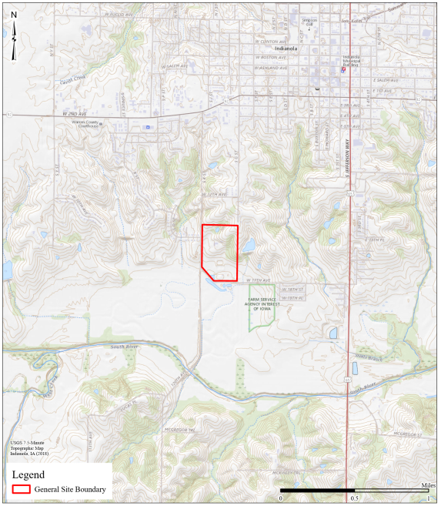
Figure 1. The proposed project area within Indianola, Iowa city limits.
All project facilities would be designed, constructed, and operated in accordance with applicable laws, city and county ordinances, regulations, and standards. The project is anticipated to begin in 2025 and would take approximately four to six months to complete.
The adjoining north and west properties consist of a residential subdivision (to the northwest). The adjoining properties to the south are utilized for recreation and agricultural cropland. An off-leash dog park is adjacent to the project to the south. The land to the east is undeveloped land with a combination of forest and agricultural land. A municipal water treatment building is situated between the proposed north and south groups of solar arrays.

Alternatives evaluated including the proposed action
This section discusses the alternatives selection process and defines the alternatives that were considered. The implementing procedures for NEPA establish a number of policies for federal agencies to follow in order to avoid or minimize the adverse effects of their actions. Among these policies is the use of the NEPA process to identify and assess reasonable alternatives to the proposed project that would avoid or minimize adverse effects (40 CFR 1500.2(e)). Alternatives considered included: no action (maintaining the Status Quo) and construction and operation of a 17.4-acre, 4.2-MW DC distributed solar energy power system on city-owned land in Indianola, Iowa.
Screening Criteria for the proposed action:
For the proposed project to fulfill its purpose of supplying distributed power generation to the City of Indianola, the site on which the solar energy power system would be constructed and operated had to meet the following requirements:
• Located in a relatively undeveloped area near Indianola;
• Adjacent to existing grid connections;
• Accessible via existing roadways;
• Possessing of size, configuration, land use, and topography which accommodates sufficient quantity of PV modules to produce 7.63 MW;
• No structures to be demolished;
• No impact to surface waters;
• Attainable compliance with local ordinances and development permits;
• Availability for lease / development; and
• Reasonable land and development costs.
The proposed Project area was chosen by the City of Indianola because it meets the required criteria and is available for lease. The City has chosen the point of interconnection for its capacity to accommodate the proposed energy generation without adversely affecting system stability.

2.1 Proposed Action and Preferred Alternative
The Proposed Action will include the construction and operation of a 4.2-megawatt (MW) direct current (DC) solar energy power system that will generate electricity for the City of Indianola. The project involves installation of ground mounted photo voltaic (PV) solar arrays of various kilowatt (kW) sizes using single axis trackers as detailed in Appendix B. Each array will be placed generally as shown on the project layout in Figure 2. These are estimates and the module placements may vary inside the general layout area. The layout areas have been previously disturbed through either agricultural activities or prior construction in the area. This staging area will receive heavy traffic and may be rutted at times. Ground-located facilities will be surrounded by perimeter safety fencing and will feature internet accessible Supervisory Control and Data Acquisition (SCADA) readouts.

Access to the facility for construction and operations will be from existing two-track access roads. The arrays will be supported on driven piles. The areas where arrays will be installed will be accessed by vehicles driving on the existing ground surface. No grading for roads will be required and no new roads will be constructed.

The buried medium voltage (MV) electric line that will connect the arrays to Indianola’s grid will involve approximately 100 feet of trenching within the defined project area (Figure 2). Each array will have driven posts for mounting of the racking with cross pieces for the actual module installation. The posts for racking will be in rows with the posts generally 8—10 feet apart and 4—6 feet deep, posts are generally 3 inches in diameter. Each row of racking will be connected by a trench along the edge of the array. The trench from each portion of the array will extend to the location of the transformer on a concrete pad, where the city will take control of the energy generated. The trenches will be 18—24 inches deep and 12 inches wide. The MV line will connect to an existing overhead power line located on the west boundary of the project area.
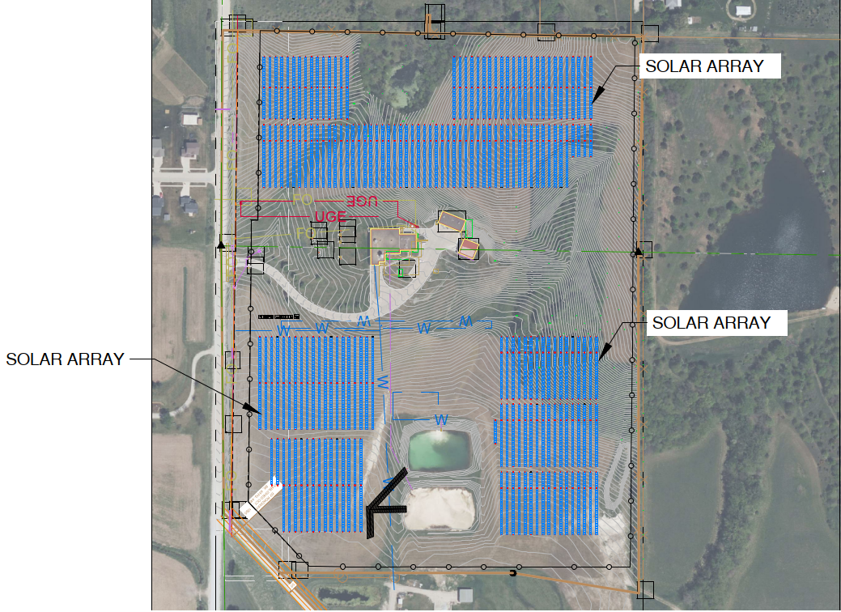
Figure 2. Project layout and location of arrays.

Decommissioning
Within six months of ceasing energy generation operations, SE Municipal Iowa would remove all solar equipment from the property, except for electrical lines buried at least four feet deep. Major pieces of equipment may be recyclable or reusable. The galvanized steel and aluminum racks may be sold for scrap or recycled. Electrical equipment could either be salvaged for reuse or recycled. Components such as the cabling would have a high resale value due to copper and aluminum content. Concrete from footings could be crushed and recycled as granular fill material. As much of the facility would consist of reusable or recyclable materials, it is anticipated that there would be minimal residual waste for disposal as a result of decommissioning the facility. Small amounts of registrable waste materials would be generated and managed in accordance with state requirements or subsequent applicable legislation. Residual non-hazardous wastes would be disposed of at a licensed landfill in operation at the time of decommissioning.

At the time of decommissioning, a rehabilitation plan will be developed to restore agricultural lands and wildlife habitat in areas affected by the project to the same or functionally similar preconstruction state, unless circumstances prevailing shortly in advance of the start of decommissioning indicate that another use is more appropriately or explicitly desired by the landowner.

The Rehabilitation Plan will include, but may not be limited to the following:
- Access roads and other areas which may have become compacted during operation or decommissioning will be de-compacted to pre-existing conditions.
- Restoration of any drainage patterns, including farm drainage tiles that were impacted by the project and existing within the project location at the initiation of project construction to the same condition or better condition than it was before construction.
- Where project infrastructure has been removed, disturbed areas will be seeded with quick-growing native species to prevent topsoil erosion, unless seeding is immediately applied by the landowner. Erosion and sediment control measures and SWPPP protection will be installed at ditches and will be left in place until the ground cover is fully established.

All access roads will be removed; this includes any geotextile material beneath the roads and granular material. All granular and geotextile materials would be removed from the site by a dump truck. Where any access roads will be removed within areas that were previously used for agricultural purposes, topsoil will be redistributed to provide similar ground cover as was present within the areas prior to site disturbance. The exception to removal of the access roads and associated culverts or their related material would be upon written request from the landowner to leave all or a portion of these facilities in place for future use by the landowner.

Beginning on the commercial operations date, a financial security in an amount equal to the expected net cost to complete the restoration will be maintained, with the amount updated every five years based on an estimate by a qualified third-party engineer.

2.2 Other Alternative Evaluated and Not Carried Forward

Other means of electricity generation were considered, but it was determined that the only viable means of power generation in this instance would be from the construction and operation of a solar array. This EA evaluates the proposed action and the no-action alternatives.

Wind: The average hourly wind speed in Indianola experiences significant seasonal variation (Cedar Lake Ventures n.d). The strongest winds occur in northwestern Iowa and although there are wind power farms across the state, most are in the state's northern and western areas, and none are currently located in the vicinity of Indianola (USGS n.d.). Since average wind speeds experience seasonal variation and may drop below industry standards during significant periods of the year, the use of wind turbines to generate electricity is not feasible at this time and the alternative was not considered.

Geothermal: Although moderate geothermal energy potential exists across much of the state, there are a few small areas in southeastern Iowa with the high-temperature resources needed for power generation. Iowa does not generate utility-scale electricity from geothermal energy; However, several commercial and residential sites in the state use geothermal heat pumps to heat and cool buildings (U.S. EIA 2020). This alternative was not considered as geothermal sources would likely not meet the utility-scale energy generation required for the City of Indianola.

2.3 No Action Alternative (Status Quo)
Under the No Action Alternative, the project area would not be developed with a solar facility. Indianola would not receive the generated power from this potential alternative energy/solar source and would require another means of providing renewable for its customers. The project area would continue to be available for agricultural production until such time that it is developed per its designated industrial zoning. The anticipated generation from this potential alternative energy/solar source would not be available, and Indianola would have to seek alternative electric generation sources to replace existing power supply contracts that will come to an end. The project area would continue as farmed agricultural land. The No Action Alternative does not achieve the project’s purpose and need. For this EA, the No Action Alternative is carried forward through the environmental analysis for comparison to the Proposed Action.

2.4 Environmental Resources Not Carried Forward for Detailed Analysis
The determination of environmental resources to be analyzed versus those not carried forward for detailed analysis is part of the EA scoping process Per 40 CFR 1502.4(d)(1)] the lead agency can “identify and eliminate from detailed study the issues which are not significant, or which have been covered by prior environmental review”. Some resource areas or some aspects of resource areas would not be affected by the proposed or alternative actions. Resource areas that have been eliminated from further study in this document and the rationale for eliminating them are presented below:
Coastal Resources - The project area is not located within a state identified in the Coastal Zone Management Act of 1972 or Coastal Barriers Resources Act; therefore, there are no effects to coastal resources. No further analysis is required.
Electromagnetic Fields and Interference (EMF) - No EMF transmitting objects such as overhead high-voltage electric transmission lines, substations, cell or microwave towers will be installed as part of the Proposed Action; therefore, detailed analysis of EMF is not required. All of the necessary transmission lines are currently present, adjacent to the subject property.
Corridor Analysis – A corridor analysis is not applicable for this project area as it does not follow a linear path nor have large electrical transmission lines, telecommunication cables, water or wastewater pipelines leading to or away from it; therefore, a detailed analysis is not required.

affected environment, environmental consequences, and mitigation measures
This chapter describes the current conditions of the environmental resources, either manmade or natural, that would be affected by implementation of the Proposed Action or alternatives. This chapter also describes the potential environmental effects that are likely to occur as a result of implementation of the Proposed Action. The No Action Alternative provides a baseline against which the effects of the Proposed Action can be compared. The terms below describe the types of effects being discussed in this EA.
Long-Term or Short-Term: These characteristics do not refer to any rigid time period. Short-term impacts would be those that are temporary and short-lived. Long-term impacts would be those that are more likely to be persistent and chronic.
Direct or Indirect: A direct impact would be caused by and occur contemporaneously at or near the location of the action. An indirect impact would be caused by a proposed action and might occur later in time or be farther removed in distance but could still be a reasonably foreseeable outcome of the action.
Negligible, Minor, Moderate, or Major: These relative terms are used to characterize the magnitude or intensity of an impact. Negligible impacts would generally be perceptible but would be at the lower level of detection. A minor impact would be slight, but detectable. A moderate impact would be readily apparent, but less than major. A major impact would be significant; an impact having major unfavorable or undesirable outcomes on the man-made or natural environment.
Beneficial: A beneficial impact would be one having positive outcomes on the man-made or natural environment. A single act might result in major impacts on one environmental resource and beneficial impacts on another resource.
Federal actions are subject to Federal environmental laws and regulations; however, the project must comply with applicable state and local regulations. The impact analysis addressed Federal, state, and local requirements were applicable and the various environmental resources and coordination efforts to determine the environmental consequences on the resources described in this chapter. When multiple regulations apply to a similar environmental resource, the more stringent regulations are used to evaluate the environmental consequences.

Land Use

Affected Environment
Land use refers to the use of land for various activities, including commercial, industrial, recreational, agricultural, and residential. Adopted plans and development regulations control the type of land use and the intensity of development or activities permitted. Changes in land use patterns that result from development can affect the character of an area and result in physical effects to the environment. This section describes the land use and ownership resources occurring in the project area and the potential effects to those resources due to project implementation.
General Land Use
The proposed project would consist of a solar facility including four separate groups of solar arrays totaling 17.4 acres in an area that currently consists of agricultural cropland. The northern group of arrays will occupy approximately 8.6 acres while the arrays to the southeast and southwest will occupy 6.2 and 2.6 acres, respectively. The proposed project area is in Warren County, Iowa, located within the southern boundary of Indianola, Iowa city limits. As such, the project area falls within the jurisdiction of Warren County and the City of Indianola and is within Warren County Assessor Parcel Nos. 48870360463 and 48870360645. These parcels are zoned as Agricultural/Open Space Zoning District (A1) (City of Indianola n.d.) (Appendix A).
Important Farmland
The Farmland Protection Policy Act (FPPA) and USDA Departmental Regulation No. 9500-3, Land Use Policy, provide protection for important farmland, prime forestland, and prime rangeland. The USDA regulation 7 CFR Part 658 implements the FPPA (1970). The FPPA, 7 U.S.C. 4201, was enacted in 1981 in order to minimize the loss of prime farmland and unique farm, forest, and range lands as a result of Federal actions by converting these lands to nonagricultural uses. As defined by FPPA, prime farmland is farmland that has the best combination of physical and chemical characteristics for producing food, feed, forage, fiber and oilseed crops, and is also available for these uses. A unique farmland is land other than prime farmland that is used for production of specific high-value food and fiber crops; it has the special combination of soil quality, location, growing season, and moisture supply needed to economically produce sustained high quality or high yields of specific crops.
The USDA Natural Resources Conservation Service (NRCS) soil survey contains information regarding USDA-identified prime farmland soils, which are required for a prime farmland designation. Soil types and their farmland classification are shown in Table 1 below. The land within the project boundary includes prime farmland and farmland of statewide importance (Fig. 3; Table 1; Appendix A) (USDA NRCS 2023).
Table 1. Prime Farmland within the project boundary.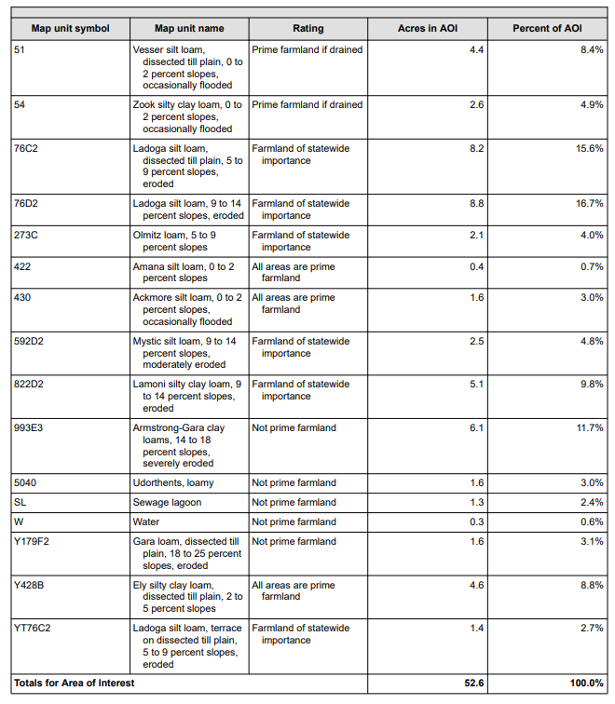

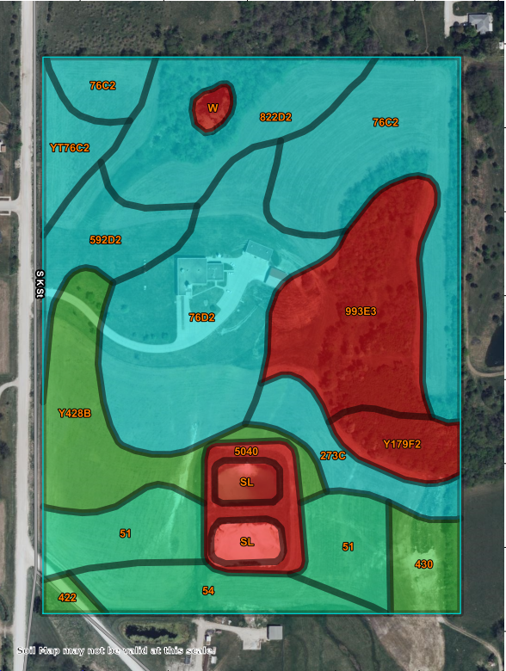
Figure 3. NRCS Soil Survey. All areas are prime farmland except those shaded red.

Formally Classified Lands
Formally Classified Lands (FCLs) are properties administered either by federal, state, or local agencies, or properties that have been given special protection through formal legislative designation. Review of FCLs for the project area began with a review of the USDA guidance document regarding FCLs. FCLs may cover a broad spectrum of agency oversight, so documentation entails referencing multiple agency databases. The USGS Protected Areas Database of the U.S. (PAD-US) combines several agency databases into a single source documenting lands with some level of federal, state, local, and private protection (Appendix A). Review of the PAD-US revealed that there are no known protected areas within the project area. The nearest PAD-US documented protected land is the City-owned Downey Memorial Park and Indianola Off-Leash Park located approximately 250 feet to the south. In addition to PAD-US, multiple agency databases were reviewed including the United States Fish and Wildlife Service (USFWS), United States Forest Service (USFS), Iowa State Historic Preservation Office (SHPO), the National Park Service (NPS), and USGS to determine if the project area is located within the administrative boundaries of FCLs. No FCLs were identified within or adjacent to the project area.

Environmental Consequences
No Action Alternative
Under the No Action Alternative, the project area would continue to be cultivated and produce crops; therefore, there would be no change in land use and no effects are anticipated.

Preferred Alternative
Land use will change from crop production to solar electric generation. Since the current zoning classification of the project area is for agricultural use, a Special Use Permit application will be submitted to the City of Indianola. Effects related to the change in land use are considered minor. Resources produced within the project area will change from crops to electricity for the City.

The applicant submitted a Farmland Conversion Impact Rating Form AD-1006 to the NRCS to evaluate the project’s effects to prime farmland. Acres to be converted are as shown:
- Total acres to be converted directly: 29.7
- Total acres to be converted indirectly: 0
- Total acres in site: 29.7
- Total acres prime and unique farmland: 9.4
- Total acres statewide important or local important farmland: 15.6

Mr. Patrick Chase, a USDA soil scientist, assisted in the completion of Parts I through V of the Form on June 2, 2022. The NRCS indicated the proposed project scored an effect rating of 55 (Appendix A). The NRCS detailed that the FPPA law states that sites with a rating less than 160 require no further consideration for protection and no additional evaluation is necessary; therefore, no significant effects to prime farmland are anticipated.

Mitigation Measures
The change in land use from agriculture to energy generation will require a Special Use Permit from the City. Ground disturbance activities will not occur until the Special Use Permit has been approved/received and any additional mitigative measures specified in the Permit will be adhered to.

Floodplains

Affected Environment
According to the Federal Emergency Management Agency (FEMA) Flood Insurance Rate Map (FIRM) Panel No. 19181C0277F, effective November 16, 2018, a 500-year floodplain (Zone A) is located along the southern boundary of the project area. The remainder of the area is located within an area designated as Zone X, or outside of a floodplain (Figure 4 below and Exhibit 6 in Appendix A) (FEMA 2023B). No critical infrastructure will be placed in the 100-year floodplain.
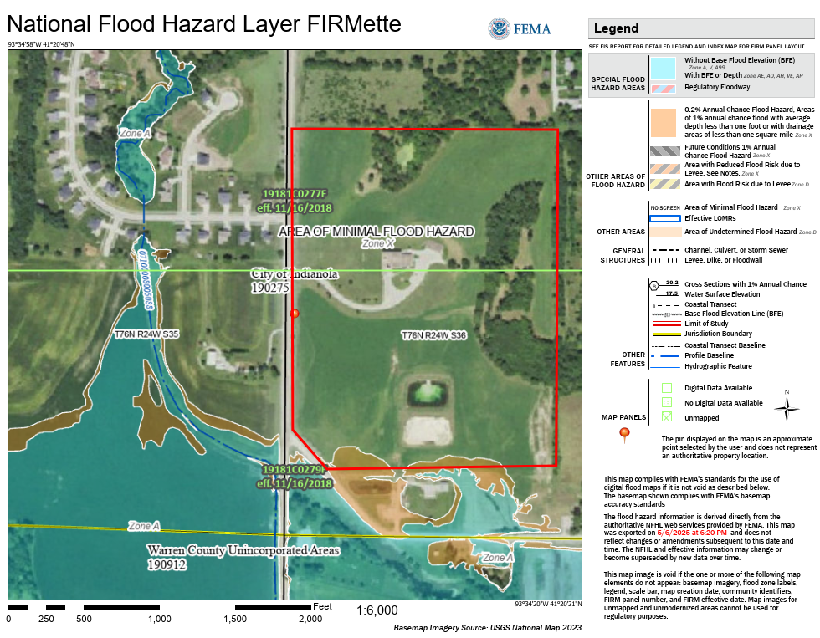
Figure 4. Floodplain map showing Zone X, an area of minimal flood hazard, within the project area.

Environmental Consequences
While no construction will take place in the 100-year flood zone and no critical actions (i.e., construction or operation of power-generating infrastructure) will take place in the 100- or 500-year flood zones, an approximate 751-foot length of security fencing will overlap with the 500-year floodplain along the southern boundary of the project area (Figure 5).

The USDA Rural Development’s (RD) implementing regulations for floodplain management are found at 7 CFR, Part 1970, Subpart F. As outlined in RD Instruction 1970.256, projects considered critical actions within a 100- year floodplain will adhere to the standards for federal agencies by which to evaluate flood and floodplain effects and therefore require an eight-step decision-making process pursuant to USDA RD guidelines and procedures for projects which do not normally require scoping with the agency.

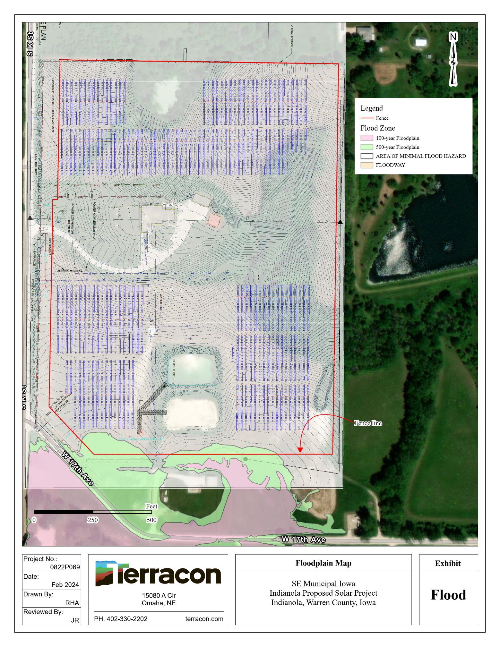
Figure 5. Floodplain map highlighting the southern boundary fence line, which avoids the 100-year floodplain.

Mitigation Measures
Since no features of the project will be placed either temporarily or permanently in a 100-year floodplain, no mitigation measures are warranted.

Wetlands

Affected Environment
The U.S. Army Corps of Engineers (USACE) and Environmental Protection Agency (EPA) define wetlands as follows: "Wetlands are areas that are inundated or saturated by surface or ground water at a frequency and duration sufficient to support, and that under normal circumstances do support, a prevalence of vegetation typically adapted for life in saturated soil conditions. Wetlands generally include swamps, marshes, bogs, and similar areas.”
For an area to satisfy this definition, it must exhibit the required indicators in all three categories: soil, hydrology, and vegetation. If any one of the three categories is missing wetland indicators, the area in question does not satisfy the USACE and EPA’s definition of a wetland.
A Wetland/Waters of the United States (WOTUS) Delineation was conducted in October 2022. Five wetlands, two swales, one pond, and two lagoons were documented within the project area, with one of those wetlands within the area of disturbance (Terracon 2022A). The wetland within the area of disturbance, designated as Wetland Area 1 within the Wetland/WOTUS Delineation Report, is approximately 0.16 acres in size and is located in the northern parcel within a vegetated swale. Surface water runoff from this area would run southwest before entering a stormwater culvert just north of the access drive to the Water Plant. This culvert appears to discharge to the roadside ditch that runs along South K Street. Runoff within this ditch runs south before entering a stormwater culvert that runs under W. 17th Avenue. Wetland Area 1 did not appear to have a connection to potential WOTUS and is assumed to be non-jurisdictional due to a lack of a continuous surface connection to a relatively permanent waterway. A copy of the Delineation Report is included in Appendix A.

Environmental Consequences
No Action Alternative
Under the No Action Alternative, the project area would continue to be farmed, and the existing wetland would not be impacted by construction or other activities related to the installation of the solar facility.

Preferred Alternative
The Proposed Action would result in negligible negative effects to the existing wetland due to temporary disturbance from equipment access. The northern arrays will be pile-supported, which will involve the installation of driven piles within the wetland. Due to the pile installation and vehicle/foot traffic within the area, there is a potential for wetland vegetation to be temporarily and adversely affected by crushing. Some shading will occur in the areas directly underneath the panels; however, this is not expected to result in vegetation mortality (Graham et al. 2021). Wetland hydrology and soils are not likely to be affected by the installation of pile-supported panels. USACE typically does not consider pilings driven into wetlands as a discharge of fill material that would require authorization under Section 404 of the Clean Water Act (CWA). However, the agency indicates it will review each project on a case-by-case basis. If the placement of the pilings would have the effect of fill material, the USACE is more likely to require authorization and mitigation for permanent wetland losses of one-tenth of an acre or more (email communication between Terracon and USACE on October 22, 2024).

Construction will commence and finalize within four to six months. Pile supports will remain in place over the lifetime of the solar facility (25 years) and will be removed during decommissioning. No grading or filling will take place within the wetland area.

Mitigation Measures
To prevent soil compaction and rutting in wetlands due to equipment access, if soils are wet during construction, the applicant will incorporate the use of timber matting, which can be removed after the piles are installed. This measure, in addition to reseeding, will aid vegetation reestablishment after construction.

Water Resources
    - Affected Environment
Surface Water
The project area is within the Lake Rock Watershed (HUC 07100008). Data from the USGS National Hydrography Dataset (NHD) indicates that no streams or waterbodies are present within the project area, however two lagoons are apparent in aerial images of the project area which separate the southeast and southwest arrays, and a pond occupies an approximate half-acre area abutting the northern group of solar arrays. Outside of the project area, several reservoirs are depicted to the northeast and northwest.

Groundwater
A sole source aquifer is not located within the state of Iowa (U.S. EPA 2023A); however, the Jordan Aquifer stretches across the state and is used by many communities as a major water source. The City of Indianola's water source is the Cambrian-Jordan Sandstone Aquifer, which lies approximately 2,600 feet below ground level (City of Indianola 2024A). It is assumed that the Cambrian-Jordan Sandstone Aquifer is located beneath the ground surface of the project area.
    - Environmental Consequences
No Action Alternative
Under the No Action Alternative, the existing land, unimproved areas, and associated pervious cover would remain; therefore, the amount of runoff would not increase, groundwater infiltration would remain the same, and the potential for erosion due to disturbed soil would not be present. No effects to groundwater or surface water resources are anticipated.

Preferred Alternative
Implementation of the Proposed Action would result in no direct effects to surface waters associated with construction and operation of the facility. The Proposed Action may result in negligible, short-term, negative indirect effects to surface water quality. During construction, approximately 17.4 acres of soils will be disturbed (including but not limited to temporary vehicle access and equipment/component storage), which may increase the opportunity for sediment to leave the construction area and enter surface waters. This has the potential to adversely affect water quality if best management practices (BMPs) are not implemented to control sediment or other pollutants during construction.

Surface Water
Because the amount of soil to be disturbed is expected to be greater than one acre, the Proposed Action would require authorization under the Iowa Department of Natural Resources (IDNR) Construction Storm Water General Permit that authorizes stormwater discharge under the National Pollutant Discharge Elimination System (NPDES). Prior to any ground disturbance, a Notice of Intent (NOI) must be filed with the IDNR and a Stormwater Pollution Prevention Plan (SWPPP) prepared and implemented to minimize construction-related impacts. Implementation of the SWPPP and BMPs and compliance with the terms and conditions of the IDNR NPDES General Permit would ensure any potential effects are not significant.

After construction activities are completed, the arrays and concrete pads for structures would be considered disconnected impervious surfaces with pervious surfaces retained between the arrays, resulting in a negligible increase in the amount of runoff and slightly decreasing infiltration during rain events. Management of runoff from the arrays and structures will be part of the project design and will prioritize retaining stormwater by maximizing vegetated surface area where practical. Proper revegetation practices would minimize potential effects to surface waters.

Ground Water
The proposed action will not require the use of groundwater from the Cambrian-Jordan Sandstone Aquifer since the proposed solar facility will not require water to operate as there will be no maintenance or operations facilities within the project area. Water used during the construction phase would arrive from outside sources via water truck and no additional wells or public utility tie-ins will be utilized. Additionally, given that only a small portion of the project area will become impervious, the reduction of percolation to the Cambrian-Jordan Sandstone aquifer is expected to be de minimis; therefore, no adverse effects to groundwater resources are anticipated.
    - Mitigation Measures
Because the area of disturbed soil will exceed one acre, authorization under the IDNR NPDES General Permit is required along with the implementation of a SWPPP. The contractor will implement BMPs to ensure that during rain events, sediment and debris do not leave the project area. BMPs to be utilized may include but are not limited to:

- Installing silt fences around material stockpiles, storm water drainage routes, culverts, and drains;
- Installing hay or fabric filters, netting, and mulching around material stockpiles, storm water drainage routes, culverts, and drains;
- Watering disturbed areas to control windblown dust;
- Installing track-out protection to minimize sediment being tracked onto pavement from vehicles exiting the work site;
- Suspending work during rainy conditions;
- Planning and conducting earthwork in a manner that minimizes the duration of exposure of unprotected soils;
- Maintaining temporary erosion control measures, such as berms, dikes, drains, sedimentation basins, seeding, and mulching, until permanent drainage and erosion control facilities are completed and operative; and
- Employing good housekeeping measures to minimize exposure of materials stored on site to stormwater.

Biological Resources

Affected Environment
General Fish, Wildlife, and Vegetation Resources
The project area lies within the Rolling Loess Prairies ecoregion, which is characterized by a mosaic of tallgrass prairie and oak-hickory forest (IDNR. N.d.4). The project area itself is a combination of a developed water treatment plant and agricultural cropland adjacent to and south of the City of Indianola, Iowa. Species that may be found in the project area include common species of insects, amphibians, reptiles, birds, and mammals that are adapted to suburban conditions and associated human presence. Vegetation on the site is managed through agricultural practices and landscaping. There are no streams within the project boundary; however, there is one pond near the north project boundary that may have been created for livestock watering. There are large trees located near the northeast and southeast corners of the project area.

Federal and State Listed Species
Section 7 of the Endangered Species Act (ESA) directs all federal agencies to use their existing authorities to conserve threatened and endangered (T&E) species and, in consultation with the USFWS, to ensure that their actions (funded or carried out) do not jeopardize listed species or destroy or adversely modify critical habitat. Lists of T&E species are published by the USFWS. Under the ESA, it is the responsibility of the federal action agency or its designated representative to determine if a proposed action “may affect” endangered, threatened, or proposed species, or designated critical habitat, and if so, to consult with the USFWS further. Similarly, it is the responsibility of the federal action agency or project proponent, not the USFWS, to make “no effect” determinations. According to the USFWS, if a “no effect” determination has been made for a proposed project, it is not necessary to seek concurrence from the USFWS. However, if a “may affect” determination has been made for a proposed project, consultation with the USFWS will be necessary.
Federally listed threatened and endangered species are listed on the USFWS Information, Planning, and Conservation System (IPaC). IPaC generated a species list and report dated November 27, 2024. The list of T&E species compiled on the IPaC report includes five threatened, endangered, or proposed threatened/endangered species with ranges that may extend into the project area (Appendix C). Additionally, a summary of species listed by the IDNR is also provided in Appendix C (IDNR n.d.1). The IDNR indicated, in a correspondence dated January 11, 2023, that no record of protected species or rare natural communities were found within the project area (Appendix C).
Migratory Birds/Protect Bald and Golden Eagles
The federal Bald and Golden Eagle Protection Act (Eagle Act) (16 U.S.C. 668-668c) provides for the protection of the bald eagle (Haliaeetus leucocephalus) and golden eagle (Aquila chrysaetos). Under the Eagle Act, “take” of eagles, their parts, nests, or eggs is prohibited. Disturbance resulting in injury to an eagle or a decrease in productivity or nest abandonment by substantially interfering with normal breeding, feeding, or sheltering behavior is a form of “take.”

Under the Migratory Bird Treaty Act (MBTA), it is illegal to “take, possess, import, export, transport, sell, purchase, barter, or offer for sale, purchase, or barter, any migratory bird, or the parts, nests, or eggs of such a bird except under the terms of a valid permit issued pursuant to Federal regulations.”

The IDNR’s “Iowa’s Important Bird Conservations Areas” map identifies areas of key habitat for breeding bird species in the State (IDNR n.d.2). The project area is not located in a Bird Conservation Area (Figure 6). Furthermore, land cover within the project area is primarily agricultural, except for patches of hardwood forest on the north and east project boundaries, which does not provide suitable habitat for ground nesting birds.

Table 2. State and Federal listed species and their habitats.
Species | Protection Status | Habitat Description | Habitat Present
Mammals
Indiana bat  (Myotis sodalist) | FE, SE | Roosts in tree cavities or under loose bark on trees such as shagbark hickory, elm, beech, birch, oak, maple, ash, sassafras, sycamore, pine, aspen, cottonwood, locust, and hemlock. May travel thousands of kilometers during migration. Found from New Hampshire south to northern Florida and west to Iowa, Missouri, and Oklahoma. Hibernates in limestone caves, where bats cluster in the thousands. | Yes; presence of forested areas along the project’s east and north boundaries.
Tricolored bat  (Perimyotis subflavus) | FPE | Generally found in partially open landscapes with large trees and woodland edges. May be found in grasslands, suburban areas, and hardwood woodlands. Avoids dense woodlands and large, open fields. Typically forages along forest edges and over waterways. Roosts in tree foliage, beard lichen, or built structures. Hibernates in caves, mines, or built structures in the winter. | Yes; presence of forested areas along the project’s east and north boundaries.
Birds
Barn owl  (Tyto alba) | SE | Savanna species that nests and roosts in dark, secluded places. Often found roosting and nesting in barns or abandoned buildings. Hunts in grassland habitats along field edges, fencerows, and wetland edges where their favored prey is most available. | Yes; presence of agricultural fields, and forested areas along the project’s east and north boundaries.
Henslow’s sparrow (Ammodramus henslowii) | ST | Prefers tall, dense grass with a well-developed litter layer and little to no woody vegetation. Found primarily in grasslands greater than 100 acres. | No; absence of suitable habitat within or near the project area.
King rail  (Rallus elegans) | SE | Found in wetland and grassland complexes, typically along the sedge-meadow zone at the edges of marshes. | No; absence of suitable habitat within or near the project area.
Northern harrier (Circus cyaneus) | SE | Ground-nesting species that hunts in open fields, marshes, meadows, and pastures. Prefers large tracts of undisturbed grassland. Uncommon to southern Iowa. | Yes; presence of agricultural fields which may be utilized for hunting.
Short-eared owl (Asio flammeus) | SE | Ground-nesting species that hunts in open fields, marshes, meadows, and pastures. Prefers large tracts of undisturbed grassland. | Yes; presence of agricultural fields which may be utilized for hunting.
Insects
Byssus skipper  (Problema byssus) | ST | Found in tallgrass prairie. | No; absence of suitable habitat within or near the project area.
Western Regal Fritillary (Argynnis idalia occidentalis) | FPT | Inhabits native tallgrass prairie ecosystems. Their unique habitat requirements restrict the larvae to feeding exclusively on members of the Viola genus, particularly prairie violet (Viola pedatifida). However, adults can inhabit somewhat marginal habitats in degraded prairies, hay fields, and pastureland, if they have access to nectar-producing plants for foraging. | No; absence of suitable habitat within or near the project area.
Monarch butterfly (Danaus Plexippus) | FPT | In general, breeding areas are patches of milkweed in North America and some other regions. Open fields where flowering plants are present would support foraging. | Yes; there is potential areas for milkweed and other flowering species in the roadside ditches and field margins.
Plants
Eastern prairie fringed orchid (Platanthera leucophaea) | FT | Occurs in a wide variety of habitats, from mesic prairie to wetlands such as sedge meadows, marsh edges, and even bogs. Requires full sun for optimum growth and flowering and a grassy habitat with little or no woody encroachment. | No; absence of suitable habitat within or near the project area.
Mead’s milkweed (Asclepias meadii) | SE | Primarily occurs in mesic to dry-mesic areas. Its habitat is characterized by drought and fire-adapted vegetation such as tallgrass prairie, but can also occur in hay meadows, and in thin soil glades or barrens. | No; absence of suitable habitat within or near the project area.
Prairie bush-clover (Lespedeza leptostachya) | FT, ST | May be found in disturbed tallgrass prairie habitats that have been previously mowed, burned, cultivated, or grazed, in addition to undisturbed remnant prairie sites. The species is adapted to a diverse assortment of prairie soil conditions and can occur in a variety of prairie types including dry, dry-mesic, mesic, or bedrock prairies. | No; absence of suitable habitat within or near the project area.
Slender ladies’-tresses  (Spiranthes lacera) | ST | Occurs in moist to dry meadows, fields, prairies, open woods, and disturbed areas such as along roadsides and in lawns. | Yes; potential habitat exists along adjacent roadways and lawn areas near the water treatment plant.
Slim-leaved panic grass  (Dichantehlium digitatum) | ST | Found in dry meadows or prairies and open woodlands. | Yes; small openings in forested areas on the east and north site boundaries may provide habitat.
Ground pine  (Lycopodium clavatum) | SE | Found in moist shaded woodlands and roadsides. | Yes; forested areas on the north and east boundaries of the site, as well as the roadsides to the west and south of the project boundary may provide habitat.
FE – Federal Endangered, FPE – Federal Proposed Endangered,
FT – Federal Threatened, FPT – Federal Proposed Threatened,
SE - State Endangered, ST – State Threatened

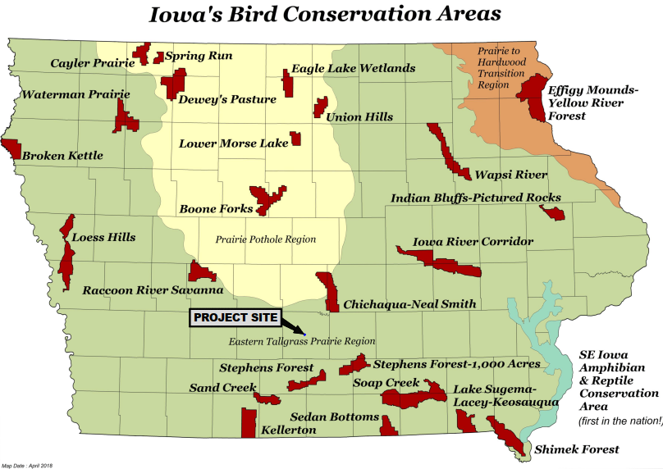
Figure 6. Iowa’s Bird Conservation Areas.

Wildlife Resources and Vegetation
The project area has been disturbed by agricultural activity since at least 1938 and continues to be utilized for crop production.

Invasive Plant Species and Noxious Weeds
Executive Order 13112 (Invasive Species) was created to prevent the introduction of invasive species and to provide for their control. The Federal government cannot fund or authorize actions that may promote the introduction or spread of invasive species. The IDNR lists 38 invasive plant species (IDNR n.d.3) and Chapter 317 of the Iowa Code lists 26 noxious weed species in the State (Iowa Code 2024) (Appendix C). Terracon reported observing one noxious weed species: Canada thistle (Cirsium arvense), and four invasive species: Canada thistle (Cirsium arvense), Queen Anne’s lace (Daucus carota), wild parsnip (Pastinaca sativa), and reed canary grass (Phalaris arundinacea), during a wetland delineation conducted October 5, 2022 (Terracon 2022A) (Appendix C).

Environmental Consequences
No Action Alternative
Under the No Action Alternative, the project area would remain in its current condition resulting in no effects to wildlife or habitat.

Preferred Alternative
Federal and State Listed Species
Implementation of the Proposed Action would remove existing vegetation, which consists of agricultural crops and approximately two acres of wooded land. Potentially suitable habitat for several federal and/or state-listed species is present within the project area and immediate vicinity. Determinations of effect for each species are provided below.

- Indiana bat – The Indiana bat roosts in mature trees with cavities and loose bark during the warm season and hibernates in caves over winter. This project will require limited tree clearing to accommodate the eastern groups of solar arrays. Tree clearing will be limited to an approximate two-acre area, and the earliest tree removal would occur would be after August 1 to minimize the potential to adversely impact bat pups should they be in the area. The timing of tree removal renders take reasonably unlikely to occur. The loss of available roosting habitat indicates that a determination of may affect, not likely to adversely affect is appropriate. The project area is adjacent to approximately 10 – 20 acres of similar wooded habitat that will remain available to bats after the project is constructed.
- Tricolored bat – The tricolored bat roosts amongst living and dead leaves, particularly those of living or recently dead hardwoods, and hibernates in caves, mines, or buildings over winter. This project will require limited tree clearing to accommodate the eastern groups of solar arrays. Tree clearing will be limited to an approximate two-acre area, and the earliest tree removal would occur would be after August 1 to minimize the potential to adversely impact bat pups should they be in the area. The timing of tree removal renders take reasonably unlikely to occur. The loss of available roosting habitat has resulted in a determination of may affect, not likely to adversely affect.
This determination is further supported by the IPaC-assisted determination key (D-key) and a standing analysis completed by the Service. The project area is adjacent to approximately 10 – 20 acres of similar forested habitat that will remain available to bats after the project is constructed. According to guidance provided by the USFWS, tree removal thresholds within seasonal restrictions are ≤5 acres when coupled with the small percentage of forest cover within the broader project area.
However, based on the results of the IPaC determination key (D-key), further consultation with the USFWS is required for this species. The IPaC D-key Consistency Letter suggests coordination with the Illinois-Iowa Ecological Field Office to review methods to avoid or minimize potential adverse effects to the tricolored bat.
- Barn owl – The barn owl has the widest distribution of any owl species and can be found in agricultural fields, marshes, grasslands, and open areas. They tend to nest in tree cavities, abandoned buildings, and caves. As this project will require the conversion of agricultural land to solar production and limited tree clearing, in turn reducing available forage and habitat for this species, a determination of may affect, not likely to adversely affect is most appropriate; however, larger tracts of woodland and agricultural land are located adjacent to the project area, further from the urban center of Indianola, and likely provide superior habitat for this species.
- Henslow’s sparrow – This species generally prefers prairie grassland habitats but may also occupy hayfields and pastures. The project area is currently occupied by row crops, which is not suitable habitat for this species; therefore, no effect to this species is anticipated.
- King rail – The king rail may be found in freshwater marshes dominated by reeds and cattails, where they forage for aquatic insects and crabs. This habitat is not available within the project area, therefore no effect to this species is anticipated.
- Northern harrier – The northern harrier prefers open prairie grasslands and marshes where they construct ground nests and hunt for small mammals, reptiles, and amphibians. Northern harriers may also hunt for rodents in agricultural fields. As this project will require the conversion of agricultural land to solar production, in turn reducing available forage for this species, a determination of may affect, not likely to adversely affect is most appropriate; however, larger tracts of agricultural land are located south of and adjacent to the project area, further from the urban center of Indianola, and likely provide equal or superior foraging space for this species. Additionally, the presence of solar panels would not preclude this species from foraging between the arrays.
- Short-eared owl - This species generally prefers open grassland and marsh habitats but may also occupy hayfields and pastures. Short-eared owls may also hunt for rodents in agricultural fields. As this project will require the conversion of agricultural land to solar production, in turn reducing available forage for this species, a determination of may affect, not likely to adversely affect is most appropriate; however, larger tracts of agricultural land are located south of and adjacent to the project area, further from the urban center of Indianola, and likely provide equal or superior foraging space for this species. Additionally, the presence of solar panels would not preclude this species from foraging between the arrays.
- Byssus skipper – This species is found in tallgrass prairie and marsh habitats. The project area consists of previously disturbed agricultural cropland, therefore no effect to this species is anticipated.
- Western Regal Fritillary – This species is found in native tallgrass prairie ecosystems, which are not present in or near the project area, therefore no effect to the species is anticipated.
- Monarch butterfly – There is potential habitat present in the project area for this species. During construction, habitat would be disrupted temporarily. After construction and revegetation, pollinator species would be incorporated into the reclamation seed mix, therefore, improving habitat for this species in the long term. The Project may affect, but is not likely to adversely affect this species.
- Eastern prairie fringed orchid – This species is found in tallgrass prairies. The project area consists of previously disturbed agricultural cropland, therefore no effect to this species is anticipated.
- Mead’s milkweed – This species is found in tallgrass prairies. The project area consists of previously disturbed agricultural cropland, therefore no effect to this species is anticipated.
- Prairie bush clover – This species may be found in a variety of habitats including disturbed and undisturbed prairies of the upper-Midwest, including areas that have been previously mowed, burned, cultivated, or grazed, in addition to undisturbed remnant prairie sites. The project area consists of previously disturbed agricultural cropland, therefore no effect to this species is anticipated.
- Slender ladies’-tresses – This species can be found in disturbed or undisturbed forests, meadows, or prairies. Potential habitat exists along the adjacent roadways along the western and southern boundaries of the project area as well as the grassed area surrounding the water treatment facility and may be indirectly impacted by project activities. Therefore, a determination of may affect, not likely to adversely affect is appropriate.
- Slim-leaved panic grass – This perennial grass occurs in dry meadows or prairies and open woodlands. The forested acres on the east boundary of the project area include small openings where this species may establish. Potentially suitable habitat may be directly affected by the removal of trees along the northeastern project boundary, but the area affected will be less than five acres. Therefore, a determination of may affect, not likely to adversely affect is appropriate.
- Ground pine – This species is found along moist, shaded woodlands and roadsides. The forested acres to the east and roadsides along the west and south boundaries of the project area may provide suitable habitat. Potentially suitable habitat may be directly affected by the removal of trees along the northeastern project boundary, but the area affected will be less than five acres. Therefore, a determination of may affect, not likely to adversely affect is appropriate.

Migratory Bird Treaty Act and Golden Eagle Protection Act
The project area consists of land that was previously disturbed by agricultural production. No effect to coastal habitat for shore birds or other migratory birds is expected. According to the Bald and Golden Eagle Protection Act (16 U.S.C. 668-668c) (BGEPA), development within 660 feet of an eagle nest is subject to development restrictions and potential mitigation. A bald eagle nest was not observed within the project area during a wetland delineation conducted by Terracon in October 2022 (Terracon 2022A). Furthermore, project development consists of the placement of solar panels which will be significantly lower to the ground than the surrounding tree cover, limiting the potential for panels to be used as vantage point structures. Effects to eagles that may use the project area as a flight corridor are not likely. New powerlines will be buried below PV panels or attached to the underside of the panels. There will be no new overhead lines constructed in association with the arrays or other features of the project; therefore, an electrical hazard is not present, and no effect is anticipated.
The Project area is not located within a Bird Conservation Area. The project is not expected to have a negative effect on avian species due to the nature of the development and siting of the project. Solar panels are generally no higher than 15 feet above ground surface and are not anticipated to affect bird flight or migration pathways.

Invasive Plant Species and Noxious Weeds
Construction work and associated soil disturbance can make areas more susceptible to the spread of invasive vegetation species which could have adverse effects on existing vegetation within the proposed project area. Weeds can crowd out native herbaceous species and create unsuitable conditions for native species of animals, birds, and insects that depend on a diverse native plant community.

Mitigation Measures
To minimize potential impacts to tricolored and Indiana bats, tree clearing will take place after August 1, when pups are able to feed and forage on their own. Additional mitigation measures identified by the USFWS may be required to avoid deleterious effects to listed bat species.
A survey for eagle nests should be conducted no more than one week prior to tree removal to avoid disruptions to nesting eagles should they be present.
Temporary erosion control measures would be used during construction to eliminate soil erosion and spread of invasive species. Generally, soils used for project construction would be acquired from the surrounding landscape where possible. Revegetation efforts will utilize species that are endemic to the area and are suitable for the soil types that exist within the project area. Reseeding efforts should also be initiated as soon as practical after construction is completed, and should include, in addition to grasses, native forbs and pollinator species to occupy the niches that invasive weeds may otherwise colonize. An increase in weed species is expected for the first one or two growing seasons after construction. A weed management plan will be developed by the applicant that specifies post-construction measures to be taken to identify and manage noxious weed species until the project area is revegetated with desirable species. These measures may include overseeding, controlled grazing, or chemical treatments depending on the species identified and the desired measure of control.
Additional mitigation measures are proposed and outlined within the Biological Assessment (BA) provided in Appendix C. As part of the consultation process under Section 7 of the ESA, the USFWS may add mitigation/conservation measures to protect listed species and their suitable habitat to ensure effects to listed species/suitable habitat are minimal and non-significant.

Cultural Resources and Historic Properties

Affected Environment
The cultural environment includes those aspects of the physical environment that relate to human culture and society, along with the social institutions that form and maintain communities and link them to their surroundings. Section 106 of the National Historic Preservation Act (Section 106) requires federal agencies to take into account the effects of their “undertakings” on historic properties that are within the proposal’s “area of potential effect” (APE) and to provide the Advisory Council on Historic Preservation (ACHP) with a reasonable opportunity to comment on such undertakings. The regulations implementing Section 106 establish the process through which federal agencies meet this statutory requirement. Notwithstanding the above statement, in most cases agency actions will not be reviewed by the ACHP but rather by State Historic Preservation Officers (SHPO) and Tribal Historic Preservation Officers (THPOs) on and off tribal land. Federal agencies must consider whether their activities could affect historic properties that are already listed, determined eligible, or not yet evaluated under the National Register of Historic Places (NRHP) criteria. Properties that are either listed in or eligible for listing in the NRHP are provided the same measure of consideration under Section 106.

Criteria have been established as guidance for evaluating potential entries to the NRHP. “Significance” in American history, architecture, archaeology, and culture is granted to districts, sites, buildings, structures, and objects that possess integrity of location, design, setting, materials, workmanship, feeling, and association, and that meet at least one of the following criteria:

- An association with events that have made a significant contribution to the broad patterns of history (Criterion A);
- An association with the lives of persons significant in history (Criterion B);
- Embody the distinctive characteristics of a type, period, or method of construction;
- Represent the work of a master; possess high artistic value; or represent a significant and distinguished entity whose components may lack individual distinction (Criterion C); or
- Have yielded, or may likely yield, information important in prehistory or history (Criterion D).

In Iowa, cultural resources are protected under the federal National Historic Preservation Act (NHPA) of 1966, as amended.

The National Historic Preservation Act of 1966, as amended (54 U.S.C. § 300101et seq.) and the Advisory Council on Historic Preservation's implementing regulations, 36 CFR Part 800, require federal agencies to consider the effect their actions may have on historic properties prior to carrying out such actions.

A Phase IA Desktop Review of the Area of Potential Effect (APE) included a 1.6 km-(1 mile-) buffer around the proposed project area that is generally framed by South Y Street on the west, West Salem Avenue on the north, the southern bluff of South River on the south, and South 4th Street was completed by Bear Creek Archaeology, Inc., (BCA) in May 2022 (BCA 2022A, Appendix F). The investigation meets or exceeds the guidelines for archeological investigations in Iowa offered by the Association of Iowa Archaeologists and was conducted in accordance with the National Historic Preservation Act (Advisory Council of Historic Preservation 2004, 2016) and the Secretary of the Interior’s standards for the identification of historic properties (National Park Service 2001). The Phase IA Desktop Review involved an archival review and desktop landform assessment of the bounded area for its potential to contain prehistoric and historic cultural resources utilizing information from I-Sites Pro (Office of the State Archaeologist [OSA], Iowa City) as well as a review of various historic maps and plats, which were examined to identity Euroamerican cultural resources.

No historic period structures were seen on plat maps and older aerial photographs and no previously recorded archeological sites have been identified at the location of the proposed solar facility. Subsequent to the Phase IA Desktop Review, a Phase I Cultural Resources Investigation was conducted by BCA for the proposed project area, focusing on the areas where solar arrays were proposed. BCA reported archaeological materials were not discovered during its field investigation and recommended no further investigations (BCA 2022B).

Environmental Consequences
No Action Alternative
Under the No Action alternative, no changes to cultural resources are anticipated due to the lack of ground disturbance.

Preferred Alternative
A significant effect on cultural resources would result if any of the following were to occur from construction or operation of the Proposed Action: 1) Damage to, or loss of, a site of archaeological, Tribal, or historical value that is listed, or eligible for listing, in the NRHP; or 2) Adverse effects to NRHP-eligible properties that cannot be satisfactorily mitigated as determined through consultation with the SHPO and other consulting parties.

Summary of Government-to-Government Consultation

To comply with tribal consultation requirements, letters were sent to seven federally recognized tribes in accordance with 54 U.S.C. § 300101et seq. The results of the archeological survey prepared by Bear Creek Archeology were provided to the ISHPO and the following tribes:

Apache Tribe of Oklahoma
Iowa Tribe of Kansas and Nebraska
Iowa Tribe of Oklahoma
Menominee Indian Tribe
Sac and Fox Nation Missouri
Sac and Fox Nation of the Mississippi
Sac and Fox Nation Oklahoma

No responses were received from the tribes.

Dates and responses associated with Section 106 consultation are provided in Table 8. Tribal correspondence is provided in Appendix F.

USDA and Bear Creek recommended that the proposed undertaking will have no effect on resources listed on the NRHP or on resources eligible for such listing, as no historic properties were found within the project area investigated. The ISHPO provided a concurrence with the recommendation by email on September 26, 2022 (Appendix F).

Mitigation Measures
No mitigation is anticipated; however, there is a potential to encounter currently unidentified cultural resources during the project development process, which is known as inadvertent discovery. If buried cultural resources are discovered during construction activities, construction activity would should immediately cease within a 50-foot radius, and the SHPO and RUS shall be notified within 24 hours. All seven tribes will be notified of an inadvertent discovery. Construction within the 50-foot radius of the find will not continue until notification from RUS is received. An inadvertent discovery plan should be developed and kept on site during construction and maintenance activities. The construction and maintenance crews will be familiar with the plan and its contents, such that they can take action if an inadvertent discovery is made.

Aesthetics

Affected Environment
Visual and aesthetic resources include features of both the built and natural environment that together compose the visual environment. Examples of these resources can include parks, natural areas, scenic features, open vistas, water bodies, and other landscape features. Historic or urban districts can also be visual resources. These visual resources create aesthetic qualities that are valued by the public that is viewing or could view the resources. Viewers may include neighbors (who occupy land adjacent or visible to the project), travelers (who may see the Proposed Action using existing transportation), and Native Americans and other consulting parties with an interest in the project area.

The visual quality of an area may be affected by the introduction of solar panels and support structures. Visually sensitive viewers include residents, recreators, and travelers on local roads. Highly sensitive areas include regions of high scenic beauty, scenic overlooks, scenic highways, wilderness areas, integral vistas, parks, national forests, and along wild and scenic, recreational, and/or national inventory rivers.

Adjoining properties to the project area include residential acreages, residential subdivisions, and a water treatment facility owned by the City of Indianola. The project area spans dissected uplands before descending to the valley floor of the South River. The project area can be seen from S. K Street looking east, W. 17th Avenue looking north, and residential areas to the north and west. The nearest public use space that could be used to view the project area is the city-owned Downey Memorial Park and Indianola Off-Leash Park located approximately 250 feet to the south.

Environmental Consequences
No Action Alternative
Under the No Action Alternative, the project area would remain undeveloped, and the current visual qualities of the area would remain unchanged.

Preferred Alternative
The proposed facility is not anticipated to have an adverse visual effect on the natural features or character of the surrounding area since there are no scenic byways within vicinity of the project area. There is an existing row of low woody vegetation along S. K Street that provides some natural screening of the project area as viewed from the residences on the west side of S. K Street. The project may cause a non-significant effect to the viewshed. Woody vegetation along the northern edge of the project boundary provides natural screening for residents to the north.

Mitigation Measures
The solar panels will be positioned to minimize glare on adjacent properties and roadways. Visual screening may also be incorporated using low-growing species of woody vegetation along the southern project boundary. Planning for the height of the vegetation would be critical to ensure vegetation does not shade the panels as it matures. Panels associated with solar projects are generally no higher than 15 feet above the ground surface. While solar farms may alter scenic views in rural areas and potentially cause visual disturbances like glare, the project area has already been developed as a water treatment plant. Therefore, any additional disruption to the visual landscape by the installation of solar panels is anticipated to be of minimal significance.

Air Quality

Affected Environment
Air quality within the project area is regulated by the IDNR, which administers federal and state air quality standards within Iowa. The United States Environmental Protection Agency (EPA) has set national ambient air quality standards (NAAQS) under the Clean Air Act (CAA) and its associated Amendments. The CAA was signed December 31, 1970, and amended August 7, 1977, and September 14, 1990. The CAA Amendments set emission limits for certain air pollutants from specific sources, set new source performance standards based on best demonstrated technologies, and established national emission standards for hazardous air pollutants. Federal air quality standards have been established for six criteria pollutants: ozone (O₃), particulate matter (PM 2.5 and 10), nitrogen dioxide (NO₂), carbon monoxide (CO), sulfur dioxide (SO₂), and lead (Pb). Although O₃ is considered a criteria pollutant and is measurable in the atmosphere, it is often not considered as a pollutant when reporting emissions from specific sources, because O₃ is not typically emitted directly from most emissions sources. Ozone is formed in the atmosphere from its precursors – nitrogen oxides (NO_{x}) and volatile organic compounds (VOCs) – that are directly emitted from various sources. Thus, emissions of NO_{x} and VOCs are commonly reported instead of O₃.

Table 3. National Ambient Air Quality Standards.
Pollutant | Primary/Secondary | Value | Form
Carbon Monoxide  1-hr average  8-hr average | Primary | 35 ppm  9 ppm | No to be exceeded more than once per year
Nitrogen Dioxide  1-hr average  Annual average | Primary  Primary and Secondary | 100 ppb  53 ppb | Hourly - 98th percentile of 1-hour daily maximum concentrations, averaged over 3 years  Annual Average – Annual Mean
Ozone  8-hr average(b) | Primary and Secondary | 0.070 ppm | Annual fourth highest maximum 8-hour concentration, averaged over 3 years
Lead | Primary and Secondary | 0.15 µg/m³ | Rolling average
PM₁₀  24-hr average | Primary and Secondary | 150 µg/m³ | Not to be exceeded more than one per year on average over 3 years
PM_{2.5}  24-hr average  Annual average  Annual average | Primary and Secondary  Primary  Secondary | 35 µg/m³  12.0 µg/m³  15.0 µg/m³ | 98th Percentile, averaged over 3 years  Annual mean, averaged over 3 years  Annual mean, averaged over 3 years
Sulfur Dioxide  1-hr average  3-hr average | Primary  Secondary | 75 ppb  0.5 ppm | 99th Percentile of 1-hr daily maximum concentrations, averaged over 3 years  Not to be exceeded more than one per year

Under these standards, a geographic location with pollutant levels below air quality standards is said to be in “attainment,” while higher levels are in “non-attainment.”

The CAA Amendments requires federal actions to conform to any applicable State Implementation Plan (SIP). EPA has promulgated regulations implementing this requirement under 40 CFR Part 93. A SIP must be developed to achieve the NAAQS in non-attainment areas (i.e., areas not currently attaining the NAAQS for any pollutant) or to maintain attainment of the NAAQS in maintenance areas (i.e., areas that were non-attainment areas but are currently attaining that NAAQS). General conformity refers to federal actions other than those conducted according to specified transportation plans (which are subject to the Transportation Conformity Rule). Therefore, the General Conformity rule applies only to non-transportation actions in non-attainment or maintenance areas.

New construction and conversion activities which are located in "non-attainment" or "maintenance" areas, as determined by the EPA, may need to be modified or mitigation measures developed and implemented to conform to the SIP. The Clean Air Act (42 U.S.C. 7401 et seq.) prohibits federal assistance to projects that are not in conformance with the SIP.

According to the EPA Green Book Nonattainment Areas for Criteria Pollutants, Warren County, Iowa is not located within a non-attainment area for any major pollutants (U.S. EPA 2023B).

Environmental Consequences
No Action Alternative
Under the No Action Alternative, the proposed project area would remain in its current condition; therefore, air quality effects from the operation of farming equipment would continue and no additional air quality effects are anticipated.

Preferred Alternative
Temporary effects to air quality are anticipated during the clearing, grading, and excavation of the project area due to dust generated from earthwork and construction. Fugitive dust emissions and emissions from construction vehicles may temporarily increase levels of air pollutants during construction. Effects to air quality are expected to be short-term and minor. The proposed project and related operations are not anticipated to result in air emissions of significant quantity to degrade general air quality in the surrounding area, nor is the proposed project anticipated to require air permitting.

The quantity of uncontrolled fugitive dust emissions from a construction site is proportional to the area of land being worked on and the level of construction activity. These emissions would produce slightly elevated short-term PM₁₀ ambient air concentrations. The EPA estimates that the effects of fugitive dust from construction activities would be reduced significantly with an effective watering program.

The project area is currently in attainment and therefore no additional mitigation measures are required for development. Additionally, there would be no long-term air quality effects associated with routine operation of the solar farm. Construction of a solar farm could alternatively reduce air emissions, as this is a renewable energy project.

Mitigation Measures
Dust mitigation measures will be required during construction of the proposed solar farm. Measures may include watering of disturbed areas and sweeping or other methods to control tire track-out at intersections with construction and paved areas. Minor emissions from construction can be further reduced or mitigated through the use of BMPs. BMPs for dust control include:

- Spraying water on exposed surfaces to minimize dust,
- limiting the area of uncovered soil to the minimum needed for each activity,
- siting of staging areas to minimize fugitive dust,
- using a soil stabilizer (chemical dust suppressor),
- mulching,
- using a temporary gravel cover,
- limiting the number and speed of vehicles on the site,
- covering trucks transporting soil, sand, or other loose material off-site,
- limiting vehicle idling time,
- using low or ultra-low sulfur fuel (including biodiesel),
- conducting proper vehicle maintenance, and
- and using electric-powered tools (instead of gas-powered tools).

It is anticipated that construction contractors will properly maintain their fleet of vehicles/equipment so that air emissions are kept to a minimum. Any air pollutants would be widely dispersed across the project area and short-term in nature. Air pollutants would be minimized by dust suppression (watering) and vehicle maintenance. Watering the disturbed area of the construction site twice per day with approximately 3,500 gallons per acre per day would reduce Total Suspended Particles emissions as much as 50 percent (U.S. EPA 1995).

The operation of the facility will not produce emissions; therefore, no mitigation measures are warranted for this resource during the operation of the solar facility.

Socio-Economic Impact Assessment

Affected Environment

According to the U.S Census Bureau, the population of Warren County, Iowa is 52,403 with a median household income of $89,741 and 6.3 percent of the population in poverty. The economy of Warren County, Iowa employs 27,607 people with the largest industries being management, business, science and arts occupations (10,875 employed), sales and office occupations (5,873 employed), and service occupations (3,928 employed) (U.S. Census Bureau, n.d). The highest paying industries are Management of Companies and Enterprise ($84,554/year), Utilities ($83,036/year), and Public Administration ($75,625) (Data USA, n.d). Table 4 compares the median household income, poverty rates, and unemployment rates between the city of Indianola, the county of Warren, the state of Iowa, and a one-mile radius surrounding the proposed project area.

Table 4. Population, economic and employment demographics.
Geographic Area | Total Population | Median Household Income | Poverty Rate | Percent Minority Population
Proposed Project Site 1-mile Radius¹ | 3,826 | NA | N/A | 8%
Indianola² | 15,833 | $73,534 | 8.7% | 7.2%
Warren County³ | 52,403 | $89,741 | 6.3% | 4.0%
Iowa⁴ | 3,190,369 | $70,571 | 11.0% | 10.2%
¹EJSCREEN Census 2010 Summary Report and EJSCREEN ACS Summary Report.
²US Census QuickFacts for Indianola, Iowa.
³US Census QuickFacts for Warren County, Iowa
⁴US Census QuickFacts for Iowa
-Table sources included in Appendix D

Environmental Consequences
No Action Alternative
Under the No Action Alternative there would be no anticipated effects to local socioeconomics.
Preferred Alternative
Under the preferred alternative, it is anticipated that there would be minor, short-term, temporary positive effects on the local economy. Short-term effects include incidental spending by construction workers and the purchase of locally available construction materials. Additionally, temporary jobs would be created for construction workers during construction activities. Long-term effects include hiring workers for site maintenance and groundskeeping activities. The operation of the preferred alternative may result in a social benefit to the residents of Indianola by providing a locked-in rate for electricity which may benefit local businesses and consumers by mitigating potential rate increases for the duration of the power purchase agreement.

Mitigation Measures
No mitigation measures are warranted because no adverse socioeconomic effects are anticipated.

Miscellaneous Issues

Noise

Affected Environment
Noise is generally defined as loud, unpleasant, unexpected, or undesired sound that interferes or disrupts normal activities. Sound is commonly measured in decibels (dB) on the A-weighted scale, the scale most similar to the range of sounds the human ear can hear. The Day-Night Average Sound Level (DNL) is an average measure of sound. Federal agencies accept the DNL descriptor as a standard for estimating sound effects and establishing guidelines for compatible land uses.

EPA guidelines and many other federal agencies state that outdoor sound levels in excess of 55 dB DNL are “normally unacceptable” for noise-sensitive land uses such as residences, schools, or hospitals (U.S. EPA 2016). The closest sensitive noise receptors to the project area are private residences located north and west of the proposed solar facility.

Noise-generating sources in the area include State Hwy 92 (W 2nd Ave), which runs west to east through Indianola approximately 1 mile north of the project site, and N Hwy 69/Hwy 65, which runs north to south through Indianola and approximately 4,838 feet east of the project site.

According to the National Transportation Noise Map (Appendix A, Exhibit 8), S Jefferson Way/N Hwy 69/Hwy 65 has a dBA noise level of 55.0-69.9 dB DNL. State Hwy 92/W 2nd Ave has similar noise levels, while DNL levels on S K St, the road adjacent to the project site on the western perimeter, are between 45.0-54.9 dBA.

Environmental Consequences
No Action Alternative
Under the No Action Alternative, the proposed project area would remain in its current condition; therefore, no changes to noise are anticipated.
Preferred Alternative

The National Transportation Noise Map indicates that the potential for disruptive noise within the vicinity of the project site is low. Existing noise levels are not expected to exceed 69.9 dB DNL. For reference, most common environmental noise levels do not exceed 60 dB, which is the level of normal conversation. However, continued exposure to noise levels above 85 dBA (adjusted decibels) over time will cause hearing loss. According to the National Institute for Occupational Safety and Health, the maximum exposure time at 85 dBA is eight hours.

Increases in noise levels would occur in the immediate vicinity of the proposed project site during the construction phase. However, adherence to appropriate Occupational Safety and Health Administration (OSHA) standards would protect the workforce from excessive noise. Noise effects during construction of the proposed project would be short-term in duration and limited to daytime hours. Construction would involve driving steel piles into the ground. Equipment used would include mechanical pile drivers.

Pile driving may have maximum decibel levels between 95 and 115 at a 50-foot distance (WSDOT 2017). The closest sensitive noise receptor is a residential property located approximately 150 feet west of the northmost group of proposed solar arrays. Sound level measurements are often reported using the ‘A-weighting’ scale of a sound level meter. Since the human ear does not respond equally to all frequencies (or pitches), measured sound levels are often adjusted or weighted to correspond to the frequency response of human hearing and the human perception of loudness. A-weighting slightly boosts high-frequency sound while reducing low-frequency components providing a better indicator of perceived loudness at relatively modest volumes. These measurements are called A-weighted levels, (abbreviated dBA).

The exterior noise level would decrease to an approximate average of 93 dB at 150 feet from the construction area. Within the residence, with an assumed noise attenuation of 28 dB with all windows closed, the noise level within the home is expected to drop to 65 dB (Locher et al. 2018). Project effects to noise levels during construction are anticipated to be short-term and limited to the duration of project construction activities. No long-term or significant adverse effect to noise levels will occur as a result of project construction.

The two main sources of sound emissions from Project operation will be the inverter strings and associated transformers. The solar panels produce DC voltage which must be converted to alternating current (AC) voltage through a series of inverters. The inverter produces 73 dBA at one meter and 67 dBA at three meters. Electrical equipment associated with the solar site and transmission line will be located over 1,000 feet from any receptors. As such, no significant effects from noise-generating activities or sources are expected as a result of the proposed solar farm operations.

Potential effects to noise levels as a result of project decommissioning will be similar to those experienced during construction. Other than short-term and localized noise during decommissioning, which will occur primarily during daylight hours, no significant adverse effect to noise levels will occur as a result of project decommissioning.

Mitigation Measures
Construction will take place during normal business hours and equipment will meet all local, state, and federal noise regulations. No mitigation or management measures are anticipated beyond OSHA mandated hearing protection for workers on site.

Transportation

Affected Environment
The proposed project area is located within the city limits of Indianola, Iowa. Primary access to the project area is via an ingress/egress driveway off S. K Street, immediately west of the project area. The Iowa Department of Transportation (IDOT) reported Average Annual Daily Traffic (AADT) on the stretch of S. K Street between W. 17th Avenue to W. 12th Avenue to be 730 vehicles in 2016 (IDOT n.d.1). West 17th Avenue borders the southern project boundary. AADT on the stretch of W. 17th Avenue between S. K Street and S. 3rd Street was reported to be 300 vehicles in 2012.

The IDOT requires permits for oversized or overweight (OSOW) vehicles on roadways (IDOT n.d.2) Similarly, Warren County requires an Annual OSOW Trip Permit Application be submitted for oversized vehicles (Warren County Iowa 2024).

There are no airports within the project area. The closest airport is the privately owned, uncontrolled Nash Field Indianola Airport (FAA Identifier: 6Z6) located approximately 2.6 miles southeast of the nearest project boundary.

No railroads currently operate within Indianola’s city limits. Two railroads, BNSF Railway Co. and Union Pacific Railroad, run along the northeast section of Warren, County Iowa (IDOT 2022). The closer of two, Union Pacific Railroad, intersects Beech, Iowa at its shortest point from the proposed project location, approximately 11.5 miles northeast of the nearest project boundary.

Environmental Consequences
No Action Alternative
Under the No Action Alternative, the proposed project area would remain in its current condition therefore no changes to transportation or traffic would occur.

Preferred Alternative
During construction of the Proposed Action, additional traffic is anticipated associated with construction worker commutes and equipment transportation. Equipment will be transported via public roadways due to the lack of railways and airports in the immediate vicinity of the project area. No street closures are anticipated, and the roads in the vicinity of the proposed project will remain accessible to property owners and city workers needing regular access to the water plant. If applicable, the contractor would obtain an OSOW Truck Permit from the IDOT and/or Warren County to comply with local and state transportation regulations.
Post-construction, there would not be any notable increases in traffic from current conditions since the facility will not be staffed. No short- or long-term significant effects to transportation are anticipated.

Mitigation Measures
The IDOT regulates OSOW vehicle movements and haul routes along federal- and state-maintained roadways, and Warren County regulates OSOW vehicle movement along county-maintained roads. Proposed haul routes should be approved by Warren County and the IDOT prior to mobilization and permits obtained if required according to vehicle load.

The contractor bringing equipment and materials to the project area will provide signage indicating “equipment entering/exiting” or similar warnings on the roads where appropriate. Should lanes need to be narrowed or closed, a traffic control plan will be implemented after being approved by the City of Indianola and Warren County.

Human Health and Safety
Public, media, regulatory, and scientific concern that exposure to power-frequency and EMF may cause a variety of health effects has been increasing. Consequently, attempts to locate transmission lines and substations near residential areas, schools, health facilities, and other public facilities have created controversy in some areas of the United States. Health and safety considerations should be made prior to the development of new transmission lines.

General public health issues include emergency response and preparedness, which ensure project construction and facility operation do not pose a threat to public health and safety. Emergency services for any medical and/or fire-related incidents at the project area would be provided by the Indianola Fire Department. MercyOne Indianola Urgent Care provides emergency medical services to the area.

Affected Environment
Environmental Risk Management
A Phase I Environmental Site Assessment was prepared in accordance with ASTM E1527-13, Standard Practice for Environmental Site Assessments: Phase I Environmental Site Assessment Process dated July 7, 2022. The Phase I Environmental Site Assessment reviewed the project area and adjoining properties for the potential of contaminants of concern associated with current and historic use of the project area and surrounding properties. The assessment included a site visit and review of government databases and historic images/maps. The assessment concluded that no Recognized Environmental Conditions (RECs) or Controlled RECs (CREC) were identified in connection with the project area by activities conducted on-site or at adjacent properties. (Terracon 2022B). The assessment can be read in full in Appendix E.

Environmental Consequences
No Action Alternative
Under the No Action Alternative, the proposed project area would remain in its current condition; therefore, no changes to human health and safety are anticipated.

Preferred Alternative
The project will deliver its generation to a transformer along the west project boundary owned by the municipal buyer of the electricity and will connect to its distribution system. Power will not be exported to the transmission system. As such, the project does not propose to add new transmission lines or distribution grid. Associated electrical equipment for the proposed solar facility will be located within the security fence approximately 75 feet east of the point of interconnection. Since no new transmission lines are proposed, EMF is not considered a concern for this project. The greatest hazard for health and safety from high-voltage transmission lines and equipment is the risk of primary electrical shock from direct contact with equipment or conductors. Therefore, electrical lines and equipment are designed and built with safe electrical clearances, security fencing and controlled access.

Before decommissioning the project, a complete waste audit and waste reduction work plan will be completed in accordance with any applicable guidance or requirements of relevant regulations in effect at the time of decommissioning.

Typical waste material and modes of disposal, recycling or reuse are listed in Table 5. As much of the facility would consist of reusable or recyclable materials, there would be a minimal residual waste for disposal as a result of the decommissioning the facility. Small amounts of registrable waste materials would be managed in accordance with state requirements or subsequent applicable legislation. Residual non-hazardous wastes would be disposed of at a licensed landfill in operation at the time of decommissioning.

Table 5. Waste material and modes of disposal.
Material | Typical Mode of Disposal
Concrete foundations | Crush and recycle as granular material
Solar Panels | Reuse or recycle
Steel and aluminum racks and mounts | Salvage for reuse or recycle for scrap
Cabling Recycle | Recycle
Inverter step-up transformers, inverters and circuit breakers | Salvage for reuse or recycle for scrap
Granular material | Reuse or recycle as granular material
Oils/lubricants | Recycle
Geotextile material | Dispose in landfill
Miscellaneous non-recyclable materials | Dispose in landfill
Electrical major equipment. Main Transformer, Combinerbox, Inverter Stations, Switch Gear, etc. | Salvage for reuse or recycle for scrap

3.11.3 Mitigation Measures
Electrical equipment developed at the site should contain appropriate clearances, security fencing and controlled access.

Cumulative EFFECTS
The consideration of cumulative effects consists of an assessment of the total effect on a resource, ecosystem, or community from past, present and future actions that have altered the quantity, quality, or context of those resources within a broad geographic scope. The CEQ regulations define cumulative effects as “…effects on the environment that result from the incremental effects of the action when added to the effects of other past, present, and reasonably foreseeable actions regardless of what agency (Federal or non-Federal) or person undertakes such other actions. Cumulative effects can result from actions with individually minor but collectively significant effects taking place over a period of time,” (40 CFR 1508.1 (i)). The cumulative effects analysis considers the aggregate effects of direct and indirect effects from federal, nonfederal, public, and private actions on the quality or quantity of a resource. The intent of the cumulative-effects analysis is to determine the magnitude and significance of cumulative effects, both beneficial and adverse, and to determine the contribution of the proposed action to those aggregate effects.

The area of cumulative effects considered is within the city limits of Indianola over a 25-year period or the approximate life of the solar project. At the time this EA was prepared, there were 14 development projects being evaluated within the city limits of Indianola, mostly involving re-platting and subdivision rezoning (City of Indianola, 2025).

Environmental Consequences
No Action Alternative
Under the No Action alternative, there would be no cumulative effects as no effects would occur.

Preferred Alternative

Cumulative effects to which the project will contribute include conversion of farmland to other uses that do not produce food or fiber crops. Farmland conversion is occurring in rural areas throughout Iowa due to other types of development unrelated to solar power development. The cumulative effect of farmland conversion would occur only during the operational life of the facility.

Wherever construction disturbs topsoil, the potential for colonization by noxious weeds exists. Noxious weed infestations reduce biodiversity, reduce crop yields, and have an adverse effect on ecosystems in general.

Mitigation Measures
Foreseeable future projects would be compatible with expanding capacities of existing industrial and commercial operations, including the construction of additional solar arrays. These expansions in combination with the proposed project should not lead to increased cumulative effects on the environment provided this and future projects include mitigation measures associated with losses of farmland, minimizing soil erosion, and invasive weed management.

Table 7. Summary of Cumulative Effects
Resource | Past and Current Uses | Proposed Action | Future Actions (25 years) | Anticipated Cumulative Effects
Land Use | Agriculture, City Water Plant | Conversion to solar energy generation | Solar energy contributing to Indianola’s energy portfolio | Reduction in farmland acres
Floodplains | Not used for flood storage | De minimus impact to 500-year floodplain (chain link fence) | None | None
Wetlands | Present within project area | Minimal from pilings supporting arrays | None | None
Water Resources | None present | No effects | None | None
Biological Resources (General) | Agriculture, lawn | Limited impacts, some benefit by revegetation | None | None
Biological – T&E Species | Some bat habitat present | Tree removal | None | None if trees are replaced elsewhere
Biological – Migratory Birds | Nesting trees present | Tree removal | None | None if trees are replaced elsewhere
Biological – Bald and Golden Eagles | Some habitat present | Tree removal | None | None if trees are replaced elsewhere
Biological – Invasive Species | Not currently weed infested | Spead of weed seeds controlled by mitigation measures. | Beneficial if vegetation cover is replaced with more diverse community. | Unquantifiable but weeds will spread their seeds to other areas nearby until vegetation community becomes stable.
Historic/Cultural Resources | None present | No effects | None | None
Aesthetics | Agriculture and City water facility | Solar panels and ancillary facilities | None | None
Air Quality | In attainment | Will continue in attainment | None | Clean renewable energy benefits communities by reducing greenhouse gas emissions.
Socio-economic/Environmental Justice | No EJ community present | Possibly beneficial. May create some construction jobs. | Will stabilize energy prices over the life of the facility | None
Noise | No noise – vacant land. Some short term noise when land is being planted, harvested. | Short term and minor construction noise | Will not create noise. Solar panels are silent. Some low level noise from other equipment | None
Transportation | None in project area | Short term and minor effects at approaches during construction. | Traffic will not increase in the long term. | None
Human Health and Safety | No safety hazards present | None | None | None

summary of mitigation

Land Resources
The expected land use changes are in compliance with local zoning ordinances. The change in use from agricultural to energy generation will require a Special Use Permit from the City.

Wetlands
To prevent soil compaction and rutting in the wetland due to equipment access, the applicant will incorporate the use of timber matting, which can be removed after the piles are installed. This measure will aid vegetation reestablishment after construction.

Water Resources
- Implementation of a Stormwater Pollution Prevention Plan.
- Implement BMPs to ensure that during rain events, sediment and debris do not leave the project area and increase sediment loading and pollutants entering existing stormwater system. BMPs to be utilized can include:
  - Planning and conducting earthwork in a manner that minimizes the duration of exposure of unprotected soils;
  - Stabilizing staging areas during construction activities;
  - Maintaining temporary erosion control measures, such as berms, dikes, drains, sedimentation basins, grassing, and mulching, until permanent drainage and erosion control facilities are completed and operative;
  - Mulching of disturbed areas in lieu of permanent erosion controls, such as revegetation;
- Design of solar array should include stormwater management such as appropriate revegetation.

Biology
Tree clearing will occur after August 1 to minimize potential for adverse effects to Indiana bats and tricolored bats.

If large stick nests are observed during leaf-off, they should be monitored closely to determine whether they are utilized by eagles or other raptor species protected under the Migratory Bird Treaty Act. In Iowa, bald eagles typically begin nesting in January. Eagle nest presence/absence surveys should be conducted no sooner than two weeks prior to project initiation. If an eagle nest is observed, a buffer of at least 660 feet will be implemented to avoid disturbance of nesting birds.

- The general BMPs below would be implemented to avoid the potential spread of invasive/exotic plant species during construction (Perron 2008):
  - Minimize soil disturbance whenever possible. Invasive plants readily colonize areas of disturbed soil.
  - Stabilize disturbed soils as soon as possible by seeding and/or using mulch, hay, riprap, or gravel that is free of invasive plant material. Seeds of native species should be used whenever possible. Species on the prohibited invasive plant list should not be planted.
  - Materials such as fill, loam, mulch, hay, riprap, and gravel should not be brought into project areas from sites where invasive plants are known to occur.

Cultural Resources
If buried cultural resources are discovered during construction activities, construction activity should immediately cease within a 50-foot radius and the SHPO and RUS notified within 24 hours. All twelve tribes will be notified of an inadvertent discovery. Construction within the 50-foot radius of the find will not continue until notification from RUS is received. An inadvertent discovery plan will be implemented and kept on site during construction and maintenance activities. The construction and maintenance crews will be familiar with the plan and its contents, such that they can take action if an inadvertent discovery is made.

Air Quality
Dust mitigation measures will be required during construction of the proposed solar farm. Measures may include watering of disturbed areas and sweeping or other methods to control tire track-out at intersections with construction and paved areas. Implementation of BMPs for dust control include:
- Spraying water on exposed surfaces to minimize dust,
- limiting the area of uncovered soil to the minimum needed for each activity,
- siting of staging areas to minimize fugitive dust,
- using a soil stabilizer (chemical dust suppressor),
- mulching,
- using a temporary gravel cover,
- limiting the number and speed of vehicles on the site,
- covering trucks transporting soil, sand, or other loose material off-site,
- limiting vehicle idling time,
- using low or ultra-low sulfur fuel (including biodiesel),
- conducting proper vehicle maintenance, and
- using electric-powered tools (instead of gas-powered tools).
- contractors will properly maintain their fleet of vehicles/equipment so that air emissions are kept to a minimum.

Transportation
The IDOT regulates OSOW vehicle movements and haul routes along federal- and state-maintained roadways, and Warren County regulates OSOW vehicle movement along county-maintained roads. Proposed haul routes should be approved by Warren County and IDOT prior to mobilization and permits obtained if required according to vehicle load.

consultation and public involvement
A Request for Consultation to prepare this EA was provided to the following agencies:
Table 8. Consulting agencies.
Agency/Tribe | Letter Date | Response Date | Type of Response
Board of Supervisors | September 29, 2022 | Not applicable. | No response provided.
City of Indianola | September 29, 2022 | Not applicable. | No response provided.
Federal Emergency Management Agency | September 29, 2022 | Not applicable. | No response provided.
United States Fish and Wildlife Service | September 29, 2022 | October 29, 2024 | IPaC Consistency Letter
U.S. Department of Agriculture Rural Development Service | November 22, 2024 and May 2025  Biological Evaluation
U.S. Army Corps of Engineers-Rock Island District | September 29, 2022 | Not applicable. | No response provided.
Environmental Protection Agency | September 29, 2022 | Not applicable. | No response provided.
Warren County Historic Preservation Commission | September 29, 2022 | Not applicable. | No response provided.
IDNR | September 14, 2022 | December 27, 2022 | Found no site-specific records that would be impacted.
Iowa State Historic Preservation Office (SHPO) | (Approximate) July 2022 | September 26, 2022 | Concurrence (No Historic Properties Affected – No Properties).
Apache Tribe of Oklahoma | August 18, 2022 | Not applicable. | No response provided.
Iowa Tribe of Kansas and Nebraska | August 18, 2022 | Not applicable. | No response provided.
Iowa Tribe of Oklahoma | August 18, 2022 | Not applicable. | No response provided.
Menominee Indian Tribe of Wisconsin | August 18, 2022 | Not applicable. | No response provided.
Sac & Fox Nation of Missouri in Kansas and Nebraska | August 18, 2022 | Not applicable. | No response provided.
Sac & Fox Nation, Oklahoma | August 18, 2022 | Not applicable. | No response provided.
Sac & Fox Tribe of the Mississippi in Iowa | August 18, 2022 | Not applicable. | No response provided.
Copies of correspondence are included in Appendix F.

list of preparers
Table 9. EA Preparers
Name | Affiliation | Title | Responsibilities
Jennifer Peters | Terracon Consultants | Group Manager, Senior Associate | Senior Technical Report Review, Project Management
Reece Allen | Terracon Consultants | Field Scientist | Project Management, Report Preparation
Anna Keenan | Terracon Consultants | Staff Scientist | Report Preparation
Jean Ramer | Terracon Consultants | Senior Scientist | Project Management, Report Preparation
Chris L. Heeren | Bear Creek Archeology, Inc. | Project Archeologist | Cultural Resources Investigation
Joe B. Thompson | Bear Creek Archeology, Inc. | Principal Investigator | Cultural Resources Investigation

References
Bear Creek Archeology, Inc. (BCA) 2022A. A Phase IA Desktop Review for a Proposed Solar Facility Near Indianola, Washington Township, Warren County, Iowa. May 2022.
BCA. 2022B. Phase I Cultural Resources Investigation for a Proposed Solar Facility Near Indianola, Lincoln Township, Warren County, Iowa. July 2022.
Cedar Lake Ventures, Inc. N.d. Weather Spark: The Weather Year-Round in Indianola. Available online: https://weatherspark.com/y/10316/Average-Weather-in-Indianola-Iowa-United-States-Year-Round/. Accessed January 18, 2024.
Center for Hearing and Communication. Common Environmental Noise Levels. Available online: https://www.chchearing.org/common-environmental-noise-levels. Accessed November 27, 2024.
City-Data. 2022. Available online: http://www.city-data.com/city/Indianola-Iowa.html. Accessed September 13, 2022.
City of Indianola. N.d. City Zoning Map. Available online: https://www.indianolaiowa.gov/206/City-Zoning-Map. Accessed January 6, 2024.
City of Indianola. 2024A. Water. Available online: https://www.indianola.com/water. Accessed January 4, 2024.
City of Indianola. 2024B. Where Does My Electricity Come From? Available online: https://www.indianola.com/news/where-does-my-electricity-come-from. Accessed January 19, 2024.
City of Indianola. 2025. Community Update 2024. Available online: https://www.indianolaiowa.gov/1185/Community-Update-2024 Accessed January 10, 2025.
Data USA. N.d. Warren County, Iowa. Available online: https://datausa.io/profile/geo/warren-county-ia. Accessed January 8, 2024.
Federal Emergency Management Agency (FEMA). 2023A. Federal Flood Risk Management Standard. Available online: https://www.fema.gov/floodplain-management/intergovernmental/federal-flood-risk-management-standard. Accessed January 25, 2024.
FEMA. 2023B. Zone C or X (Unshaded). Available online: https://www.fema.gov/glossary/zone-c-or-x-unshaded. Accessed January 6, 2024.
Federal Highway Administration (FHWA). National Transportation Noise. Available online: https://maps.dot.gov/BTS/NationalTransportationNoiseMap/. Accessed November 27, 2024.
Graham, M., Ates, S., Melathopoulos, A. P., Moldenke, A. R., DeBano, S. J., Best, L. R., & Higgins, C. W. 2021. Partial shading by solar panels delays bloom, increases floral abundance during the late season for pollinators in a dryland, agrivoltaic ecosystem. Scientific Reports, 11(1). https://doi.org/10.1038/s41598-021-86756-4.
Invasive.Org. 2022. Available online: https://www.invasive.org/species/list.cfm?id=70. Accessed September 28, 2022.
Iowa Code. 2024. 317.1A Noxious Weeds. Available online: https://www.legis.iowa.gov/docs/code/317.1A.pdf. Accessed January 10, 2024.
Iowa Department of Natural Resources (IDNR). N.d.1. Natural Resources Inventory. Available online: https://programs.iowadnr.gov/naturalareasinventory/pages/RepDistinctSpeciesByCounty.aspx?CountyID=91. Accessed August 3, 2023.
IDNR. N.d.2. Bird Conservation Areas. Available online: https://www.iowadnr.gov/Conservation/Bird-Conservation-Areas. Accessed January 24, 2024.
IDNR. N.d.3. Invasive Plant Species. Available online: https://www.iowadnr.gov/conservation/forestry/forest-health/invasive-plants. Accessed January 10, 2024.
IDNR. N.d.4. Bionet, 2024. Available online:
https://programs.iowadnr.gov/bionet/Docs/Ecoregions. Accessed February 19, 2024.
Iowa Department of Transportation (IDOT). N.d.1 Available online: https://iowadot.gov/maps/Digital-maps/Traffic-maps/County. Accessed January 5, 2024.
IDOT. N.d.2 Available online: https://iowadot.gov/mvd/motorcarriers/motorcarriers/osowpermits_determine. Accessed January 5, 2024.
IDOT. 2022. Iowa Railroads. Available online: https://iowadot.gov/iowarail/railroads/maps/basemap.pdf. Accessed January 5, 2024.

Iowa Utilities Board. 2022. Available online: https://iub.iowa.gov/regulated-industries/electric/electric-service-area-boundary-map. Accessed September 15, 2022.
Locher, B., Piquerez, A., Habermacher, M., Ragettli, M., Röösli, M., Brink, M., Cajochen, C., Vienneau, D., Foraster, M., Müller, U., & Wunderli, J. 2018. Differences between outdoor and indoor sound levels for open, tilted, and closed windows. International Journal of Environmental Research and Public Health, 15(1), 149. https://doi.org/10.3390/ijerph15010149.
Nature Serve Explorer, 2022. Available online: https://explorer.natureserve.org/Taxon/ELEMENT_GLOBAL.2.722986/Western_Great_Plains_Shortgrass_Prairie. Accessed on November 5, 2022.
Solar Energy Development Programmatic EIS Information Center. 2022. Available online: https://solareis.anl.gov/index.cfm. Accessed on September 24, 2022.
Solar Energy Industries Association. 2022. Available online: https://www.seia.org/. Accessed September 24, 2022.
Terracon Consultants, Inc. (Terracon). 2022A. Wetland/WOTUS Delineation Report: SE Municipal Iowa – Indianola. October 31, 2022. Project Number 0822P069.
Terracon. 2022B. Phase I Environmental Site Assessment prepared for SE Iowa Municipal Solar, LLC. July 7, 2022. Project Number 0522P061 Task 13.
Terracon. 2024. Biological Evaluation prepared for SE Iowa Municipal Solar, LLC. November 22, 2024. Project Number 0822P069.
The Multiagency Avian-Solar Collaborative Working Group. 2016, Avian-Solar Science Coordination Plan, November.
United States Nuclear Regulatory Commission (US NRC). 2022. “Combined License Application for New Reactors.” Available online: https://www.nrc.gov/reactors/new-reactors/large-lwr/col.html. Accessed October 3, 2022.
U.S. Bureau of Reclamation. 2012. Approved Resource Management Plan Amendments/Record of Decision (ROD) for Solar Energy Development in Six Southwestern States.
U.S. Census Bureau. N.d. Warren County, Iowa. Available online: https://data.census.gov/profile/Warren_County,_Iowa?g=050XX00US19181. Accessed January 8, 2024.
U.S. Department of Agriculture – Natural Resource Conservation Service (USDA NRCS). 2023. Custom Soil Resource Report for Cherry County, Nebraska. Available at: https://websoilsurvey.sc.egov.usda.gov/app/, accessed September 22, 2023.
U.S. Department of Energy (U.S. DOE) (n.d.). U.S. Average Annual Wind Speed at 80 Meters. Available online: https://windexchange.energy.gov/maps-data/319. Accessed January 5, 2024.
U.S. Department of Transportation Federal Highway Administration. 2017. Construction Noise Handbook: Construction Equipment Noise Levels and Ranges. Available online: https://www.fhwa.dot.gov/environment/noise/construction_noise/handbook/handbook09.cfm. Accessed January 8, 2024.
U.S. Energy Information Administration (U.S. EIA). 2020. Today in Energy. Available online: https://www.eia.gov/todayinenergy/detail.php?id=44576. Accessed January 5, 2024.
U.S. Environmental Protection Agency (U.S. EPA). 1995. Compilation of Air Pollutant Factors, Volume 1: Stationary Point and Area Sources (AP-42), 5th edition, United States Environmental Protection Agency, Ann Arbor, January 1995.
U.S EPA. 2016. EPA Identifies Noise Levels Affecting Health and Welfare. Available online: https://www.epa.gov/archive/epa/aboutepa/epa-identifies-noise-levels-affecting-health-and-welfare.html. Accessed November 10, 2023.

U.S. EPA. 2023A. Map of Sole Source Aquifer Locations. Available online: https://www.epa.gov/dwssa/map-sole-source-aquifer-locations. Accessed January 5, 2024.
U.S. EPA. 2023B. Current Nonattainment Counties for All Criteria Pollutants. Available online: https://www3.epa.gov/airquality/greenbook/ancl.html. Accessed January 8, 2024.
U.S. Fish and Wildlife Service. 2022. Available online: https://www.fws.gov/story/incidental-take-beneficial-practices-solar. Accessed on September 28, 2022.
U.S. Geological Survey (USGS). 2022. Protected Areas Database. Available online: https://maps.usgs.gov/padus/. Accessed on September 16, 2022
USGS. N.d. The U.S. Wind Turbine Database. Available online: https://eerscmap.usgs.gov/uswtdb/. Accessed January 18, 2024.
Warren County Iowa. 2024. Permits. Available online: https://www.warrencountyia.gov/government/business-and-planning/engineer/#permits. Accessed January 5, 2024.
Washington State Department of Transportation (WSDOT). 2017. WSDOT Biological Assessment Guidance, SCDA-80. Chapter 7.0 Construction Noise Impact Assessment

