~~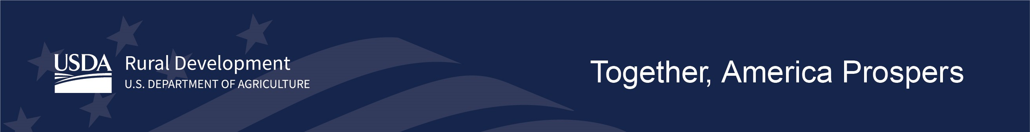~~

**USDA OneRD Teams Portal**

**Access Authorization and Management Form**

**Company Info**

|  |  |
| --- | --- |
| Company Legal Name |  |
| Company TIN |  |
| DUNS Number |  |
| SAMS/CAGE Code |  |
| Teams Channel Requested | OneRD Guaranteed Multi-State Lender  OneRD Lender Food Supply Chain |

**Authorized User Access**

|  |  |  |  |  |  |
| --- | --- | --- | --- | --- | --- |
|  | Last Name | First Name | Email | eAuthID  (if eAuth registered, otherwise “TBD”) | Add/Remove  plus, initials of RD staff when task completed |
| 1 |  |  |  |  |  |
| 2 |  |  |  |  |  |
| 3 |  |  |  |  |  |
| 4 |  |  |  |  |  |
| 5 |  |  |  |  |  |
| 6 |  |  |  |  |  |
| 7 |  |  |  |  |  |
| 8 |  |  |  |  |  |
| 9 |  |  |  |  |  |
| 10 |  |  |  |  |  |
| 11 |  |  |  |  |  |
| 12 |  |  |  |  |  |
| 13 |  |  |  |  |  |
| 14 |  |  |  |  |  |
| 15 |  |  |  |  |  |